**StudyBook**

**Design Document, version 2**

**March 30, 2012**

**Group Members:  
Chris Freels  
Douglas Gorman  
Naveen Neelakandan**

**Group Number: 4-2**

**Lab Instructor:  
Richard Sween**

This page intentionally left blank.

Table of Contents

**1. Overview Class Diagram1**

**2. Detailed Class Diagrams2**

2.1. Data Classes2

2.1.1. Student2

2.1.2. Course3

2.1.3. Utilities4

2.1.4. Calendar 5

2.1.5. Event 6

2.1.6. DiscussionBoard 7

2.1.7. Topic 8

2.1.8. Reply9

2.1.9. DocumentBoard10

2.1.10. Document 11

2.1.11. Adboard 12

2.1.12. Ad13

**3. Sequence Diagrams20**

3.1. Add Course12

3.2. Remove Course13

3.3. Post Ad14

3.4. Create Event15

**Appendix A: Database Design19**

**Appendix B: Task Role & Assignments20**

**1. Overview Class Diagram**

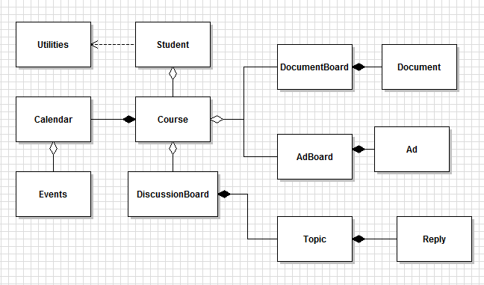

**2. Detailed Class Diagrams**

**2.1. Data Classes**

**2.1.1. Student**

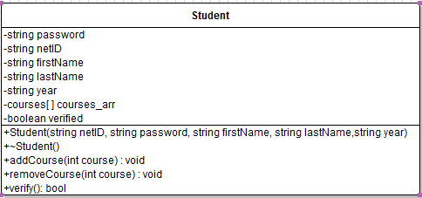

* Student(string netID, string password, string firstName, string lastName,string year) : Constructor. Creates a new student in the database with the attributes given in the parameters.
* ~Student() : Destructor to delete the student from the database permanently.
* addCourse(int course): Adds a course to the student’s courses[]. The course to be added is specified by the course number passes as a parameter to the method.
* removeCourse(int course): Deletes a course from the student’s courses[]. The course to be deleted is specified by the course number passes as a parameter to the method.
* verify() : Returns a boolean value as to whether the student is valid by sending an email with a randomly generated code to the student’s msstate email account. If the student then enters the correct code, the method returns a True value.

**2.1.2. Course**

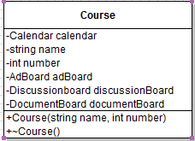

* Course() : Constructor. Creates a new course in the database with the attributes given in the parameters
* ~Course() : Destructor to delete a course from the database

**2.1.3. Utilities**

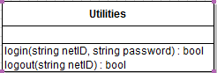

* login(string netID, string password ) : Queries the database for the student’s password depending on the netID. Logs a student into the application and starts a new session provided the username and password are correct. Else, returns an Boolean false value.
* logout(string netID) : Terminates the student’s current session and logs out the student. In case of any error, returns a boolean false value

**2.1.4. Calendar**

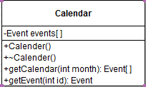

* Calender(): Constructor which will create a new calendar in the database and initialize an Event array.
* ~Calender(): Destructor to delete a calendar from database
* getCalendar(int month) : Returns an array of Events with the matching month integer.
* getEvent(int id) : Returns the event matching the given id number.

**2.1.5. Event**

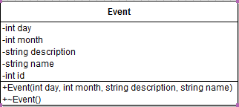

* Event(int day, int month, string description, string name) : Constructor. Creates an event with the given data and generates an id number.
* ~Event(int id): Deletes the event from the database.

**2.1.6. DiscussionBoard**

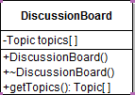

* DiscussionBoard(): Constructor which will create a new DiscussionBoard in the database and initialize a Topics array.
* ~DiscussionBoard():Destructor to delete a DiscussionBoard from database
* getTopics(): Returns an array of topics held in the Discussion board.

**2.1.7. Topic**

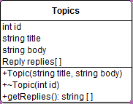

* Topic(string title, string body) : Constructor. Creates a topic with the given data and generates a unique id number. Also initializes an array of Replies.
* ~Topic() : Deletes a topic from the database
* getReplies(): Returns the Reply array as an array of strings.

**2.1.8. Reply**

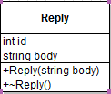

* Reply(string body) : Constructor. Creates a reply with the given data and generates a unique id number.
* ~Reply() : Deletes the reply from the database.

**2.1.9. DocumentBoard**

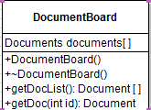

* DocumentBoard : Constructor which will create a new DocumentBoard in the database and initialize an array of documents
* ~DocumentBoard : Destructor to delete a DocumentBoard from database
* getDocList() : Returns an array of Documents from the database.
* getDoc(int id) : Returns the Document with the specified id number from the database.

**2.1.10. Document**

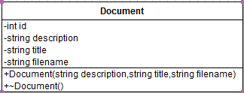

* Document(string description, string title, string filename) : Constructor. Creates up a Document with a title, filename, and description.
* ~Doc() : Deletes the specified Document from the database.

**2.1.11. AdBoard**

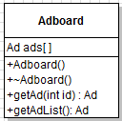

* Adboard() : Constructor. Creates an Adboard in the database and initializes an array of Ads.
* ~Adboard() : Deletes an Adboard from the database
* getAd(int id) : The getAd function returns the ad with the specified id number.
* getAdList() : The getAdList returns an array of Ads.

**2.1.12. Ad**

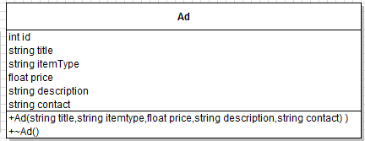

* Ad(string title, string itemtype, float price, string description, string contact) : Constructor. Creates a new Ad in the database with the given attributes.
* ~Ad() : Deletes the Ad from the database.

**3. Sequence Diagrams**

**3.1. Add Course**

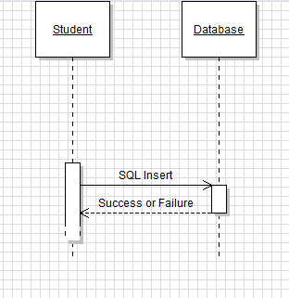

**3.2. Remove Course**

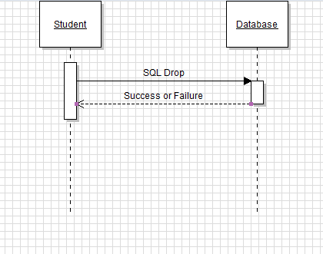

**3.3. Post Ad**

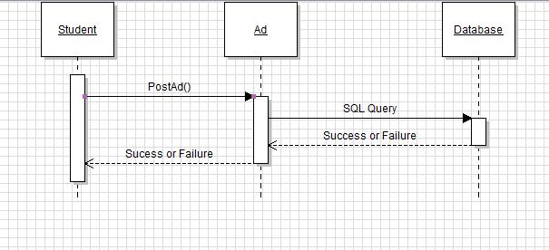

**3.4. Create Event**

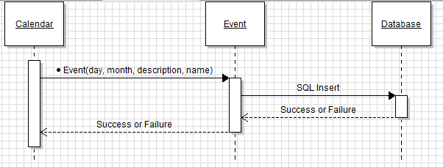

**Appendix A: Database Design**

("*" = Primary Key, "#" = Foreign Key)

**A.1 STUDENT table**  
*NETID  
NAME  
YEAR  
PASSWORD

**A.2 COURSE table**\*COURSENUMBER  
NAME

**A.3 DOCUMENT table  
\***DOCUMENTID  
#COURSENUMBER  
TITLE  
FILENAME  
FILE  
DESCRIPTION

**A.4 TOPIC table**\*TOPICID  
#COURSENUMBER  
TITLE  
BODY

**A.5 REPLY table**

*REPLYID#TOPICIDBODY

**A.6 AD table**\*ADID  
#COURSENUMBER  
TITLETYPE  
PRICE  
DESCRIPTION  
CONTACT

**A.7 EVENT table  
\***EVINTID  
#COURSENUMBER  
DAY  
MONTH  
NAME  
DESCRIPTION

A.8 STUDENT_COURSE table

*NETID

*COURSENUMBER

**A.8 STUDENT_IN_COURSE**  
#NETID  
#COURSENUMBER

**Appendix B: Initial Task and Role Assignments**

* Presentation Assignments:
  + Requirements - Chris Freels
  + Design - Naveen Neelakandan
  + Final - Douglas Gorman

* Current Task Assignments:
  + Registration, Login/Logout, Document Board– Naveen Neelakandan
  + Advertisement Board, Web layout – Douglas Gorman
  + Calender, Discussion Board– ChrisFreels