StudyBook

Requirements Document, version 2

February 30, 2012

Group Members:
Chris Freels
Douglas Gorman
NaveenNeelakandan

Group Number: 4-2

Lab Instructor:
Richard Sween

This page intentionally left blank.
Table of Contents
1. Introduction 1
1.1. Purpose 1
1.2. Definitions, Acronyms, and Abbreviations 1
1.3. References 1
2. System Overview 2
2.1. Purpose 2
2.2. Case Diagram 2
3. Specific Requirements 3
3.1. Register (Required) 3
3.1.1. Description 3
3.1.2. Actors 3
3.1.3. Steps 3
3.2. Login (Required) 4
3.2.1. Description 4
3.2.2. Actors 4
3.2.3. Steps 4
3.3. Logout (Required) 5
3.3.1. Description 5
3.3.2. Actors 5
3.3.3. Steps 5
3.4. Edit Profile (Required) 6
3.4.1. Description 6
3.4.2. Actors 6
3.4.3. Steps 6
3.5. Delete Profile (Required) 7
3.5.1. Description 7
3.5.2. Actors 7
3.5.3. Steps 7
3.6. Join Class(Required) 8
3.6.1. Description 8
3.6.2. Actors 8
3.6.3. Steps 8
3.7. Post to Discussion Board(Required) 9
3.7.1. Description 9
3.7.2. Actors 9
3.7.3. Steps 9
3.8. Reply to Discussion Board (Required) 10
3.8.1. Description 10
3.8.2. Actors 10
3.8.3. Steps 10
3.9. Create Study Session (Required) 11
3.9.1. Description 11
3.9.2. Actors 11
3.9.3. Steps 11
3.10. Start Study Session (Medium) 12
3.10.1. Description 12
3.10.2. Actors 12
3.10.3. Steps 12
3.11. Join Online Study Session (Medium) 13
3.9.1. Description 13
3.9.2. Actors 13
3.9.3. Steps 13
3.12. Edit Class Calendar (Required) 14
3.10.1. Description 14
3.10.2. Actors 14
3.10.3. Steps 14

3.13. Post Ads (Required) 15
3.13.1. Description 15
3.13.2. Actors 15
3.13.3. Steps 15
3.14. View Ads (Required) 16
3.14.1. Description 16
3.14.2. Actors 16
3.14.3. Steps 16
3.15. Edit Ads (Required) 17
3.15.1. Description 17
3.15.2. Actors 17
3.15.3. Steps 17
3.16. Delete Ads (Required) 18
3.16.1. Description 18
3.16.2. Actors 18
3.16.3. Steps 18
3.17. Submit Documents (Required) 19
3.17.1. Description 19
3.17.2. Actors 19
3.17.3. Steps 19
3.18. View Documents (Required) 20
3.18.1. Description 20
3.18.2. Actors 20
3.18.3. Steps 20
3.19. Flag Documents (Required) 21
3.19.1. Description 21
3.19.2. Actors 21
3.19.3. Steps 21

3.20. Delete Documents (Required) 22
3.20.1. Description 22
3.20.2. Actors 22
3.20.3. Steps 22
Appendix A: User Interface 23
A.1 Login 24
A.2 Post Advertisement 24
Appendix B: Initial Task and Role Assignments 26

1. Introduction

1.1. Purpose
The purpose of this Requirements Document is to specify the software requirements of StudyBook, Mississippi State University social network that will assist students in meeting classmates, setting up study sessions, and keeping up with school work and assignments. This document will help define the concept and functionality of StudyBook.
The intended audience of this document is the software developers, Mr. Crumpton and Mr. Sween.

1.2 Definitions, Acronyms, and Abbreviations
Registered User – a user who has an account on the site and is logged in
Unregistered User- a user who is not logged in and does not have an account
Member of class – a registered user who has the class added to his/her class list
Virtual Whiteboard – and interactive document on which all user can see but only one user at a time may edit
Study session – may be either an online or offline meeting to study for the class. An online study session will include voice and text chat and should make use of the whiteboard.
Study session Leader – The member of class who sets up a study session
Class – A class refers to the specific section of a course that the user is in.
1.3. References
IEEE Std. 830-1998, IEEE Recommended Practice for Software Requirements Specifications, Institute for Electrical and Electronic Engineers, Piscataway, New Jersey, 1998.

2. System Overview

2.1 Purpose
Studybook will be a social network for people with a valid Mississippi State University NetID. The site will require an account to use. Users will be able to join classes and maintain a simple profile. Each class will have its own homepage with a discussion board, a calendar, and a study event creator. Any member of a class will be able to edit the class calendar, create new posts on the discussion board, reply to posts on the discussion board, create study events, and join study events. Study events may simply be a way to organize a study group but they may also be online study sessions. An online study group will include voice chat and a whiteboard. The whiteboard will only be used by the group leader and whoever else the leader gives permission to. The entire group will be able to see changes on the whiteboard in real-time. Alerts for study sessions and calendar events may be sent to the user by email or text if he/she requests it. Students may also submit and download documents such as class notes to the class homepage.
2.2 Use Case Diagram
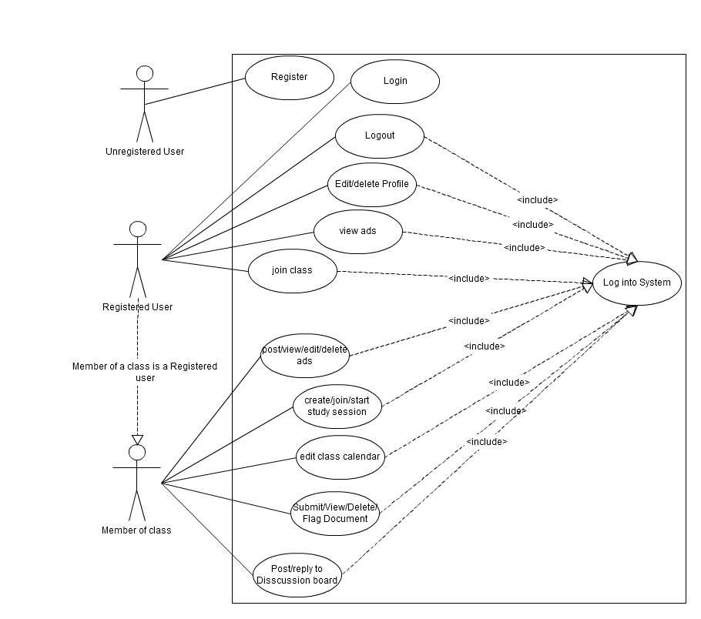
StudyBook
3. Specific Requirements
3.1 Register (Required)

3.1.1 Description
An unregistered user would use this function to make an account to be able to use the site.

3.1.2 Actors
Unregistered User

3.1.3 Steps
- The unregistered user starts at the main page of the StudyBook web application and clicks the link labeled Register.
- The application displays a page with a form for the user to fill out. The form will include first name, last name, password, Msstate email address, classification (e.g. Junior or Senior), and major.
- The unregistered user will fill out the form and submit it to the application.
- The application will check the information against a database to see if it is valid and if it is, the unregistered user will become a registered user.

3.2 Login (Required)

3.2.1 Description
A registered user would use this function to log into the site to gain access to the site functions.

3.2.2 Actors
Registered User

3.2.3 Steps
- The registered user starts on the main page of the StudyBook web application and clicks the link labeled Log In.
- The application displays a page with a form for the user to fill out. The form will include the registered user’s email address and password.
- The registered user will fill out the form and submit it to the application.
- The application will verify the information by checking the email address and password against a database and if it is valid will display the user’s profile page allowing the user to access site features. If the information is not valid the application will display the log in form with an error message stating the problem that occurred.

3.3 Logout (Required)

3.3.1 Description
A registered user would use this function to log into the site to gain access to the site functions.

3.3.2 Actors
Registered User

3.3.3 Steps
- The Registered user will click the Logout button located on any page.
- The application will display the main page and the registered user will not have access to site features.

3.4. Edit Profile (Required)

3.4.1 Description
A user would use this functionality to edit his/her already existing profile

3.4.2 Actors
Registered User

3.4.3 Steps
- The user starts at the main page (Home) and after logging in to their account, clicks on the link labeled edit profile.
- The application displays a pagewith a form for the user to fill out. The form will include first name, last name, password, Msstate email address, classification (e.g. Junior or Senior), and major.
- Once filled out the user then clicks a button labeled Edit.
- The application will check that all of the fields have valid information.
- If all the information given is valid, the profile is updated ,else an error is shown informing the user which field has an invalid entry.

3.5. Delete Profile (Required)

3.4.1 Description
A user would use this functionality to deletehis/her existing profile.

3.4.2 Actors
Registered User

3.4.3 Steps
- The user starts at the main page (Home) and after logging in to their account, clicks on the link labeled edit profile.
- The application then displays a page and in the bottom of the page, there is a link labeled delete profile.
- The user clicks on this link and the application brings up a page with a proceed button on it. The page also contains a warning that the account will be permanently deleted if the user presses the proceed button.
- If the user wishes to delete his/her account he/she clicks on the proceed button and the account is deleted.
- The user is redirected to the main page of the StudyBook web application and no longer has an account to log in.

3.6. Join Class (Required)

3.6.1 Description
A user would use this functionality to join an available class and section.

3.6.2 Actors
Member of class

3.6.3 Steps
- The user starts at the main page (Home) and after logging in to their account, clicks on the link labeled join class.
- The application then displays entries for the user such as class name and teacher name and section number.
- Once filled out the user then clicks a button labeled join class.
- The application then displays a page with the classes joined as well as the section number.

3.7 Post to Discussion Board(Required)

3.7.1 Description
A student would use this to post up a specific question on the discussion board.

3.7.2 Actors
Member of Class

3.7.3 Steps
- The student starts at the main page of the course and clicks the link labeled Discussion
- In the Discussions section, the student clicks on the link labeled Post Discussion
- The application will display a Text box where the student can type in any question he/she has to post.
- The student will click submit once he/she has entered the discussion question.
- The discussion tab now appears under the Discussion board page.

3.8 Reply to Discussion Board(Required)

3.8.1 Description
A user would use this functionality to post a message to a discussion board.

3.8.2 Actors
Member of class

3.8.3 Steps
- The student starts at the main page of the course page and after logging in, clicks on the tab discussion.
- The application displays a list of discussion tabs
- The user clicks on a discussion tab.
- The application lists the discussion and an option for posting to discussion.
- The user clicks on post link and enters in what is to be posted.
- The application then posts information to the discussion board.

3.9 Create Study Session(Required)

3.9.1 Description
The student would use this functionality to create a study session within the class.

3.9.2 Actors
Member of class

3.9.3 Steps
- The student starts at the main page of the course and clicks on the link labeled study session.
- The application then displays the current study session and the link create study session.
- The user clicks on create study session.
- The application then displays a list of entries such as study session name, time, location, and online or offline.
- The user then enters said information, clicks the submit button, and the previous page is updated.
- Every member in the class will receive the invitation and the study session will be added to the calendar.

3.10 Start Study Online Session(Medium)

3.10.1 Description
The student would use this functionality to begin a study session already setup.

3.10.2 Actors
Study Session Leader

3.10.3 Steps
- The student starts at the main page of the course and clicks on the link labeled study session.
- The application then displays a list of study sessions already setup.
- The Study Session Leader clicks on the study session they wish to start. Only the Session Leader is given the option of starting a study session.
- The application displays a virtual whiteboard as well as an option to enable voice/text chat
- The Study Session Leader can then write on the whiteboard himself/herself or allow others to write on it by yielding control temporarily. Only one person has access to the whiteboard at any one time.
- Once, the study session is over, the Study Session Leader exits the application by clicking on the back link and the study session is ended.

3.11 Join Online Study Session(Medium)

3.11.1 Description
A student would use this to join an ongoingOnline study session.

3.11.2Actors
Member of Class

3.11.3 Steps
- The student starts at the main page of the course and clicks the link labeled Study Session
- The application then displays a list of study sessions already setup.
- If there are any Online Study Session ongoing, the student can click on this to add himself/herself to the Study Session.
- The student will now be able to view the whiteboard of the study session as well as have an option to enable voice/text chat.

3.12 Edit Calendar(Required)

3.12.1 Description
The user would use this functionality to add an event to the calendar.

3.12.2 Actors
Member of Class

3.12.3 Steps
- The user logs in to their account (Home) and clicks on the link labeled calendar.
- The application displays an updated current calendar with links such as add to calendar
- The user clicks on the link add to calendar.
- The application prompts the user with entries for date, time and the information to be added.
- Once the user enters this information and clicks add to calendar.
- The application updates the calendar for this individual user.

3.13 Post Ads(Required)

3.13.1 Description
A student would use this to put up advertisements of book or other materials he wants to sell at the end of the semester.

3.13.2 Actors
Member of Class

3.13.3 Steps
- The student starts at the main page of the course and clicks the link labeled advertisements
- In the advertisements section, the student clicks on the link labeled Post Ads
- The application will display a form with a few categories. Categories include Type of item to be sold, selling price , condition of item and contact information
- The student will fill up the form accordingly and submit it.
- The ad now appears under the advertisements section in the main course page.

3.14 View Ads(Required)

3.14.1 Description
A student would use this to view advertisements posted for a specific course.

3.14.2 Actors
Any Registered User

3.14.3 Steps
- The student starts at the main page of the course and clicks the link labeled advertisements.
- The application now displays the advertisements section under which all ads posted in the course are displayed in chronological order with a brief description of the type of item.
- The student will click on any ad that interests him to find out more such as the price, condition of item and the contact details of the seller.

3.15 Edit Ads (Required)

3.15.1 Description
A user would use this functionality to join an available class.

3.15.2 Actors
Poster of Ad

3.15.3 Steps
- The user starts at the main page and after logging in to their account, clicks on the link labeled advertisements.
- The application displaysthe advertisements section under which all ads posted in the course are displayed with a link labeled edit next to ads posted by the user
- The user clicks on the link labeled edit and the application will display a form with a few categories. Categories include Type of item to be sold, selling price, condition of item and contact information.
- The student will fill up the form accordingly and submit it
- The updated Ad now shows up under the advertisements section.

3.16 Delete Ads (Required)

3.16.1 Description
A user would use this functionality to join an available class.

3.16.2 Actors
Poster of Ad

3.16.3 Steps
- The user starts at the main page and after logging in to their account, clicks on the link labeled advertisements.
- The application displays the advertisements section under which all ads posted in the course are displayed with a link labeled delete next to ads posted by the user
- The user clicks on the link labeled delete and the application deletes the Ad.
- The deleted Ad now does not show up under the advertisements section.

3.17 Submit Document(Required)

3.17.1 Description
Student will be able to upload any authorized pdf document (such as notes) to the website. Anyone registered in the course can then view this document.

3.17.2 Actors
Member of class

3.17.3 Steps
- The student starts on the main page of the course and clicks on the Documents link
- Under the documents link, the student clicks on the link to Upload Document
- The application brings up a form where the student can type in the name of the document and select the document to be uploaded from his computer.
- The application checks if the document is in pdf format and if it is, the document is uploaded to the server and a confirmation screen appears. Else, the upload is unsuccessful and the student is shown an error message.
- The student clicks on the back links to go to the previous screen

3.18 View Document(Required)

3.18.1 Description
Students will able to view any document uploaded to the server under the course listing

3.18.2 Actors
Member of class

3.18.3 Steps
- The student starts on the main page of the course and clicks on the Documents link
- Under the documents link, the student clicks on the link to view Document
- The application brings up a page featuring all documents to have been uploaded for the specific course by chronological order.
- The student clicks on any document he is interested in and the application brings up a page featuring the document.
- The student clicks on the back links to go to the previous screen

3.19 Flag Document(Required)

3.19.1 Description
Students will able to flag any document uploaded to the server under the course listing for if it contains inappropriate content

3.19.2 Actors
Member of class

3.19.3 Steps
- The student starts on the main page of the course and clicks on the Documents link
- Under the documents link, the student clicks on the link to view Document
- The application brings up a page featuring all documents to have been uploaded for the specific course by chronological order with a box marked flag on each one.
- The student clicks on the flag button next to any document he/she deems to contain inappropriate content.
- The document is deleted from the website if more than 5 students have flagged it.
3.20 Delete Document (Required)

3.20.1 Description
Students will able to view any document uploaded to the server under the course listing

3.20.2 Actors
Member of class

3.20.3 Steps
- The student starts on the main page of the course and clicks on the Documents link
- Under the documents link, the student clicks on the link to view Document
- The application brings up a page featuring all documents to have been uploaded for the specific course by chronological order with a box marked flag on each one.
- The student clicks on any document he is interested in and the application brings up a page featuring the document.
- If the student has uploaded the document then the student will be able to click a delete button next to the document and the document will be removed from the site and the database
- The student clicks on the back links to go to the previous screen

Appendix A: User Interface

A.1 Login
The following images depict the user interface as seen by the student when they are logging in to the application.

A.2 Post Advertisement
The following images depict the user interface as seen by the student when they are posting an advertisement.

Appendix B: Initial Task and Role Assignments

- Presentation Assignments:
  - Requirements (2/23) - Chris Freels
  - Design (Naveen Neelakandan)
  - Final(Douglas Gorman)

- Initial Task Assignments:
  - HTML, User Interface Design – NaveenNeelakandan
  - Database creation and management – Douglas Gorman
  - Java server pages and servlets – Chris Freels

