Contents
Abstract iv
List of figures v
1. Introduction 1
1.1. Motivation 1
1.2. Problem Definition 2
1.3. Objective of Project 2
1.4. Limitation of Project 2
2. Literature Survey 3
2.1. Denial-of-service attack 3
a. Means 3
b. Manifestations 4
c. Methods of attack 4
d. Incidents 15
e. Performing DoS-attacks 17
f. Prevention and response 17
g. Side effects of DoS attacks 20
h. Denial-of-service attacks and the law 21
2.2. Overlay Network 22
a. Uses of overlay networks 22
b. List of overlay network protocols 23
2.3. File System 24
a. Aspects of file systems 24
b. Types of file systems 26
2.4. File systems and operating systems 29
a. Flat file systems 30
b. File systems under Unix-like operating systems 31
c. File systems under Linux 32
d. File systems under Solaris 33
e. File systems under Mac OS X 33
f. File systems under Plan 9 from Bell Labs 34
g. File systems under Microsoft Windows 35
h. Data retrieval process 36
2.5. The Java Language 38
a. The Java Programming Language 38
b. The Java Platform 39
c. What Can Java Do? 40
d. How Will Java Change My Life? 41
2.6. About J2ee 43
a. J2EE Components 44
b. J2EE Clients 45
c. Web Components 48
d. Business Components 48
e. Packaging 49
f. Development Roles 51
g. J2EE Product Provider 51
h. Tool Provider 52
i. Application Component Provider 52
j. Application Assembler 53
k. Application Deployer and Administrator 53
l. Reference Implementation Software 54
m. Database Access 54
n. Tools 56
2.7. Introduction jsp 57
a. The nuts and bolts 57
2.8. Structured Overlay Network 61
2.9. Peer-to-Peer search 61
3. Module Description 62
3.1. Module 1: User Interface Design 62
3.2. Module 2: Client Application 62
3.3. Module 3: Location Guard 62
3.4. Module 4: Routing Guard 62
3.5. Module 5: File Server 63
4. UML Diagrams 64
4.1. Data Flow Diagram 64
4.2. Use Case Diagram 65
4.3. Class Diagram 66
4.4. Collaboration Diagram 67
4.5. Sequence Diagram 68
4.6. State Diagram 69
4.7. Activity Diagram 70
5. System Architecture 71
6. Module Diagram 72
6.1. Client Application 72
6.2. Location Guard 72
6.3. Routing Guard 72
6.4. File Servers 73
7. Sample coding 74
8. Screen Shots 83
8.1. Server Screenshot 83
8.2. Client Screenshot 84
8.3. Client Requesting topic from Server 85
8.4. Client Requesting Book 86
8.5. Attacker 87
8.6. Server Attacked 88
8.7. Location Guard 89
8.8. Request from Client to Location Guard : Topic 90
8.9. Request From Client to Location Guard : Book 91
9. Testing 92
9.1. System Testing 92
9.2. Types Of Tests 92
a. Unit testing 92
b. Integration testing 92
c. Functional test 93
d. System Test 93
e. White Box Testing 94
f. Black Box Testing 94
g. Unit Testing 94
9.3. Integration Testing 94
a. Acceptance Testing 95
10. Conclusion 96
11. References 97

Abstract

An overlay network is a virtual network formed by nodes (desktop workstations) on top of an existing TCP/IP-network. Overlay networks typically support a lookup protocol. A lookup operation identifies the location of a file given its filename. Location of a file denotes the IP-address of the node that currently hosts the file. This project is a location hiding approach for mitigating the denial of service attacks on the chord overlay network. Serverless distributed computing has received significant attention from both the industry and the research community. Among the most popular applications are the wide-area network file systems, exemplified by CFS, Farsite, and OceanStore. These file systems store files on a large collection of untrusted nodes that form an overlay network. They use cryptographic techniques to maintain file confidentiality and integrity from malicious nodes. Unfortunately, cryptographic techniques cannot protect a file holder from a denial-of-service (DoS) attack or a host compromise attack. Hence, most of these distributed file systems are vulnerable to targeted file attacks, wherein an adversary attempts to attack a small (chosen) set of files by attacking the nodes that host them.

List of figures

Figure 2-1 Multitier Applications 44
Figure 2-2 Server Communications 47
Figure 2-3 Business and EIS Tiers 49
Figure 4-1 Use Case Diagram 65
Figure 4-2 Class Diagram 66
Figure 4-3 Collaboration Diagram 67
Figure 4-4 Sequence Diagram 68
Figure 4-5 State Diagram 69
Figure 4-6 Activity Diagram 70
Figure 5-1 System Architecture 71
Figure 5-2 Location Guard Conceptual Design 71
Figure 6-1 Client Application 72
Figure 6-2 Location Guard 72
Figure 6-3 Routing Guard 72
Figure 6-4 File Servers 73
Figure 8-1 Server Screenshot 83
Figure 8-2 Client Screenshot 84
Figure 8-3 Client Requests Book 85
Figure 8-4 Client Requesting Book 86
Figure 8-5 Attacker 87
Figure 8-6 Server Attacked 88
Figure 8-7 Location Guard 89
Figure 8-8 Client requesting topics from location guard 90
Figure 8-9 Request from Client to Location Guard : Book 91

Introduction

SEVERAL serverless file storage services, like CFS, Farsite, OceanStore, and SiRiUS, have recently emerged. In contrast to traditional file systems, they harness the resources available at desktop workstations that are distributed over a wide-area network. The collective resources available at these desktop workstations amount to several petaflops of computing power and several hundred petabytes of storage space. These emerging trends have motivated serverless file storage as one of the most popular applications over decentralized overlay networks. An overlay network is a virtual network formed by nodes (desktop workstations) on top of an existing TCP/IP-network. Overlay networks typically support a lookup protocol. A lookup operation identifies the location of a file given its filename. Location of a file denotes the IP-address of the node that currently hosts the file. There are four important issues that need to be addressed to enable wide deployment of serverless file systems for mission critical applications.
Bearing these issues in mind, in this paper, we present LocationGuard as an effective technique for countering targeted file attacks. The fundamental idea behind LocationGuard is to hide the very location of a file and its replicas such that a legal user who possesses a file’s location key can easily and securely locate the file on the overlay network; but without knowing the file’s location key, an adversary would not be able to even locate the file, let alone access it or attempt to attack it. LocationGuard implements an efficient capability-based file access control mechanism through three essential components.

Motivation
The main reason for Denial of Service attacks on the file servers is due to inadequate hiding of resources present on Servers. This enables attacker to get info regarding the files such as names of files, file size and also their location.

Problem Definition
The aim of the project is to develop and location hiding technique for files present on chord overlay network. By using encrypted Location Key instead of file names, the location of files in the servers can be hidden.

Objective of Project
The objective of this project is “To develop a location hiding technique for securing overlay file storage systems from Denial Of Service attacks(DOS).”.
A denial-of-service attack (DoS attack) or distributed denial-of-service attack (DDoS attack) is an attempt to make a computer resource unavailable to its intended users. Although the means to carry out, motives for, and targets of a DoS attack may vary, it generally consists of the concerted efforts of a person or people to prevent an Internet site or service from functioning efficiently or at all, temporarily or indefinitely.
An overlay network is a computer network which is built on top of another network. Nodes in the overlay can be thought of as being connected by virtual or logical links, each of which corresponds to a path, perhaps through many physical links, in the underlying network.

Limitation of Project
Our experimental results quantify the overhead of employing location guards and demonstrate the effectiveness of the LocationGuard scheme against DoS attacks, host compromise attacks, and various location inference attacks.

Literature Survey

Denial-of-service attack
A denial-of-service attack (DoS attack) or distributed denial-of-service attack (DDoS attack) is an attempt to make a computer resource unavailable to its intended users. Although the means to carry out, motives for, and targets of a DoS attack may vary, it generally consists of the concerted efforts of a person or people to prevent an Internet site or service from functioning efficiently or at all, temporarily or indefinitely. Perpetrators of DoS attacks typically target sites or services hosted on high-profile web servers such as banks, credit card payment gateways, and even root name servers.
One common method of attack involves saturating the target (victim) machine with external communications requests, such that it cannot respond to legitimate traffic, or responds so slowly as to be rendered effectively unavailable. In general terms, DoS attacks are implemented by either forcing the targeted computer(s) to reset, or consuming its resources so that it can no longer provide its intended service or obstructing the communication media between the intended users and the victim so that they can no longer communicate adequately.
Denial-of-service attacks are considered violations of the IAB's Internet proper use policy, and also violate the acceptable use policies of virtually all Internet Service Providers. They also commonly constitute violations of the laws of individual nations.

Means
As there are two main types of attack (wired and wireless), different material is to be used for each of the two types.
Attacks on wired networks require a great deal of computing power, often even requiring the need of distributed computing. Attacks on wired networks do not require any NICs or external antennae, yet often do have the need of a (broadband) connection to the Internet.
Attacks on wireless networks require a high-power Negative Impedance Converter (NIC) and usually a high-gain (directional) external antenna (to increase range as well as power output). High power NICs fall in the range of the 300mW-cards. Examples can be found from companies such as Demarc Technology Group.

Manifestations
The United States Computer Emergency Response Team defines symptoms of denial-of-service attacks to include:
- Unusually slow network performance (opening files or accessing web sites)
- Unavailability of a particular web site
- Inability to access any web site
- Dramatic increase in the number of spam emails received—(this type of DoS attack is considered an e-mail bomb)^{[2]}
Denial-of-service attacks can also lead to problems in the network 'branches' around the actual computer being attacked. For example, the bandwidth of a router between the Internet and a LAN may be consumed by an attack, compromising not only the intended computer, but also the entire network.
If the attack is conducted on a sufficiently large scale, entire geographical regions of Internet connectivity can be compromised without the attacker's knowledge or intent by incorrectly configured or flimsy network infrastructure equipment.

Methods of attack
A "denial-of-service" attack is characterized by an explicit attempt by attackers to prevent legitimate users of a service from using that service. Attacks can be directed at any network device, including attacks on routing devices and web, electronic mail, or Domain Name System servers.
A DoS attack can be perpetrated in a number of ways. The five basic types of attack are:
- Consumption of computational resources, such as bandwidth, disk space, or processor time
- Disruption of configuration information, such as routing information.
- Disruption of state information, such as unsolicited resetting of TCP sessions.
- Disruption of physical network components.
- Obstructing the communication media between the intended users and the victim so that they can no longer communicate adequately.
A DoS attack may include execution of malware intended to:
- Max out the processor's usage, preventing any work from occurring.
- Trigger errors in the microcode of the machine.
- Trigger errors in the sequencing of instructions, so as to force the computer into an unstable state or lock-up.
- Exploit errors in the operating system, causing resource starvation and/or thrashing, i.e. to use up all available facilities so no real work can be accomplished.
- Crash the operating system itself.

ICMP flood
See also: Smurf attack, Ping flood, and Ping of death
A smurf attack is one particular variant of a flooding DoS attack on the public Internet. It relies on misconfigured network devices that allow packets to be sent to all computer hosts on a particular network via the broadcast address of the network, rather than a specific machine. The network then serves as a smurf amplifier. In such an attack, the perpetrators will send large numbers of IP packets with the source address faked to appear to be the address of the victim. The network's bandwidth is quickly used up, preventing legitimate packets from getting through to their destination.^{[3]} To combat Denial of Service attacks on the Internet, services like the Smurf Amplifier Registry have given network service providers the ability to identify misconfigured networks and to take appropriate action such as filtering.
Ping flood is based on sending the victim an overwhelming number of ping packets, usually using the "ping" command from unix like hosts (the -t flag on Windows systems has a far less malignant function). It is very simple to launch, the primary requirement being access to greater bandwidth than the victim.
SYN flood sends a flood of TCP/SYN packets, often with a forged sender address. Each of these packets is handled like a connection request, causing the server to spawn a half-open connection, by sending back a TCP/SYN-ACK packet, and waiting for a packet in response from the sender address. However, because the sender address is forged, the response never comes. These half-open connections saturate the number of available connections the server is able to make, keeping it from responding to legitimate requests until after the attack ends.

Teardrop attacks
A Teardrop attack involves sending mangled IP fragments with overlapping, over-sized payloads to the target machine. This can crash various operating systems due to a bug in their TCP/IP fragmentation re-assembly code.^{[4]} Windows 3.1x, Windows 95 and Windows NT operating systems, as well as versions of Linux prior to versions 2.0.32 and 2.1.63 are vulnerable to this attack.

Peer-to-peer attacks
Attackers have found a way to exploit a number of bugs in peer-to-peer servers to initiate DDoS attacks. The most aggressive of these peer-to-peer-DDoS attacks exploits DC++. Peer-to-peer attacks are different from regular botnet-based attacks. With peer-to-peer there is no botnet and the attacker does not have to communicate with the clients it subverts. Instead, the attacker acts as a 'puppet master,' instructing clients of large peer-to-peer file sharing hubs to disconnect from their peer-to-peer network and to connect to the victim’s website instead. As a result, several thousand computers may aggressively try to connect to a target website. While a typical web server can handle a few hundred connections/sec before performance begins to degrade, most web servers fail almost instantly under five or six thousand connections/sec. With a moderately big peer-to-peer attack a site could potentially be hit with up to 750,000 connections in a short order. The targeted web server will be plugged up by the incoming connections. While peer-to-peer attacks are easy to identify with signatures, the large number of IP addresses that need to be blocked (often over 250,000 during the course of a big attack) means that this type of attack can overwhelm mitigation defenses. Even if a mitigation device can keep blocking IP addresses, there are other problems to consider. For instance, there is a brief moment where the connection is opened on the server side before the signature itself comes through. Only once the connection is opened to the server can the identifying signature be sent and detected, and the connection torn down. Even tearing down connections takes server resources and can harm the server.
This method of attack can be prevented by specifying in the p2p protocol which ports are allowed or not. If port 80 is not allowed, the possibilities for attack on websites can be very limited.

Permanent denial-of-service attacks
A permanent denial-of-service (PDoS), also known loosely as phlashing,^{[5]} is an attack that damages a system so badly that it requires replacement or reinstallation of hardware.^{[6]} Unlike the distributed denial-of-service attack, a PDoS attack exploits security flaws in the remote management interfaces of the victim's hardware, be it routers, printers, or other networking hardware. These flaws leave the door open for an attacker to remotely 'update' the device firmware to a modified, corrupt or defective firmware image, therefore "bricking" the device and making it permanently unusable for its original purpose. The PDoS is a pure hardware targeted attack which can be much faster and requires fewer resources than using a botnet in a DDoS attack. Because of these features, and the potential and high probability of security exploits on Network Enabled Embedded Devices (NEEDs), this technique has come to the attention of numerous hacker communities. PhlashDance is a tool created by Rich Smith^{[7]} (an employee of Hewlett-Packard's Systems Security Lab) used to detect and demonstrate PDoS vulnerabilities at the 2008 EUSecWest Applied Security Conference in London.^{[7]}

Application level floods
On IRC, IRC floods are a common electronic warfare weapon.
Various DoS-causing exploits such as buffer overflow can cause server-running software to get confused and fill the disk space or consume all available memory or CPU time.
Other kinds of DoS rely primarily on brute force, flooding the target with an overwhelming flux of packets, oversaturating its connection bandwidth or depleting the target's system resources. Bandwidth-saturating floods rely on the attacker having higher bandwidth available than the victim; a common way of achieving this today is via Distributed Denial of Service, employing a botnet. Other floods may use specific packet types or connection requests to saturate finite resources by, for example, occupying the maximum number of open connections or filling the victim's disk space with logs.
A "banana attack" is another particular type of DoS. It involves redirecting outgoing messages from the client back onto the client, preventing outside access, as well as flooding the client with the sent packets.
An attacker with access to a victim's computer may slow it until it is unusable or crash it by using a fork bomb.

Nuke
A Nuke is an old denial-of-service attack against computer networks consisting of fragmented or otherwise invalid ICMP packets sent to the target, achieved by using a modified ping utility to repeatedly send this corrupt data, thus slowing down the affected computer until it comes to a complete stop.
In online gaming, nuking is used by spamming another user, or all other users, with random repeated messages in quick succession. Such techniques are also seen in instant messaging programs as repeatedly sending text can be assigned to a macro or AppleScript. Modern operating systems are usually resistant to these nuke attacks, and online games now have third party "Flood control."
A specific example of a nuke attack that gained some prominence is the WinNuke, which exploited the vulnerability in the NetBIOS handler in Windows 95. A string of out-of-band data was sent to TCP port 139 of the victim's machine, causing it to lock up and display a Blue Screen of Death (BSOD).

Distributed attack
A distributed denial of service attack (DDoS) occurs when multiple systems flood the bandwidth or resources of a targeted system, usually one or more web servers. These systems are compromised by attackers using a variety of methods.
Malware can carry DDoS attack mechanisms; one of the better-known examples of this was MyDoom. Its DoS mechanism was triggered on a specific date and time. This type of DDoS involved hardcoding the target IP address prior to release of the malware and no further interaction was necessary to launch the attack.
A system may also be compromised with a trojan, allowing the attacker to download a zombie agent (or the trojan may contain one). Attackers can also break into systems using automated tools that exploit flaws in programs that listen for connections from remote hosts. This scenario primarily concerns systems acting as servers on the web.
Stacheldraht is a classic example of a DDoS tool. It utilizes a layered structure where the attacker uses a client program to connect to handlers, which are compromised systems that issue commands to the zombie agents, which in turn facilitate the DDoS attack. Agents are compromised via the handlers by the attacker, using automated routines to exploit vulnerabilities in programs that accept remote connections running on the targeted remote hosts. Each handler can control up to a thousand agents.^{[8]}
These collections of systems compromisers are known as botnets. DDoS tools like stacheldraht still use classic DoS attack methods centered on IP spoofing and amplification like smurf attacks and fraggle attacks (these are also known as bandwidth consumption attacks). SYN floods (also known as resource starvation attacks) may also be used. Newer tools can use DNS servers for DoS purposes. (see next section)
Unlike MyDoom's DDoS mechanism, botnets can be turned against any IP address. Script kiddies use them to deny the availability of well known websites to legitimate users.^{[1]} More sophisticated attackers use DDoS tools for the purposes of extortion — even against their business rivals.^{[9]}
It is important to note the difference between a DDoS and DoS attack. If an attacker mounts an attack from a single host it would be classified as a DoS attack. In fact, any attack against availability would be classed as a Denial of Service attack. On the other hand, if an attacker uses a thousand systems to simultaneously launch smurf attacks against a remote host, this would be classified as a DDoS attack.
The major advantages to an attacker of using a distributed denial-of-service attack are that multiple machines can generate more attack traffic than one machine, multiple attack machines are harder to turn off than one attack machine, and that the behavior of each attack machine can be stealthier, making it harder to track down and shut down. These attacker advantages cause challenges for defense mechanisms. For example, merely purchasing more incoming bandwidth than the current volume of the attack might not help, because the attacker might be able to simply add more attack machines.
Although most DDoS attacks are malicious in nature, the same technique can be used to aid the Internet community. Internet fraud schemes, such as Nigerian 419 scams or phishing, commonly involve fraudulent websites that either impersonate a real website for purposes of stealing the victim's identity, or lend credibility to a scammer's fictional business venture to lure the victim into a false sense of confidence. Scam baiters, who combat these scams by posing as victims for the purpose of wasting the scammer's time and money and obtaining information that can be used by authorities, will forward sites they encounter during the course of their conversations to groups that specialize in site-killing.^{[citation needed]} The group will first try to have a site taken down by informing the host of said site that the site is being used fraudulently. In the case where that approach fails, the group will organize a "takedown" of the site by encouraging its members to visit the site en masse and continually refresh its content (an intentional form of the Slashdot effect sometimes referred to as flash mobbing, although that term is technically reserved for real-world gatherings). Alternately, some groups have special web pages that link to images hosted by these fake sites and show the images to visitors (usually members or supporters of the site-killing group) while constantly reloading them, which is known as intentional bandwidth hogging.^{[citation needed]} The purpose, similar to malicious DoS attacks, is to (a.) rapidly consume all of the website's allocated monthly bandwidth, after which requests for the site's content are refused, (b.) draw the attention of the site's host, who when faced with the constant onslaught on the entire hosting network's resources, will usually remove the site, and/or (c.) take up all available connections and maximum throughput of the host so that would-be victims cannot access the site.

Reflected attack
A distributed reflected denial of service attack (DRDoS) involves sending forged requests of some type to a very large number of computers that will reply to the requests. Using Internet protocol spoofing, the source address is set to that of the targeted victim, which means all the replies will go to (and flood) the target.
ICMP Echo Request attacks (Smurf Attack) can be considered one form of reflected attack, as the flooding host(s) send Echo Requests to the broadcast addresses of mis-configured networks, thereby enticing many hosts to send Echo Reply packets to the victim. Some early DDoS programs implemented a distributed form of this attack.
Many services can be exploited to act as reflectors, some harder to block than others.^{[10]} DNS amplification attacks involve a new mechanism that increased the amplification effect, using a much larger list of DNS servers than seen earlier.^{[11]}

Degradation-of-service attacks
"Pulsing" zombies are compromised computers that are directed to launch intermittent and short-lived flooding of victim websites with the intent of merely slowing it rather than crashing it. This type of attack, referred to as "degradation-of-service" rather than "denial-of-service", can be more difficult to detect than regular zombie invasions and can disrupt and hamper connection to websites for prolonged periods of time, potentially causing more damage than concentrated floods.^{[12][13]} Exposure of degradation-of-service attacks is complicated further by the matter of discerning whether the attacks really are attacks or just healthy and likely desired increases in website traffic.^{[14]}

Unintentional denial of service
Aka VIPDoS
This describes a situation where a website ends up denied, not due to a deliberate attack by a single individual or group of individuals, but simply due to a sudden enormous spike in popularity. This can happen when an extremely popular website posts a prominent link to a second, less well-prepared site, for example, as part of a news story. The result is that a significant proportion of the primary site's regular users — potentially hundreds of thousands of people — click that link in the space of a few hours, having the same effect on the target website as a DDoS attack.
An example of this was when Michael Jackson died in 2009, websites such as Google and Twitter, slowed down or even crashed and their servers thought the requests were from a virus or spyware trying to cause a Denial of Service attack.
Millions of people “Googling” the star’s name were greeted with an error page rather than a list of results – warning users that “your query looks similar to automated requests from a computer virus or spyware application”. Twitter.com crashed at least once and ran very slowly for some time. News sites and link sites — sites whose primary function is to provide links to interesting content elsewhere on the Internet — are most likely to cause this phenomenon. The canonical example is the Slashdot effect. Sites such as Digg, the Drudge Report, Fark, Something Awful, and the webcomic Penny Arcade have their own corresponding "effects", known as "the Digg effect", being "drudged", "farking", "goonrushing" and "wanging"; respectively. Routers have also been known to create unintentional DoS attacks, as both D-Link and Netgear routers have created NTP vandalism by flooding NTP servers without respecting the restrictions of client types or geographical limitations. Similar unintentional denials of service can also occur via other media, e.g. when a URL is mentioned on television. If a server is being indexed by Google or another search engine during peak periods of activity, or does not have a lot of available bandwidth while being indexed, it can also experience the effects of a DoS attack. Legal action has been taken in at least one such case. In 2006, Universal Tube & Rollform Equipment Corporation sued YouTube: massive numbers of would-be youtube.com users accidentally typed the tube company's URL, utube.com. As a result, the tube company ended up having to spend large amounts of money on upgrading their bandwidth.^{[15]}

Denial-of-Service Level II
The goal of DoS L2 (possibly DDoS) attack is to cause a launching of a defense mechanism which blocks the network segment from which the attack originated. In case of distributed attack or IP header modification (that depends on the kind of security behavior) it will fully block the attacked network from Internet, but without system crash.

Blind denial of service
Blind denial-of-service attacks are particularly pernicious. With a blind attack, the attacker has a significant advantage. If the attacker must be able to receive traffic from the victim, then she must either subvert the routing fabric or use his own IP address. Either provides an opportunity for the victim to track the attacker and/or filter out his traffic. With a blind attack the attacker can use forged IP addresses, making it extremely difficult for the victim to filter out their packets. The TCP SYN flood attack is an example of a blind attack. Designers should make every attempt possible to prevent blind denial of service attacks.^{[16]}

Incidents
- The first major attack involving DNS servers as reflectors occurred in January 2001. The target was Register.com.^{[17]} This attack, which forged requests for the MX records of AOL.com (to amplify the attack) lasted about a week before it could be traced back to all attacking hosts and shut off. It used a list of tens of thousands of DNS records that were a year old at the time of the attack.
- In February, 2001, the Irish Government's Department of Finance server was hit by a denial of service attack carried out as part of a student campaign from NUI Maynooth. The Department officially complained to the University authorities and a number of students were disciplined.^{[citation needed]}
- In July 2002, the Honeynet Project Reverse Challenge was issued.^{[18]} The binary that was analyzed turned out to be yet another DDoS agent, which implemented several DNS related attacks, including an optimized form of a reflection attack.
- On two occasions to date, attackers have performed DNS Backbone DDoS Attacks on the DNS root servers. Since these machines are intended to provide service to all Internet users, these two denial of service attacks might be classified as attempts to take down the entire Internet, though it is unclear what the attackers' true motivations were. The first occurred in October 2002 and disrupted service at 9 of the 13 root servers. The second occurred in February 2007 and caused disruptions at two of the root servers.^{[19]}
- In February 2007, more than 10,000 online game servers in games such as Return to Castle Wolfenstein, Halo, Counter-Strike and many others were attacked by "RUS" hacker group. The DDoS attack was made from more than a thousand computer units located in the republics of the former Soviet Union, mostly from Russia, Uzbekistan and Belarus. Minor attacks are still continuing to be made today.^{[citation needed]}
- In the weeks leading up to the five-day 2008 South Ossetia war, a DDoS attack directed at Georgian government sites containing the message: “win+love+in+Rusia" effectively overloaded and shut down multiple Georgian servers. Websites targeted included the Web site of the Georgian president, Mikhail Saakashvili, rendered inoperable for 24 hours, and the National Bank of Georgia. While heavy suspicion was placed on Russia for orchestrating the attack through a proxy, the St. Petersburg-based criminal gang known as the Russian Business Network, or R.B.N, the Russian government denied the allegations, stating that it was possible that individuals in Russia or elsewhere had taken it upon themselves to start the attacks.^{[20]}
- During the 2009 Iranian election protests, foreign activists seeking to help the opposition engaged in DDoS attacks against Iran's government. The official website of the Iranian government (ahmedinejad.ir) was rendered inaccessible on several occasions.^{[21]} Critics claimed that the DDoS attacks also cut off internet access for protesters inside Iran; activists countered that, while this may have been true, the attacks still hindered President Mahmoud Ahmadinejad's government enough to aid the opposition.
- On June 25, 2009, the day Michael Jackson died, the spike in searches related to Michael Jackson was so big that Google News initially mistook it for an automated attack. As a result, for about 25 minutes, when some people searched Google News they saw a "We're sorry" page before finding the articles they were looking for.^{[22]}
- June of 2009 the famous P2P site known as The Pirate Bay was rendered inaccessable due to a DDoS attack. This was most likely provoked by the recent sellout to Global Gaming Factory X AB, which was seen as a "take the money and run" solution to the website's legal issues.^{[23]}
- Multiple waves of July 2009 cyber attacks targeted a number of major websites in South Korea and the United States. The attacker used botnet and file update through internet is known to assist its spread. As it turns out, a computer trojan was coded to scan for existing MyDoom bots. MyDoom was a worm in 2004, and in July around 20,000-50,000 were present. MyDoom has a backdoor, which the DDoS bot could exploit. Since then, the DDoS bot removed itself, and completely formatted the hard drives. Most of the bots originated from China, and North Korea.
- On August 6th, 2009 several social networking sites, including Twitter, Facebook, Livejournal, and Google blogging pages were hit by DDoS attacks, apparently aimed at Georgian blogger "Cyxymu". Although Google came through with only minor set-backs, these attacks left Twitter crippled for hours and Facebook did eventually restore service although some users still experienced trouble. Twitter's Site latency has continued to improve, however some web requests continue to fail.^{[24][25][26]}

Performing DoS-attacks
A wide array of programs are used to launch DoS-attacks. Most of these programs are completely focused on performing DoS-attacks, while others are also true Packet injectors, thus able to perform other tasks as well.^{[27]}

Prevention and response

Surviving attacks
The investigative process should begin immediately after the DoS attack begins. There will be multiple phone calls, callbacks, emails, pages and faxes between the victim organization, one's provider, and others involved. This can be a very time consuming process. It has taken some very large networks with plenty of resources several hours to halt a DoS attack.^{[citation needed]}
The easiest way to survive an attack is to have planned for the attack. Having a separate emergency block of IP addresses for critical servers with a separate route can be invaluable. A separate route (perhaps a DSL) is not that extravagant, and it can be used for load balancing or sharing under normal circumstances and switched to emergency mode in the event of an attack.^{[citation needed]}
Filtering is often ineffective^{[28]}, as the route to the filter will normally be swamped so only a trickle of traffic will survive. However, by using an extremely resilient stateful packet filter that will inexpensively drop any unwanted packets, surviving a DoS attack becomes much easier.^{[citation needed]} When such a high performance packet filtering server is attached to an ultra-high bandwidth connection (preferably an internet backbone), communication with the outside world will be unimpaired so long as not all of the available bandwidth is saturated, and performance behind the packet filter will remain normal as long as the packet filter drops all DoS packets.^{[29]} It should be noted however, that in this case the victim of the DoS attack still would need to pay for the excessive bandwidth. The price of service unavailability thus needs to be weighed against the price of truly exorbitant bandwidth/traffic.

Firewalls
Firewalls have simple rules such as to allow or deny protocols, ports or IP addresses. Some DoS attacks are too complex for today's firewalls, e.g. if there is an attack on port 80 (web service), firewalls cannot prevent that attack because they cannot distinguish good traffic from DoS attack traffic. Additionally, firewalls are too deep in the network hierarchy. Routers may be affected even before the firewall gets the traffic. Nonetheless, firewalls can effectively prevent users from launching simple flooding type attacks from machines behind the firewall.
Modern stateful firewalls like Check Point FW1 NGX and Cisco PIX have a built-in capability to differentiate good traffic from DoS attack traffic. This capability is known as a "Defender", as it confirms TCP connections are valid before proxying TCP packets to service networks (including border routers). A similar ability is present in OpenBSD's pF, which is available for other BSDs as well. In that context, it is called "synproxy".^{[citation needed]}

Switches
Most switches have some rate-limiting and ACL capability. Some switches provide automatic and/or system-wide rate limiting, traffic shaping, delayed binding (TCP splicing), deep packet inspection and Bogon filtering (bogus IP filtering) to detect and remediate denial of service attacks through automatic rate filtering and WAN Link failover and balancing.^{[citation needed]}
These schemes will work as long as the DoS attacks are something that can be prevented by using them. For example SYN flood can be prevented using delayed binding or TCP splicing. Similarly content based DoS can be prevented using deep packet inspection. Attacks originating from dark addresses or going to dark addresses can be prevented using Bogon filtering. Automatic rate filtering can work as long as you have set rate-thresholds correctly and granularly. Wan-link failover will work as long as both links have DoS/DDoS prevention mechanism.^{[citation needed]}

Routers
Similar to switches, routers have some rate-limiting and ACL capability. They, too, are manually set. Most routers can be easily overwhelmed under DoS attack. If you add rules to take flow statistics out of the router during the DoS attacks, they further slow down and complicate the matter. Cisco IOS has features that prevents flooding, i.e. example settings.^{[30]}

Application front end hardware
`Application front end hardware is intelligent hardware placed on the network before traffic reaches the servers. It can be used on networks in conjunction with routers and switches. Application front end hardware analyzes data packets as they enter the system, and then identifies them as priority, regular, or dangerous. There are more than 25 bandwidth management vendors. Hardware acceleration is key to bandwidth management. Look for granularity of bandwidth management, hardware acceleration, and automation while selecting an appliance.^{[citation needed]}

IPS based prevention
Intrusion-prevention systems (IPS) are effective if the attacks have signatures associated with them. However, the trend among the attacks is to have legitimate content but bad intent. Intrusion-prevention systems which work on content recognition cannot block behavior based DoS attacks.^{[citation needed]}
An ASIC based IPS can detect and block denial of service attacks because they have the processing power and the granularity to analyze the attacks and act like a circuit breaker in an automated way.^{[citation needed]}
A rate-based IPS (RBIPS) must analyze traffic granularly and continuously monitor the traffic pattern and determine if there is traffic anomaly. It must let the legitimate traffic flow while blocking the DoS attack traffic.^{[citation needed]}

Prevention via proactive testing
Test platforms such as Mu Dynamics' Service Analyzer are available to perform simulated denial-of-service attacks that can be used to evaluate defensive mechanisms such IPS, RBIPS, as well as the popular denial-of-service mitigation products from Arbor Networks. An example of proactive testing of denial-of-service throttling capabilities in a switch was published earlier this year: The Juniper EX 4200 switch with integrated denial-of-service throttling was tested by Network Test and the resulting review was published in Network World.

Side effects of DoS attacks

Backscatter
In computer network security, backscatter is a side-effect of a spoofed denial of service (DoS) attack. In this kind of attack, the attacker spoofs (or forges) the source address in IP packets sent to the victim. In general, the victim machine can not distinguish between the spoofed packets and legitimate packets, so the victim responds to the spoofed packets as it normally would. These response packets are known as backscatter.
If the attacker is spoofing source addresses randomly, the backscatter response packets from the victim will be sent back to random destinations. This effect can be used by network telescopes as an indirect evidence of such attacks.
The term "backscatter analysis" refers to observing backscatter packets arriving at a statistically significant portion of the IP address space to determine characteristics of DoS attacks and victims.
An educational animation describing such backscatter can be found on the animations page maintained by the Cooperative Association for Internet Data Analysis.

Denial-of-service attacks and the law
In the Police and Justice Act 2006, the United Kingdom specifically outlawed denial-of-service attacks and set a maximum penalty of 10 years in prison.^{[31]}

Overlay Network
An overlay network is a computer network which is built on top of another network. Nodes in the overlay can be thought of as being connected by virtual or logical links, each of which corresponds to a path, perhaps through many physical links, in the underlying network. For example, many peer-to-peer networks are overlay networks because they run on top of the Internet. Dial-up Internet is an overlay upon the telephone network.

Uses of overlay networks
Overlay networks can be constructed in order to permit routing messages to destinations not specified by an IP address. For example, distributed hash tables can be used to route messages to a node having specific logical address, whose IP address is not known in advance.
Overlay networks have also been proposed as a way to improve Internet routing, such as through quality of service guarantees to achieve higher-quality streaming media. Previous proposals such as IntServ, DiffServ, and IP Multicast have not seen wide acceptance largely because they require modification of all routers in the network. On the other hand, an overlay network can be incrementally deployed on end-hosts running the overlay protocol software, without cooperation from ISPs. The overlay has no control over how packets are routed in the underlying network between two overlay nodes, but it can control, for example, the sequence of overlay nodes a message traverses before reaching its destination.
For example, Akamai Technologies manages an overlay network which provides reliable, efficient content delivery (a kind of multicast). Academic research includes End System Multicast and Overcast for multicast; RON (Resilient Overlay Network) for resilient routing; and OverQoS for quality of service guarantees, among others.

List of overlay network protocols
- JXTA
- Distributed hash tables (DHTs), such as KAD and other protocols based on the Kademlia algorithm, for example.
- Many peer-to-peer protocols including Gnutella, Gnutella2, Freenet and I2P. (Examples: Limewire, Shareaza, utorrent, etc.)
- Solipsis: a France Télécom system for massively shared virtual world.

File System
In computing, a file system (often also written as filesystem) is a method for storing and organizing computer files and the data they contain to make it easy to find and access them. File systems may use a data storage device such as a hard disk or CD-ROM and involve maintaining the physical location of the files, they might provide access to data on a file server by acting as clients for a network protocol (e.g., NFS, SMB, or 9P clients), or they may be virtual and exist only as an access method for virtual data (e.g., procfs). It is distinguished from a directory service and registry.
More formally, a file system is a special-purpose database for the storage, organization, manipulation, and retrieval of data.

Aspects of file systems
Most file systems make use of an underlying data storage device that offers access to an array of fixed-size physical sectors, generally a power of 2 in size (512 bytes or 1, 2, or 4 KiB are most common). The file system software is responsible for organizing these sectors into files and directories, and keeping track of which sectors belong to which file and which are not being used. Most file systems address data in fixed-sized units called "clusters" or "blocks" which contain a certain number of disk sectors (usually 1-64). This is the smallest amount of disk space that can be allocated to hold a file.
However, file systems need not make use of a storage device at all. A file system can be used to organize and represent access to any data, whether it be stored or dynamically generated (e.g., procfs).

File names
A file name is a name assigned to a file in order to secure storage location in the computer memory. Whether the file system has an underlying storage device or not, file systems typically have directories which associate file names with files, usually by connecting the file name to an index in a file allocation table of some sort, such as the FAT in a DOS file system, or an inode in a Unix-like file system. Directory structures may be flat, or allow hierarchies where directories may contain subdirectories. In some file systems, file names are structured, with special syntax for filename extensions and version numbers. In others, file names are simple strings, and per-file metadata is stored elsewhere. A file name is a name assigned to a file in order to secure storage location in the computer memory.

Metadata
Other bookkeeping information is typically associated with each file within a file system. The length of the data contained in a file may be stored as the number of blocks allocated for the file or as an exact byte count. The time that the file was last modified may be stored as the file's timestamp. Some file systems also store the file creation time, the time it was last accessed, and the time that the file's meta-data was changed. (Note that many early PC operating systems did not keep track of file times.) Other information can include the file's device type (e.g., block, character, socket, subdirectory, etc.), its owner user-ID and group-ID, and its access permission settings (e.g., whether the file is read-only, executable, etc.).
Arbitrary attributes can be associated on advanced file systems, such as XFS, ext2/ext3, some versions of UFS, and HFS+, using extended file attributes. This feature is implemented in the kernels of Linux, FreeBSD and Mac OS X operating systems, and allows metadata to be associated with the file at the file system level. This, for example, could be the author of a document, the character encoding of a plain-text document, or a checksum.

Hierarchical file systems
The hierarchical file system was an early research interest of Dennis Ritchie of Unix fame; previous implementations were restricted to only a few levels, notably the IBM implementations, even of their early databases like IMS. After the success of Unix, Ritchie extended the file system concept to every object in his later operating system developments, such as Plan 9 and Inferno.

Facilities
Traditional file systems offer facilities to create, move and delete both files and directories. They lack facilities to create additional links to a directory (hard links in Unix), rename parent links (".." in Unix-like OS), and create bidirectional links to files.
Traditional file systems also offer facilities to truncate, append to, create, move, delete and in-place modify files. They do not offer facilities to prepend to or truncate from the beginning of a file, let alone arbitrary insertion into or deletion from a file. The operations provided are highly asymmetric and lack the generality to be useful in unexpected contexts. For example, interprocess pipes in Unix have to be implemented outside of the file system because the pipes concept does not offer truncation from the beginning of files.

Secure access
Secure access to basic file system operations can be based on a scheme of access control lists or capabilities. Research has shown access control lists to be difficult to secure properly, which is why research operating systems tend to use capabilities.^{[citation needed]} Commercial file systems still use access control lists.
See also: secure computing

Types of file systems
File system types can be classified into disk file systems, network file systems and special purpose file systems.

Disk file systems
A disk file system is a file system designed for the storage of files on a data storage device, most commonly a disk drive, which might be directly or indirectly connected to the computer. Examples of disk file systems include FAT (FAT12, FAT16, FAT32, exFAT), NTFS, HFS and HFS+, HPFS, UFS, ext2, ext3, ext4, btrfs, ISO 9660, ODS-5,Veritas File System, ZFS and UDF. Some disk file systems are journaling file systems or versioning file systems.

Flash file systems
Main article: Flash file system
A flash file system is a file system designed for storing files on flash memory devices. These are becoming more prevalent as the number of mobile devices are increasing, and the capacity of flash memories increase.
While a disk file system can be used on a flash device, this is suboptimal for several reasons:
- Erasing blocks: Flash memory blocks have to be explicitly erased before they can be rewritten. The time taken to erase blocks can be significant, thus it is beneficial to erase unused blocks while the device is idle.
- Random access: Disk file systems are optimized to avoid disk seeks whenever possible, due to the high cost of seeking. Flash memory devices impose no seek latency.
- Wear levelling: Flash memory devices tend to wear out when a single block is repeatedly overwritten; flash file systems are designed to spread out writes evenly.
Log-structured file systems have many of the desirable properties for a flash file system. Such file systems include JFFS2 and YAFFS.

Database file systems
A new concept for file management is the concept of a database-based file system. Instead of, or in addition to, hierarchical structured management, files are identified by their characteristics, like type of file, topic, author, or similar metadata.

Transactional file systems
Each disk operation may involve changes to a number of different files and disk structures. In many cases, these changes are related, meaning that it is important that they all be executed at the same time. Take for example a bank sending another bank some money electronically. The bank's computer will "send" the transfer instruction to the other bank and also update its own records to indicate the transfer has occurred. If for some reason the computer crashes before it has had a chance to update its own records, then on reset, there will be no record of the transfer but the bank will be missing some money.
Transaction processing introduces the guarantee that at any point while it is running, a transaction can either be finished completely or reverted completely (though not necessarily both at any given point). This means that if there is a crash or power failure, after recovery, the stored state will be consistent. (Either the money will be transferred or it will not be transferred, but it won't ever go missing "in transit".)
This type of file system is designed to be fault tolerant, but may incur additional overhead to do so.
Journaling file systems are one technique used to introduce transaction-level consistency to filesystem structures.

Network file systems
Main article: Network file system
A network file system is a file system that acts as a client for a remote file access protocol, providing access to files on a server. Examples of network file systems include clients for the NFS, AFS, SMB protocols, and file-system-like clients for FTP and WebDAV.

Shared Disk file systems
Main article: Shared disk file system
A shared disk file system is one in which a number of machines (usually servers) all have access to the same external disk subsystem (usually a SAN). The file system arbitrates access to that subsytem, preventing write collision's. Examples include GFS from Red Hat and GPFS from IBM.

Special purpose file systems
Main article: special file system
A special purpose file system is basically any file system that is not a disk file system or network file system. This includes systems where the files are arranged dynamically by software, intended for such purposes as communication between computer processes or temporary file space.
Special purpose file systems are most commonly used by file-centric operating systems such as Unix. Examples include the procfs (/proc) file system used by some Unix variants, which grants access to information about processes and other operating system features.
Deep space science exploration craft, like Voyager I & II used digital tape-based special file systems. Most modern space exploration craft like Cassini-Huygens used Real-time operating system file systems or RTOS influenced file systems. The Mars Rovers are one such example of an RTOS file system, important in this case because they are implemented in flash memory.
Crash counting is a feature of a file system designed as an alternative to journaling. It is claimed^{[who?]} that it maintains consistency across crashes without the code complexity of implementing journaling.^{[citation needed]}

File systems and operating systems
Most operating systems provide a file system, as a file system is an integral part of any modern operating system. Early microcomputer operating systems' only real task was file management — a fact reflected in their names (see DOS). Some early operating systems had a separate component for handling file systems which was called a disk operating system. On some microcomputers, the disk operating system was loaded separately from the rest of the operating system. On early operating systems, there was usually support for only one, native, unnamed file system; for example, CP/M supports only its own file system, which might be called "CP/M file system" if needed, but which didn't bear any official name at all.
Because of this, there needs to be an interface provided by the operating system software between the user and the file system. This interface can be textual (such as provided by a command line interface, such as the Unix shell, or OpenVMS DCL) or graphical (such as provided by a graphical user interface, such as file browsers). If graphical, the metaphor of the folder, containing documents, other files, and nested folders is often used (see also: directory and folder).

Flat file systems
In a flat file system, there are no subdirectories—everything is stored at the same (root) level on the media, be it a hard disk, floppy disk, etc. While simple, this system rapidly becomes inefficient as the number of files grows, and makes it difficult for users to organize data into related groups.
Like many small systems before it, the original Apple Macintosh featured a flat file system, called Macintosh File System. Its version of Mac OS was unusual in that the file management software (Macintosh Finder) created the illusion of a partially hierarchical filing system on top of MFS. This structure meant that every file on a disk had to have a unique name, even if it appeared to be in a separate folder. MFS was quickly replaced with Hierarchical File System, which supported real directories.
A recent addition to the flat file system family is Amazon's S3, a remote storage service, which is intentionally simplistic to allow users the ability to customize how their data is stored. The only constructs are buckets (imagine a disk drive of unlimited size) and objects (similar, but not identical to the standard concept of a file). Advanced file management is allowed by being able to use nearly any character (including '/') in the object's name, and the ability to select subsets of the bucket's content based on identical prefixes.

File systems under Unix-like operating systems
Unix-like operating systems create a virtual file system, which makes all the files on all the devices appear to exist in a single hierarchy. This means, in those systems, there is one root directory, and every file existing on the system is located under it somewhere. Unix-like systems can use a RAM disk or network shared resource as its root directory.
Unix-like systems assign a device name to each device, but this is not how the files on that device are accessed. Instead, to gain access to files on another device, the operating system must first be informed where in the directory tree those files should appear. This process is called mounting a file system. For example, to access the files on a CD-ROM, one must tell the operating system "Take the file system from this CD-ROM and make it appear under such-and-such directory". The directory given to the operating system is called the mount point - it might, for example, be /media. The /media directory exists on many Unix systems (as specified in the Filesystem Hierarchy Standard) and is intended specifically for use as a mount point for removable media such as CDs, DVDs and like floppy disks. It may be empty, or it may contain subdirectories for mounting individual devices. Generally, only the administrator (i.e. root user) may authorize the mounting of file systems.
Unix-like operating systems often include software and tools that assist in the mounting process and provide it new functionality. Some of these strategies have been coined "auto-mounting" as a reflection of their purpose.
- In many situations, file systems other than the root need to be available as soon as the operating system has booted. All Unix-like systems therefore provide a facility for mounting file systems at boot time. System administrators define these file systems in the configuration file fstab or vfstab in Solaris Operating Environment, which also indicates options and mount points.
- In some situations, there is no need to mount certain file systems at boot time, although their use may be desired thereafter. There are some utilities for Unix-like systems that allow the mounting of predefined file systems upon demand.
- Removable media have become very common with microcomputer platforms. They allow programs and data to be transferred between machines without a physical connection. Common examples include USB flash drives, CD-ROMs, and DVDs. Utilities have therefore been developed to detect the presence and availability of a medium and then mount that medium without any user intervention.
- Progressive Unix-like systems have also introduced a concept called supermounting; see, for example, the Linux supermount-ng project. For example, a floppy disk that has been supermounted can be physically removed from the system. Under normal circumstances, the disk should have been synchronized and then unmounted before its removal. Provided synchronization has occurred, a different disk can be inserted into the drive. The system automatically notices that the disk has changed and updates the mount point contents to reflect the new medium. Similar functionality is found on Windows machines.
- A similar innovation preferred by some users is the use of autofs, a system that, like supermounting, eliminates the need for manual mounting commands. The difference from supermount, other than compatibility in an apparent greater range of applications such as access to file systems on network servers, is that devices are mounted transparently when requests to their file systems are made, as would be appropriate for file systems on network servers, rather than relying on events such as the insertion of media, as would be appropriate for removable media.

File systems under Linux
Linux supports many different file systems, but common choices for the system disk include the ext* family (such as ext2,ext3 and ext4), XFS, JFS, ReiserFS and btrfs.

File systems under Solaris
The Sun Microsystems Solaris operating system in earlier releases defaulted to (non-journaled or non-logging) UFS for bootable and supplementary file systems. Solaris (as most operating systems based upon open standards and/or open source^{[citation needed]}) defaulted to, supported, and extended UFS.
Support for other file systems and significant enhancements were added over time, including Veritas Software Corp. (Journaling) VxFS, Sun Microsystems (Clustering) QFS, Sun Microsystems (Journaling) UFS, and Sun Microsystems (open source, poolable, 128 bit compressible, and error-correcting) ZFS.
Kernel extensions were added to Solaris to allow for bootable Veritas VxFS operation. Logging or Journaling was added to UFS in Sun's Solaris 7. Releases of Solaris 10, Solaris Express, OpenSolaris, and other open source variants of the Solaris operating system later supported bootable ZFS.
Logical Volume Management allows for spanning a file system across multiple devices for the purpose of adding redundancy, capacity, and/or throughput. Legacy environments in Solaris may use Solaris Volume Manager (formerly known as Solstice DiskSuite.) Multiple operating systems (including Solaris) may use Veritas Volume Manager. Modern Solaris based operating systems eclipse the need for Volume Management through leveraging virtual storage pools in ZFS.

File systems under Mac OS X
Mac OS X uses a file system that it inherited from classic Mac OS called HFS Plus. HFS Plus is a metadata-rich and case preserving file system. Due to the Unix roots of Mac OS X, Unix permissions were added to HFS Plus. Later versions of HFS Plus added journaling to prevent corruption of the file system structure and introduced a number of optimizations to the allocation algorithms in an attempt to defragment files automatically without requiring an external defragmenter.
Filenames can be up to 255 characters. HFS Plus uses Unicode to store filenames. On Mac OS X, the filetype can come from the type code, stored in file's metadata, or the filename.
HFS Plus has three kinds of links: Unix-style hard links, Unix-style symbolic links and aliases. Aliases are designed to maintain a link to their original file even if they are moved or renamed; they are not interpreted by the file system itself, but by the File Manager code in userland.
Mac OS X also supports the UFS file system, derived from the BSD Unix Fast File System via NeXTSTEP. However, as of Mac OS X 10.5 (Leopard), Mac OS X can no longer be installed on a UFS volume, nor can a pre-Leopard system installed on a UFS volume be upgraded to Leopard.^{[1]}

File systems under Plan 9 from Bell Labs
Plan 9 from Bell Labs was originally designed to extend some of Unix's good points, and to introduce some new ideas of its own while fixing the shortcomings of Unix.
With respect to file systems, the Unix system of treating things as files was continued, but in Plan 9, everything is treated as a file, and accessed as a file would be (i.e., no ioctl or mmap). Perhaps surprisingly, while the file interface is made universal it is also simplified considerably, for example symlinks, hard links and suid are made obsolete, and an atomic create/open operation is introduced. More importantly the set of file operations becomes well defined and subversions of this like ioctl are eliminated.
Secondly, the underlying 9P protocol was used to remove the difference between local and remote files (except for a possible difference in latency or in throughput). This has the advantage that a device or devices, represented by files, on a remote computer could be used as though it were the local computer's own device(s). This means that under Plan 9, multiple file servers provide access to devices, classing them as file systems. Servers for "synthetic" file systems can also run in user space bringing many of the advantages of micro kernel systems while maintaining the simplicity of the system.
Everything on a Plan 9 system has an abstraction as a file; networking, graphics, debugging, authentication, capabilities, encryption, and other services are accessed via I-O operations on file descriptors. For example, this allows the use of the IP stack of a gateway machine without need of NAT, or provides a network-transparent window system without the need of any extra code.
Another example: a Plan-9 application receives FTP service by opening an FTP site. The ftpfs server handles the open by essentially mounting the remote FTP site as part of the local file system. With ftpfs as an intermediary, the application can now use the usual file-system operations to access the FTP site as if it were part of the local file system. A further example is the mail system which uses file servers that synthesize virtual files and directories to represent a user mailbox as /mail/fs/mbox. The wikifs provides a file system interface to a wiki.
These file systems are organized with the help of private, per-process namespaces, allowing each process to have a different view of the many file systems that provide resources in a distributed system.
The Inferno operating system shares these concepts with Plan 9.

File systems under Microsoft Windows
Directory listing in a Windows command shell
Windows makes use of the FAT and NTFS file systems.
The File Allocation Table (FAT) filing system, supported by all versions of Microsoft Windows, was an evolution of that used in Microsoft's earlier operating system (MS-DOS which in turn was based on 86-DOS). FAT ultimately traces its roots back to the short-lived M-DOS project and Standalone disk BASIC before it. Over the years various features have been added to it, inspired by similar features found on file systems used by operating systems such as Unix.
Older versions of the FAT file system (FAT12 and FAT16) had file name length limits, a limit on the number of entries in the root directory of the file system and had restrictions on the maximum size of FAT-formatted disks or partitions. Specifically, FAT12 and FAT16 had a limit of 8 characters for the file name, and 3 characters for the extension (such as .exe). This is commonly referred to as the 8.3 filename limit. VFAT, which was an extension to FAT12 and FAT16 introduced in Windows NT 3.5 and subsequently included in Windows 95, allowed long file names (LFN). FAT32 also addressed many of the limits in FAT12 and FAT16, but remains limited compared to NTFS.
NTFS, introduced with the Windows NT operating system, allowed ACL-based permission control. Hard links, multiple file streams, attribute indexing, quota tracking, compression and mount-points for other file systems (called "junctions") are also supported, though not all these features are well-documented.
Unlike many other operating systems, Windows uses a drive letter abstraction at the user level to distinguish one disk or partition from another. For example, the path C:\WINDOWS represents a directory WINDOWS on the partition represented by the letter C. The C drive is most commonly used for the primary hard disk partition, on which Windows is usually installed and from which it boots. This "tradition" has become so firmly ingrained that bugs came about in older versions of Windows which made assumptions that the drive that the operating system was installed on was C. The tradition of using "C" for the drive letter can be traced to MS-DOS, where the letters A and B were reserved for up to two floppy disk drives. Network drives may also be mapped to drive letters.

Data retrieval process
The operating system calls on the IFS (Installable File System) manager. The IFS calls on the correct FSD (File System Driver) in order to open the selected file from a choice of four FSDs that work with different storage systems—NTFS, VFAT, CDFS (for optical drives), and Network. The FSD gets the location on the disk for the first cluster of the file from the FAT (File Allocation Table), FAT32, VFAT (Virtual File Allocation Table), or, in the case of Windows NT based, the MFT (Master File Table). In short, the whole point of the FAT, FAT32, VFAT, or MFT is to map out all the files on the disk and record where they are located (which track and sector of the disk).

The Java Language
Java is two things: a programming language and a platform.

The Java Programming Language
Java is a high-level programming language that is all of the following:
Simple
- Object-oriented
- Distributed
- Interpreted
- Robust
- Secure
- Architecture-neutral
- Portable
- High-performance
- Multithreaded
- Dynamic

Java is also unusual in that each Java program is both compiled and interpreted. With a compiler, you translate a Java program into an intermediate language called Java byte codes--the platform-independent codes interpreted by the Java interpreter. With an interpreter, each Java byte code instruction is parsed and run on the computer. Compilation happens just once; interpretation occurs each time the program is executed. This figure illustrates how this works.
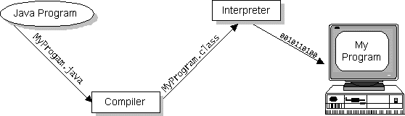

Java byte codes can be considered as the machine code instructions for the Java Virtual Machine (Java VM). Every Java interpreter, whether it's a Java development tool or a Web browser that can run Java applets, is an implementation of the Java VM. The Java VM can also be implemented in hardware.
Java byte codes help make "write once, run anywhere" possible. The Java program can be compiled into byte codes on any platform that has a Java compiler. The byte codes can then be run on any implementation of the Java VM. For example, the same Java program can run on Windows NT, Solaris, and Macintosh.

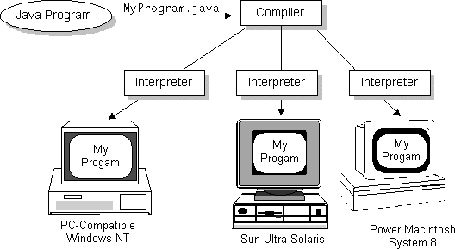

The Java Platform
A platform is the hardware or software environment in which a program runs. The Java platform differs from most other platforms in that it's a software-only platform that runs on top of other, hardware-based platforms. Most other platforms are described as a combination of hardware and operating system.
The Java platform has two components:
- The Java Virtual Machine (Java VM)
- The Java Application Programming Interface (Java API)
The Java API is a large collection of ready-made software components that provide many useful capabilities, such as graphical user interface (GUI) widgets. The Java API is grouped into libraries (packages) of related components.
The following figure depicts a Java program, such as an application or applet, that's running on the Java platform. As the figure shows, the Java API and Virtual Machine insulates the Java program from hardware dependencies.
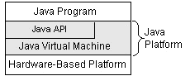

As a platform-independent environment, Java can be a bit slower than native code. However, smart compilers, well-tuned interpreters, and just-in-time byte code compilers can bring Java's performance close to that of native code without threatening portability.

What Can Java Do?
Probably the most well-known Java programs are Java applets. An applet is a Java program that adheres to certain conventions that allow it to run within a Java-enabled browser.
However, Java is not just for writing cute, entertaining applets for the World Wide Web ("Web"). Java is a general-purpose, high-level programming language and a powerful software platform. Using the generous Java API, we can write many types of programs.
The most common types of programs are probably applets and applications, where a Java application is a standalone program that runs directly on the Java platform.
How does the Java API support all of these kinds of programs? With packages of software components that provide a wide range of functionality. The core API is the API included in every full implementation of the Java platform. The core API gives you the following features:
- The Essentials: Objects, strings, threads, numbers, input and output, data structures, system properties, date and time, and so on.
- Applets: The set of conventions used by Java applets.
- Networking: URLs, TCP and UDP sockets, and IP addresses.
- Internationalization: Help for writing programs that can be localized for users worldwide. Programs can automatically adapt to specific locales and be displayed in the appropriate language.
- Security: Both low-level and high-level, including electronic signatures, public/private key management, access control, and certificates.
- Software components: Known as JavaBeans, can plug into existing component architectures such as Microsoft's OLE/COM/Active-X architecture, OpenDoc, and Netscape's Live Connect.
- Object serialization: Allows lightweight persistence and communication via Remote Method Invocation (RMI).
- Java Database Connectivity (JDBC): Provides uniform access to a wide range of relational databases.
Java not only has a core API, but also standard extensions. The standard extensions define APIs for 3D, servers, collaboration, telephony, speech, animation, and more.

How Will Java Change My Life?
Java is likely to make your programs better and requires less effort than other languages. We believe that Java will help you do the following:
- Get started quickly: Although Java is a powerful object-oriented language, it's easy to learn, especially for programmers already familiar with C or C++.
- Write less code: Comparisons of program metrics (class counts, method counts, and so on) suggest that a program written in Java can be four times smaller than the same program in C++.
- Write better code: The Java language encourages good coding practices, and its garbage collection helps you avoid memory leaks. Java's object orientation, its JavaBeans component architecture, and its wide-ranging, easily extendible API let you reuse other people's tested code and introduce fewer bugs.
- Develop programs faster: Your development time may be as much as twice as fast versus writing the same program in C++. Why? You write fewer lines of code with Java and Java is a simpler programming language than C++.
- Avoid platform dependencies with 100% Pure Java: You can keep your program portable by following the purity tips mentioned throughout this book and avoiding the use of libraries written in other languages.
- Write once, run anywhere: Because 100% Pure Java programs are compiled into machine-independent byte codes, they run consistently on any Java platform.
Distribute software more easily: You can upgrade applets easily from a central server. Applets take advantage of the Java feature of allowing new classes to be loaded "on the fly," without recompiling the entire program.
We explore the java.net package, which provides support for networking. Its creators have called Java “programming for the Internet.” These networking classes encapsulate the “socket” paradigm pioneered in the Berkeley Software Distribution (BSD) from the University of California at Berkeley.

About J2ee

The J2EE platform uses a multitiered distributed application model. Application logic is divided into components according to function, and the various application components that make up a J2EE application are installed on different machines depending on the tier in the multitiered J2EE environment to which the application component belongs. Figure 1-1 shows two multitiered J2EE applications divided into the tiers described in the following list. The J2EE application parts shown in Figure 1-1 are presented in J2EE Components.
- Client-tier components run on the client machine.
- Web-tier components run on the J2EE server.
- Business-tier components run on the J2EE server.
- Enterprise information system (EIS)-tier software runs on the EIS server.
Although a J2EE application can consist of the three or four tiers shown in Figure 1-1, J2EE multitiered applications are generally considered to be three-tiered applications because they are distributed over three different locations: client machines, the J2EE server machine, and the database or legacy machines at the back end. Three-tiered applications that run in this way extend the standard two-tiered client and server model by placing a multithreaded application server between the client application and back-end storage.
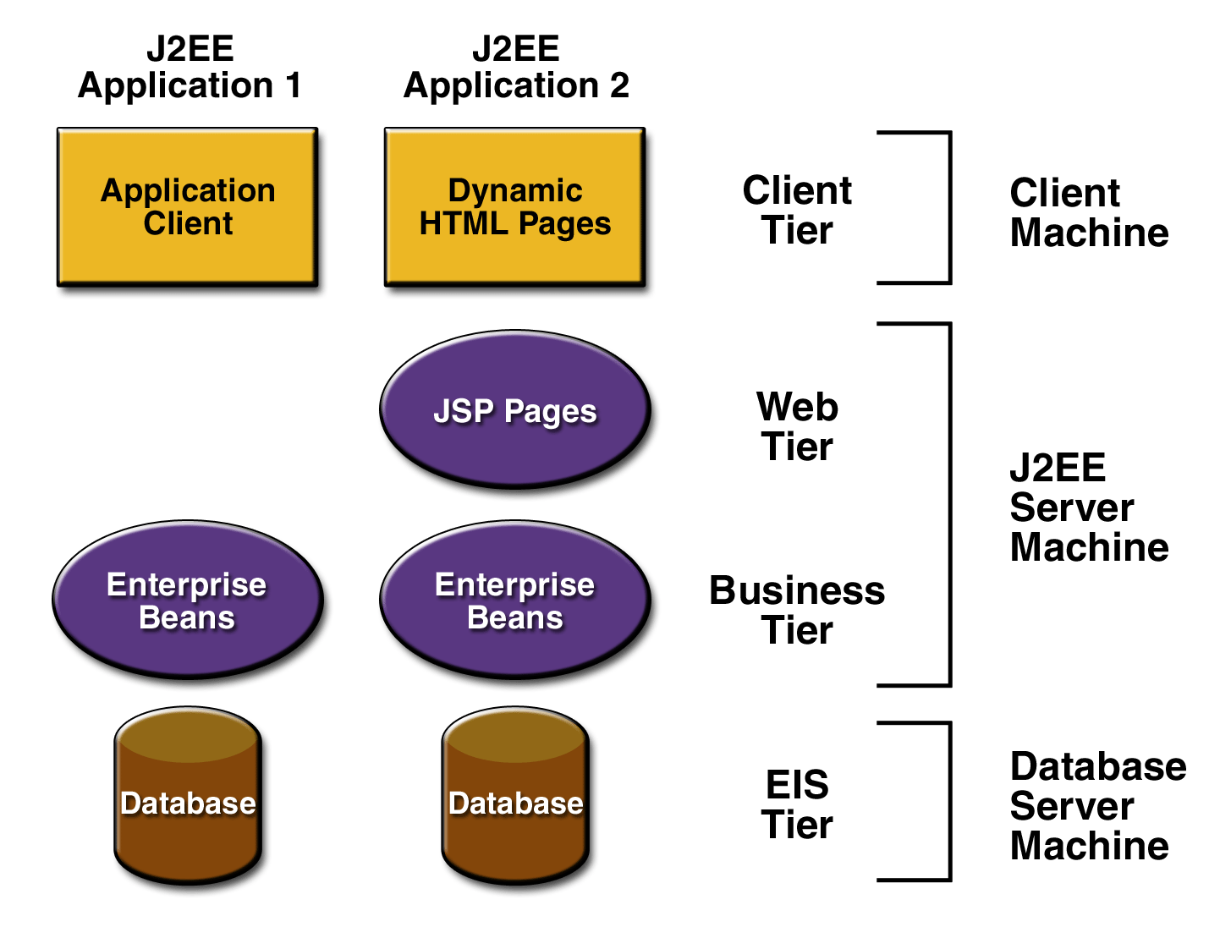
Figure 2-1 Multitier Applications

J2EE Components
J2EE applications are made up of components. A J2EE component is a self-contained functional software unit that is assembled into a J2EE application with its related classes and files and that communicates with other components. The J2EE specification defines the following J2EE components:
- Application clients and applets are components that run on the client.
- Java Servlet and Java Server Pages (JSP) technology components are Web components that run on the server.
- Enterprise JavaBeans (EJB) components (enterprise beans) are business components that run on the server.
J2EE components are written in the Java programming language and are compiled in the same way as any program in the language. The difference between J2EE components and "standard" Java classes is that J2EE components are assembled into a J2EE application, verified to be well formed and in compliance with the J2EE specification, and deployed to production, where they are run and managed by the J2EE server.

J2EE Clients
A J2EE client can be a Web client or an application client.

Web Clients
A Web client consists of two parts: dynamic Web pages containing various types of markup language (HTML, XML, and so on), which are generated by Web components running in the Web tier, and a Web browser, which renders the pages received from the server.
A Web client is sometimes called a thin client. Thin clients usually do not do things like query databases, execute complex business rules, or connect to legacy applications. When you use a thin client, heavyweight operations like these are off-loaded to enterprise beans executing on the J2EE server where they can leverage the security, speed, services, and reliability of J2EE server-side technologies.

Applets
A Web page received from the Web tier can include an embedded applet. An applet is a small client application written in the Java programming language that executes in the Java virtual machine installed in the Web browser. However, client systems will likely need the Java Plug-in and possibly a security policy for the applet to successfully execute in the Web browser.
Web components are the preferred API for creating a Web client program because no plug-ins or security policy files are needed on the client systems. Also, Web components enable cleaner and more modular application design because they provide a way to separate applications programming from Web page design. Personnel involved in Web page design thus do not need to understand Java programming language syntax to do their jobs.

Application Clients
A J2EE application client runs on a client machine and provides a way for users to handle tasks that require a richer user interface than can be provided by a markup language. It typically has a graphical user interface (GUI) created from Swing or Abstract Window Toolkit (AWT) APIs, but a command-line interface is certainly possible.
Application clients directly access enterprise beans running in the business tier. However, if application requirements warrant it, a J2EE application client can open an HTTP connection to establish communication with a servlet running in the Web tier.

JavaBeans Component Architecture
The server and client tiers might also include components based on the JavaBeans component architecture (JavaBeans component) to manage the data flow between an application client or applet and components running on the J2EE server or between server components and a database. JavaBeans components are not considered J2EE components by the J2EE specification.
JavaBeans components have instance variables and get and set methods for accessing the data in the instance variables. JavaBeans components used in this way are typically simple in design and implementation, but should conform to the naming and design conventions outlined in the JavaBeans component architecture.

J2EE Server Communications
Figure 1-2 shows the various elements that can make up the client tier. The client communicates with the business tier running on the J2EE server either directly or, as in the case of a client running in a browser, by going through JSP pages or servlets running in the Web tiers.
Your J2EE application uses a thin browser-based client or thick application client. In deciding which one to use, you should be aware of the trade-offs between keeping functionality on the client and close to the user (thick client) and off-loading as much functionality as possible to the server (thin client). The more functionality you off-load to the server, the easier it is to distribute, deploy, and manage the application; however, keeping more functionality on the client can make for a better perceived user experience. 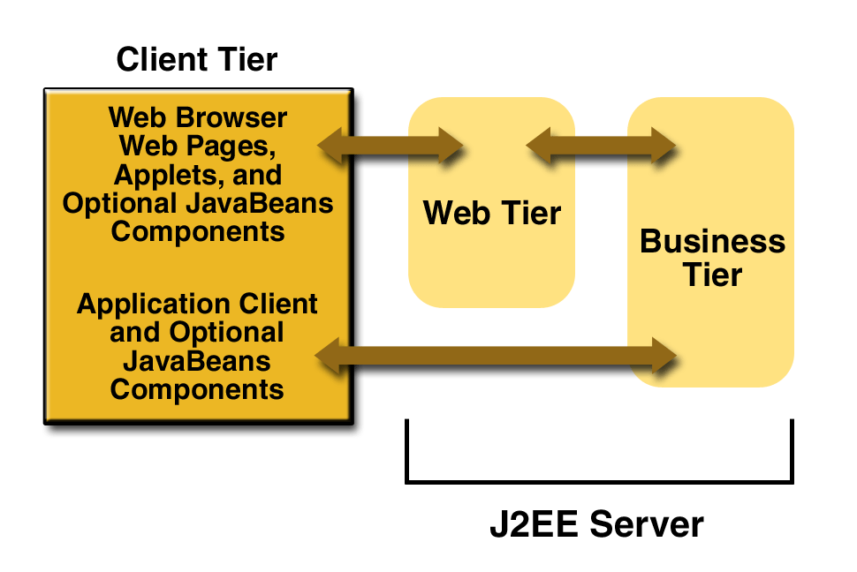
Figure 2-2 Server Communications

Web Components
J2EE Web components can be either servlets or JSP pages. Servlets are Java programming language classes that dynamically process requests and construct responses. JSP pages are text-based documents that execute as servlets but allow a more natural approach to creating static content.
Static HTML pages and applets are bundled with Web components during application assembly, but are not considered Web components by the J2EE specification. Server-side utility classes can also be bundled with Web components and, like HTML pages, are not considered Web components.
Like the client tier and as shown in Figure 1-3, the Web tier might include a JavaBeans component to manage the user input and send that input to enterprise beans running in the business tier for processing.

Business Components
Business code, which is logic that solves or meets the needs of a particular business domain such as banking, retail, or finance, is handled by enterprise beans running in the business tier. Figure 1-4 shows how an enterprise bean receives data from client programs, processes it (if necessary), and sends it to the enterprise information system tier for storage. An enterprise bean also retrieves data from storage, processes it (if necessary), and sends it back to the client program.
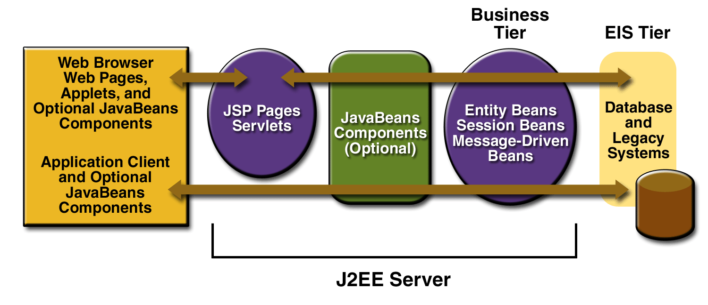
Figure 2-3 Business and EIS Tiers
There are three kinds of enterprise beans: session beans, entity beans, and message-driven beans. A session bean represents a transient conversation with a client. When the client finishes executing, the session bean and its data are gone. In contrast, an entity bean represents persistent data stored in one row of a database table. If the client terminates or if the server shuts down, the underlying services ensure that the entity bean data is saved.
A message-driven bean combines features of a session bean and a Java Message Service ("JMS") message listener, allowing a business component to receive JMS messages asynchronously. This tutorial describes entity beans and session beans.

Packaging
J2EE components are packaged separately and bundled into a J2EE application for deployment. Each component, its related files such as GIF and HTML files or server-side utility classes, and a deployment descriptor are assembled into a module and added to the J2EE application. A J2EE application is composed of one or more enterprise bean, Web, or application client component modules. The final enterprise solution can use one J2EE application or be made up of two or more J2EE applications, depending on design requirements.
A J2EE application and each of its modules has its own deployment descriptor. A deployment descriptor is an XML document with an .xml extension that describes a component's deployment settings. An enterprise bean module deployment descriptor, for example, declares transaction attributes and security authorizations for an enterprise bean. Because deployment descriptor information is declarative, it can be changed without modifying the bean source code. At run time, the J2EE server reads the deployment descriptor and acts upon the component accordingly.
A J2EE application with all of its modules is delivered in an Enterprise Archive (EAR) file. An EAR file is a standard Java Archive (JAR) file with an .ear extension. In the GUI version of the J2EE SDK application deployment tool, you create an EAR file first and add JAR and Web Archive (WAR) files to the EAR. If you use the command line packager tools, however, you create the JAR and WAR files first and then create the EAR
- files, and related Each EJB JAR file contains a deployment descriptor, the enterprise bean files.
- Each application client JAR file contains a deployment descriptor, the class files for the application client, and related files.
- Each WAR file contains a deployment descriptor, the Web component files, and related resources.
Using modules and EAR files makes it possible to assemble a number of different J2EE applications using some of the same components. No extra coding is needed; it is just a matter of assembling various J2EE modules into J2EE EAR files.

Development Roles
Reusable modules make it possible to divide the application development and deployment process into distinct roles so that different people or companies can perform different parts of the process.
The first two roles involve purchasing and installing the J2EE product and tools. Once software is purchased and installed, J2EE components can be developed by application component providers, assembled by application assemblers, and deployed by application deployers. In a large organization, each of these roles might be executed by different individuals or teams. This division of labor works because each of the earlier roles outputs a portable file that is the input for a subsequent role. For example, in the application component development phase, an enterprise bean software developer delivers EJB JAR files. In the application assembly role, another developer combines these EJB JAR files into a J2EE application and saves it in an EAR file. In the application deployment role, a system administrator at the customer site uses the EAR file to install the J2EE application into a J2EE server.
The different roles are not always executed by different people. If you work for a small company, for example, or if you are prototyping a sample application, you might perform the tasks in every phase.

J2EE Product Provider
The J2EE product provider is the company that designs and makes available for purchase the J2EE platform, APIs, and other features defined in the J2EE specification. Product providers are typically operating system, database system, application server, or Web server vendors who implement the J2EE platform according to the Java 2 Platform, Enterprise Edition Specification.

Tool Provider
The tool provider is the company or person who creates development, assembly, and packaging tools used by component providers, assemblers, and deployers. See the section Tools for information on the tools available with J2EE SDK version 1.3.

Application Component Provider
The application component provider is the company or person who creates Web components, enterprise beans, applets, or application clients for use in J2EE applications.

Enterprise Bean Developer
An enterprise bean developer performs the following tasks to deliver an EJB JAR file that contains the enterprise bean:
- Writes and compiles the source code
- Specifies the deployment descriptor

Web Component Developer
A Web component developer performs the following tasks to deliver a WAR file containing the Web component:
- Writes and compiles servlet source code
- Writes JSP and HTML files
- Specifies the deployment descriptor for the Web component
- Bundles the .class, .jsp, .html, and deployment descriptor files in the WAR file.

J2EE Application Client Developer
An application client developer performs the following tasks to deliver a JAR file containing the J2EE application client:
- Writes and compiles the source code
- Specifies the deployment descriptor for the client
- Bundles the .class files and deployment descriptor into the JAR file

Application Assembler
The application assembler is the company or person who receives application component JAR files from component providers and assembles them into a J2EE application EAR file. The assembler or deployer can edit the deployment descriptor directly or use tools that correctly add XML tags according to interactive selections. A software developer performs the following tasks to deliver an EAR file containing the J2EE application:
- Assembles EJB JAR and WAR files created in the previous phases into a J2EE application (EAR) file.
- Specifies the deployment descriptor for the J2EE application.
- Verifies that the contents of the EAR file are well formed and comply with the J2EE specification.

Application Deployer and Administrator
The application deployer and administrator is the company or person who configures and deploys the J2EE application, administers the computing and networking infrastructure where J2EE applications run, and oversees the runtime environment. Duties include such things as setting transaction controls and security attributes and specifying connections to databases.
During configuration, the deployer follows instructions supplied by the application component provider to resolve external dependencies, specify security settings, and assign transaction attributes. During installation, the deployer moves the application components to the server and generates the container-specific classes and interfaces.
A deployer/system administrator performs the following tasks to install and configure a J2EE application:
- Adds the J2EE application (EAR) file created in the preceding phase to the J2EE server.
- Configures the J2EE application for the operational environment by modifying the deployment descriptor of the J2EE application.
- Verifies that the contents of the EAR file are well formed and comply with the J2EE specification.
- Deploys (installs) the J2EE application EAR file into the J2EE server.

Reference Implementation Software
The J2EE SDK is a noncommercial operational definition of the J2EE platform and specification made freely available by Sun Microsystems for demonstrations, prototyping, and educational use. It comes with the J2EE application server, Web server, relational database, J2EE APIs, and complete set of development and deployment tools.
The purpose of the J2EE SDK is to allow product providers to determine what their implementations must do under a given set of application conditions, and to run the J2EE Compatibility Test Suite to test that their J2EE products fully comply with the specification. It also allows application component developers to run their J2EE applications on the J2EE SDK to verify that applications are fully portable across all J2EE products and tools.

Database Access
The relational database provides persistent storage for application data. A J2EE implementation is not required to support a particular type of database, which means that the database supported by different J2EE products can vary. See the Release Notes included with the J2EE SDK download for a list of the databases currently supported by the reference implementation.

JDBC API 2.0
The JDBC API lets you invoke SQL commands from Java programming language methods. You use the JDBC API in an enterprise bean when you override the default container-managed persistence or have a session bean access the database. With container-managed persistence, database access operations are handled by the container, and your enterprise bean implementation contains no JDBC code or SQL commands. You can also use the JDBC API from a servlet or JSP page to access the database directly without going through an enterprise bean.
The JDBC API has two parts: an application-level interface used by the application components to access a database, and a service provider interface to attach a JDBC driver to the J2EE platform.

Java Servlet Technology 2.3
Java Servlet technology lets you define HTTP-specific servlet classes. A servlet class extends the capabilities of servers that host applications accessed by way of a request-response programming model. Although servlets can respond to any type of request, they are commonly used to extend the applications hosted by Web servers.

Java Server Pages Technology 1.2
Java Server Pages technology lets you put snippets of servlet code directly into a text-based document. A JSP page is a text-based document that contains two types of text: static template data, which can be expressed in any text-based format such as HTML, WML, and XML, and JSP elements, which determine how the page constructs dynamic content.

J2EE Connector Architecture 1.0
The J2EE Connector architecture is used by J2EE tools vendors and system integrators to create resource adapters that support access to enterprise information systems that can be plugged into any J2EE product. A resource adapter is a software component that allows J2EE application components to access and interact with the underlying resource manager. Because a resource adapter is specific to its resource manager, there is typically a different resource adapter for each type of database or enterprise information system.

Tools
The J2EE reference implementation provides an application deployment tool and an array of scripts for assembling, verifying, and deploying J2EE applications and managing your development and production environments.

Application Deployment Tool
The J2EE reference implementation provides an application deployment tool (deploytool) for assembling, verifying, and deploying J2EE applications. There are two versions: command line and GUI.
The GUI tool includes wizards for:
- Packaging, configuring, and deploying J2EE applications
- Packaging and configuring enterprise beans
- Packaging and configuring Web components
- Packaging and configuring application clients
- Packaging and configuring resource adaptors
In addition, configuration information can be set for each component and module type in the tabbed inspector panes.

Introduction jsp

The goal of the java server page specification is to simplify the creation and management of dynamic web page by separating content and presentation jsp as basically files that combine html and new scripting tags. the jsp there look somewhat like HTML but they get translated into java servlet the first time are invoked by a client. The resulting servlet is a combination of the html from the jsp file and embedded dynamic content specified by the new tag.

For our example in this c:/projavaserver/chapter11/jsp example hold our web application save the above in the file called simple jsp. Jsp and place it in the root of the web application (in the words save it as)
C:/localhost/project folder name/sourcename.jsp
You should output similar to the following.
In other words the first time jsp is loaded by the jsp container (also called the jsp ehgine)
The servlet code necessary to fulfill the jsp tages is automatically generated compiled and loaded into the servlet container. From then on as long as the jsp source for the page is not modified this compiled servlet process any browser request for the jsp page. If you modify the mouse source code for the jsp it is automatically recompiled and relocated the next time that page is request

The nuts and bolts
The structure of a jsp page is a cross between a servlet and a html page with java code enclosed between the html.

- DIRECTIVES these affect the overall structure of the servlet that result from translation
- Scripting elements these let you insert java code into the jsp page.
- Action these are special tags available jsp
- You can also write your own tags as we shall

Some general rule of JSP page:
- JSP tag are case sensitive
- Directive and scripting element have a syntax which is not based on xml alternative page.
- Tags based on html Syntax is also available.
- If the URL does not start with a it is interpreted relative to the current jsp.

The page directive
The page directive is used to define and manipulate a number of important page dependent attributed that affect the whole jsp the enter compiled class file and communication these attributed to the jsp container. The page can contain any number of page directive in any jsp. They are all assimilated during translated and applied together to the page.

Language: define the scripting language to be used for future use if jsp containers support multiple language.” java”.

Import: comma separated list of package of class just like import statement in usual java code. “omitted by default” session .the page http session when true the import object session and can be java. servlet. Http session is available for page. “true”

The http protocol
In distributed application development, the application level or wire level communication protocol determines the nature of client and servers. This is true in the case of web based application as well. The complexity of feature possible in your web browser and on the web server(say the on line store you frequent) depends on the underlying protocol that is the HYPER TEXT TRANSFER PROTOCOL(HTTP).

Http Request Methods
As an application level protocol, HTTP defines types of request that clients can send to server .The protocol also specifies how the request and responses be structured. HTTP specifies three type of request method GET,POST and HEAD has addition request meet most of the common application development needs.

The Get Request Method
Of all types of request the GET request the simplest and most frequently used Method for accessing static resource such as HTML document image etc. Get Request can also be used to retrieve dynamic information, by using additional query parameter in the request URL. For instance, you can send a parameter name= joe appended to a URL as http://www.domain.com?name=joe. The web server can use this parameter name=joe, to send content to “joe”.

The Post Request Method
The post method is commonly used for accessing dynamic resource. Typically, POST request are meant to transmit information that is request dependent, and are used when you need to send large amount of complex information to the server. The POST request allows the encapsulation of multipart message into the request body. For example you can use POST REQUEST TO UPLOAD TEXT OR BINARY FILES. Similarly, you can use POST you can use POST request in your applets to send serializable java objects, or even to the web server. POST REQUEST THEREFORE OFFER A WIDER CHOICE IN TERMS of the request.

Http response
In responses to a HTTP request, the server responds with the status of the responses, all these are part of the response header. Except for the case of the HEAD request, the server also sends the body content that corresponds to the resource specified in the request. In the http://java.sun.com/index.html URL, your Browser receives the method of the index file as part of the message and renders, the body is typical interested.

Structured Overlay Network

Structured peer-to-peer overlay networks provide a substrate for the construction of large-scale, decentralized applications, including distributed storage, group communication, and content distribution. These overlays are highly resilient; they can route messages correctly even when a large fraction of the nodes crash or the network partitions. But current overlays are not secure; even a small fraction of malicious nodes can prevent correct message delivery throughout the overlay. This problem is particularly serious in open peer-to-peer systems, where many diverse, autonomous parties without preexisting trust relationships wish to pool their resources. This paper studies attacks aimed at preventing correct message delivery in structured peer-to-peer overlays and presents defenses to these attacks. We describe and evaluate techniques that allow nodes to join the overlay, to maintain routing state, and to forward messages securely in the presence of malicious nodes.

Peer-to-Peer search
A peer-to-peer distributed network architecture is composed of participants that make a portion of their resources (such as processing power, disk storage, and network bandwidth) available directly to their peers without intermediary network hosts or servers. Peers are both suppliers and consumers of resources, in contrast to the traditional client-server model where only servers supply, and clients consume.
Peer-to-peer was popularized by file sharing systems like Napster. Peer-to-peer file sharing networks have inspired new structures and philosophies in other areas of human interaction. In such social contexts, peer-to-peer as a meme refers to the egalitarian social networking that is currently emerging throughout society, enabled by Internet technologies in general.

Module Description

Module 1: User Interface Design
In this module we are going to design a window to download books. We use the Swing package available in Java to design the User Interface. Swing is a widget toolkit for Java. It is part of Sun Microsystems' Java Foundation Classes (JFC) — an API for providing a graphical user interface (GUI) for Java programs.

Module 2: Client Application
The Client application consists of logging and request process. In this application we can login by using a user name and password. After logging inside we can select any field of books to download. Then we make a request to download the book.

Module 3: Location Guard
The Location Guard gets the request from the client application. Then it processes the request. This location guard is used in between the client and the file server. The purpose of this location guard is to hide the location of the file server to everyone who accesses the file to download. Thus we are avoiding the Denial of Service attack.

Module 4: Routing Guard
The Routing guard is present in the Location Guard. This routing guard checks whether the requested file is available in any file server. Then the request is forwarded to the file server which contains the requested file. Then the location guard sends the file to the client application.

Module 5: File Server
The file server is the owners of all the files available in the overlay network. This file server gets the request of the client through the Location Guard. Then the file server checks with the file and it sends the file to the Location guard. Thus the file is downloaded in the client application. The location of these file servers are hided from the clients and hackers by the location guard to avoid the Denial of Service.

UML Diagrams

Data Flow Diagram

Client Application
Location Guard
Routing Guard
Inference Guard
Location Key
File Server
File Server

Use Case Diagram

Login
Select Technology
Search
Request Download
View Downloaded
Figure 4-4 Use Case Diagram

Class Diagram

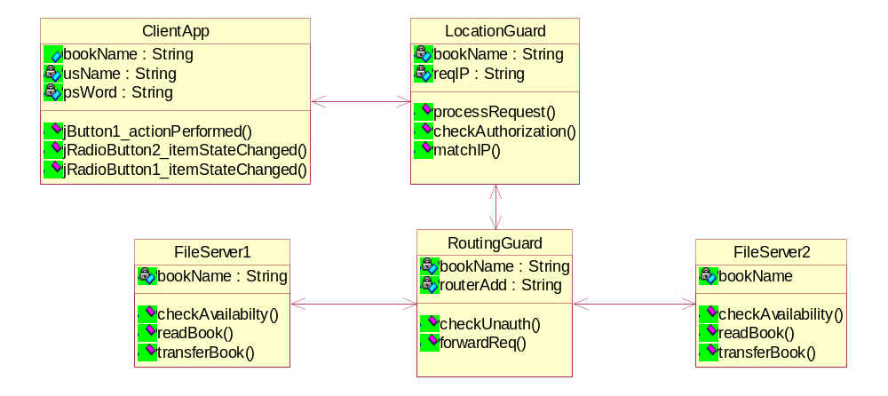
Figure 4-5 Class Diagram

Collaboration Diagram

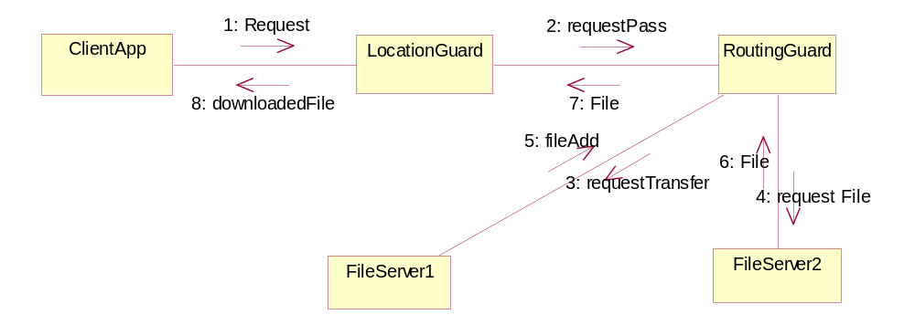
Figure 4-6 Collaboration Diagram

Sequence Diagram

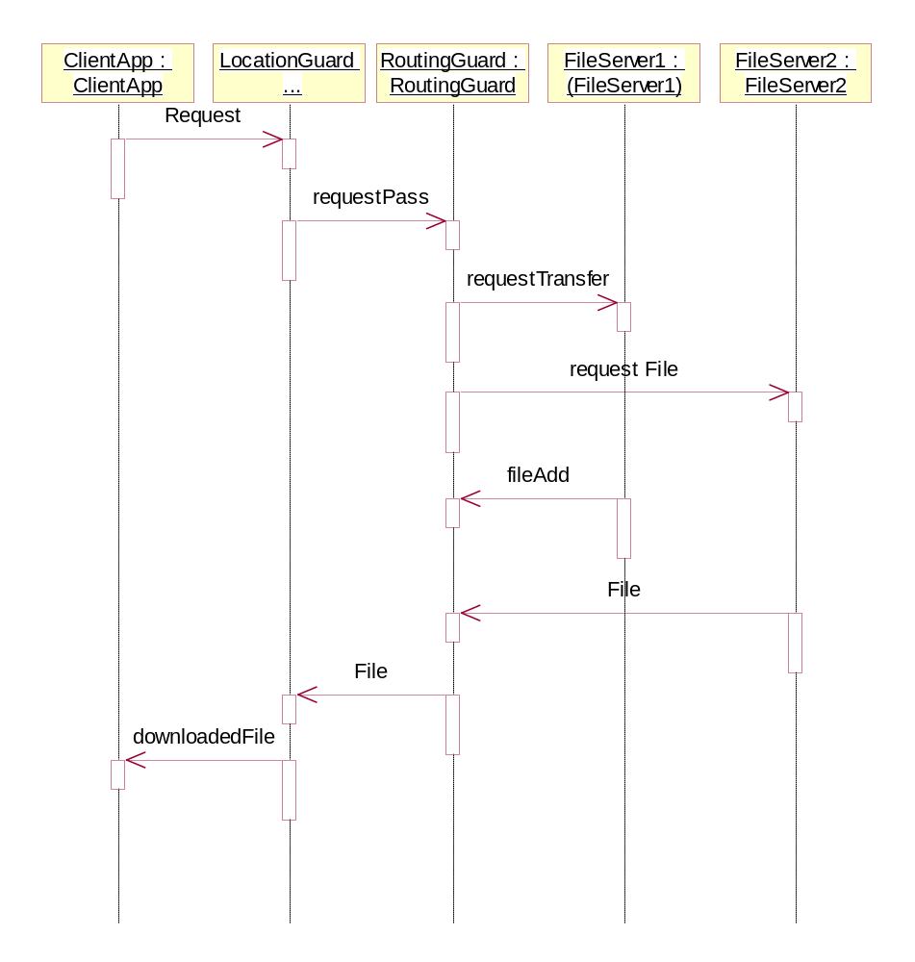
Figure 4-7 Sequence Diagram

State Diagram

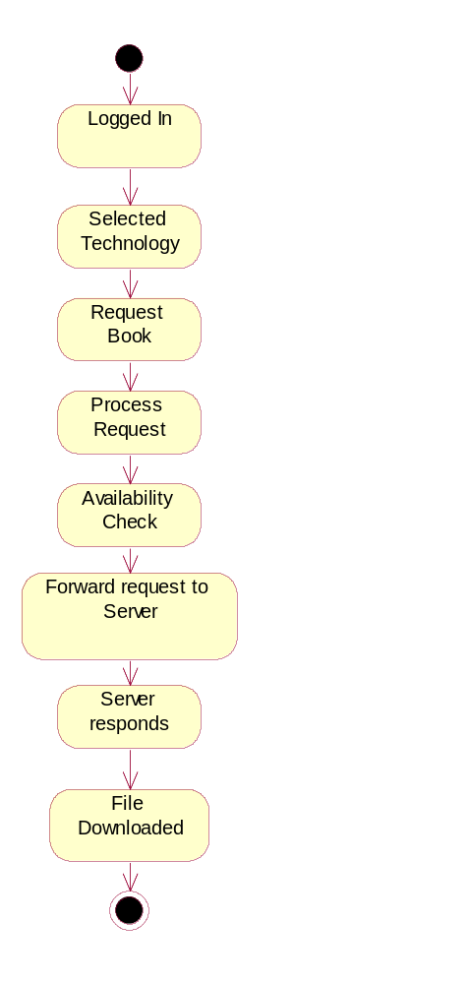
Figure 4-8 State Diagram

Activity Diagram

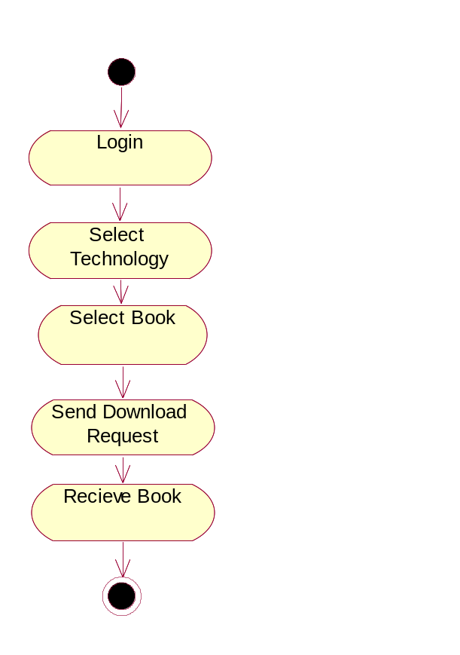
Figure 4-9 Activity Diagram

System Architecture

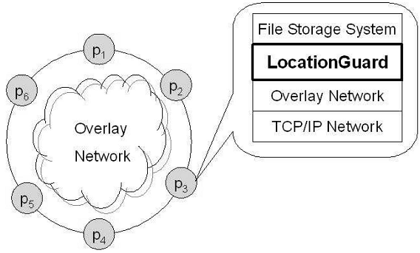
Figure 5-10 System Architecture

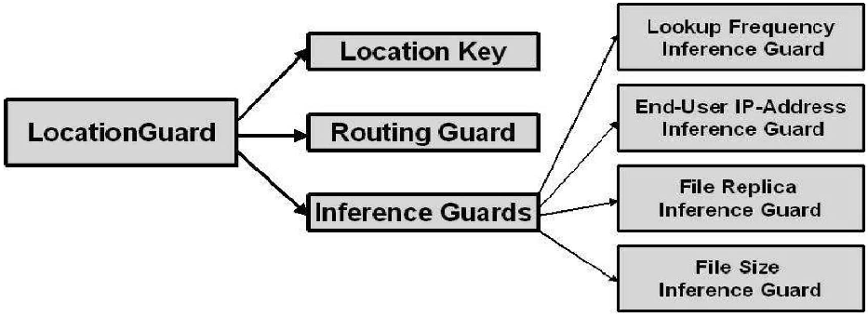
Figure 5-11 Location Guard Conceptual Design

Module Diagram

Client Application

Topic Selection
User Request
Request File
Figure 6-12 Client Application

Location Guard
Receiving Request
Processing Request
Requesting Routing Guard
Figure 6-13 Location Guard

Routing Guard

Checking File Server Availability

Forwarding request to File Server
Checking Request
Figure 6-14 Routing Guard

File Servers
Receiving Request from Routing Guard
Checking File Availability
Sending requested File
Figure 6-15 File Servers

Sample coding

/********************************************************************************/
/* LocationGuard */
/* */
/****************************************************************************/
import java.awt.*;
import java.awt.event.*;
import javax.swing.*;
import java.net.*;
import java.io.*;
import java.sql.*;
public class LocationGuard extends JFrame
{
// Variables declaration
private JLabel jLabel1;
private JLabel jLabel2;
private JLabel jLabel3;
private JLabel jLabel4;
private JLabel jLabel5;
private JLabel jLabel6;
private JLabel jLabel7;
private JLabel jLabel8;
private JTextField jTextField1;
private JPanel contentPane;
public Socket getLoReq;
public Socket sndReq;
public Socket cliRet;
public String cliApp="localhost";
public ServerSocket allRec;
public String uName="";
public String pWord="";
public String FlSer="";
public String top="";
public Connection co;
public Statement st;
public ResultSet rs;
public Socket sndFl;
public int ch=0;
public Socket rcvSer;
public ServerSocket rcv;
public Socket resp;
public String cliAdd="";
public String flSer1="" ,binaryKey="";
// End of variables declaration

public LocationGuard()
{
super();
initializeComponent();
// TODO: Add any constructor code after initializeComponent call
this.setVisible(true);
try
{
FileInputStream fis=new FileInputStream("FileServer1.txt");
while((ch=fis.read())!=-1)
flSer1+=(char)ch;
flSer1.trim();
FileInputStream fis1=new FileInputStream("ClientAddress.txt");
while((ch=fis1.read())!=-1)
cliAdd+=(char)ch;
cliAdd.trim();
allRec=new ServerSocket(7000);
rcv=new ServerSocket(9000);
while(true)
{
getLoReq=allRec.accept();
DataInputStream dis=new
DataInputStream(getLoReq.getInputStream());
top=dis.readUTF();
System.out.println(top);
jLabel3.setText("Work in Progress");
jLabel4.setText("Work in Progress");
jLabel7.setText("Transfering request to Server");
sndFl=new Socket(flSer1,8000);
encry(top);
DataOutputStream dos=new DataOutputStream(sndFl.getOutputStream());
dos.writeUTF(top);
dos.writeUTF(binaryKey);
jTextField1.setText(binaryKey);
System.out.println("Key = "+binaryKey);
jLabel7.setText("Transfered request to Server");
rcvSer=rcv.accept();
DataInputStream dis1=new DataInputStream(rcvSer.getInputStream());
String recd=dis1.readUTF();
System.out.println(recd);
jLabel7.setText("Response Accepted from Server");
resp=new Socket(cliAdd,9100);
encry(recd);
//JOptionPane.showMessageDialog(this,"");
DataOutputStream dos1=new
DataOutputStream(resp.getOutputStream());
//JOptionPane.showMessageDialog(this,"sended");
dos1.writeUTF(recd);
jLabel7.setText("Response sent to Client");
}
}
catch (Exception cv)
{
cv.printStackTrace();
}
}
/**
* This method is called from within the constructor to initialize the form.
* WARNING: Do NOT modify this code. The content of this method is always regenerated by the Windows Form Designer. Otherwise, retrieving design might not work properly.
* Tip: If you must revise this method, please backup this GUI file for JframeBuilder to retrieve your design properly in future, before revising this method.
*/
private void initializeComponent()
{
jLabel1 = new JLabel();
jLabel2 = new JLabel();
jLabel2.setFont(new Font("Book Antiqua",Font.BOLD,14));

jLabel3 = new JLabel();
jLabel3.setFont(new Font("Book Antiqua",Font.BOLD,14));
jLabel4 = new JLabel();
jLabel4.setFont(new Font("Book Antiqua",Font.BOLD,14));
jLabel5 = new JLabel();
jLabel5.setFont(new Font("Book Antiqua",Font.BOLD,14));
jLabel6 = new JLabel();
jLabel6.setFont(new Font("Book Antiqua",Font.BOLD,14));
jLabel7 = new JLabel();
jLabel8 = new JLabel();
jTextField1 = new JTextField();
contentPane = (JPanel)this.getContentPane();
// jLabel1
//jLabel1.setText("jLabel1");
jLabel1.setIcon(new ImageIcon("Java1.PNG"));
// jLabel2
jLabel2.setText("Location Guard Status");
// jLabel3
jLabel3.setText("Idle");
// jLabel4
jLabel4.setText("Idle");

jTextField1.addActionListener(new ActionListener()
{
public void actionPerformed(ActionEvent e)
{
jTextField1_actionPerformed(e);
}
};
// jLabel5
jLabel8.setText("Generated Key : ");
jLabel5.setText("Routing Guard Status");
// jLabel6
jLabel6.setText("Access Status");
// jLabel7
jLabel7.setText("Ready");
// contentPane
contentPane.setLayout(null);
addComponent(contentPane, jLabel1, 1,0,576,90);
addComponent(contentPane, jLabel2, 47,125,205,27);
addComponent(contentPane, jLabel3, 47,163,489,42);
addComponent(contentPane, jLabel4, 47,256,484,38);
addComponent(contentPane, jLabel5, 51,213,186,28);
addComponent(contentPane, jLabel6, 148,338,134,33);
addComponent(contentPane, jLabel7, 334,335,400,41);
addComponent(contentPane, jLabel8,11,365,400,22);
addComponent(contentPane, jTextField1, 11,390,500,22);
// LocationGuard
this.setTitle("LocationGuard ");
this.setLocation(new Point(50, 45));
this.setSize(new Dimension(587, 449));
this.setDefaultCloseOperation(WindowConstants.DISPOSE_ON_CLOSE);
}

/** Add Component Without a Layout Manager (Absolute Positioning) */
private void addComponent(Container container,Component c,int x,int y,int width,int height)
{
c.setBounds(x,y,width,height);
container.add(c);
}
private void jTextField1_actionPerformed(ActionEvent e)
{

}
public String encry(String inputString)
{
String binaryString = "", resultString1="",resultString2="";
int default = 15;
binaryString = new TextToBinary().textToBinary(inputString);
//inputString=inputString.substring(0,5);
binaryKey = new TextToBinary().textToBinary(new SessionKey().getSessionKey());
//System.out.println("Key = "+binaryKey);
//resultString1 = new XorCalculation().xorCalculator(binaryString, binaryKey);
//resultString2 = new XorCalculation().xorCalculator(resultString1, Integer.toBinaryString(defalut));
return binaryKey;
}

// TODO: Add any method code to meet your needs in the following area
//=======================Testing========================//
// The following main method is just for testing this class you built.
// After testing,you may simply delete it.
//====================================================//
public static void main(String[] args)
{
/*JFrame.setDefaultLookAndFeelDecorated(true);
JDialog.setDefaultLookAndFeelDecorated(true);
try
{
UIManager.setLookAndFeel("com.sun.java.swing.plaf.windows.WindowsLookAndFeel");}
catch (Exception ex)
{
System.out.println("Failed loading L&F: ");
System.out.println(ex);
}*/
new LocationGuard();
}
}

Screen Shots

Server Screenshot
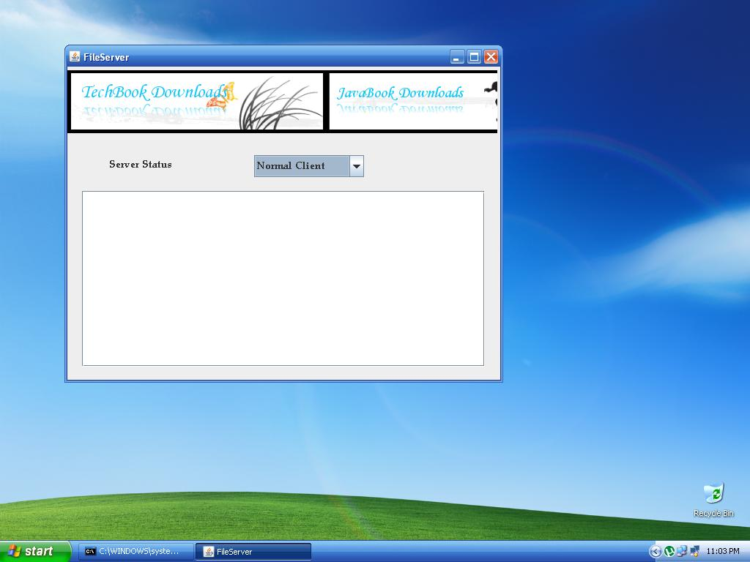
Figure 8-16 Server Screenshot

The figure shows the user interface of the server which is running in Normal Client mode i.e. before implementing Location Guard Technique.

Client Screenshot

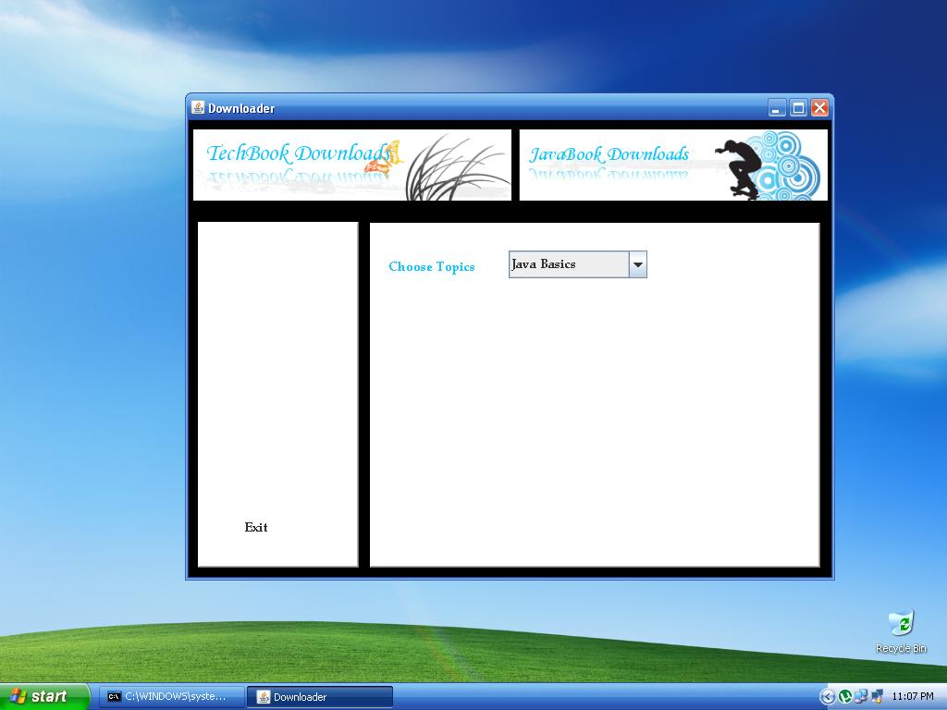
Figure 8-17 Client Screenshot

The figure shows the GUI screen of the normal user/client who accesses the books from the downloader from various topics given.

Client Requesting topic from Server
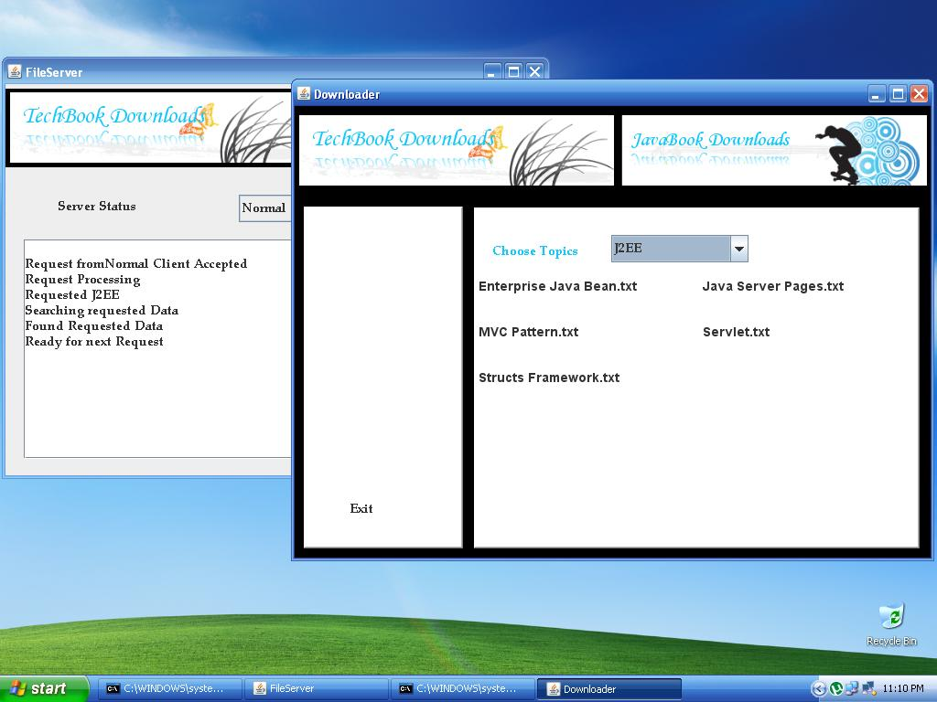
Figure 8-18 Client Requests Book

The figure depicts client requesting the books in the topic J2EE which is an option provided in the client GUI.

Client Requesting Book
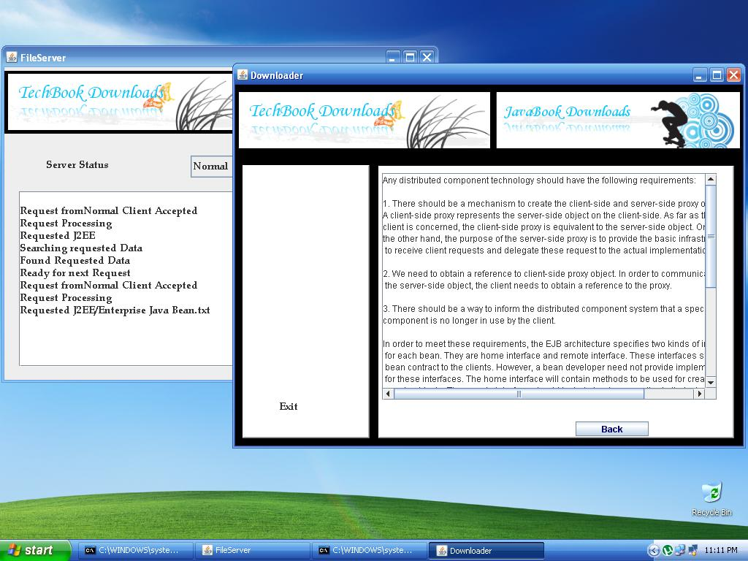
Figure 8-19 Client Requesting Book

The figure represents the process of client requesting Enterprise Java Bean book from Server which is displayed in the text area.

Attacker
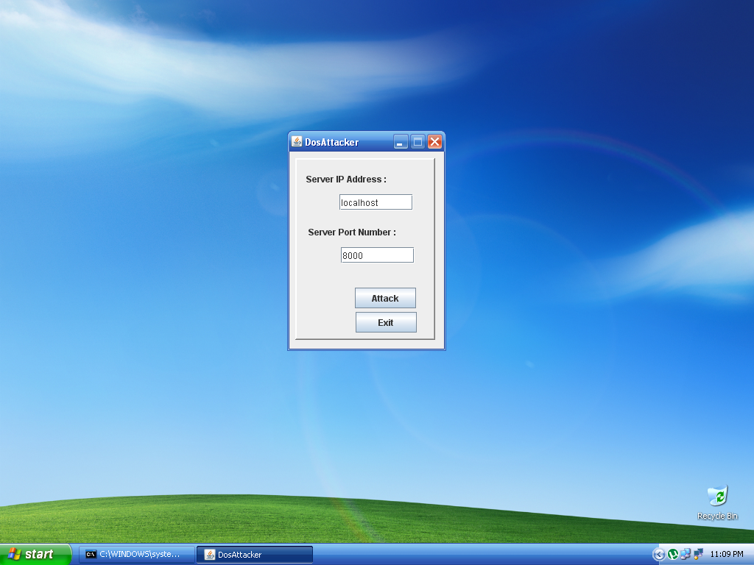
Figure 8-20 Attacker

The figure represents the interface of the attacker who uses various tools to find out the IP address and socket of server and attacks using the above shown interface.

Server Attacked
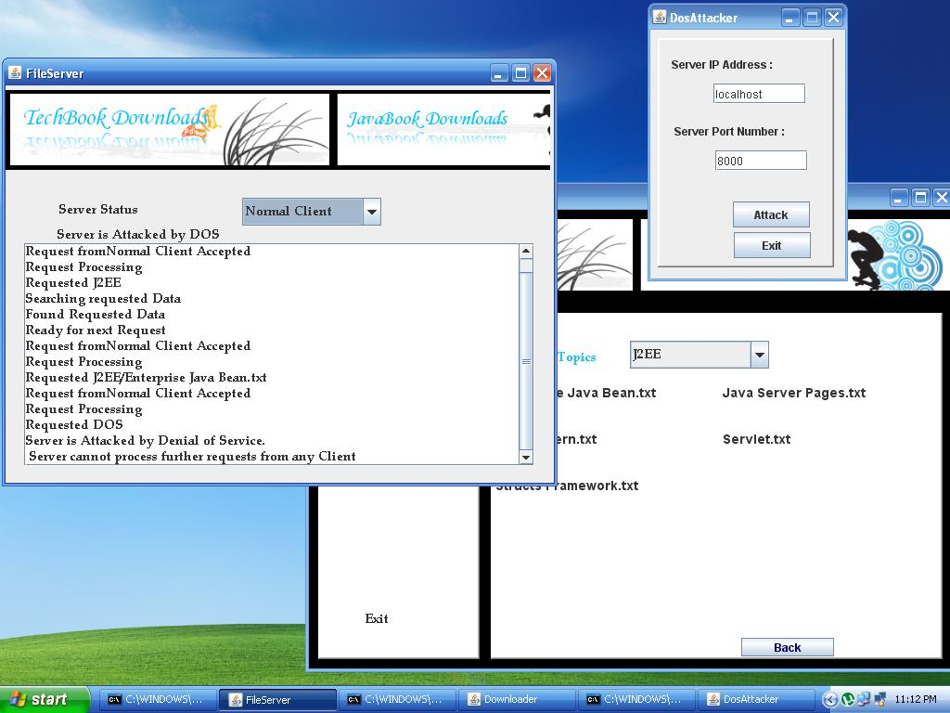
Figure 8-21 Server Attacked

The figure shows attacker using his interface to perform DoS attack on Server which cannot process any further requests from any client.

Location Guard
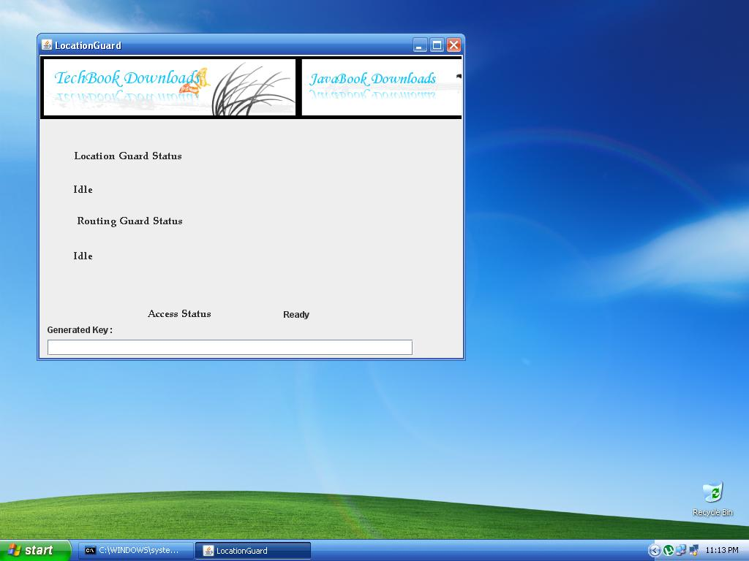
Figure 8-22 Location Guard

The figure shows interface of the location guard. The generated location key can also be viewed.

Request from Client to Location Guard : Topic
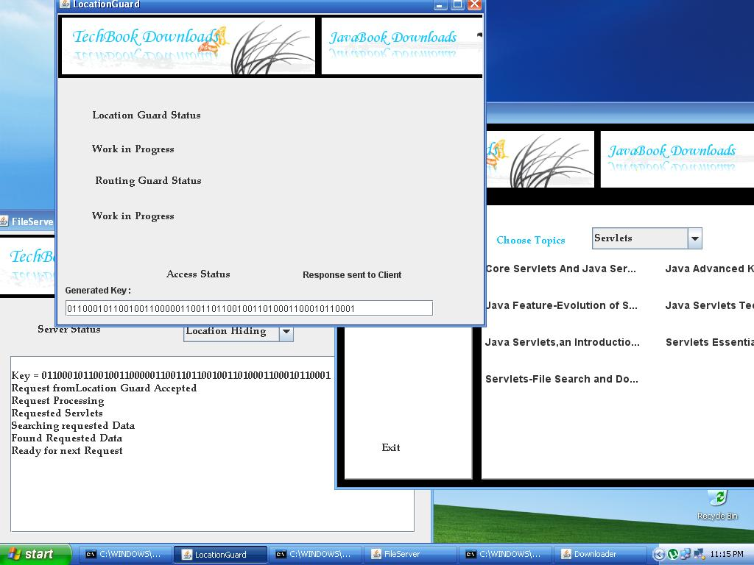
Figure 8-23 Client requesting topics from location guard

The above figure shows client requesting list of books in topic “Servlets” which is forwarded to Location Guard where an random LocationKey is generated which is forwarded to Server.

Request From Client to Location Guard : Book
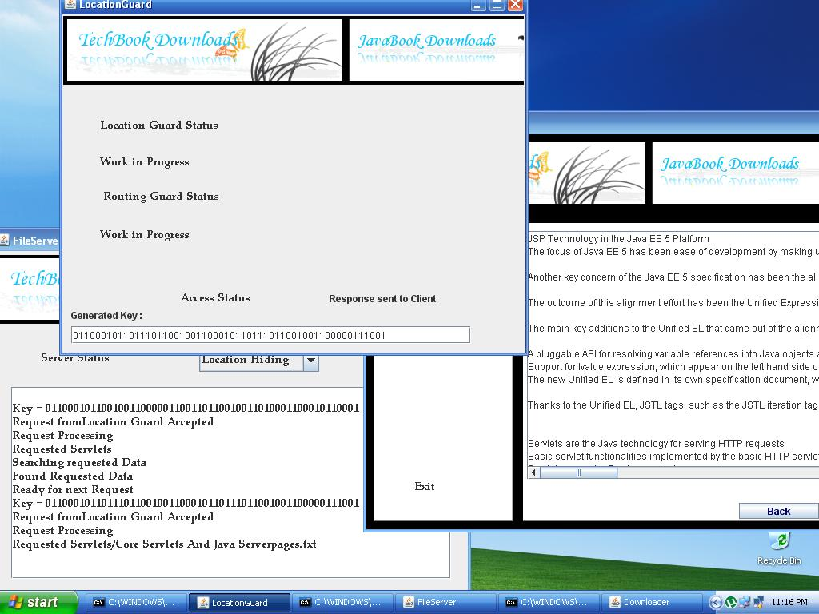
Figure 8-24 Request from Client to Location Guard : Book

The above figure shows the client requesting book from Location Guard which forwards generated Location Key to Server.

Testing

System Testing

The purpose of testing is to discover errors. Testing is the process of trying to discover every conceivable fault or weakness in a work product. It provides a way to check the functionality of components, sub assemblies, assemblies and/or a finished product It is the process of exercising software with the intent of ensuring that the
Software system meets its requirements and user expectations and does not fail in an unacceptable manner. There are various types of test. Each test type addresses a specific testing requirement.

Types Of Tests

Unit testing
Unit testing involves the design of test cases that validate that the internal program logic is functioning properly, and that program input produces valid outputs. All decision branches and internal code flow should be validated. It is the testing of individual software units of the application .it is done after the completion of an individual unit before integration. This is a structural testing, that relies on knowledge of its construction and is invasive. Unit tests perform basic tests at component level and test a specific business process, application, and/or system configuration. Unit tests ensure that each unique path of a business process performs accurately to the documented specifications and contains clearly defined inputs and expected results.

Integration testing
Integration tests are designed to test integrated software components to determine if they actually run as one program. Testing is event driven and is more concerned with the basic outcome of screens or fields. Integration tests demonstrate that although the components were individually satisfaction, as shown by successfully unit testing, the combination of components is correct and consistent. Integration testing is specifically aimed at exposing the problems that arise from the combination of components.

Functional test
Functional tests provide a systematic demonstration that functions tested are available as specified by the business and technical requirements, system documentation, and user manuals.

Functional testing is centered on the following items:

Valid Input : identified classes of valid input must be accepted.
Invalid Input : identified classes of invalid input must be rejected.
Functions : identified functions must be exercised.
Output : identified classes of application outputs must be exercised.
Systems/Procedures : interfacing systems or procedures must be invoked.

Organization and preparation of functional tests is focused on requirements, key functions, or special test cases. In addition, systematic coverage pertaining to identify
Business process flows; data fields, predefined processes, and successive processes must be considered for testing. Before functional testing is complete, additional tests are identified and the effective value of current tests is determined.

System Test
System testing ensures that the entire integrated software system meets requirements. It tests a configuration to ensure known and predictable results. An example of system testing is the configuration oriented system integration test. System testing is based on process descriptions and flows, emphasizing pre-driven process links and integration points.

White Box Testing
White Box Testing is a testing in which in which the software tester has knowledge of the inner workings, structure and language of the software, or at least its purpose. It is purpose. It is used to test areas that cannot be reached from a black box level.

Black Box Testing
Black Box Testing is testing the software without any knowledge of the inner workings, structure or language of the module being tested. Black box tests, as most other kinds of tests, must be written from a definitive source document, such as specification or requirements document, such as specification or requirements document. It is a testing in which the software under test is treated, as a black box .you cannot “see” into it. The test provides inputs and responds to outputs without considering how the software works.

Unit Testing
Unit testing is usually conducted as part of a combined code and unit test phase of the software lifecycle, although it is not uncommon for coding and unit testing to be conducted as two distinct phases.
Test strategy and approach: Field testing will be performed manually and functional tests will be written in detail.

Integration Testing

Software integration testing is the incremental integration testing of two or more integrated software components on a single platform to produce failures caused by interface defects.
The task of the integration test is to check that components or software applications, e.g. components in a software system or – one step up – software applications at the company level – interact without error.

Test Results: All the test cases mentioned above passed successfully. No defects encountered.

Acceptance Testing

User Acceptance Testing is a critical phase of any project and requires significant participation by the end user. It also ensures that the system meets the functional requirements.

Test Results: All the test cases mentioned above passed successfully. No defects encountered.

Conclusion

We have described LocationGuard—a technique for securing wide-area serverless file sharing systems from targeted file attacks. Analogous to traditional cryptographic keys that hide the contents of a file, LocationGuard hides the location of a file on an overlay network. LocationGuard protects a target file from DoS attacks, host compromise attacks, and file location inference attacks by providing a simple and efficient access control mechanism with minimal performance and storage overhead. The unique characteristics of LocationGuard approach is the careful combination of location key, routing guard, and an extensible package of location inference guards, which makes it very hard for an adversary to infer the location of a target file by either actively or passively observing the overlay network. Our experimental results quantify the overhead of employing location guards and demonstrate the effectiveness of the LocationGuard scheme against DoS attacks, host compromise attacks, and various location inference attacks.
This project is primarily focuses on the attacks performed over Serverless File Systems, with further improvements and enhancements the project can be extended to other types of networks where the location of servers can be successfully hidden.

References

- A. Adya, W. Bolosky, M. Castro, G. Cermak, R. Chaiken, J.R. Douceur, J. Howell, J.R. Lorch, M. Theimer, and R.P. Wattenhofer, “Farsite: Federated, Available and Reliable Storage for an Incompletely Trusted Environment,” Proc. Fifth Symp. Operating Systems Design and Implementation (OSDI), 2002.
- M. Atallah, K. Frikken, and M. Blanton, “Dynamic and Efficient Key Management for Access Hierarchies,” Proc. 12th ACM Conf. Computer and Comm. Security (CCS), 2005.
- M.J. Atallah, M. Blanton, and K.B. Frikken, “Incorporating Temporal Capabilities in Existing Key Management Schemes,” Proc. 12th European Symp. Research in Computer Security (ESORICS), 2007.
- J.K.B. Zhao and A. Joseph, “Tapestry: An Infrastructure for Fault- Tolerance Wide-Area Location and Routing,” Technical Report UCB/CSD-01-1141, Univ. of California, Berkeley, 2001.
- E. Cohen and D. Jefferson, “Protection in the Hydra Operating System,” Proc. Fifth ACM Symp. Operating System Principles (SOSP), 1975.

