# **RFID Verification with Facial reconization for infant monitorization**

* Install Java Version 8 from

<https://java.com/en/download/>

* Install Java SE Development kit 8u211 from

<https://www.oracle.com/technetwork/java/javase/downloads/jdk8-downloads-2133151.html>

* Install Java Runtime Environment 8u211 from

<https://www.oracle.com/technetwork/java/javase/downloads/jre8-downloads-2133155.html>

* Download Apache NetBeans 9.0 (Binaries) from

<https://netbeans.apache.org/download/nb90/nb90.html> and unzip it. Inside bin folder install netbeans64 application

* Install MySQL (full version) from

<https://www.mysql.com/downloads/>

* Download RFID java SDK from

<https://www.zebra.com/us/en/support-downloads/rfid/rfid-readers/fx7500.html>

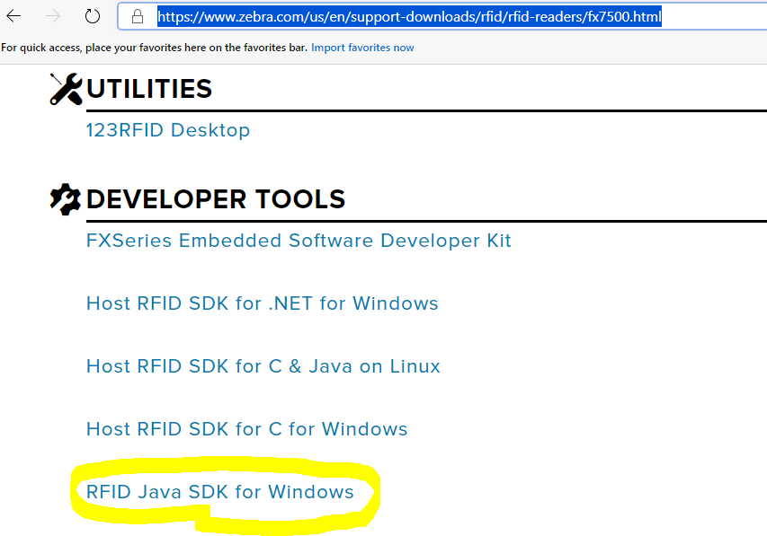

* Download the MySQL to Netbeans Connector library from

[https://dev.mysql.com/downloads/connector/j/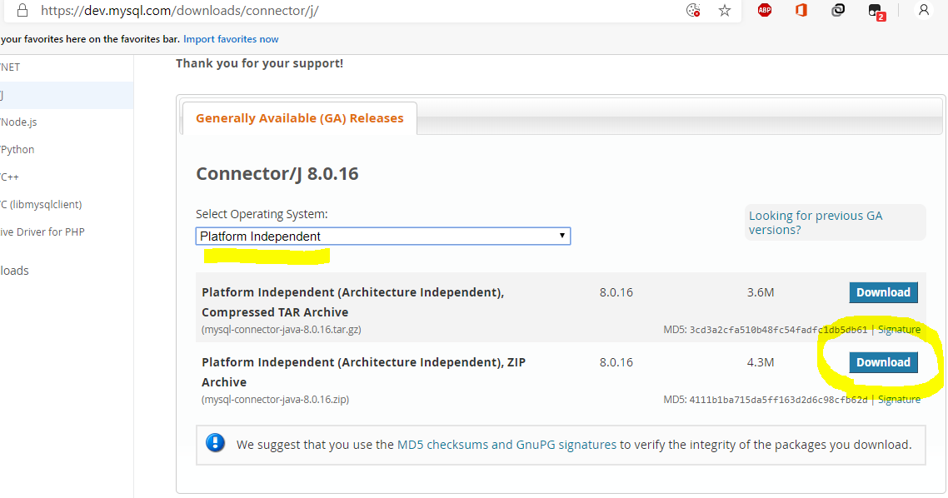](https://dev.mysql.com/downloads/connector/j/)

* Some more library for GUI inside netbeans ie for calender download the jar file from <http://www.java2s.com/Code/Jar/j/Downloadjcalendar14jar.htm>

## **Image processing requirements:**

* Python 3.6.8 (64bit amd)

Python libraries(pip installable):

In CMD type:python –m pip install lib_name==version

* Numpy(1.16.1)
* Opencv
* Imutils
* Dlib(https://files.pythonhosted.org/packages/0e/ce/f8a3cff33ac03a8219768f0694c5d703c8e037e6aba2e865f9bae22ed63c/dlib-19.8.1-cp36-cp36mwin_amd64.whl#sha256=794994fa2c54e7776659fddb148363a5556468a6d5d46be8dad311722d54bfcf)
* Face_recognition
* Pickle
* cmake