Assignmment#1:

Working with Directories

* Enter the command **cd /** and then **ls** and then hit **Enter** key
  + Take screenshot and explain what output we got?
* Enter the command now **cd /home** and then hit **Enter** key
  + Do **ls,** provide screenshot and explain what is **/home** directory used for?
* Enter **cd ..** and hit **Enter** key [ *Note: here we have space after cd then use double dot*]
  + Check what happen and give screenshot?
* Now enter **cd /var/www/html** and then type **cd** and hit **Enter** key
  + Explain what happen and give screenshot?
* Now type **cd /root** and then hit **Enter** key

Do **ls,** check any output we have on screen if yes then take screenshot?

* Enter the command **cd /** and then **ls** and then hit **Enter** key
  + Take screenshot and explain what output we got?

Ans: 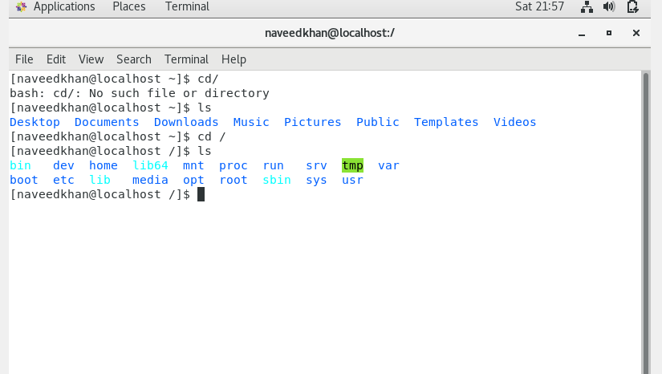

Explanation:

When we type “cd /” then we move to the far most directory and of the OS and when we type “ls” then we see all the folders inside the directory.

2-cd /home:

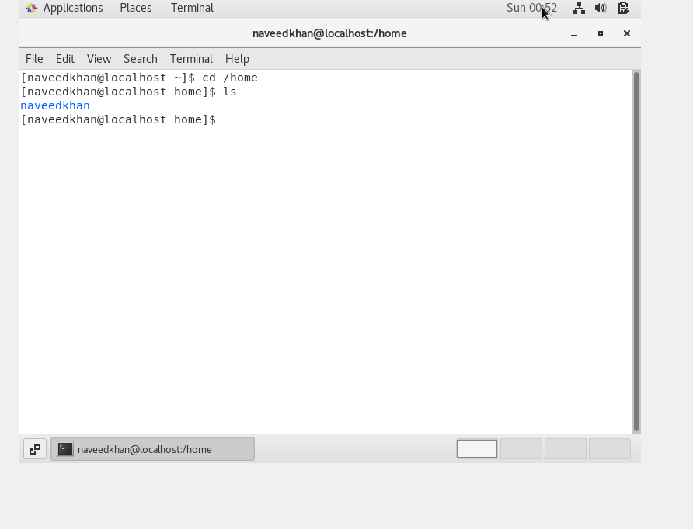

2- ls /home : is used to move on the home folder and only those folder/directories which are inside in the home folder exist visible.

3-cd .. :

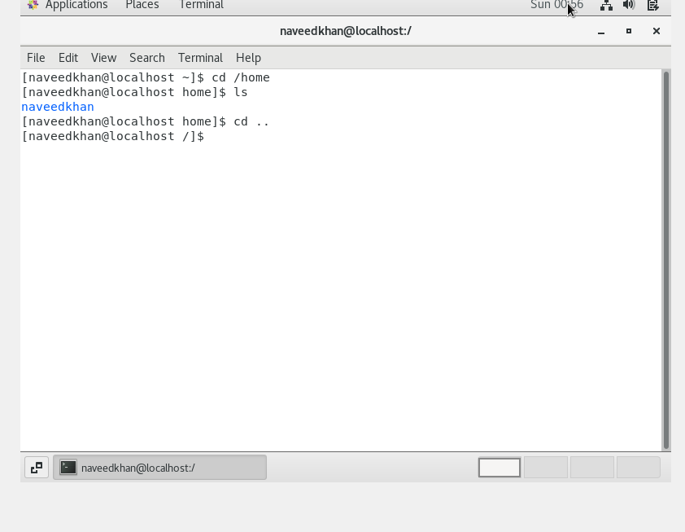

4- cd /var/ww/html:

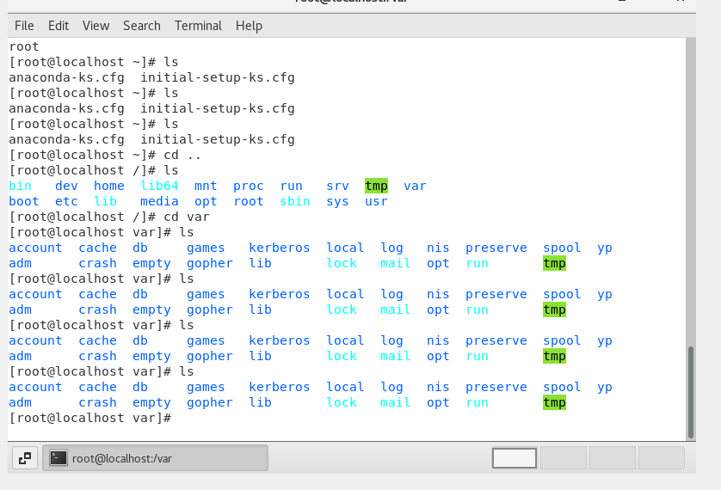

Here I don’t get www folder inside /var folders but normally it is used to store html pages.

5-cd root :

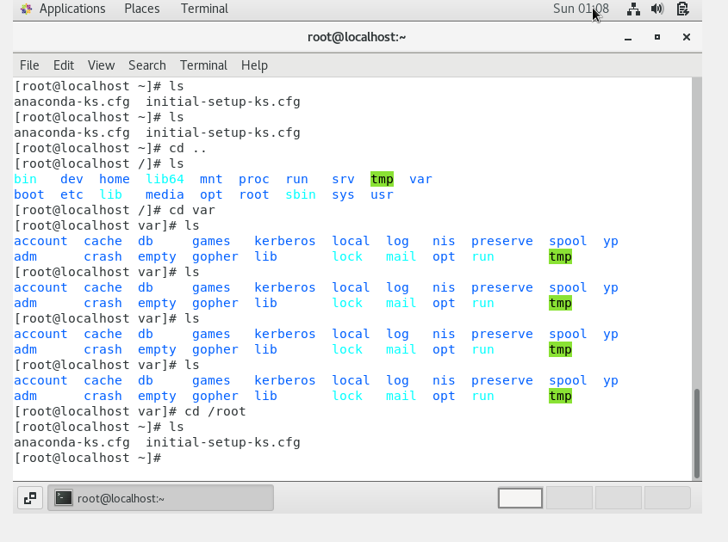

6-cd /etc:

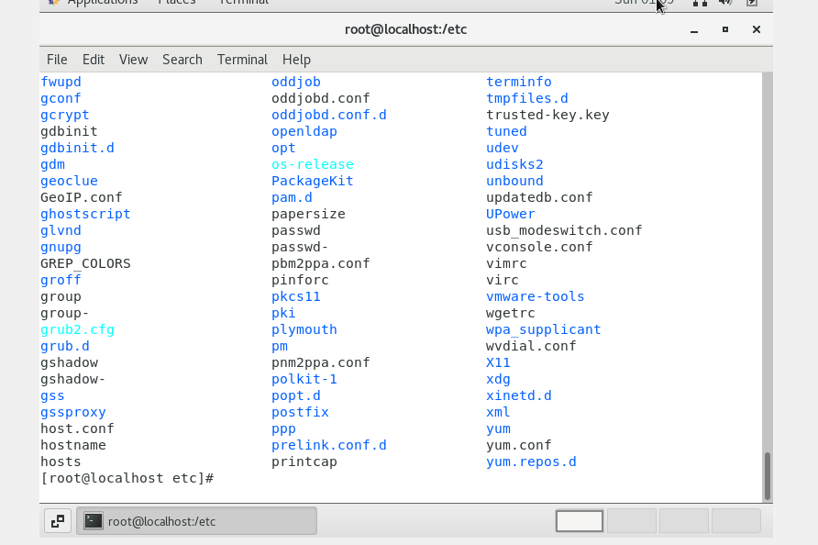

Here all conf file exist and we don’t allow to manipulate these files coz its use in OS operations.

7- ls –al:

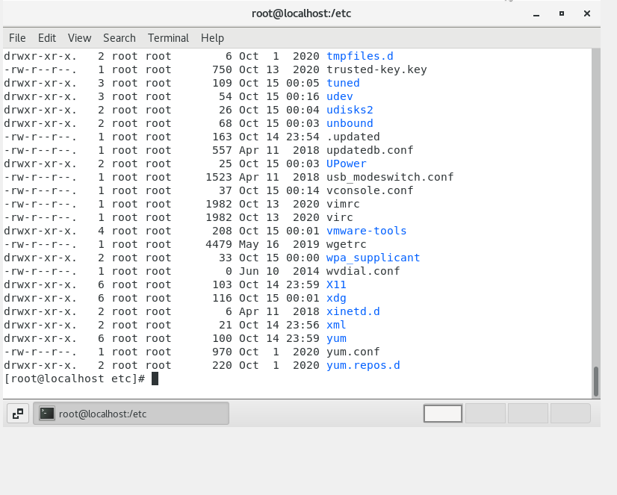

It is used to display the file information regarding write,read and execution format.

8-ls –i:

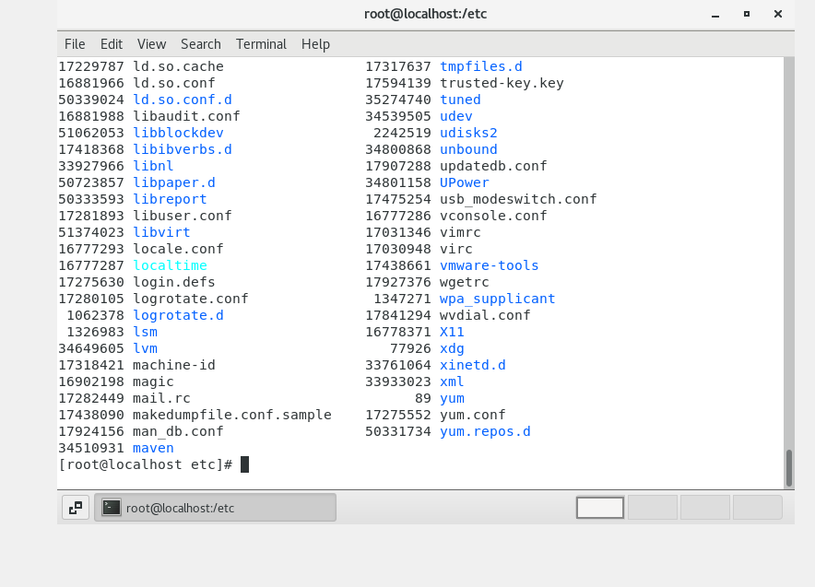

It is used to display file with file size.but it is not in human read able format.

9- ls –help:

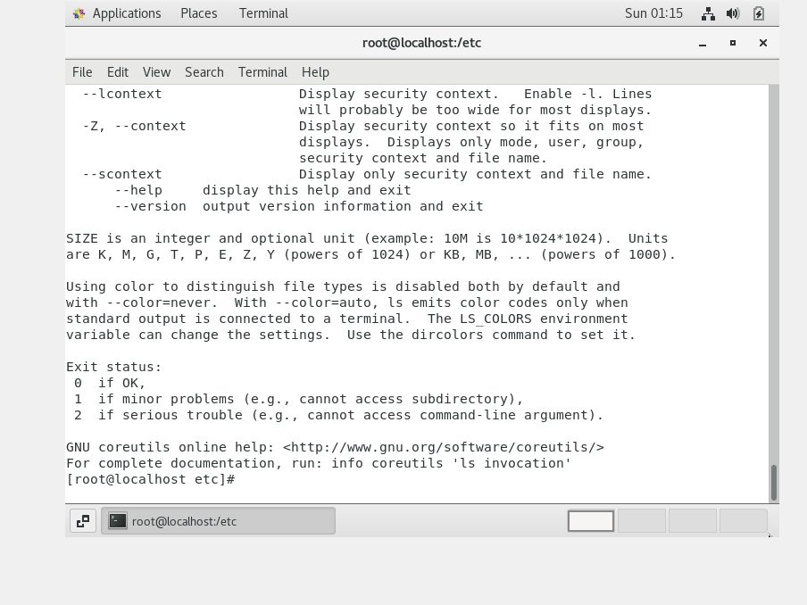

It is used to give extra information regarding commands.

10-pwd:

It is working directory which show 