

Cloud computing

Assignment#2

April 18, 2021

Muhammad Naveed (bcsf17a534)

Milestone 1:

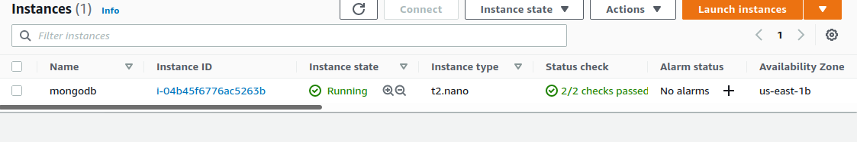

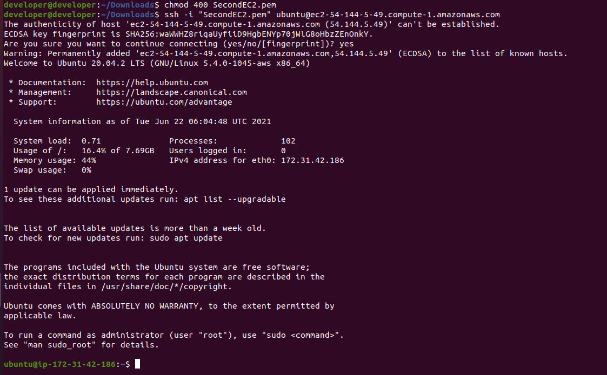

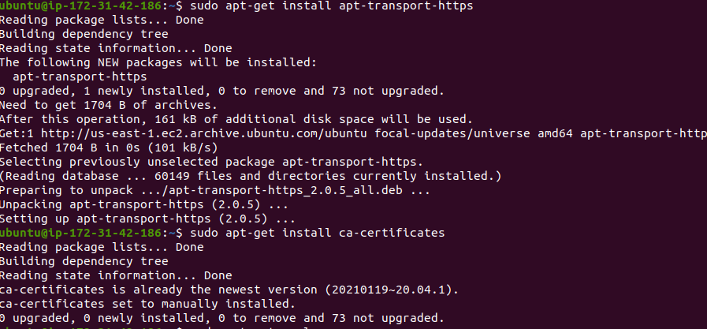

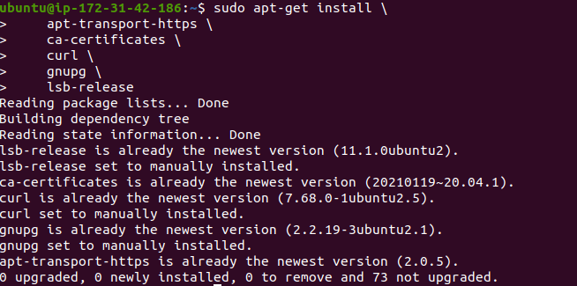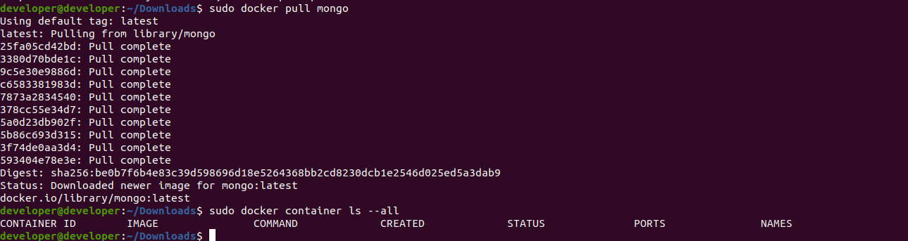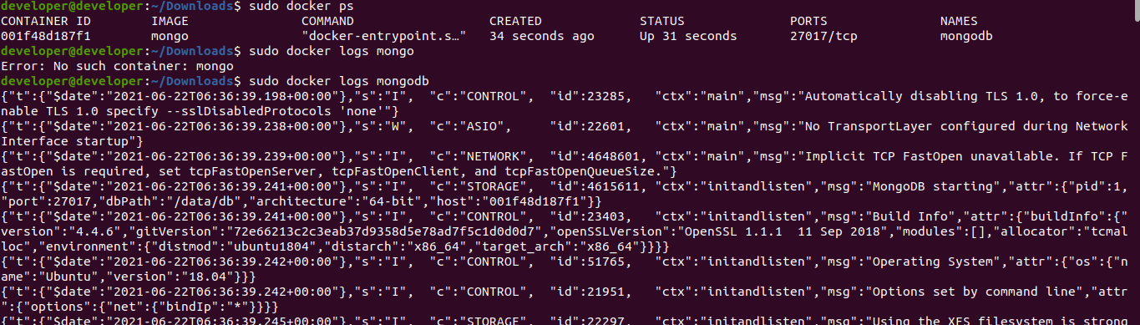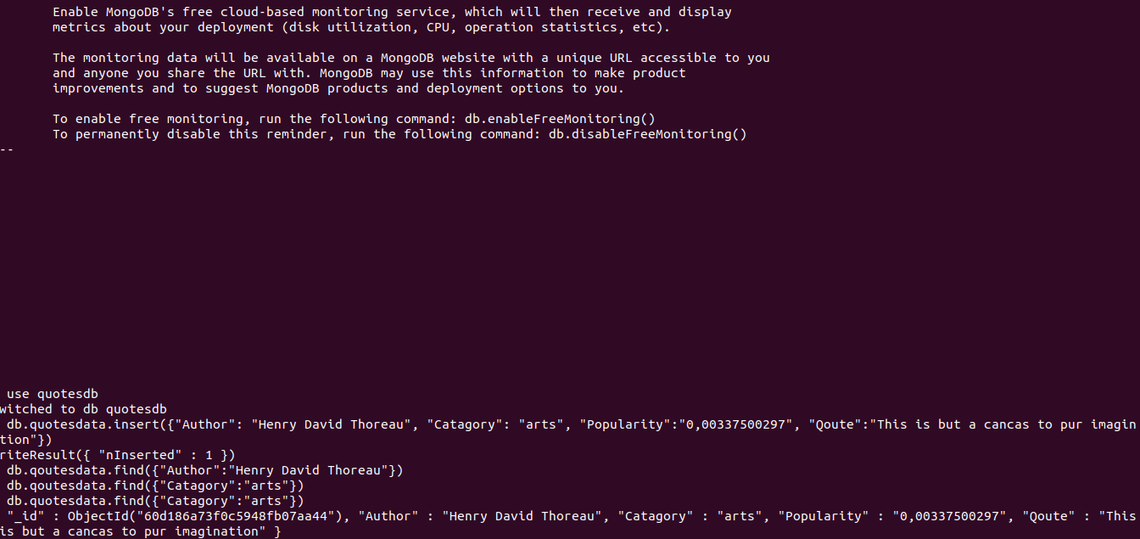

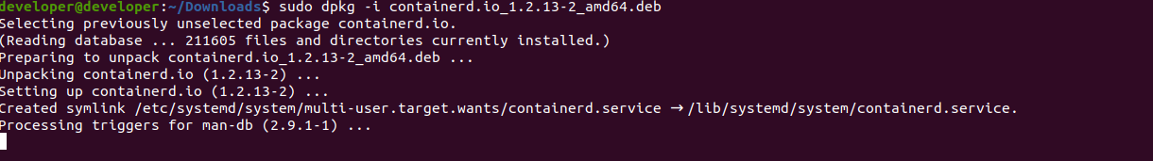

Milestone 2:

1. Install node and mongodb on your machine
2. Hit qoutesdata api through ajax call
3. Use the response in the view

