**Object-oriented Programming (CSE 233)**

**Lab Exercise 1**

**(Due Date 6th August 2020 – Marks 10)**

Student ID: ________________ Name: _______________________________________

**Lab Exercise No. 1 – NUMBER CALCULATIONS**

**Lab Objective**

In this laboratory exercise you will practice:

* Using ***System.out.println*** to output text and characters to the command window
* Compiling and executing Java applications

The follow up question and activity will give you practice modifying an existing program to perform a different task.

**Problem Description**

Write an application that will displays the first character of your name using asterisks and using one *“System.out.print”* statement.

**Lab Exercise No. 2 – NUMBER CALCULATIONS**

**Lab Objective**

In this laboratory exercise you will practice:

* Using ***Scanner*** class to obtain input from the user.
* Using ***printf*** to output information to the user.
* Using ***arithmetic operations*** to perform calculations.
* Compiling and executing Java applications

The follow up question and activity will give you practice modifying an existing program to perform a different task.

**Problem Description**

Write an application that inputs three integers from the user and displays the sum and product of the numbers.

**Follow-up Question and Activity**

Remove a semicolon from any statement in the program. Compile again.

What happens? Explain.

Modify the program so that it calculates and outputs the **AVERAGE** of three number entered by the user.

**Sample Output**

The average of 10, 20, and 30 is 20.

You will use NetBeans 8.02 IDE for the programs and will submit your lab-report.

**Exercise 1:**

/*

* This is Sirin's Program

* Made by Sirin

*/

package lab.pkg1_report;

/**

*

* @author Sirin Nofal

*/

public class Lab1_report {

/**

* @param args the command line arguments

*/

public static void main(String[] args) {

System.out.print("*********\n"

+"*\t*\n"

+ "*\n*\n"

+ "*********\n"

+ "\t*\n\t*\n*\t*\n"

+ "*********\n"

);

}

}

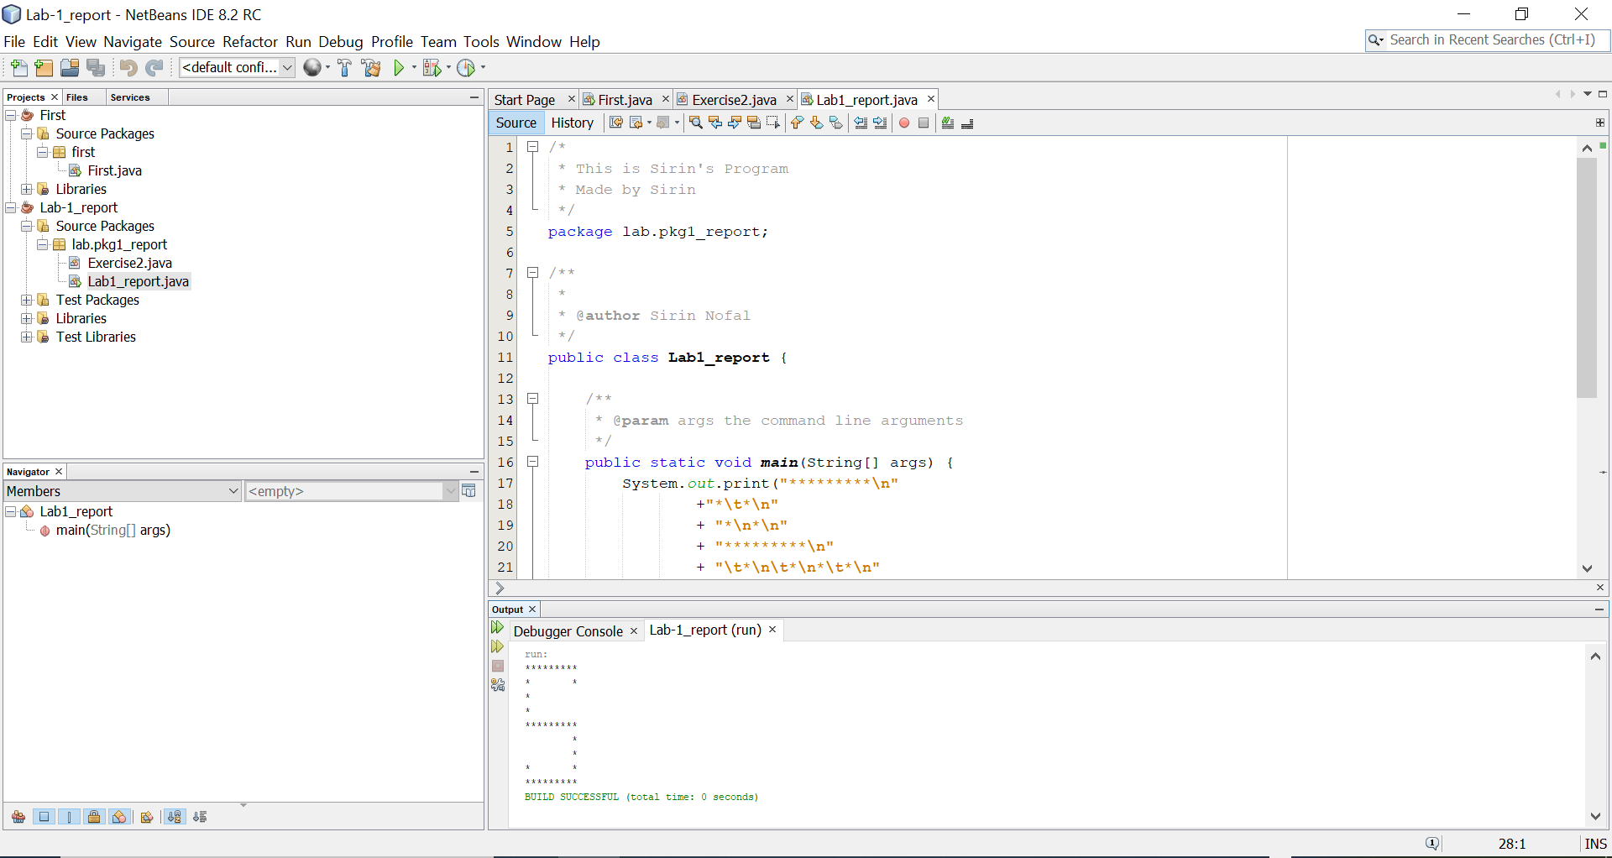

/*

* This is Sirin's Program

* Made by Sirin

*/

package lab.pkg1_report;

/**

*

* @author Sirin Nofal

*/

public class Lab1_report {

/**

* @param args the command line arguments

*/

public static void main(String[] args) {

System.out.print("*********\n"

+"*\t*\n"

+ "*\n*\n"

+ "*********\n"

+ "\t*\n\t*\n*\t*\n"

+ "*********\n"

);

}

}

**Exercise 2:**

/*

* This is Sirin's Program

* Made by Sirin

*/

package lab.pkg1_report;

import java.util.Scanner;

/**

*

* @author Sirin Nofal

*/

public class Exercise2 {

public static void main(String[] args){

int num1,num2,num3,sum,product,average;

Scanner input =new Scanner(System.in);

System.out.print("Enter 1st number:");

num1=input.nextInt();

System.out.print("Enter 2nd number:");

num2=input.nextInt();

System.out.print("Enter 3rd number:");

num3=input.nextInt();

sum=num1+num2+num3;

product=num1*num2*num3;

//System.out.printf("Sum of three numbers is: %d\n",sum);

//System.out.printf("Product of three numbers is: %d\n",product);

average = sum/3;

System.out.printf("The average of %d,%d, and %d is %d\n",num1,num2,num3,average);

}

}

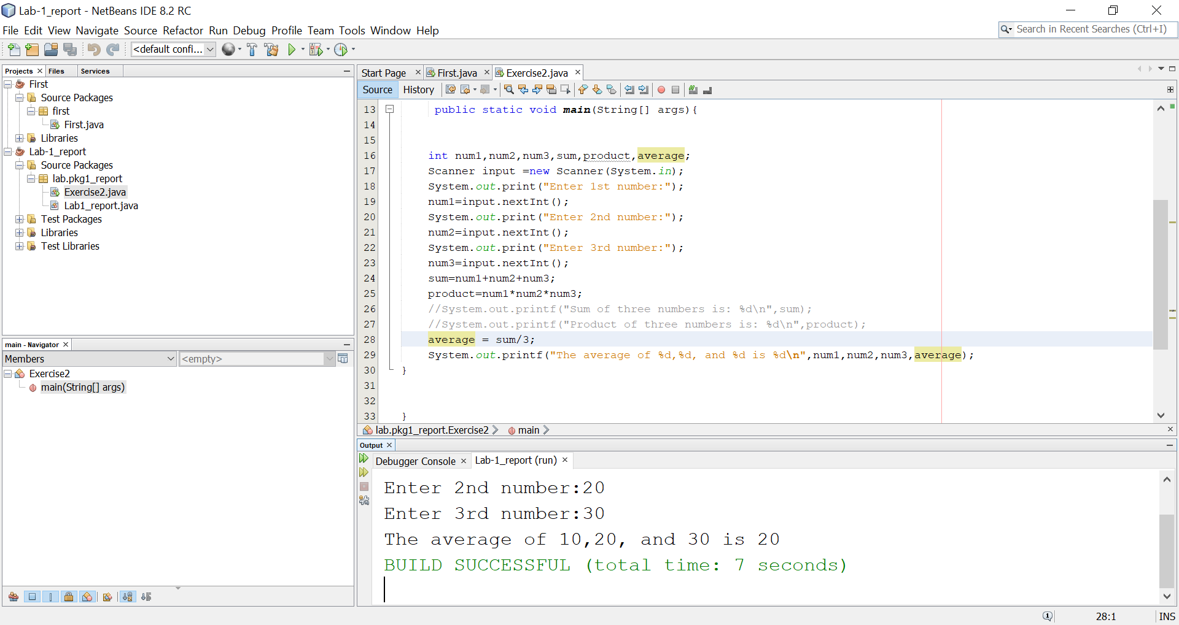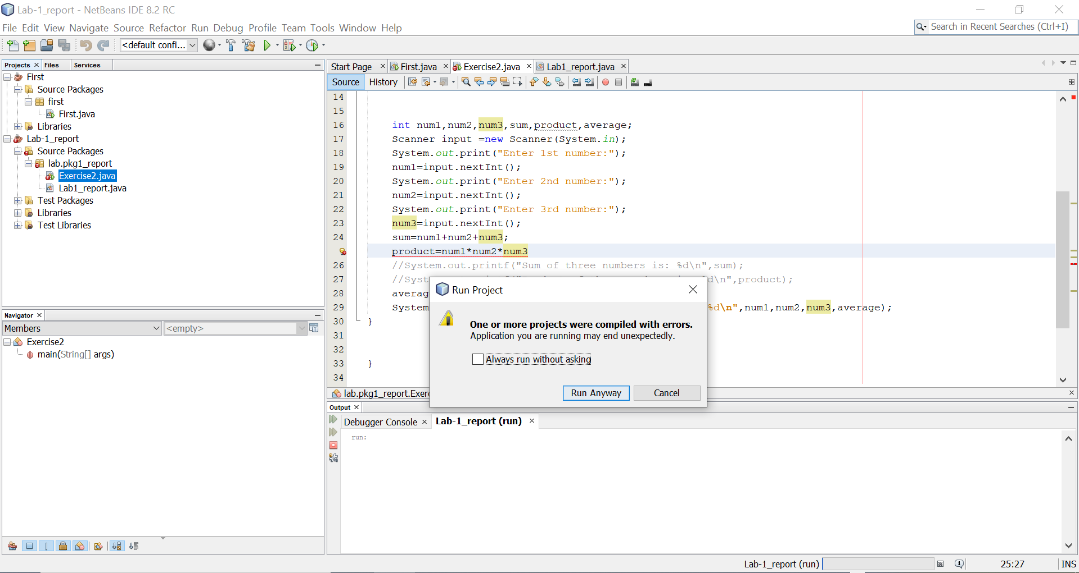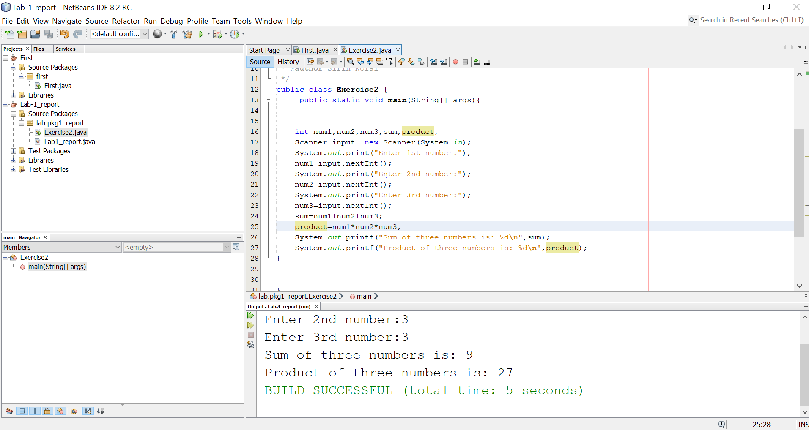

When I remove semicolon from line 25 it shows a box indicating a syntax error. But when I press on run anyway it runs.