**Object-oriented Programming (CSE 233)**

**Lab Exercise 2**

**(Due Date 6th August 2020 – Marks 10)**

Student ID: ________________ Name: _______________________________________

**Lab Objective**

In this laboratory exercise you will practice:

Write programs using repetition and selection structures and arrays.

**Problem Description**

1. Develop a Java application that prints the sum and average of even and odd numbers between two numbers (inclusive) input by the user.
2. Develop a Java application that input the 10 students’ marks (0 – 100) in an array and then prints the maximum, minimum, average of the marks of the students in the array.

You will use NetBeans 8.02 IDE for the programs development and will submit your lab-report in a single file.

Exercise 1:

/*

* This is Sirin's Program

* Made by Sirin

*/

package lab2;

import java.util.Scanner;

/**

*

* @author Sirin Nofal

*/

public class exercise1 {

/**

* @param args the command line arguments

*/

public static void main(String[] args) {

int num1,num2,evenCount=0,evenSum=0,oddCount=0,oddSum=0;

Scanner input=new Scanner(System.in);

System.out.print("Enter first number: ");

num1=input.nextInt();

System.out.print("Enter second number: ");

num2=input.nextInt();

for(int i=num1;i<=num2;i++){

if(i%2==0){

evenCount++;

evenSum+=i;

}

else{

oddCount++;

oddSum+=i;

}

}

System.out.println("Sum of even numbers: "+evenSum);

System.out.println("Average of even numbers: "+evenSum/evenCount);

System.out.println("Sum of Odd numbers: "+oddSum);

System.out.println("Average of Odd numbers: "+oddSum/oddCount);

}

}

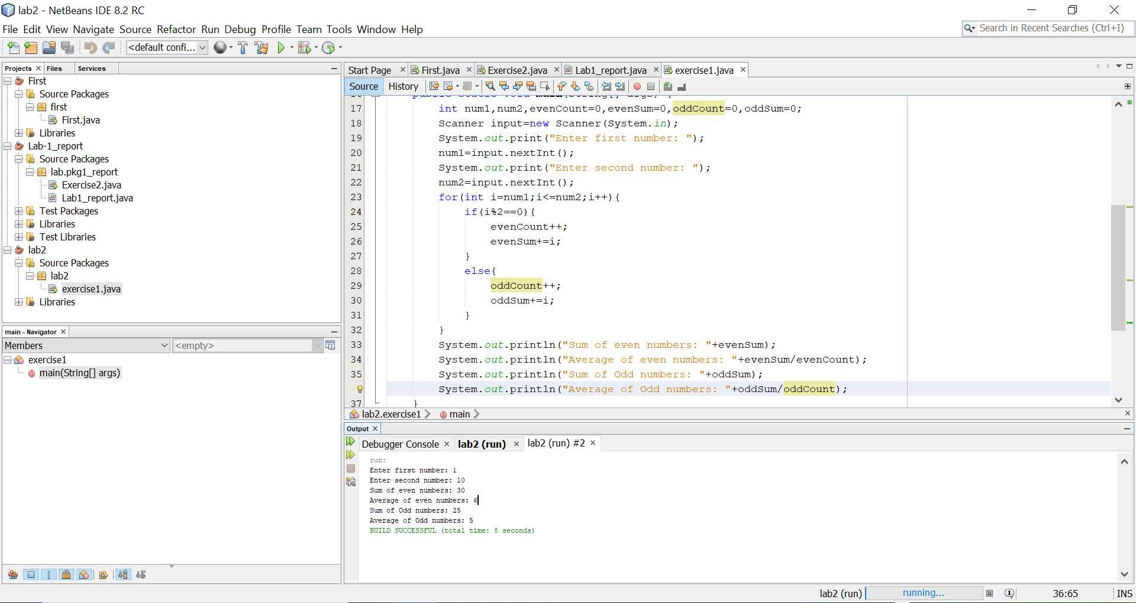

Exercise 2:

/*

* This is Sirin's Program

* Made by Sirin

*/

package lab2;

import java.util.Scanner;

/**

*

* @author Sirin Nofal

*/

public class exercise2 {

public static void main(String[] args){

int[] marks= new int[10];

Scanner input=new Scanner(System.in);

for(int i=0;i<10;i++){

System.out.print("Enter Student "+(i+1)+" marks: ");

marks[i]=input.nextInt();

}

int min=marks[0];

int max=marks[0];

int sum=0;

for(int i=0;i<10;i++){

if(marks[i]>max){

max=marks[i];

}

if(marks[i]<min){

min=marks[i];

}

sum+=marks[i];

}

System.out.println("Maximum marks of students: "+max);

System.out.println("Minimum marks of students: "+min);

System.out.println("Average marks of students: "+sum/10);

}

}

