**PAYROLL MANAGEMENT SYSTEM**

**GROUP MEMBERS:**

* **NAVEED RAZA CT-026**
* **AMNA HABIBI CT-033**
* **SURMAN AHUJA CT-035**

**SUBMITTED TO:**

* **SIR UMER**

**DATED:**

* **10-SEPTEMBER-2017**

**ORGANISATIONAL DETAILS**

Unilever is a business driven by a sense of purpose, a thread that connects us to our founding companies and their social missions to improve health, hygiene and livelihoods in the society. The Unilever Pakistan Limited, formerly Lever Brothers Pakistan Limited was established in Pakistan in 1948. Unilever Pakistan is the largest fast-moving consumer goods company in Pakistan, as well as one of the largest multinationals operating in the country.

Company’s vision is to grow our business, while decoupling our environmental footprint from our growth and increasing our positive social impact.

Unilever’s success relies on a strong expertise working in different departments

**DEPARTMENTS:**

* Accounting And Finance
* Management
* Corporative
* Graphics
* Public Relations
* Human Resources
* Purchasing

And payroll in the sense of money paid to the employees working in these departments, plays a major role in the company. A payroll is a company's list of its employees, but the term is commonly used to refer to the total amount of money that a company pays to its employees, a company's records of its employees' salaries and wages, bonuses, and withheld taxes And the company's department that calculates and pays these.

Our payroll system is designed to organize all the tasks of employee payment and the filing of employee taxes. These tasks can include keeping track of hours, calculating wages, add bonus and withholding taxes and deductions, printing and delivering receipts and paying employment taxes to the government.

The primary mission of the payroll department is to ensure that all employees are paid accurately and timely with the correct withholdings and deductions. This includes salary payments, tax withholdings, and deductions from leaves, loan etc.

**SCENARIO**

This system is integrated with an employee management system, where all the employees are working in different departments in which all their data is being submitted, which includes their full name, gender, address, email id and phone numbers. Each employee has its own specific employee id. All the departments in which the employees are working in have its name and location along with a unique department id. Each employee is assigned with a post in every department with all their job data which includes job title, job id and each job designation has its minimum and maximum salary. Every employee has to submit his or her job details which includes the date from which they started off and their last working date. The payments of the employees are done through payroll management system which provides receipts of the salaries in which all of the payment data is recorded which includes tax, loan, leave and their calculated salaries. The payments also include bonuses and allowances which are granted to specific employees depending on their commitment and time punctuality.

**UN-NORMAALIZED ERD**

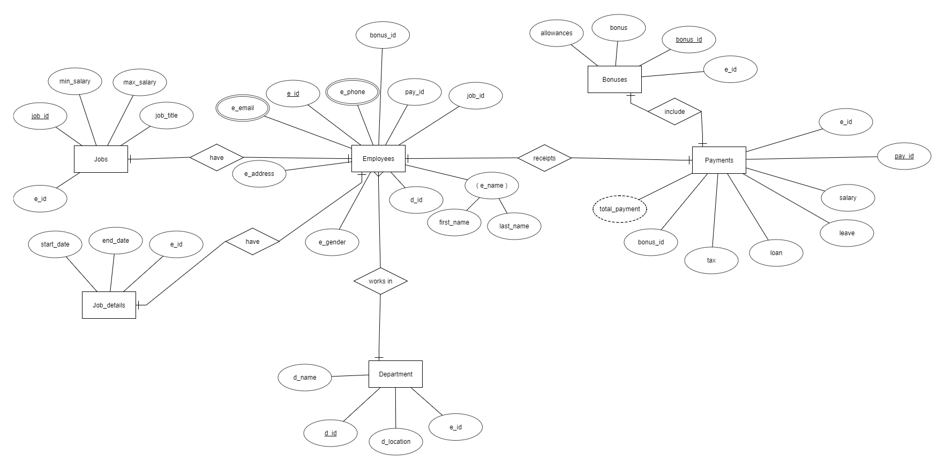

**NORMALIZED ERD**

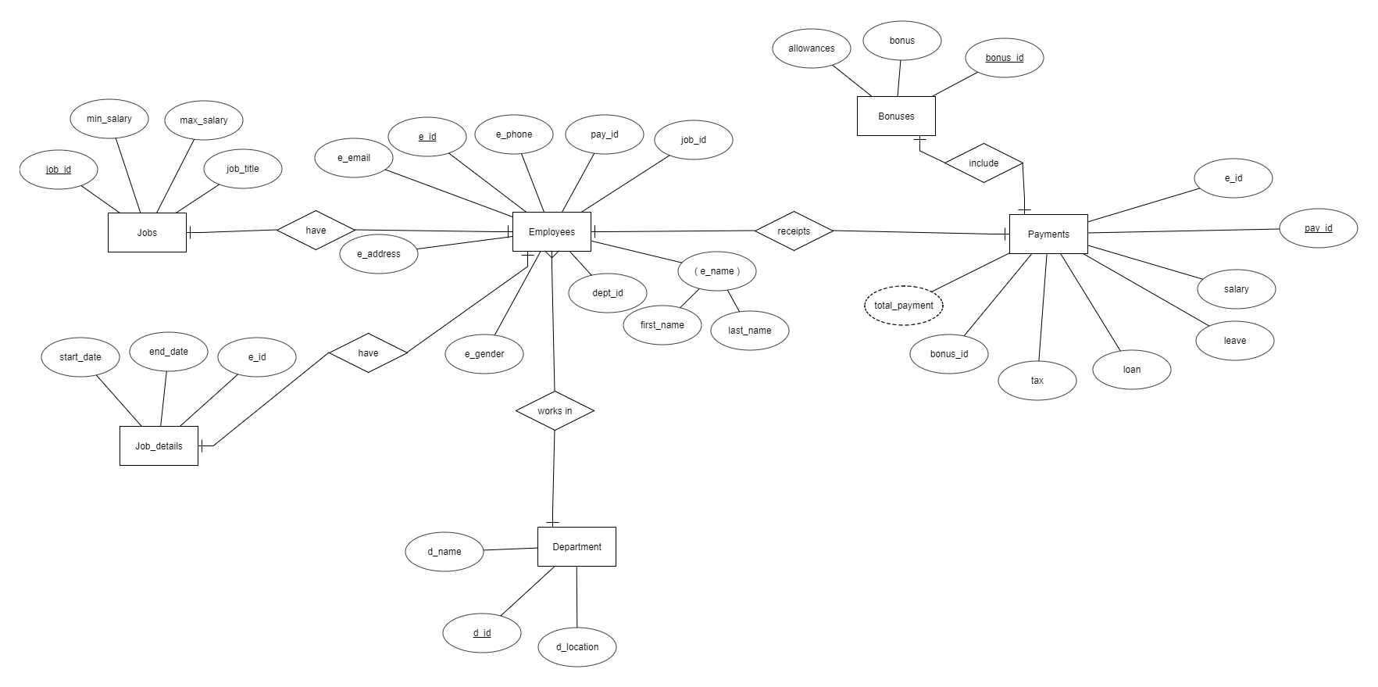

**PHYSICAL ERD**

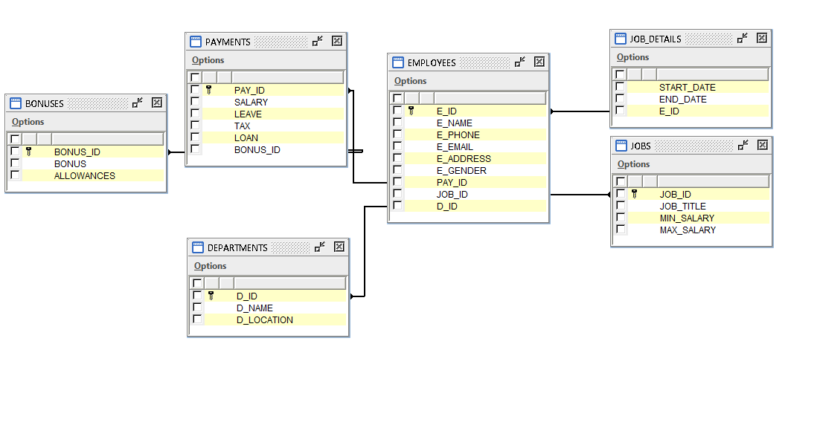

**NORMALIZED TABLES**

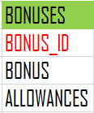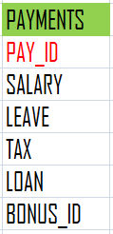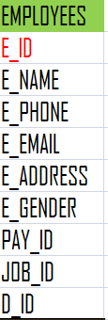

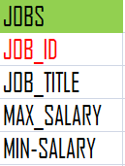

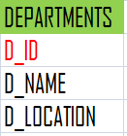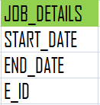

**ENTITIES AND ATTRIBUTES**

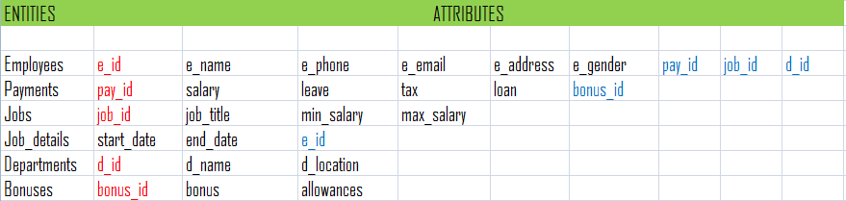

**TABLES AND DATA**

**EMPLOYEES:**

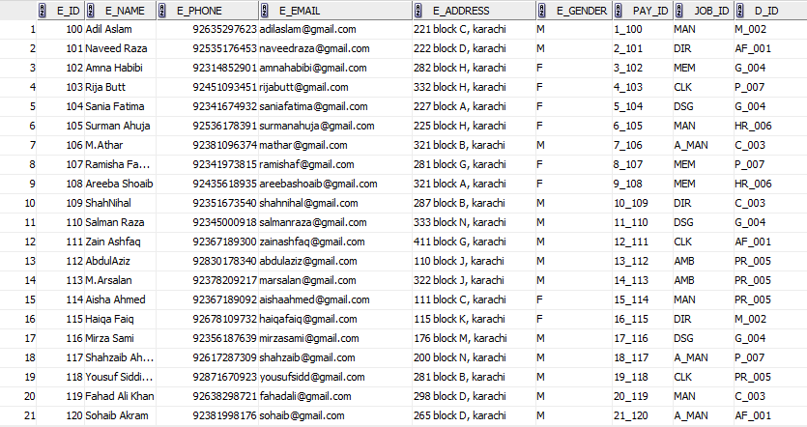

**DEPARTMENTS:**

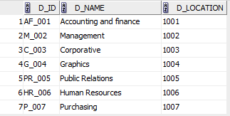

**PAYMENTS:**

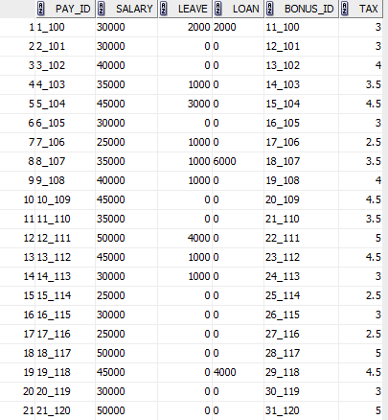

**JOBS:**

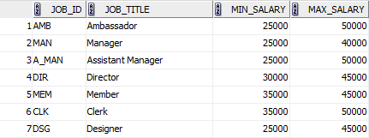

**JOB_DETAILS:**

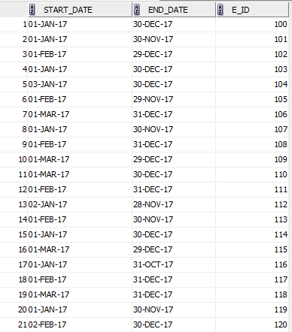

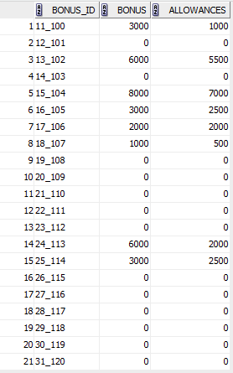**BONUSES:**

FACT FINDING QUESTIONS

1. How many departments are there in your company?

select 'There are ' || count(*) || ' departments' as "Total departments"

from departments;

1. How many numbers of employees are there in each department?

select 'There are ' || count(*) || ' employees in this department.' as "Total employees"

from employees where d_id=**'AF_001'**;

1. How can we get information of employees in a particular department?

select e_id, e_name, e_phone, e_email, e_address, e_gender, pay_id, job_id from employees where d_id = **'AF_001'**;

1. How many employees are there total in the company?

select 'There are total ' || count(*) || ' employees in our company.' as "Total Employees" from employees;

1. How many employees are male in the company?

select * from employees where e_gender='M';

1. How can we get all the job details of a particular employee?

select e_name, d_id, job_title, start_date, end_date

from employees, jobs, job_details

where employees.e_id = 101 and job_details.e_id = 101 and employees.job_id = jobs.job_id;

1. How many job positions are there in your company?

select 'There are ' || count(*) || ' job positions' as "Jobs"

from jobs;

1. What is the maximum and minimum salary for each job.

select job_title,min_salary, max_salary

from jobs;

1. How many employees have same job position?

select e.e_id, e.e_name, j.job_title, d.d_name

from employees e, jobs j, departments d

where e.job_id = 'AMB' and e.job_id = j.job_id and e.d_id = d.d_id;

1. How many employees have salary below 40000?

select 'There are ' || count(*) || ' employees having salary below 40k' as "Employees"

from payments

where salary < 40000;

1. Number of employees that were inducted in the month of January write details?

select e.e_id, e.e_name, e.e_phone, e.e_email, e.e_address, e.e_gender, e.pay_id, e.job_id, e.d_id

from employees e, job_details j

where e.e_id = j.e_id and j.start_date < '30-JAN-17';

1. Find maximum, minimum and average salary of all employees?

select MAX(salary) as "MAX", MIN(salary) as "MIN", ROUND(AVG(salary),2) as

"AVG"

from payments;

1. How many were employees inducted on the first day of the year?

select e.e_id, e.e_name, e.e_phone, e.e_email, e.e_address, e.e_gender, e.pay_id, e.job_id, e.d_id

from employees e, job_details j

where e.e_id = j.e_id and j.start_date = '01-JAN-17';

1. How many employees have the highest salary?

select e.e_id, e.e_name, p.salary

from employees e, payments p

where e.pay_id = p.pay_id and p.salary = 50000;

1. How can we get payment details of a particular employee?

select e.e_name, e.pay_id, p.salary, p.leave, p.tax, p.loan, b.bonus, b.allowances, (p.salary + b.bonus + b.allowances - p.loan -p.leave - (p.tax * p.salary / 100)) totalsalary

from employees e, payments p, bonuses b

where e.e_id = 100 and e.pay_id = p.pay_id and b.bonus_id = p.bonus_id;

1. How many employees are getting bonus?

select e.e_id, e.e_name, p.pay_id, b.bonus_id, b.bonus, b.allowances

from bonuses b, employees e, payments p

where b.bonus > 0 and b.bonus_id = p.bonus_id and p.pay_id = e.pay_id ;

1. How is the total payment calculated in your company?

select e.e_name, (p.salary + b.bonus + b.allowances - p.loan -p.leave - (p.tax * p.salary / 100)) totalsalary

from employees e, payments p, bonuses b

where e.e_id = 100 and e.pay_id = p.pay_id and b.bonus_id = p.bonus_id;

1. How can we calculate the duration of work of a particular employee?

select e.e_id, e.e_name , (j.end_date - j.start_date) as "Duration Of work"

from employees e, job_details j

where e.e_id = j.e_id;

1. How many employees have name starting with ‘A’ ?

select e.e_id, e.e_name , e_phone, e_email

from employees e

where e.e_name LIKE 'A%';

1. How many employees are getting bonus?

select 'There are ' || count(*) || ' employees getting bonuses.' as "Employees getting bonuses"

from bonuses

where bonus > 0;

1. What was the last date of induction ?

select ' The last date of induction of an employee was ' || MAX(start_date)

from job_details;

1. How many employees have taken loan?

select count(*)

from payments

where loan >0;

1. What is the maximum tax rate among the employees?

select 'The maximum tax rate is ' || MAX(tax)

from payments;

1. How many employees had deduction in salary due to leave?

select count(*)

from payments

where leave >0;

1. How can we calculate yearly salary of a particular employee?

select e.e_name, ((p.salary + b.bonus + b.allowances - p.loan -p.leave - (p.tax * p.salary / 100)) * 12 ) as "YearlySalary"

from employees e, payments p, bonuses b

where e.e_id = 100 and e.pay_id = p.pay_id and b.bonus_id = p.bonus_id;

**VIEWS**

1. Department view to see the employees working in it.

create view DEPT_AF AS

select e_id, e_name, e_phone, e_email, e_address, e_gender, pay_id, job_id

from employees

where d_id = 'AF_001';

1. Job details view of a particular employee.

create view DET_101 AS

select e_name, d_id, job_title, start_date, end_date

from employees, jobs, job_details

where employees.e_id = 101 and job_details.e_id = 101 and employees.job_id = jobs.job_id;

1. Payment details view of a particular employee.

create view EMP_100 AS

select e.e_name, e.pay_id, p.salary, p.leave, p.tax, p.loan, b.bonus, b.allowances, (p.salary + b.bonus + b.allowances - p.loan -p.leave - (p.tax * p.salary / 100)) totalsalary

from employees e, payments p, bonuses b

where e.e_id = 100 and e.pay_id = p.pay_id and b.bonus_id = p.bonus_id;

1. Job position view to see all employees on that particular position.

create view JOB_AMB AS

select e.e_id, e.e_name, j.job_title, d.d_name

from employees e, jobs j, departments d

where e.job_id = 'AMB' and e.job_id = j.job_id and e.d_id = d.d_id;

1. Bonus view to see employees getting bonuses.

create view EMP_BON AS

select e.e_id, e.e_name, p.pay_id, b.bonus_id, b.bonus, b.allowances

from bonuses b, employees e, payments p

where b.bonus > 0 and b.bonus_id = p.bonus_id and p.pay_id = e.pay_id ;

FACT FINDING QUESTIONS

1. How many departments are there in your company?

There are various departments such as Accounts and Finance, HR, Graphics, Corporate etc.

1. How many numbers of employees are there in each department?

Each department has different number of employees

1. How can we information of employees in a particular department?

Each employee has different information which can be referenced by their unique id.

1. How many employees are there total in the company?

There are around 20-25 employees in the company.

1. How many employees are male in the company?

There are around 70% of male employees.

1. How can we get all the job details of a particular employee?

Every employee have their own job details which can be referenced by their unique id.

1. How many job positions are there in your company?

There are different job positions in our company like director, manager, member, assistant manager etc.

1. What is the maximum and minimum salary for each job.

It depends on each job position.

1. How many employees have same job position?

The same job position depends on the number of departments.

1. How many employees have salary below 40000?

The salary of employees will depend on each job position.

1. Number of employees that were inducted in the month of January write details?

Around 50% of employees.

1. Find maximum, minimum and average salary of all employees?

Max= 50000, MIN=25000, AVG=35000-40000

1. How many were employees inducted on the first day of the year?

15-20%.

1. How many employees have the highest salary?

The highest salary depends on employees job positions.

1. How can we get payment details of a particular employee?

Each employee will have its own payment details which can be attained by their unique id.

1. How many employees are getting bonus?

It will depend on employee performance.

1. How is the total payment calculated in your company?

Total_salary = salary + bonus + allowances – tax – loan – leave.

1. How can we calculate the duration of work of a particular employee?

By subtracting end_date and start_date.

1. How many employees have name starting with ‘A’ ?

5 employees.

1. How many employees are getting bonus?

It will depend on employee performance.

1. What was the last date of induction?

It will be the day when the company stop inducting more employees i.e end of third month.

1. How many employees have taken loan?

Depends on employees, anyone can take loan.

1. What is the maximum tax rate among the employees?

Depends on employee salary.

1. How many employees had deduction in salary due to leave?

It will depend on employees extra leaves besides normal allotted leaves i.e 2 leaves / month.

1. How can we calculate yearly salary of a particular employee?

By multiplying the monthly salary with 12.

|  |
| --- |
|  |
|  |