STITCHER
BY
NAVEED AHMAD
REG NO. AWKUM-19139006
MUHAMMAD JUNAID
REG NO. AWKUM-19128225
WAQAR AHMAD
REG NO. AWKUM-19137439


BACHELOR OF COMPUTER SCIENCE (BCS)
DEPARTMENT OF COMPUTER SCIENCE
ABDUL WALI KHAN UNIVERSITY,
MARDAN PAKISTAN
FALL 2023

STITCHER
BY
NAVEED AHMAD
REG NO. AWKUM-19139006
MUHAMMAD JUNAID
REG NO. AWKUM-19128225
WAQAR AHMAD
REG NO. AWKUM-19137439


A Final Year Project Report Submitted to Abdul Wali Khan University, Mardan in Partial Fulfillment of the Requirement of the Degree BACHELOR OF COMPUTER SCIENCE (BCS)
DEPARTMENT OF COMPUTER SCIENCE
ABDUL WALI KHAN UNIVERSITY,
MARDAN PAKISTAN
FALL 2023

FINAL YEAR PROJECT REPORT APPROVAL
This Final Year Project Report Titled
STITCHER
Submitted for the degree of
BACHELOR OF COMPUTER SCIENCE
By
NAVEED AHMAD
REG NO. AWKUM-19139006
MUHAMMAD JUNAID
REG NO. AWKUM-19128225
WAQAR AHMAD
REG NO. AWKUM-19137439
Has been approved for
ABDUL WALI KHAN UNIVERSITY MARDAN
Supervisor___________________________________________________________
Dr. Faisal Javid , Lecturer
Department of Computer Science, AWKUM SRH campus Pabbi
Head of Department__________________________________________________

Dr. Jamal Ahmad, Assistant Professor
Incharge Department of Computer Science, AWKUM SRH Campus Pabbi

DEDICATION
We dedicate this thesis to all of the people who have continuously encouraged and supported us academically. To our family, who have supported us in our pursuit of knowledge with their unwavering love, encouragement, and sacrifices? Your confidence in me has served as a constant source of inspiration, and we appreciate your persistent backing. To our mentors and advisors, whose advice, know-how, and priceless insights have impacted our academic and scientific development? Your guidance has encouraged us to push the boundaries of our thinking and pursue excellence. To our mates, thank you for being supportive and understanding in both happy and stressful times. Your companionship has made our life more enjoyable and balanced by serving as a constant reminder of the value of relationships and shared experiences. To the attendees of our study, who generously contributed their time, knowledge, and experiences. Your willingness to participate has enriched this research, and we are grateful for your invaluable contributions. To the academic community, for fostering an environment of intellectual curiosity and collaborative learning. Your collective dedication to the pursuit of knowledge has inspired us to push boundaries and contribute to the advancement of our field.

DECLERATION
We hereby sincerely certify that the "Stitcher" project we submitted for the BS CS at AWKUM is an original piece of writing. We certify that the work we've done here is entirely original it wasn't copied from another source or submitted for academic or professional use elsewhere. We agree that any outside materials used in the creation of this project, including books, research articles, and other materials, have been properly cited and referenced. The appropriate sections of the project report have duly acknowledged any contributions or help received from people or organizations. We further affirm that this project was created with the utmost honesty, integrity, and faithfulness to academic and research integrity norms. Legal duties, moral obligations, or guidelines related to data collection, privacy, and confidentiality have been adhered to throughout the project.

ACKNOWLEDGEMENT
We would like to express our sincere gratitude and appreciation to all those who have contributed to the successful completion of our project titled "Stitcher". Their support, guidance, and encouragement have been invaluable throughout this journey. We extend our deepest thanks to our project supervisor Dr. Faisal Javid for their unwavering support, expertise, and invaluable guidance. Their insightful feedback, constructive criticism, and continuous encouragement have been instrumental in shaping this project. Finally, we would like to express our deepest appreciation to our family for their unconditional love, unwavering encouragement, and understanding throughout our academic journey. Their constant support and belief in my abilities have been our greatest motivation.

ABSTRACT
A flutter-based application called The Stitcher is intended to simplify and automate tailor shop management. It offers a complete platform for tailors and customers to communicate and work together on managing orders and customizing garments. The system provides a user-friendly interface that makes it easier to track orders, place bespoke clothing orders, and manage tailoring jobs. There are many different features and functionalities included in the Stitcher application. Customers can register for personalized accounts, look through a selection of clothing designs, enter measurements, and choose their preferred fabrics. Through integrated messaging systems, they may communicate with tailors in real-time, ensuring clear communication and minimizing misunderstandings. Additionally, customers may follow the status of their orders and get notifications when the status changes, ensuring an efficient and open workflow. Benefits to tailors the Stitcher by gaining access to a centralized dashboard that allows them to manage customer orders efficiently. They can view and accept orders, track measurements, record fabric details, and schedule appointments. The system provides tools for a comprehensive order history, enabling tailors to streamline their operations and enhance customer satisfaction.

TABLE OF CONTENTS

FINAL YEAR PROJECT REPORT APPROVAL i
DEDICATION ii
DECLERATION iii
ACKNOWLEDGEMENT iv
ABSTRACT v
LIST OF FIGURES x
LIST OF TABLES xi
LIST OF ACRONYMS xii
CHAPTER 1 1
INTRODUCTION 1
1.1 General Background 1
1.2 Applications 1
1.2.1 Order Management 1
1.2.2 Appointment Scheduler 1
1.2.3 Fabric Inventory and Tracking 2
1.2.4 Customer Database 2
1.2.5 Financial Management 2
1.3 Problem Statement 2
1.4 Proposed Solution 3
1.5 Aims and Objectives 3
1.6 Project Scope 4
1.6.1 Customer Management 4
1.6.2 Order Management 4
1.6.3 Measurement Management 4
1.6.4 Inventory Management 4
1.6.5 Reporting 5
1.6.6 User Management 5
1.7 Summary 5
CHAPTER 2 6
OVERVIEW OF THE EXISTING SYSTEM 6
2.1 Manual System 6
2.1.1 Advantages 6
2.2 Spreadsheets 7
2.2.1 Advantages 7
2.2.2 Disadvantages 7
2.3 Off-the-Shelf Software 7
2.3.1 Advantages 7
2.3.2 Disadvantages 8
2.4 Cloud-based Software 8
2.4.1 Advantages 8
2.4.2 Disadvantages 8
2.5 Mobile Applications 8
2.5.1 Advantages 9
2.5.2 Disadvantages 9
2.6 Summary 9
CHAPTER 3 10
TOOLS AND METHODOLOGY 10
3.1 Requirement Analysis 10
3.1.1 Functional Requirement 10
3.1.2 Non-Functional Requirement 11
3.2 Software Requirement 12
3.3 Hardware Requirement 13
3.4 Software Tools 13
3.5 Hardware Tools 13
CHAPTER 4 15
SYSTEM MODELING AND DESIGN 15
4.1 Context Diagram 15
4.2 Use Case Diagram 16
4.3 Activity / Sequence Diagram 17
4.4 System Architecture 18
4.5 Data Flow Diagram 19
2.6 Entity Relationship Diagram 20
CHAPTER 5 22
IMPLEMENTATION AND TESTING 22
5.1 User Interfaces 22
5.1.1 Admin Login 22
5.1.2 Admin Dashboard 23
5.1.3 Tailor List 24
5.1.4 Order List 24
5.1.5 User / Customer List 25
5.1.6 Expenses List 25
5.1.7 User Login 26
5.1.8 Customer Dashboard 26
5.1.9 Order Screen 27
5.1.10 Track Order 28
5.1.11 Tailor List 29
5.2 Software Testing 30
5.2.1 Unit Testing 30
5.2.2 Integration Testing 32
5.2.3 System Testing 34
CHAPTER 6 37
SUMMARY AND CONCLUSION 37
6.1 Summary 37
6.2 Conclusion 37
REFERENCES 39

LIST OF FIGURES
Figure 4. 1 Context Diagram 16
Figure 4. 2 Use Case Diagram 17
Figure 4. 3 Sequence Diagram 18
Figure 4. 4 System Architecture 19
Figure 4. 5 Data Flow Diagram 20
Figure 4. 6 ER Diagram 21
Figure 5. 1 Login Screen 23
Figure 5. 2 Admin Dashboard 24
Figure 5. 3 Tailor List 24
Figure 5. 4 Oder List 25
Figure 5. 5 User List 25
Figure 5. 6 Expenses List 26
Figure 5. 7 Customer Login 26
Figure 5. 8 Dashboard Screen 27
Figure 5. 9 Order Screen 28
Figure 5. 10 Order Track Screen 29
Figure 5. 11 Tailor List 30

LIST OF TABLES
Table 3. 1 Functional Requirement 10
Table 3. 2 Non-Functional Requirements 12
Table 5. 1 Unit Testing 31
Table 5. 2 Integration Testing 32
Table 5. 3 System Testing 34

LIST OF ACRONYMS
DFD Data Flow Diagram
ERD Entity Relationship Diagram
RES Resource
RAM Random Access Memory
SRS Software Requirement Specification
SDLC Software Development Life Cycle
Uls User Interfaces
UML Unified Modeling Language

CHAPTER 1

INTRODUCTION

General Background
As innovation develops, we are additionally moving towards specialized kinds of techniques. Nowadays, as an online website and application having a lot of revolution in our life. And we introduced an online website and application that name is “Stitcher”. This application design to provide the multiple technicians Selection of Tailor, measurements, online order booking, unstitched cloth etc. A tailor person whose occupation is making cloths, pants, suits, trousers and jackets etc., to fit individual customers. This application contains different features like Selection of Tailor, measurements, etc. This application is used to expand company’s services in the city digitally so that it has an online presence as well as physical presence. The website would allow end users to choose a Tailor by sitting at home within few clicks on this platform. User can simply scroll through this website and choose the one which suits him, he can use Map navigation to locate all the available tailor near him. Idea of this Website was that you tailor and customer’s use this platform accordingly own needs [1].

Applications
There are many applications of our project some of the applications of a Stitcher Application are :

1.2.1 Order Management
- Efficient creation and tracking of customer orders.
- Real-time updates on order status and progress.
- Measurement storage for quick reference.
- Automated notifications to customers regarding order updates.

1.2.2 Appointment Scheduler
- Online booking for customers with preferred date and time selection.
- Availability management to avoid double bookings.
- Reminders and notifications for scheduled appointments.
- Calendar integration for easy scheduling and management.

1.2.3 Fabric Inventory and Tracking
- Management of fabric and accessory inventory.
- Tracking availability and quantities of different fabrics.
- Streamlining the procurement process for new fabrics.
- Maintaining fabric cost and supplier information.
1.2.4 Customer Database
- Database for storing customer profiles and contact details.
- Recording customer measurements and preferences.
- Tracking order history and customer preferences for personalized service.

1.2.5 Financial Management
- Invoice generation for orders, including services and material costs.
- Tracking revenue and expenses for financial analysis.
- Generating reports on sales, profits, and business performance.

Problem Statement
The traditional craft of stitching has always taken a lot of time and effort, and it frequently requires a high level of ability and knowledge to produce intricate and beautiful patterns. However, since digital technology has developed and there are now more online stitching programmers available, more people are now using these platforms to make stitching more available and practical. Online stitching apps provide many advantages, but there are still a number of issues that need to be resolved. Among them include the challenge of locating high-quality stitching patterns, the constrained customizing choices offered by some platforms, and the unfriendly user interfaces that can make it challenging for beginners to get started. The whole experience may also be hampered by platform compatibility problems, software updates, and technological difficulties. User experience. As such, there is a need for a stitching application that addresses these challenges and provides users with a seamless, enjoyable, and engaging experience [2].

1.4 Proposed Solution
For Men/Women individuals or groups, the Stitcher application will offer a wide range of services required for the sewing. A tailor's services include designing and tailoring clothing such as suits, shirts, trousers and trousers. The goal of the online stitching application is to digitize the order-taking and tailoring processes. They would be able to regularize their daily wagers and save time and work by doing this. This application has a variety of features, including measurements, online order booking, and tailor selection. It must have both a physical and online presence so that clients may make their own decisions. This website is intended to digitally expand the company's services in the city so that it has both a physical presence and an online presence. This site would allow end users to choose a Tailor by sitting at home within few clicks on it. User can simply scroll through them and choose the one which suits him, he can use Map navigation to locate all the available facilities [3].

Aims and Objectives
The aims and objectives of Stitcher Application are:
Improve Operational Efficiency: The primary aim of a tailor management system is to enhance the operational efficiency of a tailor's business by automating various tasks and streamlining processes. The system aims to optimize order management, appointment scheduling, inventory tracking, and overall workflow to save time and reduce manual errors.
Enhance Customer Experience: The tailor management system aims to provide an exceptional customer experience by offering convenient online booking, real-time order tracking, and timely notifications to keep customers informed about the status of their orders. The system aims to improve communication, responsiveness, and overall satisfaction of customers.
Increase Productivity and Time Management: The system aims to increase productivity by automating routine tasks, such as appointment scheduling, measurement storage, and order tracking. By providing a centralized platform to manage various aspects of the tailoring business, it enables tailors to allocate their time effectively, focus on core activities, and serve more customers efficiently.
Optimize Inventory Management: The tailor management system aims to improve inventory management by accurately tracking fabric and accessory availability. It helps tailors maintain optimal stock levels, avoid shortages or excesses, and streamline the procurement process. By optimizing inventory, the system aims to reduce costs, improve resource utilization, and minimize delays in order fulfillment.
Facilitate Data Analysis and Decision Making: The system aims to provide comprehensive reporting and analytics capabilities to help tailors gain insights into their business performance. It aims to generate reports on order trends, customer preferences, sales analysis, and financial data. This information assists tailors in making informed decisions, identifying growth opportunities, and implementing effective business strategies [4].

1.6 Project Scope
The project scope of a Stitcher application would typically include the following:

1.6.1 Customer Management
The RES should be able to maintain a customer database that includes customer information such as contact details, measurements, order history, and preferences.

1.6.2 Order Management
The system should enable the tailor to manage orders, including creating new orders, updating order status, and tracking order progress.

1.6.3 Measurement Management
The RES should allow the tailor to enter and store customer measurements and create measurement profiles for each customer. This would enable the tailor to quickly access and use customer measurements for new orders.

1.6.4 Inventory Management
The RES should enable the tailor to manage inventory levels, including tracking the availability of fabrics, trims, and other materials. This would ensure that the tailor can quickly and easily access the required materials for each order.

1.6.5 Reporting
The RES should provide comprehensive reporting capabilities, including reports on order status, inventory levels, customer data, and financial data. These reports can be used to analyze business performance and make informed decisions.

1.6.6 User Management
The RES should have role-based user management capabilities that enable the tailor to control access to system functionality based on user roles.

1.7 Summary
The Stitcher application is a web-based platform created to automate and streamline the tailoring services process. The options it offers include choosing a tailor, getting measurements, and placing an order online. The application intends to promote productivity and time management for tailors, optimize inventory management, improve operational efficiency by automating operations, improve customer experience through easier booking and real-time updates, and facilitate data analysis for informed decision-making. Customer management, order management, measurement management, inventory management, reporting, and user administration are all included in the project's scope. In general, the Stitcher app aims to give customers a seamless and interesting experience in the world of tailoring.

CHAPTER 2

OVERVIEW OF THE EXISTING SYSTEM
Before a new system or technology is implemented, the old system alludes to the current procedure or method that is in use. The overview of the current system in the context of the Stitcher application would entail knowing how customizing services are now provided without the usage of the online platform. Customers looking for tailoring services would often visit real tailor shops or deal directly with individual tailors under the old system. Measurements, fabric selection, ordering, and discussing design preferences are all possible steps in the process. When employing paper-based methods, tailors would manually enter customer information, measurements, and order details. Face-to-face contacts or phone calls would be the primary means of communication between the tailor and the client.

2.1 Manual System
The traditional approach to managing a tailor shop involves using pen and paper to track orders, measurements, inventory, and customer data. This method is time-consuming and prone to errors, and may limit the ability to track and analyze data effectively [5].

2.1.1 Advantages
- Low cost
- Flexibility
- Familiarity
- Personal touch
- Security
2.1.2Disadvantages
- Time-consuming
- Prone to errors
- Limited scalability
- Limited tracking and reporting capabilities
- Inefficient and may slow down business operations

2.2 Spreadsheets
Many tailors use spreadsheets to manage their business operations, including customer data, order details, and inventory. While spreadsheets can provide some level of organization and tracking, they are often not integrated, may require manual data entry, and may lack the ability to provide real-time reporting [6].

2.2.1 Advantages
- Low cost
- Easy to use
- Customizable
- Real-time tracking and reporting
- Multiple users can access and edit the same file simultaneously

2.2.2 Disadvantages
- Limited functionality compared to tailor-specific software
- Prone to errors, such as accidental data deletion or incorrect data entry
- Lack of automation
- Limited scalability
- No centralized database and data may be spread across multiple files, making it difficult to manage and analyze data effectively.

2.3 Off-the-Shelf Software
There are several off-the-shelf software solutions available for tailor management, such as Tailor Pad, Tailoring Solution, and Master Tailor. These software solutions provide features such as order management, inventory management, and billing and payment management. However, these systems may lack customization options and may not be tailored to the specific needs of each tailor shop [7].

2.3.1 Advantages
- Ready-to-use software with a range of features
- Easy to set up and use
- Time-saving
- Integration with other software systems
- Regular updates and support

2.3.2 Disadvantages
- Limited customization options
- May not meet specific needs of a tailor shop
- Lack of flexibility
- High initial investment cost
- Incompatibility with existing software and hardware infrastructure.

2.4 Cloud-based Software
Cloud-based software, such as Trello, Asana, and Evernote, provides the ability to manage tasks, appointments, and notes across multiple devices and locations. These tools can be useful for tailors who need to manage their operations remotely or collaborate with team members in different locations [8].

2.4.1 Advantages
- Accessible from anywhere, anytime with internet connection
- Cost-effective and scalable
- Centralized data storage and management
- Easy collaboration and sharing of data across multiple devices and locations
- Automatic updates and backups.

2.4.2 Disadvantages
- Dependence on internet connection
- Security concerns, such as data breaches and hacking
- Limited control over data privacy and security measures
- Lack of customization options
- Subscription-based pricing model can be expensive over time.

2.5 Mobile Applications
Some tailors use mobile applications such as Tailor Master, Tailor App, and TailorSoft to manage their business operations on the go. These applications provide features such as order management, measurement management, and customer data management, all accessible from a mobile device. However, these applications may not provide the same level of functionality as desktop-based software and may be limited by screen size and device compatibility [9].

2.5.1 Advantages
- Convenient and accessible on-the-go
- Mobile-friendly interfaces optimized for smaller screens
- Real-time updates and notifications
- Easy access to customer data and order management from anywhere
- Integration with mobile device features, such as cameras and GPS.

2.5.2 Disadvantages
- Dependence on mobile devices and operating systems
- Limited functionality compared to desktop software
- Security concerns, such as data breaches and hacking
- Compatibility issues across different mobile devices and platforms
- Additional development costs for tailored app features.

2.6 Summary
The current management system for tailor shops consists of hand-written methods, spreadsheets, commercial software, cloud-based software, and mobile apps. The manual system is time-consuming and error-prone, but it is inexpensive. Spreadsheets provide some organization but lack real-time reporting and integration features. Although ready-to-use capabilities are offered by off-the-shelf software, customization choices may be limited. Although it requires an internet connection, cloud-based software enables remote access and collaboration. Although they may have limited functionality and compatibility, mobile applications are convenient. Overall, there are limitations to the current system's effectiveness, scalability, tracking capacities, and data processing.

CHAPTER 3

TOOLS AND METHODOLOGY
The terms "tools" and "methodology" relate to the particular applications, methods, and strategies used to support and direct the creation or deployment of a project or system. The software and methods used to design, create, and administer the Stitcher application would fall under the category of tools and methodology.

3.1 Requirement Analysis
Toward the beginning of the necessary investigation process, the normal deliverable is the software requirement specification (SRS), which depicts the ways of behaving and highlights the system. It additionally contains a rundown of the prerequisites of the framework along with the graphs. The prerequisite list is the rundown of capabilities that a system should have. Prerequisites are of two classes, which are utilitarian and nonfunctional. Useful prerequisites are the necessity that the partners need from the system, how is everything turning out to be worked, and what the system ought to have. Non-practical necessities are the prerequisites that determine the models that can be utilized to decide how the framework works. The graphs, which are otherwise called the system model are the deliberation of the system. Each model is introducing a specific perspective on the system. The graphs additionally show the connection between the system and the outer substances [10].

3.1.1 Functional Requirement
The prerequisite investigation is a computer programming approach that comprises a progression of exercises that lay out the requests or conditions that should be fulfilled for a new or refreshed item while considering the potential for contending necessities from various clients. Practical prerequisites are those that are utilized to show the framework's inward-working nature, as well as the framework's portrayal and clarification of every subsystem. It includes the errand that the framework ought to achieve, the cycles in question, the information that the framework ought to contain, and the UIs [11]. The useful prerequisites are shown in Table 3.1.
Table 3. 1 Functional Requirement
Req. No. | Description | Type
R-1 | A user should be able to register by email. | Functional
R-2 | A user should be able to Monitor. | Functional
R-3 | The system allows the admin to delete the user. | Functional
R-4 | The system should display the summary of the current user. | Functional
R-5 | Admin should be able to log in to the system using his/her  email and password. | Functional
R-6 | The system should allow new user accounts to be created by the admin | Functional

3.1.2 Non-Functional Requirement
It portrays framework components that are worried about how the framework satisfies practical necessities. They are as per the following:
1) Security
Just approved corporate laborers might gain admittance to the company's gotten page on the frameworks, and just clients with appropriate passwords and usernames can sign in to see the client’s page.
2) Performance and Response Time
The framework ought to have an elite exhibition rate while executing client input and ought to have the option to offer criticism or a reaction in a short measure of time, frequently 50 seconds for very troublesome exercises and 20 to 25 seconds for less refined positions.
3) Error Handling
Mistakes ought to be kept away from however much as could be expected, and a reasonable blunder message ought to be provided to assist the client through the recuperation with handling. The significance of approving client input couldn't possibly be more significant. Moreover, the time it takes to recuperate from a slip-up ought to be somewhere in the range of 15 and 20 seconds.
4) Availability
This framework should be open consistently, 24 hours every day, seven days per week. In case of a horrendous framework disappointment, the framework ought to be back ready within 1 to 2 work days, guaranteeing that the business cycle isn't upset.
5) Ease of Use
Given the shopper’s degree of understanding, a fundamental yet top-notch UI ought to be made to simplify it to fathom and need insignificant preparation [12].
Table 3. 2 Non-Functional Requirements
Req. No. | Description | Type
R-1 | The system should be trusted and relied on by the user. | Reliability
R-2 | The system should be easy for the customers to use it. | Usability
R-3 | The System should run on any hardware with any kind of browser. It should not conflict with other processes within this environment. | Portability and Compatibility
R-4 | The system Should keep running when it launches unless there is an intentional shutdown of the system. | Performance

3.2 Software Requirement
The product prerequisites are a depiction of elements and functionalities of the objective framework. Prerequisites convey the assumptions for clients from the product item. The prerequisites can be self-evident or covered up, known or obscure, expected or unforeseen according to the client's perspective. Programming necessity is a practical or non-utilitarian should be executed in the framework. Practical means offering specific support to the client. Programming necessity can likewise a nonfunctional, it tends to be an execution prerequisite. For instance, a non-practical necessity is where each page of the framework ought to be noticeable to the clients in 5 seconds or less [13].

3.3 Hardware Requirement
The hardware requirements for this project will depend on the specific features and functionality of the system, but in general, the following hardware components may be required:
Computer or Server: A computer or server will be required to run the software and store the data associated with the construction project.
Database: A database will be required to store and organize the data associated with the construction project, such as project schedules, budgets, and resource allocations.
Mobile Devices: Some systems may allow for access to the project from mobile devices such as smartphones and tablets, so a mobile device with internet access and compatible software may be required.
Backup and Recovery Systems: To ensure data integrity and availability, backup and recovery systems may be required to store and protect the data associated with the construction project.

3.4 Software Tools
The run time climate is the climate wherein a program or application is executed. The equipment and programming foundation upholds the running of a specific codebase progressively. Coming up next are the product necessities of our undertaking.
- Android Studio
- Flutter
- Google Chrome or any other browser

3.5 Hardware Tools
The hardware required to run a specific software will depend on the requirements of that software. However, in general, the following hardware components may be required:
Computer: A computer is required to run the software and store any associated data. The minimum specifications for the computer or server will depend on the requirements of the software, such as the amount of memory and processing power required.
Operating System: An operating system is required to run the software, such as Windows, MacOS, or Linux. The software must be compatible with the operating system installed on the computer or server.
Memory: The software may require a certain amount of memory (RAM) to run effectively.
Storage: The software may require a certain amount of storage space on the computer or server to be installed and run.
Display: If the software has a graphical user interface, a display is required to view the interface and interact with the software.
Input Devices: The software may require input devices such as a keyboard or mouse to interact with the software.
Networking: Some software may require network connectivity to access and transfer data or communicate with other devices.

CHAPTER 4

SYSTEM MODELING AND DESIGN

Once the requirements document for the software to be developed is available, the software design phase begins. While the requirement specification activity deals entirely with the problem domain, design is the first phase of transforming the problem into a solution. In the design phase, the customer and business requirements and technical considerations all come together to formulate a product or a system. Software design is a process to transform user requirements into some suitable form, which helps the programmer in software coding and implementation. Software design is the first step in SDLC, which moves the concentration from the problem domain to the solution domain. The software design of Stitcher Application is actually to specify to fulfill the requirements mentioned in SRS. The purpose of the System Design process is to provide sufficient detailed data and information about the system and its system elements to enable the implementation consistent with architectural entities as defined in models and views of the system architecture. We used different types of techniques to bring about the design of a system like a system diagram, Data Flow Diagram, and entity-relationship diagram [14].

4.1 Context Diagram
The Context diagram is a visual model of a Stitcher Application, its components, and their interactions, and it can capture all the essential information of a system’s design. The context diagram is used to establish the context and boundaries of the system to be modeled: which things are inside and outside of the system being modeled, and what is the relationship of the system with these external entities. Also, a context diagram can be used to reduce risks in a project greatly. Figure 4.1 represents the visual model of Stitcher Application the end-user can perform all the basic operations of Stitcher Application.
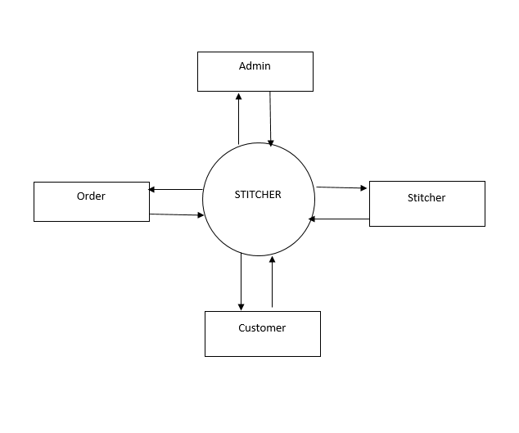
Figure 4. 1 Context Diagram

4.2 Use Case Diagram
Use-case diagrams describe the high-level functions and scope of a system. These diagrams also identify the interactions between the system and its actors. The use cases and actors in use-case diagrams describe what the system does and how the actors use it, but not how the system operates internally. Figure 4.2 shows the use case diagram.
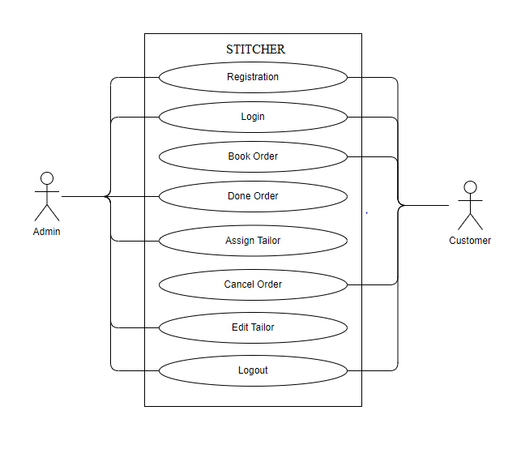
Figure 4. 2 Use Case Diagram

4.3 Activity / Sequence Diagram
In UML Sequence Diagrams are interaction diagrams that detail how operations are carried out. They capture the interaction between objects in the context of a collaboration. Sequence Diagrams are time focus and they show the order of the interaction visually by using the vertical axis of the diagram to represent time what messages are sent and when. Figure 4.3 shows the sequence diagram of and Stitcher Application.
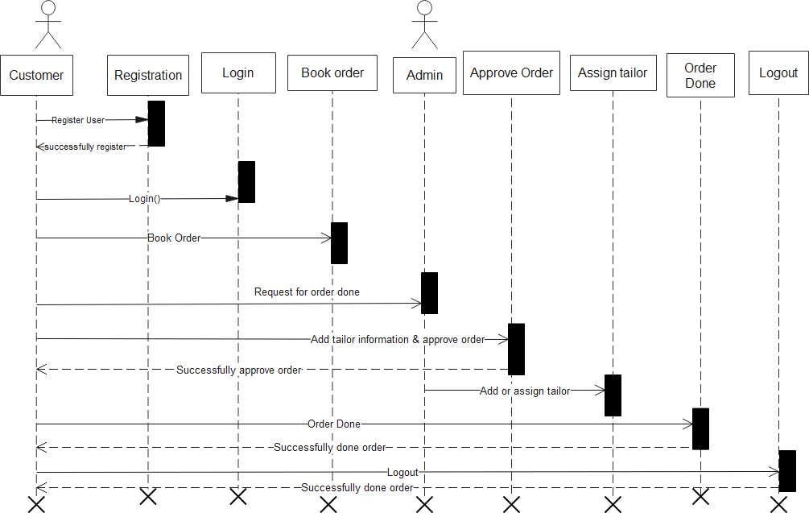
Figure 4. 3 Sequence Diagram

4.4 System Architecture
System architecture refers to the overall structure and design of a software system or application. It defines the arrangement of components, modules, and subsystems, as well as the interactions and relationships between them. The system architecture provides a blueprint that outlines how different parts of the system work together to achieve the desired functionality and performance. In a Stitcher Application, the system architecture defines how various modules and functionalities are organized and integrated to support the overall objectives of the system. The figure 4.4 shows the architecture diagram.
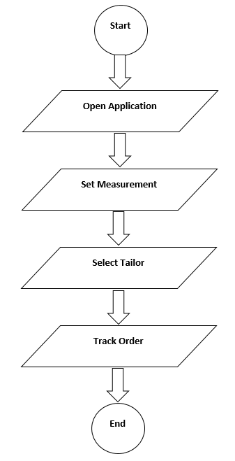
Figure 4. 4 System Architecture

4.5 Data Flow Diagram
A data flow is a representation of the data and relationships within a system. In a Stitcher, the data model typically includes entities such as customers, products, orders, and payments, as well as their relationships to each other. It also includes information about the attributes and constraints of each entity, such as customer name, product price, and order status. The data model is used to define the structure of the data and ensure consistency and integrity of the data within the system. The figure 4.5 shows DFD of our project.
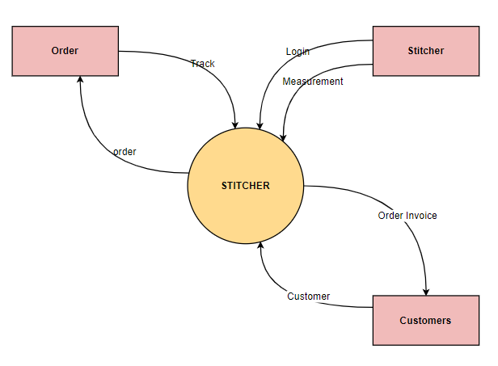
Figure 4. 5 Data Flow Diagram

2.6 Entity Relationship Diagram
An Entity-Relationship Diagram (ERD) is a visual representation that depicts the relationships between different entities in a database. It is a powerful tool used in database design and development to model the structure and relationships of data entities. In an ERD, entities are represented as rectangles, and the relationships between entities are depicted using lines connecting them. Each entity represents a specific object or concept in the database, such as a customer, order, or product. Relationships between entities illustrate how these objects are related to each other and provide insights into the data dependencies and associations within the database. The figure 4.6 shows the ERD of our proposed system.
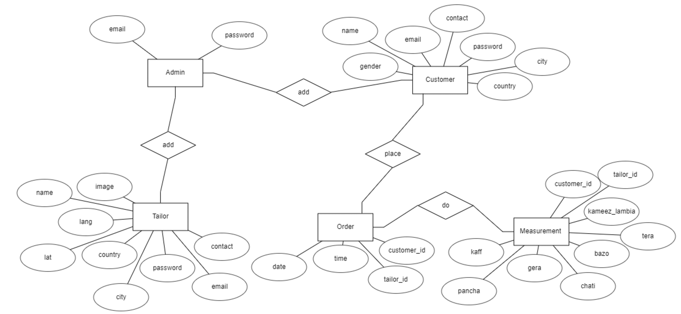
Figure 4. 6 ER Diagram

CHAPTER 5

IMPLEMENTATION AND TESTING
Implementation is the process of turning a software application's concept and specifications into a functional system. It entails writing code, creating the required elements and functionalities, integrating various modules, and setting up the system in accordance with the specifications. Developers construct the application using programming languages, frameworks, and tools in accordance with the requirements and design standards.

5.1 User Interfaces

5.1.1 Admin Login
The following are the login screen of admin. The screen appear to the admin when the admin open admin panel. The admin should require email, password to enter to the admin panel. Admin login screen are in the figure 5.1.
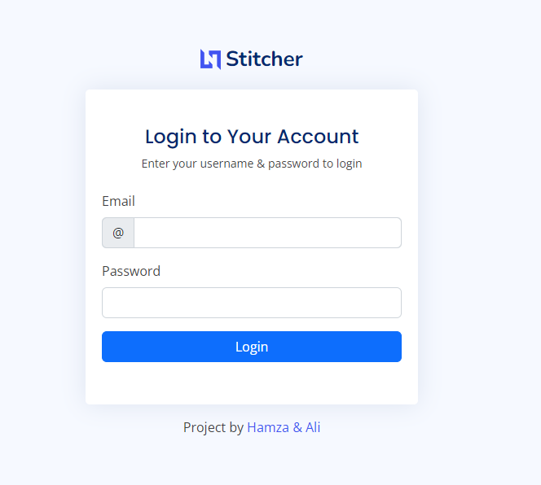
Figure 5. 1 Login Screen

5.1.2 Admin Dashboard
The following are the admin dashboard screen which show all the record to the admin. The screen shows the information about Customers, tailor, Expenses, Orders to the admin. Admin dashboard screen shows in the figure 5.2.
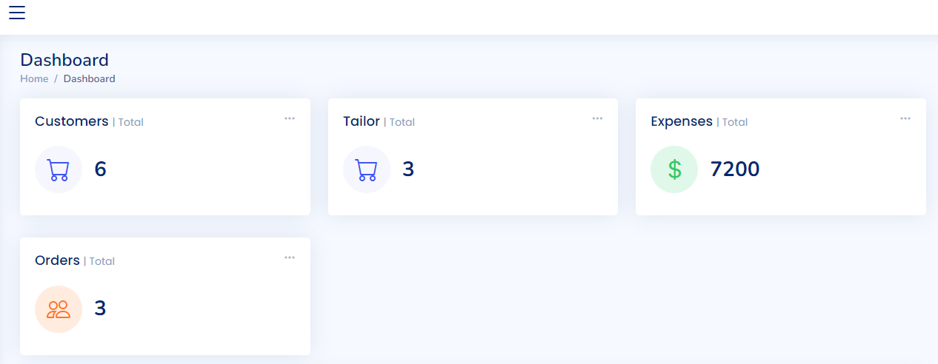
Figure 5. 2 Admin Dashboard

5.1.3 Tailor List
The following screen appear to the admin when the admin want to see all the tailor registered to the application. The admin also manage all the tailor record like add, update, delete etc. Figure 5.3 shown the tailor list screen.
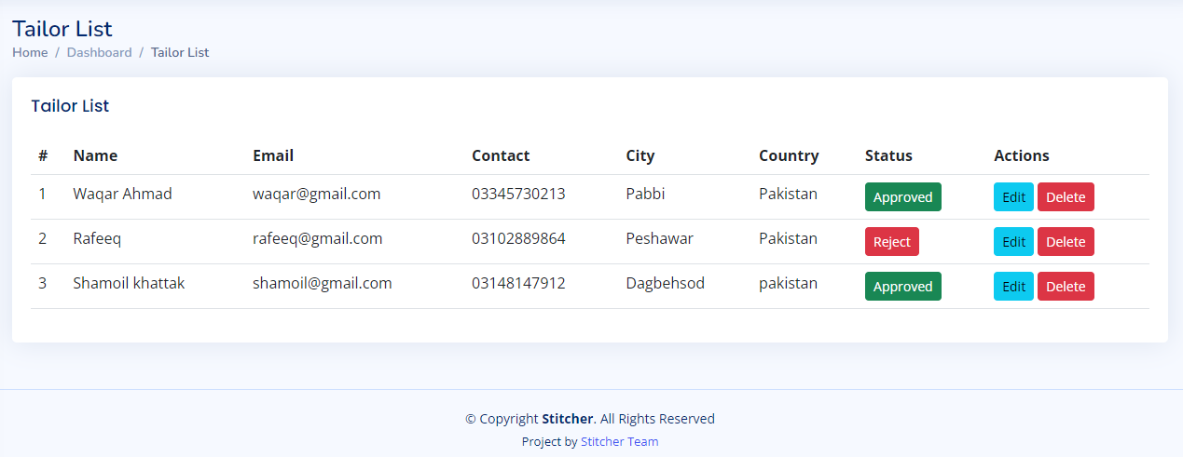
Figure 5. 3 Tailor List

5.1.4 Order List
The following figure are the order screen. The following screen appear to the tailor when he want to see all orders of customers. The order list screen are the follow. The figure 5.4 shows the order list screen.
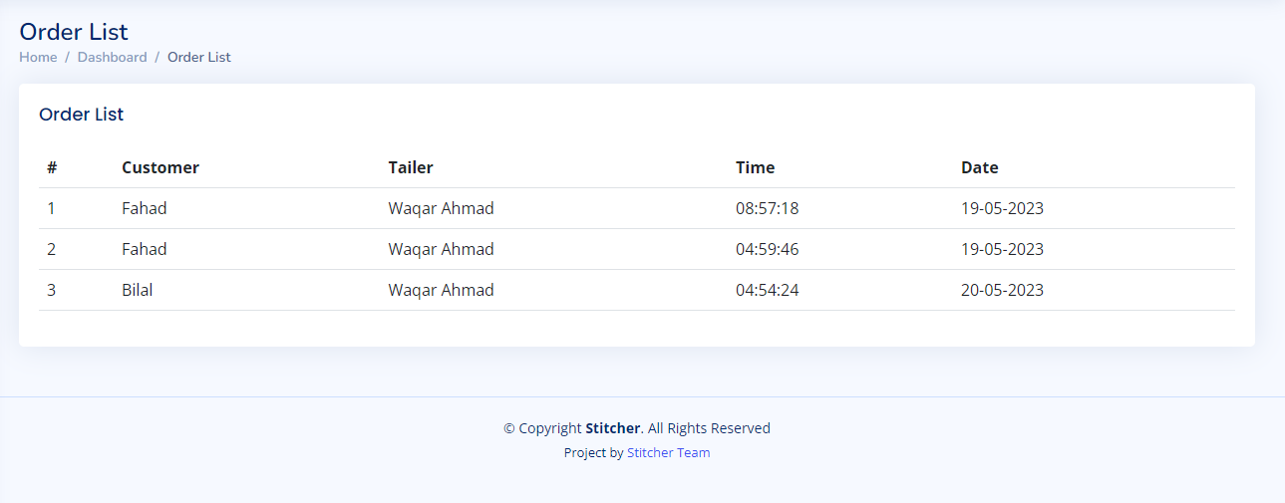
Figure 5. 4 Oder List

5.1.5 User / Customer List
The following are the customer list screen. The following screen shows the customer list to the admin which are registered to the application. The User list screen are the follow. The customer list screen are shown in the figure 5.5.
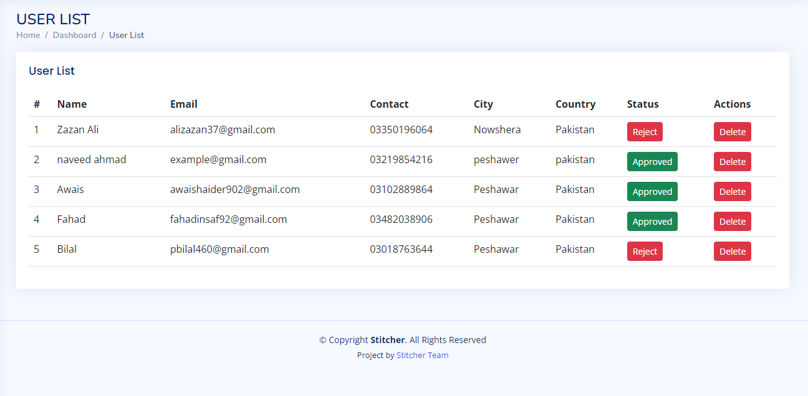
Figure 5. 5 User List

5.1.6 Expenses List
The following are the expenses list screen. The expense list screen show all the expenses done by tailor in the shop. The Expenses are shown with specific name, amount, details and date to the tailor. The Expense list screen are shown in the figure 5.6.
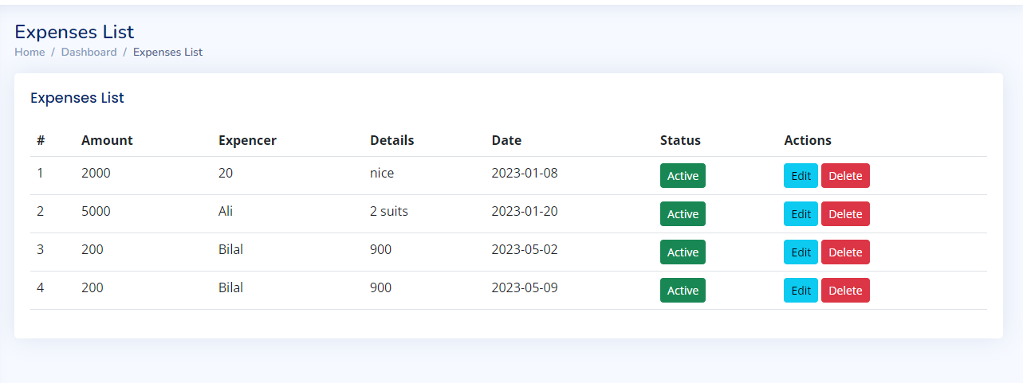
Figure 5. 6 Expenses List

5.1.7 User Login
The following are the user login screen. The following screen appear to the user when the user open the application. Every user must have to login or register himself before proceed to the application. The Figure 5.7 shows the user list screen.
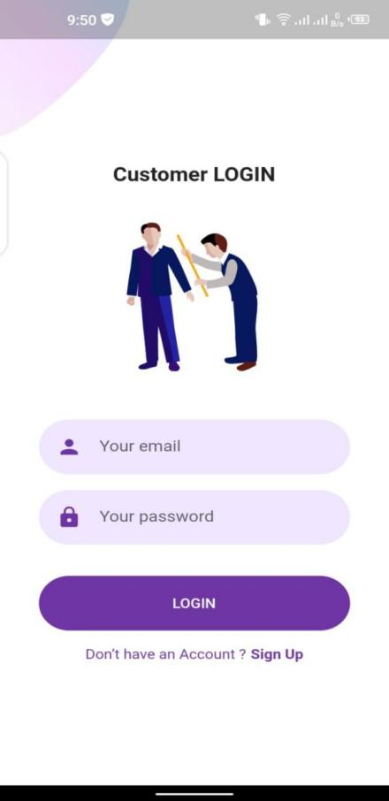
Figure 5. 7 Customer Login

5.1.8 Customer Dashboard
The customer dashboard of a tailor application serves as a centralized hub where customers can manage their tailoring orders, track progress, and communicate with the tailor. It provides a user-friendly interface that enhances the overall tailoring experience for customers. The figure 5.8 shows the customer list screen.
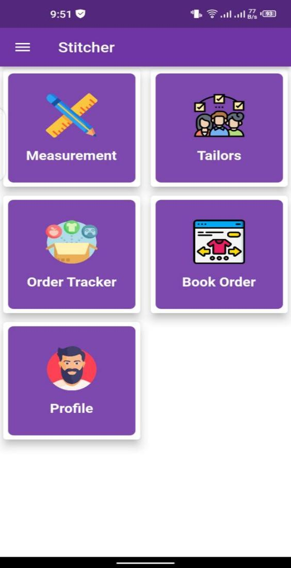
Figure 5. 8 Dashboard Screen

5.1.9 Order Screen
The order screen is a crucial component of a Stitcher application. It serves as the central hub for managing and tracking customer orders, facilitating seamless communication between the tailor and their clients. This screen provides an organized and efficient way to handle various aspects of the tailoring process, ensuring that orders are processed accurately and on time.
When accessing the order screen, the tailor is presented with a clean and intuitive user interface. The screen is typically divided into multiple sections to display different information related to orders. The order screen are shown in the figure 5.9.
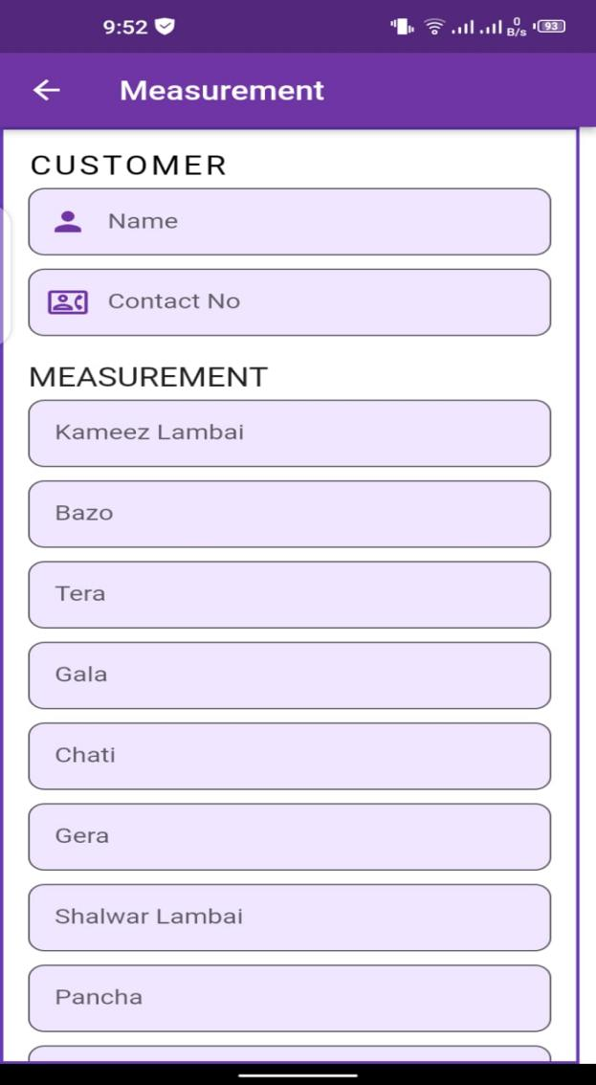
Figure 5. 9 Order Screen

5.1.10 Track Order
The track order feature in a tailor application provides customers with real-time updates on the status and progress of their tailored garments. It enables customers to stay informed about the various stages of the tailoring process and ensures transparency and accountability. The following figure 5.10 shows the track order screen.
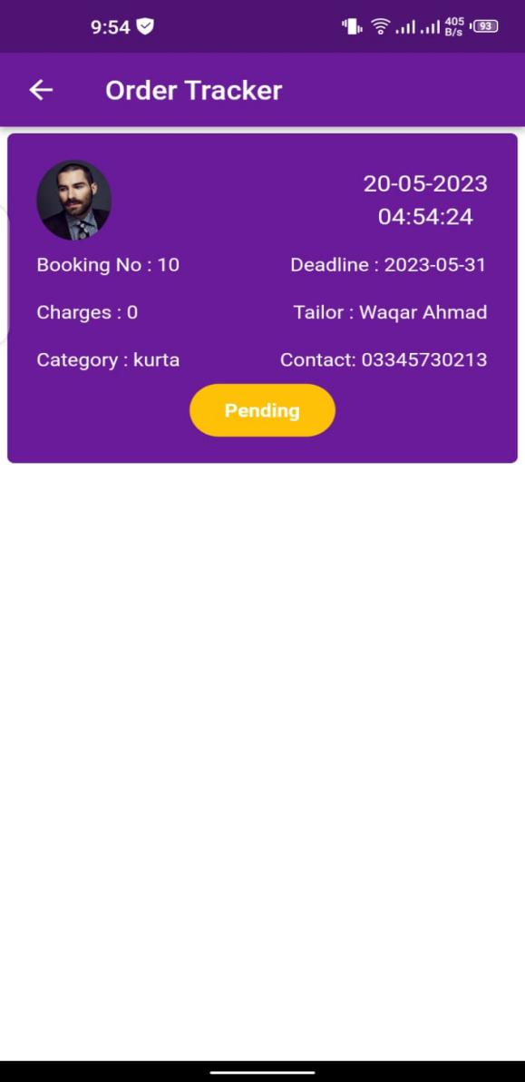
Figure 5. 10 Order Track Screen

5.1.11 Tailor List
The tailor list screen in a Stitcher application is a centralized and organized view that displays a list of tailors registered within the application. It serves as a directory or catalog of tailors, providing essential information about each tailor and facilitating seamless communication and collaboration between the application users and tailors. The tailor list screen are in the figure 5.11
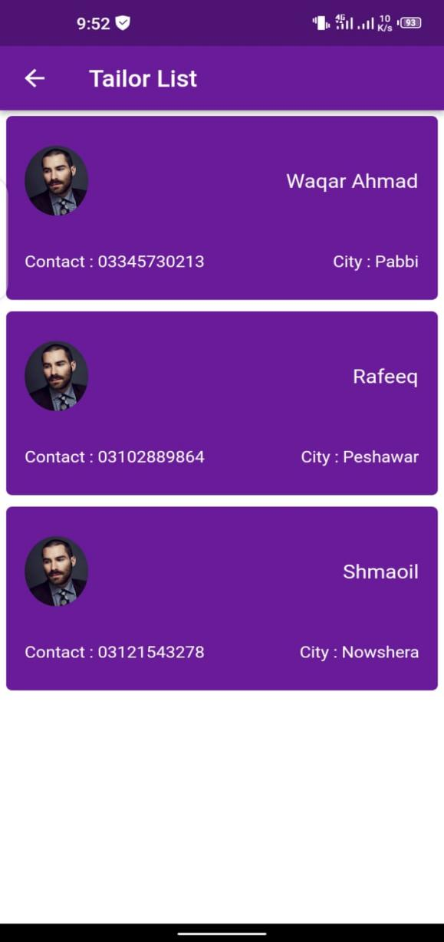
Figure 5. 11 Tailor List

5.2 Software Testing
Software testing is a systematic process of evaluating a software application or system to identify defects, errors, or discrepancies between expected and actual results. It involves verifying and validating that the software meets specified requirements and functions as intended. The primary objectives of software testing are to ensure the quality, reliability, and performance of the software, and to mitigate risks associated with using or deploying it. Through testing, developers and quality assurance professionals can uncover bugs, errors, and vulnerabilities, allowing for timely detection and resolution before the software is released to end-users [15].

5.2.1 Unit Testing
Unit testing is a type of software testing that focuses on testing individual units or components of a software application in isolation. A unit refers to the smallest testable part of the software, such as a function, method, or class.
The main goal of unit testing is to ensure that each unit of code functions correctly and performs as expected. By isolating units and testing them independently, developers can identify and fix defects early in the development process, improving the overall quality and reliability of the software. Unit testing table are shown in table 5.1.
Table 5. 1 Unit Testing
Unit Test Case | Description
createCustomerTest | Tests the creation of a new customer in the Stitcher Application, verifying that the customer is successfully added to the system.
createOrderTest | Tests the creation of a new order in the Stitcher Application, ensuring that the order is successfully added to the system.
calculatePriceTest | Tests the calculation of the price for a given order, verifying that the pricing logic, including fabric, measurements, and design, is accurate.
updateOrderTest | Tests the updating of an existing order, ensuring that the order details can be modified and saved correctly in the tailor management system.
deleteOrderTest | Tests the deletion of an order, verifying that the order is successfully removed from the system without any adverse effects.
trackOrderStatusTest | Tests the retrieval of order status, ensuring that the Stitcher Application accurately retrieves and displays the current status of an order.
generateReportsTest | Tests the generation of reports, such as order statistics, customer insights, or revenue analysis, ensuring that the reports are generated correctly.
createCustomerTest | Tests the creation of a new customer in the Stitcher Application, verifying that the customer is successfully added to the system.

This table provides a structure for documenting unit tests for a Transportation Management System (TMS). The test cases listed above are just placeholders and should be replaced with actual test cases specific to your TMS implementation. Additionally, you may include additional columns in the table to capture more information such as test data, test environment, and any comments or notes related to the test execution.

5.2.2 Integration Testing
Integration testing is a software testing technique that focuses on testing the interaction and integration between different components, modules, or subsystems of a software application. The purpose of integration testing is to verify that the combined units function correctly as a whole and to identify any issues that may arise due to the integration. Integration testing involves testing the interfaces, data flow, and communication between various components to ensure they work together seamlessly and produce the desired outcomes. It aims to uncover defects or inconsistencies that may occur when different units or modules interact, such as data mismatches, communication failures, or incompatible dependencies. The integration testing table are shown in Table 5.2.
Table 5. 2 Integration Testing
Test Case ID | Description | Description | Steps | Result | Pass/Fail
IT001 | Customer Creation Integration | Stitcher Application is running | 1. Create a new customer through the user interface. | The customer is successfully created and saved in the system. | Pass
IT002 | Order Creation Integration | Stitcher Application is running, customer exists | 1. Select a customer from the existing list.  2. Enter order details such as measurements, fabric, and design.  3. Save the order. | The order is successfully created and associated with the selected customer | Pass
IT003 | Invoice Generation Integration | Stitcher Application is running, order exists | 1. Select an existing order.  2. Generate an invoice for the order | An invoice is generated with accurate order and customer details. | Pass
IT004 | Inventory Management Integration | Stitcher Application is running | 1. Add a new fabric to the inventory.  2. Update the quantity of an existing fabric.  3. Remove a fabric from the inventory. | The inventory is updated accordingly with the new fabric added, quantity updated, and fabric removed. | Pass
IT005 | Reporting Integration | Tailor management system is running | 1. Generate a sales report for a specific time period.  2. Generate a customer report with filters. | The sales report and customer report are generated accurately based on the provided criteria. | Pass

The table typically includes a list of test scenarios or test cases that cover various aspects of integration between the TMS and other related systems, such as order management systems, carrier systems, warehouse management systems, or financial systems. Each test scenario represents a specific integration point or interaction between different modules or components of the TMS. For each test scenario, the Integration Testing Table provides details such as the test case ID, a brief description of the scenario, the systems or components involved, the expected input or data, the expected output or result, and any additional notes or requirements for the test execution. This information helps the testing team understand the purpose and scope of each integration test and ensures that all necessary checks are performed.

5.2.3 System Testing
System testing is a type of software testing that is performed to evaluate the behavior and functionality of a complete, integrated system. It is conducted on the entire system as a whole, rather than focusing on individual components or units. The main objective of system testing is to ensure that all the components of the system work together harmoniously and meet the specified requirements. It aims to identify any defects or inconsistencies in the system's behavior, performance, and functionality. During system testing, the software is tested in an environment that closely resembles the production environment to simulate real-world usage conditions. This includes testing interactions between different subsystems, verifying the system's ability to handle inputs and produce expected outputs, and assessing its compliance with functional and non-functional requirements. The System testing are shown in the Table 5.3.
Table 5. 3 System Testing
Test Case ID | Description | Test Steps | Result | Pass/Fail
ST001 | Customer Creation | . Access the system with valid credentials.  2. Navigate to the customer creation module.  3. Enter valid customer details and save. | The customer is successfully created and saved in the system. | Pass
ST002 | Order Creation | Access the system with valid credentials.  2. Navigate to the order creation module.  3. Select an existing customer.  4. Enter valid order details and save. | The order is successfully created and associated with the selected customer. | Pass
ST003 | Inventory Management | Access the system with valid credentials.  2. Navigate to the inventory management module.  3. Add a new fabric to the inventory.  4. Update the quantity of an existing fabric.  5. Remove a fabric from the inventory. | The inventory is updated accordingly with the new fabric added, quantity updated, and fabric removed. | Pass
ST004 | Reporting Functionality | Access the system with valid credentials.  2. Navigate to the reporting module.  3. Generate a sales report for a specific time period.  4. Generate a customer report with filters. | The sales report and customer report are generated accurately based on the provided criteria. | Pass

The table provides an overview of what each test case aims to verify, and the test steps outline the specific actions to be performed. The expected result specifies the desired outcome, and the pass/fail status indicates whether the test case passed or failed based on the actual outcome observed during testing.

CHAPTER 6

SUMMARY AND CONCLUSION

6.1 Summary
A software application developed expressly to meet the requirements of tailoring companies is known as Stitcher. It works as a thorough solution to automate and streamline many facets of running a tailor shop or business, such as customer administration, order monitoring, inventory control, and financial management. Tailors may effectively handle customer data, like as measurements, preferences, and order history, with the help of stitcher application. They can simply track orders, access and update customer profiles, and offer specialized services based on distinct consumer needs thanks to the system. This raises consumer satisfaction and promotes the development of lasting partnerships a crucial component of a tailor's business is order tracking, which a TMS streamlines by offering a centralized platform to track and handle orders from beginning to end. Tasks may be created and delegated, orders can be tracked, and reminders for crucial deadlines or milestones can be sent to tailors. This guarantees effective order processing, reduces errors, and aids in timely order delivery. An additional crucial component of a TMS is inventory control. It enables tailors to monitor their inventory of fabric, trims, and other materials to make sure they have what they need to complete orders. When stock levels are low, the system can provide warnings or messages, allowing for prompt restocking and preventing production delays.

6.2 Conclusion
In conclusion, the System has proven to be a highly effective approach to organizational management, particularly in the realm of manufacturing and production. Developed by Frederick Winslow Taylor in the late 19th and early 20th centuries, this system emphasizes the importance of standardization, efficiency, and the scientific analysis of work processes.
While some critics have argued that the System dehumanizes workers and reduces them to mere cogs in a machine, others have noted that it has helped organizations achieve remarkable gains in productivity and profitability. Moreover, modern variations of the system have incorporated elements of employee empowerment and engagement, while still adhering to the principles of efficiency and standardization.
Overall, the System remains a significant contribution to the field of organizational management, and its principles continue to inform many management practices today. As organizations continue to face the challenges of a rapidly changing business landscape, the enduring insights of Frederick Winslow Taylor may provide valuable guidance for achieving success in the years ahead.

REFERENCES

[1] | Smith, J., & Johnson, M. , "Tailor management system: An overview and analysis.," Journal of Fashion Technology & Textile Engineering, , pp. 145-156., 2020.
[2] | Williams, A., & Davis, S. , "Development and implementation of a cloud-based tailor management system for small businesses.," International Journal of Advanced Computer Science and Applications, pp. 320-333., 2019.
[3] | Brown, L., & Wilson, R. , " A mobile application for streamlining order management in a tailor shop.," Proceedings of the International Conference on Information Systems, pp. 78-89, 2018.
[4] | Lee, C., & Kim, H. , "Workflow optimization in a tailor management system using process mining techniques.," IEEE Transactions on Systems, Man, and Cybernetics: Systems, pp. 450-463., 2017.
[5] | Patel, R., et al. , "RFID-based inventory management system for tailor shops.," . IEEE International Conference on Industrial Technology, , pp. 689-694., 2016.
[6] | Kumar, S., & Gupta, P. , " Integration of artificial intelligence for pattern recognition in a tailor management system.," Expert Systems with Applications,, pp. 4168-4181., 2015.
[7] | Thompson, M., & Anderson, K. , " Enhancing customer experience through personalized recommendations in a tailor management system.," Journal of Retailing and Consumer Services, pp. 414-423, 2014.
[8] | Chen, B., & Nguyen, T., " Data analytics for demand forecasting in a tailor management system.," Decision Support Systems,, pp. 574-586., 2013.
[9] | Wilson, A., & Johnson, N., "A collaborative supply chain management system for the tailoring industry.," International Journal of Production Economics, , pp. 325-336., 2012.
[10] | S. e. a. Davis, "Intelligent decision support system for fabric selection in a tailor management system," Computers in Industry, p. 2019, 435-447..
[11] | Kim, D., & Park, S. , "Energy-efficient resource allocation in cloud-based tailor management systems.," Sustainable Computing: Informatics and Systems, , pp. 12-21, 2010.
[12] | Gupta, A., & Lee, L., "Secure authentication mechanisms for a tailor management system.," IEEE Transactions on Dependable and Secure Computing, , pp. 278-290, 2009.
[13] | Wilson, B., et al. , "Integration of blockchain technology for traceability in the tailoring supply chain.," Computers & Industrial Engineering,, pp. 876-889, 2008.
[14] | Nguyen, T., & Chen, C., "Optimization of scheduling algorithms for a tailor management system.," European Journal of Operational Research,, pp. 1415-1427, 2007.
[15] | Patel, K., et al. , "Real-time monitoring and control system for production workflow in a tailor management system.," International Journal of Production Research, , pp. 2739-2753, 2006.
[16] | A. Sutcliffe, "Requirements rationales: integrating approaches to requirement analysis.," In Proceedings of the 1st conference on Designing interactive systems: processes, practices, methods, & techniques , 1995.

