SHOPSPHERE
E-Commerce Data Warehouse & Business Intelligence System
Project Report
BS Data Science
Quaid-e-Awam University of Engineering, Sciences and Technology (QUEST), Nawabshah
Department of Data Science
Prepared by: Naveed Ali Memon
Roll No.: 24DS03

1. Executive Summary
ShopSphere is an e-commerce Data Warehouse and Business Intelligence project designed to integrate data from multiple sources into a centralized analytical warehouse and then present business insights through SQL analysis and an interactive Power BI dashboard. The project combines an Olist-style PostgreSQL operational dataset with additional sales/marketing, delivery/support, and customer-risk data supplied in Excel, CSV, and JSON formats.
The warehouse uses a star-schema design with eight dimension tables and one central fact table. An ETL workflow was used to extract, clean, transform, map surrogate keys, handle missing external data through Unknown members, and load the final fact table into PostgreSQL. Power BI was then connected to the warehouse to create a four-page interactive dashboard.

2. Project Objectives
- Integrate heterogeneous e-commerce data from PostgreSQL, Excel, CSV, and JSON sources.
- Design and implement a centralized PostgreSQL data warehouse.
- Apply ETL processes for extraction, transformation, data cleaning, and loading.
- Implement a star schema suitable for analytical queries.
- Create business-oriented SQL queries for sales, customer, product, seller, payment, delivery, marketing, and risk analysis.
- Develop an interactive Power BI dashboard with KPIs, charts, and slicers.
- Demonstrate how a data warehouse can support business intelligence and decision-making.

3. System Architecture
The ShopSphere architecture follows the flow below:
- Source Systems → PostgreSQL/Olist, Excel, CSV, and JSON.
- ETL Layer → Python/Pandas-based extraction, cleaning, transformation, and key mapping.
- Data Warehouse → PostgreSQL database named shopsphere_dw.
- SQL Analysis → Business queries for KPIs and analytical insights.
- Business Intelligence → Power BI dashboard connected to the warehouse.

4. Data Sources
Source | Format | Main Data | Rows
Source 1 | PostgreSQL | Olist e-commerce operational data | Multiple tables
Source 2 | Excel | Sales, targets, discounts, marketing channels, campaign cost, segments | 1,000
Source 3 | CSV | Delivery days, shipping method, support tickets, satisfaction | 1,000
Source 4 | JSON | Fraud risk, returns, customer lifetime value, risk category | 1,000

4.1 Source 1 — Olist/PostgreSQL
The main operational source contains customers, orders, order items, payments, products, sellers, reviews, and product-category translation data.
Table | Row Count
customers | 99,441
orders | 99,441
order_items | 112,650
payments | 103,886
products | 32,951
sellers | 3,095
reviews | 99,224
categories | 71

5. Data Warehouse Design
The warehouse database is named shopsphere_dw and follows a star schema. The fact table stores transactional sales at the grain of one product item within an order. Surrogate keys connect the fact table to the dimensions.

5.1 Dimension Tables
- dim_customer — customer identity and geographic information.
- dim_product — product identity, category, and physical attributes.
- dim_seller — seller identity and location.
- dim_payment — payment type and installments.
- dim_date — calendar attributes including day, month, quarter, and year.
- dim_marketing — sales target, discount, channel, campaign cost, and customer segment.
- dim_delivery — delivery days, shipping method, support tickets, and satisfaction.
- dim_risk — fraud risk score, return flag, customer lifetime value, and risk category.

5.2 Fact Table
fact_sales contains the central measures and foreign keys. Key measures include price, freight value, quantity, and total amount. The table contains 112,650 rows after the ETL and warehouse load.

6. ETL Process
- Extract — Load the PostgreSQL source tables and external Excel, CSV, and JSON files.
- Transform — Standardize columns and data types, clean missing values, aggregate payment information, and prepare business keys.
- Integrate — Match the external sources using order_id.
- Map — Convert business keys to warehouse surrogate keys.
- Handle Missing External Data — Use Unknown dimension members where external sample data is not available for a fact row.
- Load — Insert dimension records first and then load fact_sales.
- Validate — Check row counts, total sales, quantity, and foreign-key integrity.

6.1 ETL Validation Results
Validation Metric | Result
Fact rows | 112,650
Unique orders | 98,666
Total quantity | 112,650
Total sales | 15,843,553.24
Missing customer foreign keys | 0
Missing product foreign keys | 0
Missing seller foreign keys | 0
Missing date foreign keys | 0
Missing payment foreign keys | 0
Missing marketing foreign keys | 0
Missing delivery foreign keys | 0
Missing risk foreign keys | 0

7. SQL Business Analysis
Business-oriented SQL queries were created on top of the warehouse schema. The queries demonstrate how dimensional data can be joined with the fact table to answer common analytical questions.
Analysis | Key Result
Overall KPIs | Total Sales: 15,843,553.24; Total Orders: 98,666; Total Items: 112,650; Average Order Value: 160.58.
Sales by Category | The highest observed category sales include beleza_saude, relogios_presentes, cama_mesa_banho, esporte_lazer, and informatica_acessorios.
Monthly Sales Trend | Sales generally increase through 2017 and 2018, with April 2018 showing 1,159,698.04 in the analyzed result. September 2018 is very low and may represent an incomplete final period.
Sales by State | SP has 5,921,678.12 in sales in the analyzed warehouse result, followed by RJ and MG.
Top Customers | The analysis identifies the highest-sales customers and their cities/states.
Top Products | The analysis identifies products with the highest sales and quantities.
Seller Performance | The analysis identifies sellers with the highest sales and item volumes.
Payment Methods | Credit card accounts for the largest observed sales volume, followed by boleto, voucher, and debit card.
Marketing Channels | The sample-linked analysis covers Email, Google, Instagram, and Facebook across 1,000 sampled orders.
Delivery & Support | Shipping methods were compared using order counts, average delivery days, customer satisfaction, and support tickets.
Customer Risk | High, Medium, and Low risk categories were compared using risk score, returns, and customer lifetime value.

8. Power BI Dashboard
Power BI was connected directly to the PostgreSQL shopsphere_dw database. The model contains the fact table and eight dimensions with one-to-many relationships from dimensions to fact_sales.

8.1 Dashboard Pages
Page 1 — Executive Overview
- Total Sales
- Total Orders
- Total Customers
- Average Order Value
- Monthly Sales Trend
- Sales by Category
- Sales by State
- Sales by Payment Method
- Month and Year slicers
Page 2 — Customer & Product
- Top 10 Customers by Sales
- Top 10 Products by Sales
- Top 10 Sellers by Sales
- Sales by Customer Segment
Page 3 — Operations
- Orders by Shipping Method
- Average Delivery Days by Shipping Method
- Average Customer Satisfaction by Shipping Method
- Support Tickets by Shipping Method
- Average Customer Satisfaction gauge
Page 4 — Marketing & Risk
- Sales by Marketing Channel
- Campaign Cost by Marketing Channel
- Orders by Risk Category
- Fraud Risk Score vs Customer Lifetime Value
- Returns by Risk Category

8.2 Dashboard Preview
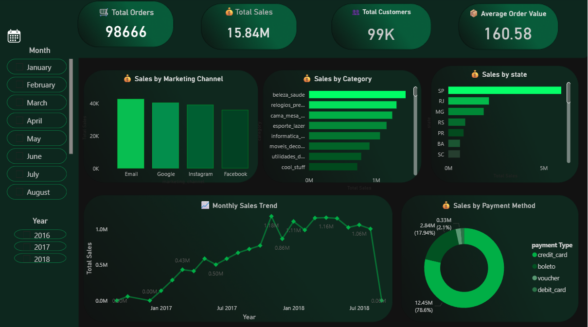
Figure 1. ShopSphere Executive Overview dashboard Page.
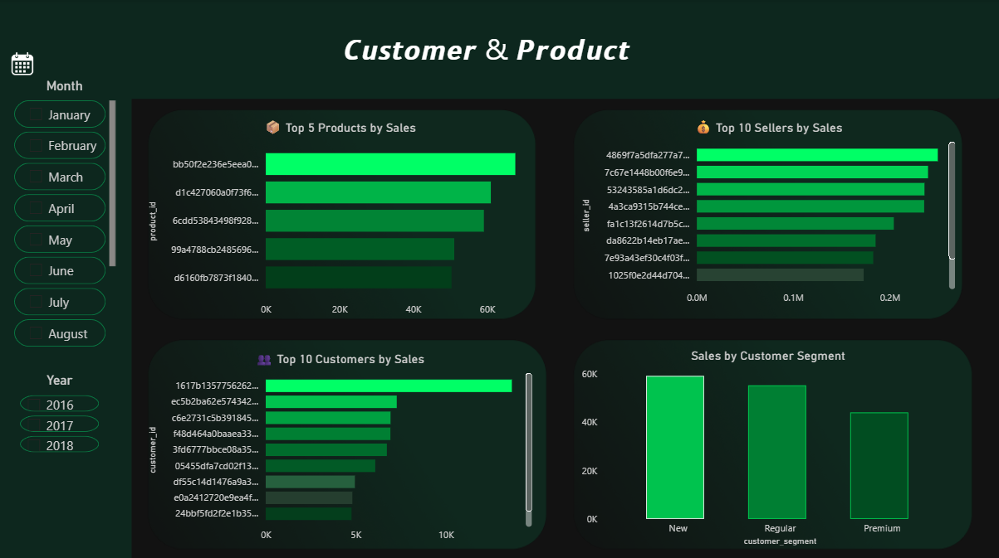
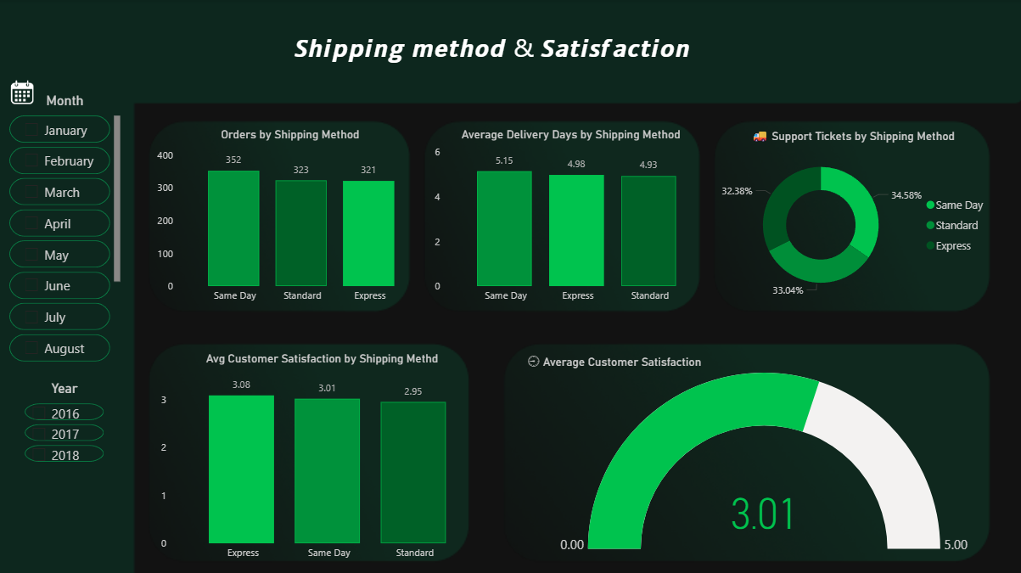

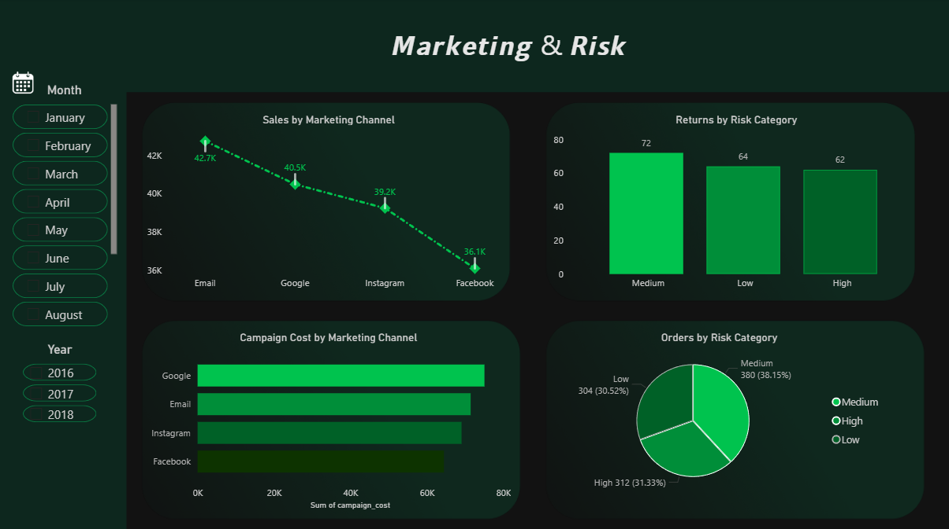

8.3 Main Power BI Measures
- Total Sales = SUM(fact_sales[total_amount])
- Total Orders = DISTINCTCOUNT(fact_sales[order_id])
- Total Items = SUM(fact_sales[quantity])
- Average Order Value = Total Sales / Total Orders
- Total Freight = SUM(fact_sales[freight_value])
- Average Freight per Order = Total Freight / Total Orders
- Total Sales LY = CALCULATE(Total Sales, SAMEPERIODLASTYEAR(dim_date[full_date]))
- Sales Growth % = (Total Sales - Total Sales LY) / Total Sales LY
- Average Sales per Item = Total Sales / Total Items
- Average Items per Order = Total Items / Total Orders
- Total Customers = DISTINCTCOUNT(fact_sales[customer_key])
- Average Sales per Customer = Total Sales / Total Customers

9. Limitations and Data Considerations
- The external Excel, CSV, and JSON sources contain 1,000 sampled order IDs each rather than complete warehouse coverage.
- These external sources map to 1,145 order-item rows in the fact table; the remaining fact rows use Unknown members for those external dimensions.
- Marketing, delivery/support, and risk visuals should therefore be interpreted as sample-linked analyses rather than full-population measurements.
- Campaign cost data is not sufficient by itself to establish profitability because complete revenue attribution and all relevant costs are not available.
- The final September 2018 sales value is very small relative to adjacent months and may reflect an incomplete period.

10. Conclusion
The ShopSphere project demonstrates a complete end-to-end Business Intelligence workflow: multi-source data integration, ETL, dimensional modeling, PostgreSQL data warehousing, SQL analytics, and interactive Power BI visualization. The completed warehouse contains validated fact and dimension data, while the dashboard converts the warehouse into business-oriented views covering sales, customers, products, operations, marketing, and risk.
The project provides a practical foundation for extending the system with additional data sources, more advanced KPIs, forecasting, customer segmentation, and automated ETL in future work.

11. Technologies Used
- PostgreSQL — operational/source database and data warehouse
- Python — ETL and data transformation
- Pandas — data manipulation
- Jupyter Notebook — ETL workflow
- SQL — warehouse analysis
- Power BI — interactive business intelligence dashboard
- Excel, CSV, JSON — external source formats

12. Appendix — Warehouse Tables
- dim_customer
- dim_product
- dim_seller
- dim_payment
- dim_date
- dim_marketing
- dim_delivery
- dim_risk
- fact_sales

