Welcome to IT Task Automation
ITTAU – IT Task Automation 1 · BTS · Lycée Guillaume Kroll
By the end of this week, you will be able to …
- explain what IT Task Automation is;
- identify repetitive tasks that could be automated;
- distinguish between a manual and an automated process;
- identify triggers and actions in simple automations;
- explain what a workflow is;
- design a simple automation workflow.
Welcome to ITTAU1
Every day, people perform repetitive tasks on computers. You download files, rename them, move data from one application to another, send similar emails, create reports or check whether something has changed. Many of these tasks can be performed manually.
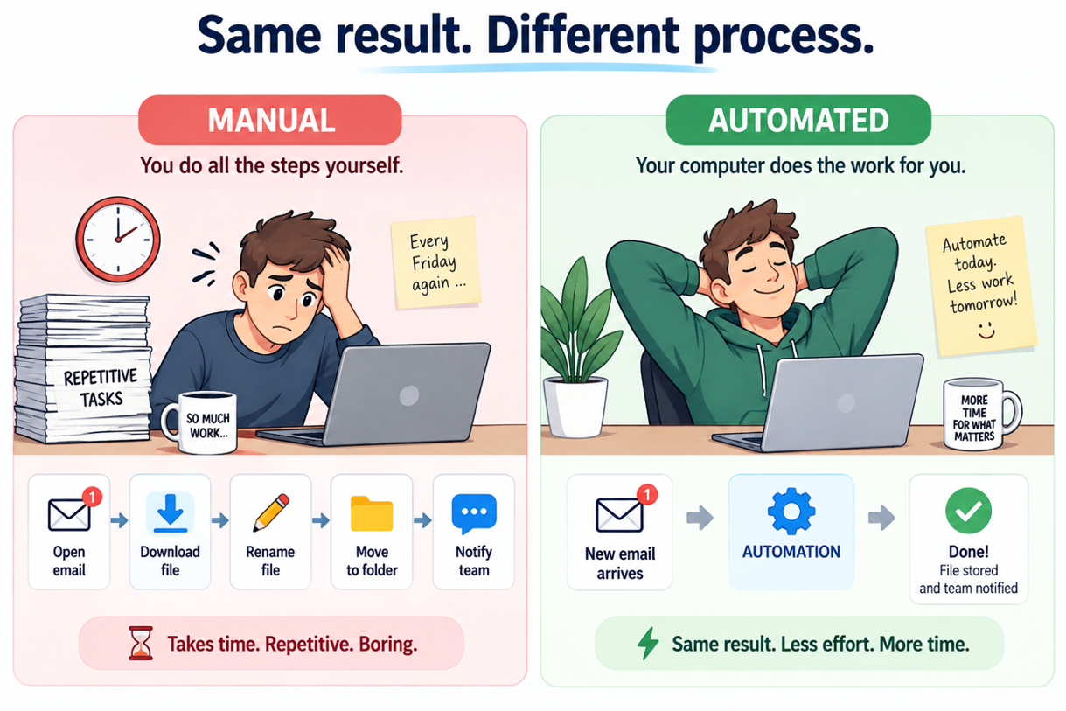
In ITTAU1 – IT Task Automation 1, you will learn how computers can perform repetitive and clearly defined tasks automatically.
During this course, you will not only learn how to use different tools. More importantly, you will learn how to analyse a process, break it down into individual steps and decide how it could be automated.
Automation starts with understanding the process
Before you can automate a task, you first need to understand what needs to happen, when it needs to happen and in which order.
Automation is all around you
Imagine the following situation:
Every Friday, you receive an email containing the latest sales report.
You must:
- open the email;
- download the attachment;
- rename the file;
- move it to the correct folder;
- inform your team that the new report is available.
The task itself is not difficult. But you perform the same steps every Friday.
What if your computer could do all of this for you?
A1 Repetitive Tasks
Work individually · 5 minutes.
Think about tasks you regularly perform in your daily life, studies, work or on your computer. Write down three repetitive tasks.
For each task, think about:
- What do you do?
- How often do you do it?
- Are the steps usually the same?
 | Task | How often? | Are the steps usually the same?
1 | Checking emails and replying to them | 5 days a week | ☐ Yes
2 | Doing homework’s and assignments | 5 days a week | ☐ No
3 | Organizing computer files | one’s a week | ☐ No

What is Task Automation?
Task Automation means using software to perform a task or a sequence of tasks automatically, with little or no manual intervention.
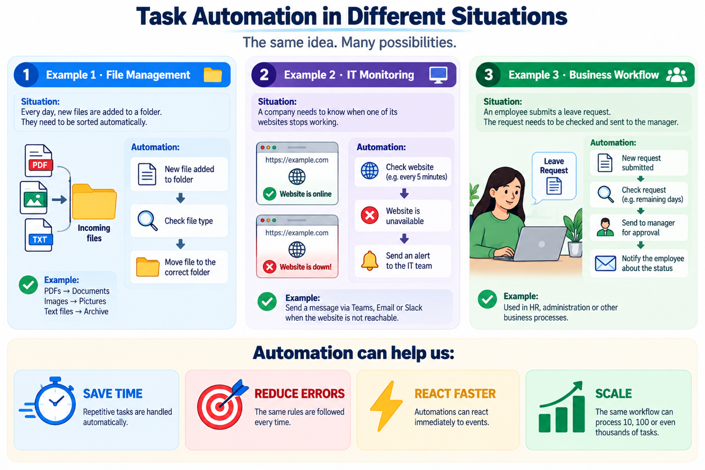

A computer does exactly what you tell it to do
Automation sounds simple: “Just let the computer do it.”
There is one problem.
A computer does not automatically understand what you mean. It needs clear and precise instructions.
A2 Automate the Teacher
Work in groups.
Imagine your teacher is now a computer.
Your task
- Your group will receive a simple action.
- Group 1 - Pack a laptop
Put the laptop into its protective laptop sleeve/case and close it.
- Group 2 - Prepare a glass of water
Fill a glass with water and place it on the table.
- Group 3 - Create a folder
Create a new folder called ITTAU1 in the Documents folder using File Explorer.
- Write precise step-by-step instructions that allow your teacher to perform the action successfully.
- Your instructions must be: CLEAR, PRECISE, ORDERED, UNAMBIGUOUS
- Afterwards, your teacher will try to follow your instructions exactly as written.
What did we learn?
- What problems occurred while the teacher was following the instructions?
Response ✏️:

- How could the instructions be improved?
Response ✏️:

💡 Remember
A computer cannot automate a process that has not been clearly defined.

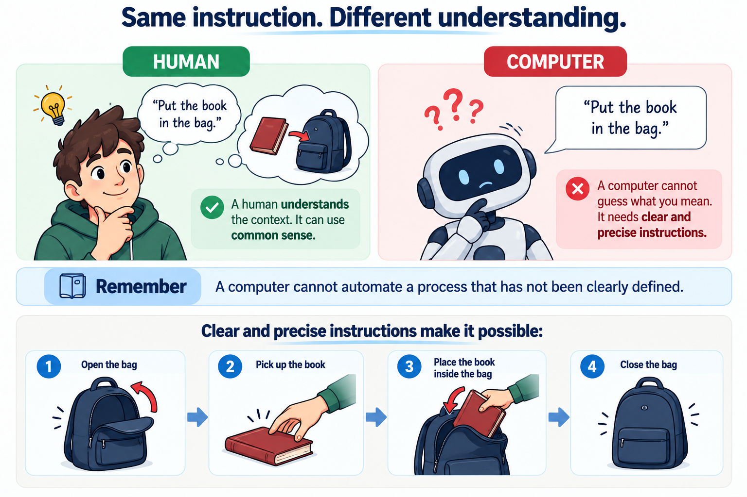

The Building Blocks of Automation
Now that we know that computers need clear instructions, we can look at how an automation is structured.
Three concepts are especially important:
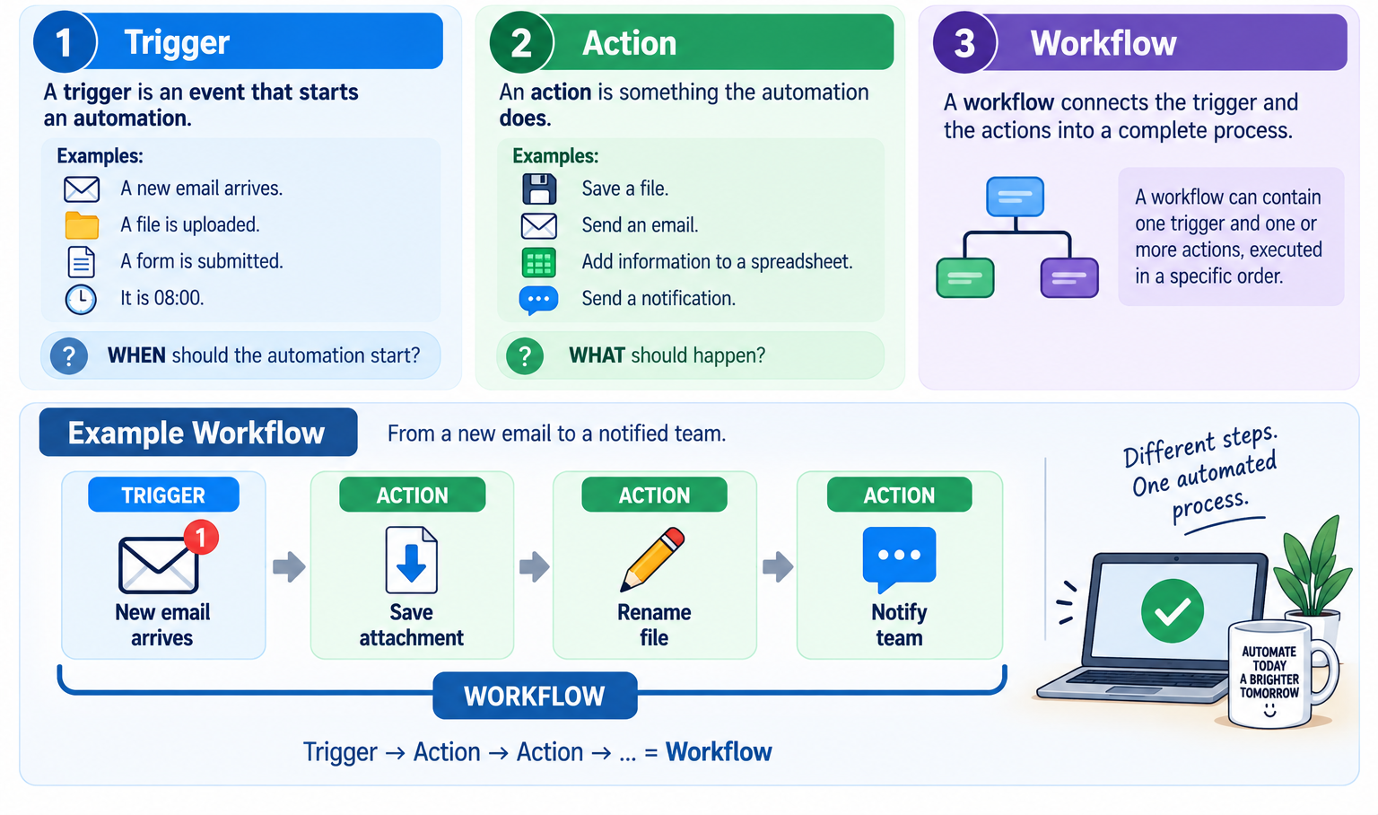
A3 Find the Trigger and Actions
Read each scenario and identify the trigger and the action(s).
- Scenario 1
A customer submits a contact form on a website. The information is saved and the sales team receives a notification.
Trigger ✏️: Submission on web
Action(s) ✏️: Sale team got notified and reviewed
- Scenario 2
A new file is uploaded to a shared folder. A backup copy of the file is automatically created.
Trigger ✏️: file uploading
Action(s) ✏️: Automatically creates a backup copy
- Scenario 3
New code is pushed to a GitHub repository. Automated tests are executed.
Trigger ✏️: Adding the new code
Action(s) ✏️: was automatically tested
Should we automate everything?
Automation can save a lot of time. However, not every task should be automated.
Imagine:
A task takes 10 minutes to complete manually. Creating the automation takes 10 hours. The task only needs to be performed once.
Was creating the automation worth it? Probably not.
On the other hand:
A task takes 10 minutes every day and will be performed hundreds of times. In that case, investing time in automation may make much more sense.
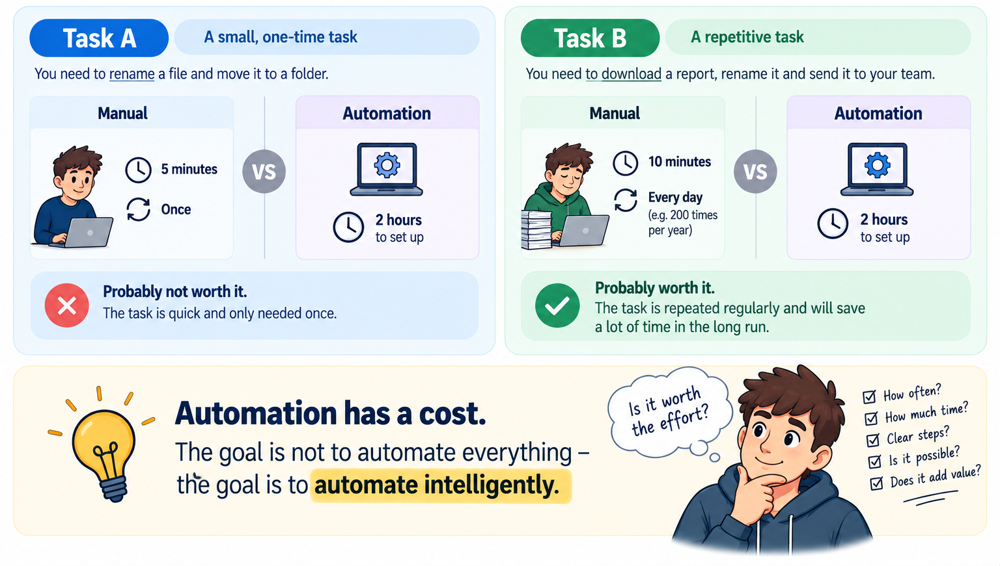
Where is automation used?
Automation is used in many different areas of IT.
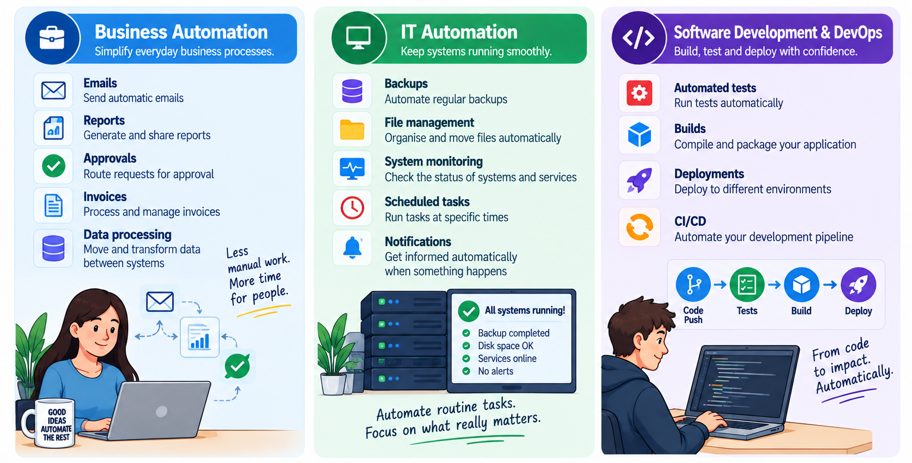
Your Journey through ITTAU1
Now you know what automation means.
During this course, we will gradually build the skills needed to create more advanced automations.
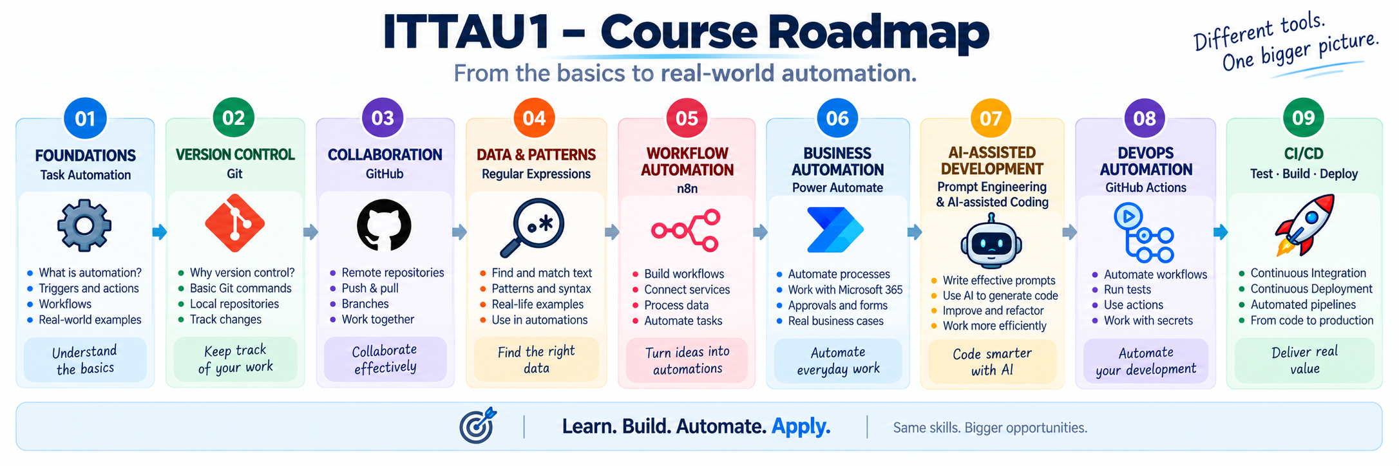
Homework - Design your first Workflow
Complete the following two tasks before the next session.
Homework 1 - Design your first Workflow
Return to the repetitive tasks you identified in A1.
Choose one task that you think could be automated.
Your goal is to transform your idea into your first automation workflow.
Deadline: Next session
Submission: EduMoodle
- What task would you like to automate?
Response ✏️:

- How is the task currently performed manually?
Describe the main steps.
Response ✏️:

- What could trigger the automation?
Trigger ✏️:

- What should happen automatically?
Action 1 ✏️:
Action 2 ✏️:
Action 3 ✏️:

- Create a clear and visually appealing diagram of your workflow.
Your diagram must show: TRIGGER → ACTION 1 → ACTION 2 → ACTION 3 → …
The steps must appear in the correct order.
You may use a diagramming tool or AI to help you create the visual representation.
Your submission should include:
☐ a clearly defined task;
☐ a trigger;
☐ all required actions;
☐ the correct order of the steps;
☐ a clear visual representation of the workflow.
Upload your completed work to EduMoodle before the next session.
Homework 2 - Prepare for Git & GitHub
Before the next session, watch the following chapter:
An Overview of Git and GitHub
Duration: 31 min 31 sec
You only need to watch this chapter. You do not need to watch any other chapters of the course.
The link is available on EduMoodle.
Important: Your goal is simply to watch the video and get a first overview of Git and GitHub.
You do not need to follow along with any practical exercises, install anything or try the commands yourself — even if the instructor in the video asks you to do so.

Check your Progress
Tick everything you feel confident about. If something is still unclear, ask about it at the beginning of the next session.
☐ I can explain what IT Task Automation means.
☐ I can identify the trigger of an automation.
☐ I can identify the actions of an automation.
☐ I can explain what a workflow is.

Next Session
You now understand the basic idea behind IT Task Automation and how a workflow is built.
Next, we will look at an important tool that will accompany us throughout the course: Git & Version Control
You will learn why developers need version control, how Git keeps track of changes and how we can use it to manage different versions of a project.
Next step: From automation concepts to version-controlled projects.

