Git and GitHub
ITTAU – IT Task Automation 1 · BTS · Lycée Guillaume Kroll
By the end of this week, you will be able to …
- explain the difference between Git and GitHub;
- create an empty GitHub repository;
- organise your ITTAU1 course documents;
- initialise a local Git repository;
- use git status, git add, git commit and git log;
- connect a local repository to GitHub;
- upload local commits with git push;
- follow the complete Git workflow.
Your ITTAU1 Course Repository
During this lesson, you will create a Git repository for your ITTAU1 course.
This repository will contain your:
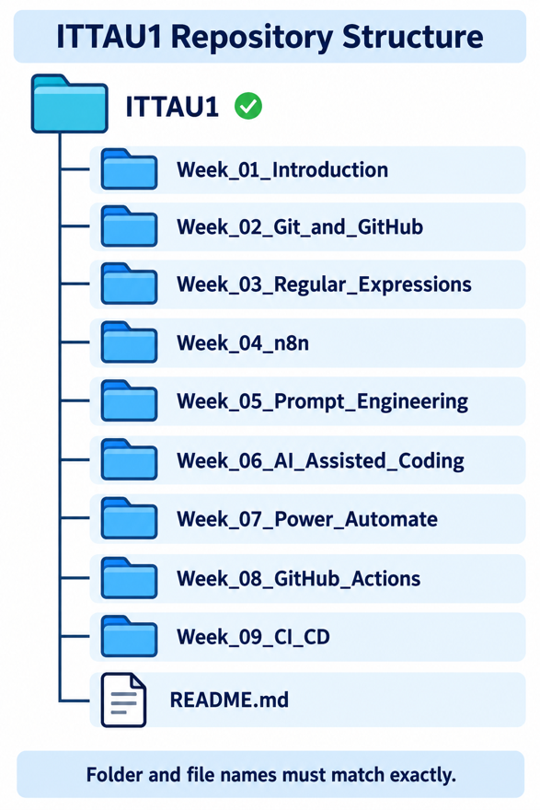
- course documents;
- exercises;
- practical work;
- notes;
- future automation projects.
Your repository will gradually contain the following structure. Look carefully at the folder names, because the same structure must be maintained throughout the semester.
From now on, you will regularly add new course documents to this repository.
Semester Assessment
Your repository structure will be checked at the end of the semester.
1 point: The complete structure is correct. All required folders and files are present, correctly named and stored in the correct location.
0 points: At least one required folder or file is missing, incorrectly named or stored in the wrong location.
There is no partial credit. The result is either 1 point or 0 points.
A1 Create Your GitHub Account
Work individually · approximately 15 minutes
- Open https://github.com
- Click Sign up.
- Create an account using your school email address. Make sure to use a secure password.
- Use your IAM username as your GitHub username. Your username will be visible to other GitHub users.
- Complete the verification and create the account.
- Open the confirmation email sent by GitHub and verify your email address.
- Sign in to your new GitHub account.
- (Optional) Open Settings → Password and authentication.
Activate two-factor authentication.
Download or copy your recovery codes. Store your recovery codes in a safe location. Never share them with anyone.
A2 Create an Empty GitHub Repository
Work individually · approximately 10 minutes
You will first create an empty online repository. Your local course documents will be uploaded to this repository later.
- Sign in to https://github.com.
- Select the plus icon in the top-right corner and choose New repository.
- Use the following settings:
  - Owner: your personal GitHub account
  - Repository name: ITTAU1
  - Description: Course documents and practical work for IT Task Automation 1
  - Visibility: Private
- Leave the following options unselected:
  - Add a README file
  - Add .gitignore
  - Choose a licence
- Select Create repository.
- Keep the repository page open. You will need its address later.
The Repository Must Be Empty
Do not add a README, .gitignore file or licence on GitHub.
The first files must come from your local computer through Git.
Checkpoint
Your repository address should look similar to: https://github.com/your-username/ITTAU1
The GitHub page should display the Quick setup section.
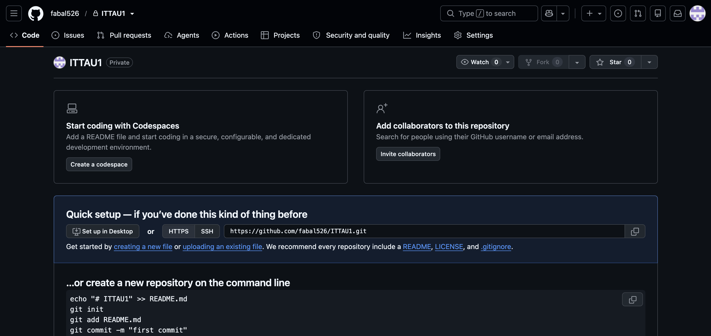

Git, GitHub and Repositories
Before working with Git commands, you need to understand where your files are stored and how Git and GitHub work together.
Study the following image. Pay particular attention to the difference between the local repository on your computer and the remote repository on GitHub.
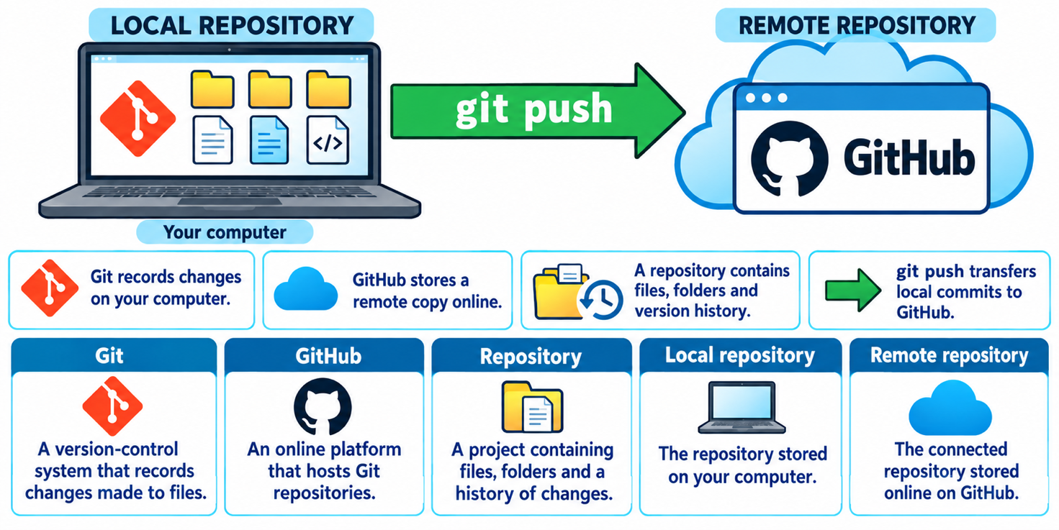

Git and GitHub Are Not the Same
Git is the version-control tool installed on your computer.
GitHub is an online service that hosts Git repositories.

A3 Create the Local Course Structure
Work individually · approximately 10 minutes
You will now create the local folders shown in the repository structure.
- Inside your Documents folder, create the following structure:
- Move your Week 1 course document into: Week_01_Introduction
- Save the current course document inside: Week_02_Git_and_GitHub

- Check the folder names carefully.
The names must be written exactly as shown. Do not add spaces or change the use of capital letters.
A4 Open the Project in the Terminal
Work individually · approximately 10 minutes
- Open the ITTAU1 folder in File Explorer.
- Right-click inside the folder and select Open in Terminal or Open Git Bash here.
- Display your current location: pwd
- Display the contents of the folder: ls
Correct Folder
Before entering Git commands, verify that the terminal is inside the ITTAU1 folder.
Running Git commands in the wrong folder can create a repository in the wrong location.
A5 Check and Configure Git
Work individually · approximately 5 minutes
- Check whether Git is installed: git -–version
- Configure your real name: git config --global user.name "Firstname Lastname"
- Configure your school email address: git config --global user.email your-school-email@example.com
- Verify the configuration:
git config --global user.name
git config --global user.email
Commit Identity
Git stores your configured name and email address inside every commit.
Use your real name and your school email address. Do not copy the example values without replacing them.
A6 Initialise the Local Repository
Work individually · approximately 5 minutes
Make sure that the terminal is still inside the ITTAU1 folder.
- Initialise the repository: git init
- Check the repository: git status
The .git Folder
git init creates a hidden folder named .git.
This folder contains the repository history and configuration. Do not delete or edit it manually.
The Git Workflow
Creating or changing a file does not immediately add it to the Git history. A change passes through three different areas before it becomes a saved version.
Study the following workflow before continuing with the practical exercises.
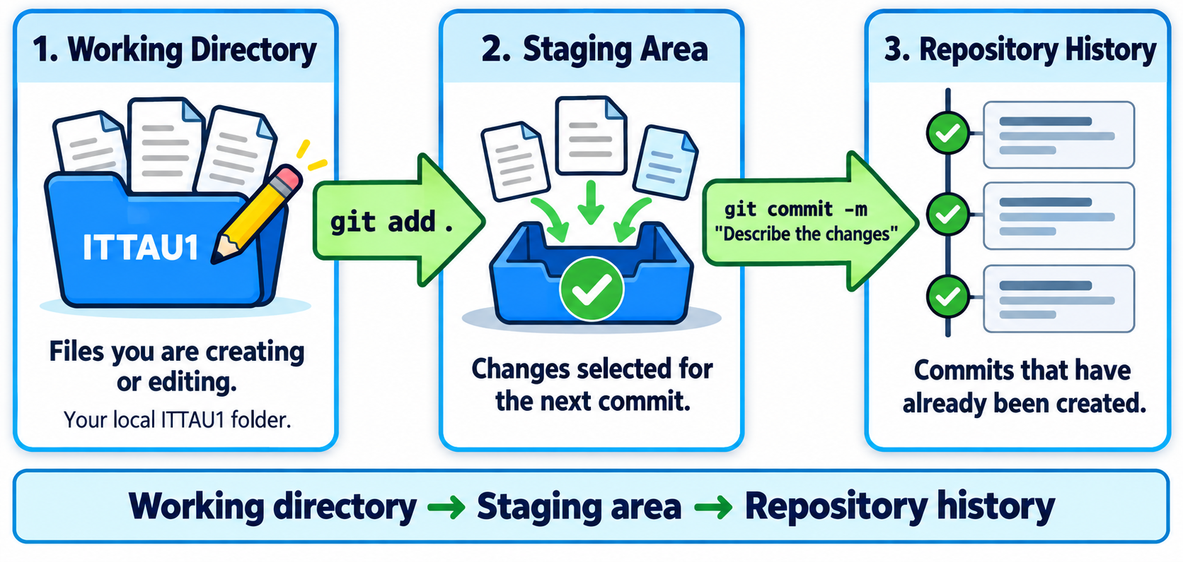
A7 Add the Course Documents
Work individually · approximately 5 minutes
- Examine the repository: git status
The documents should appear under Untracked files.
- Add all current files to the staging area: git add .
The dot means all changes inside the current folder and its subfolders.
- Examine the repository again: git status
The files should now appear under Changes to be committed.
git add Does Not Create a Commit
git add only selects changes for the next commit.
The changes are saved in the repository history only after you use git commit.

Important Git Commands
You will repeatedly use the following four commands during this lesson and throughout the course.
Study what each command does before using it in the next exercise.
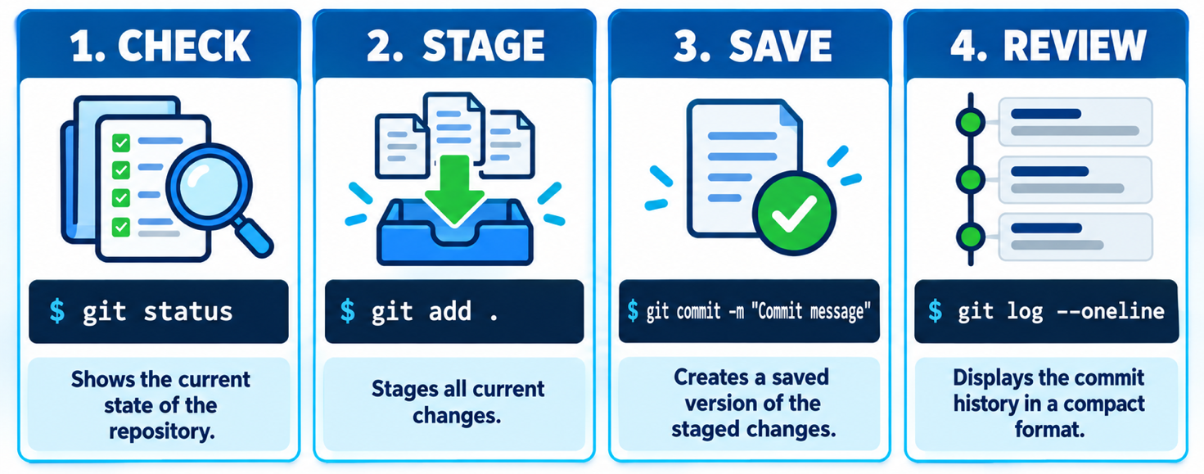
A8 Create Your First Commit
Work individually · approximately 10 minutes
- Create the first commit: git commit -m "Add Week 1 and Week 2 course documents"
Git saves the staged files in the repository history.
- Check the repository: git status
Git should display “nothing to commit, working tree clean”.
- Display the commit history: git log --oneline
You should see your first commit and its message.
What Is a Commit?
A commit is a saved version of a project.
A commit contains:
- the changed files;
- the author’s name;
- the date and time;
- a unique identifier;
- a message explaining the change.

Writing Good Commit Messages
Every commit includes a short message explaining what changed. Clear messages make the repository history easier to understand.
Compare the good and poor examples in the following image.
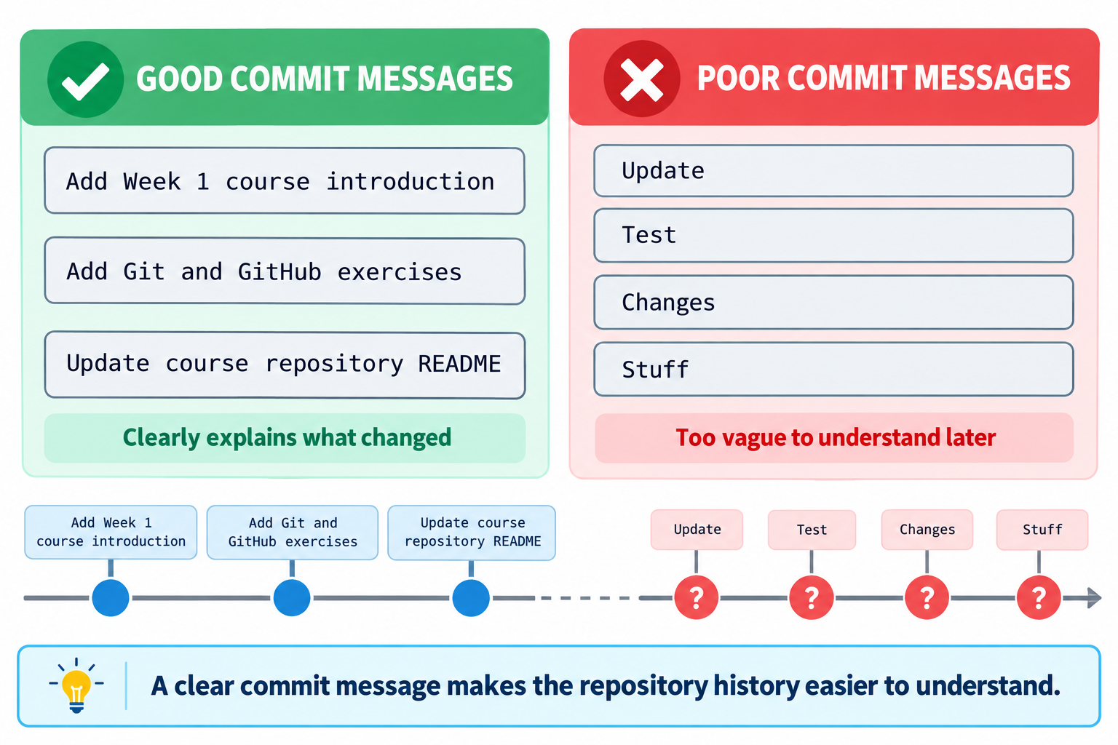
Commit Message Rule
A good commit message briefly explains what changed.
Start with a clear action such as:
- Add
- Update
- Fix
- Remove
- Rename

Connecting Git to GitHub
Your local repository and your GitHub repository currently exist separately.
Before uploading your commits, you must connect them.
Remote
A remote is an online version of a Git repository.
The conventional name of the main remote is: origin
Main branch
A branch is a line of development inside a repository.
The main branch is normally named: main
Repository address
Git uses the repository address to communicate with GitHub.
An HTTPS address looks similar to: https://github.com/your-username/ITTAU1.git
A9 Connect the Local Repository to GitHub
Work individually · approximately 10 minutes
- Return to your empty ITTAU1 repository on GitHub.
- In the Quick setup section, select HTTPS and copy the repository address.
- Return to the terminal.
- Rename the current branch to main: git branch -M main
- Connect the local repository to GitHub: git remote add origin https://github.com/your-username/ITTAU1.git
Replace your-username with your actual GitHub username.
- Verify the connection: git remote -v
The repository address should appear twice:
origin https://github.com/your-username/ITTAU1.git (fetch)
origin https://github.com/your-username/ITTAU1.git (push)
A10 GitHub Authentication
Before uploading files for the first time, you may need to authenticate the terminal with your GitHub account.
GitHub does not accept your normal account password for Git operations.
- Check whether GitHub CLI is installed: gh -–version
- If the command is not recognised, inform your teacher.
- Authenticate your terminal: gh auth login
- Select the following options:
  - HTTPS
  - Yes, authenticate Git with your GitHub credentials
  - Login with a web browser
Follow the instructions displayed in the terminal. Return to the terminal after the browser confirms the authentication.
- Copy the temporary authentication code displayed in the terminal.
- Press Enter to open the GitHub authentication page.
- Paste the code into the browser and confirm the authentication.
- Return to the terminal after GitHub confirms that the authentication was successful.
What Is Push?
Your first commit currently exists only inside the local repository on your computer. It is not yet available on GitHub.
The following image explains how git push transfers commits from the local repository to the connected remote repository.
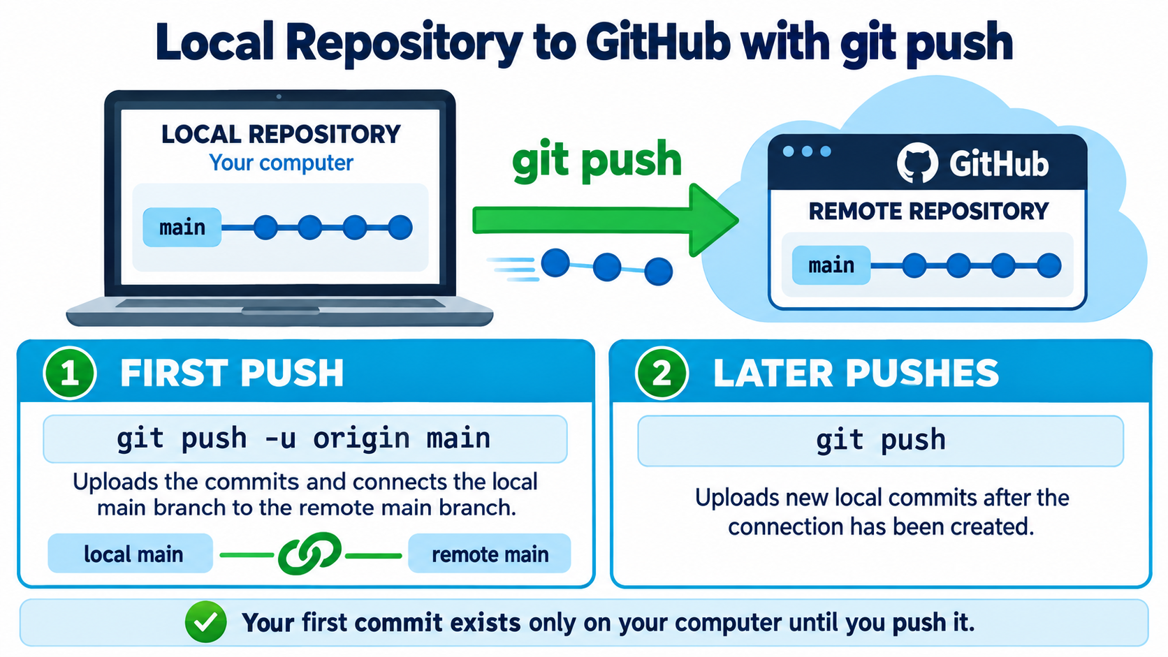
A10 Push the Course Documents to GitHub
Work individually · approximately 10 minutes
- Upload your first commit: git push -u origin main
- Return to your ITTAU1 repository on GitHub and refresh the page.
- Verify that these folders are visible:
Week_01_Introduction
Week_02_Git_and_GitHub
- Open both folders and verify that the correct documents are available.
- Open the repository’s commit history and find: Add Week 1 and Week 2 course documents
Create a README File
A repository should contain a short introduction explaining its purpose and contents. This information is normally stored in a file named README.md.
README files use Markdown, a simple language for formatting headings, lists, bold text and code.
Study the following examples before creating your own README file.
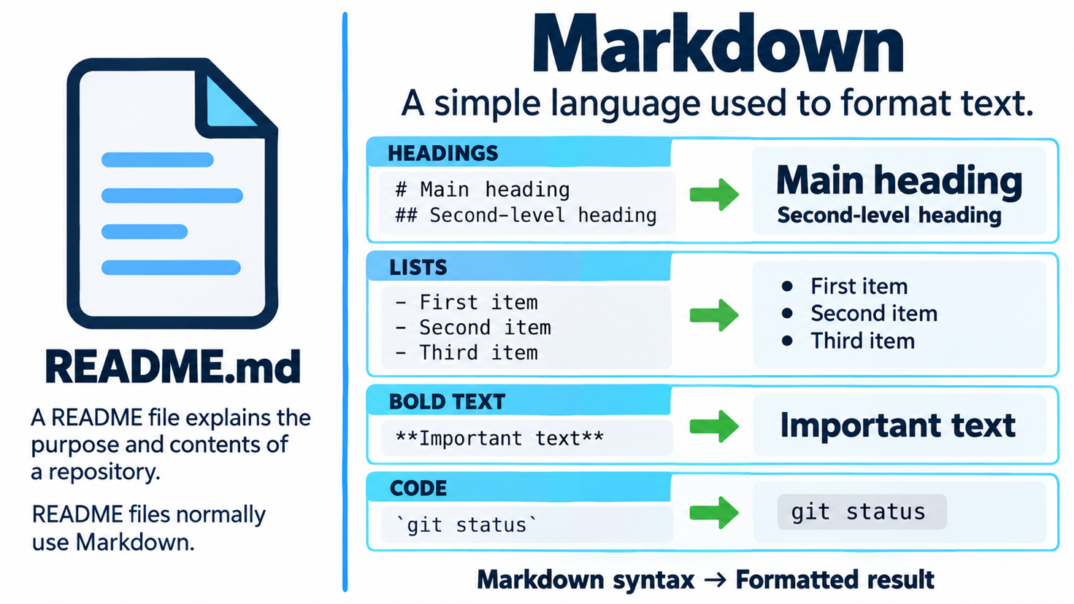
A11 Create the README File
Work individually · approximately 10 minutes
You will now create a README file locally and use the Git workflow to upload it to GitHub.
- Open the local ITTAU1 folder.
- Create a file named: README.md
- Open the file with Visual Studio Code or another text editor.
- Add the following content:
# ITTAU1 Course Repository

This repository contains my course documents and practical work for IT Task Automation 1.

## Course Content

- Week 1 - Introduction to IT Task Automation
- Week 2 - Git and GitHub

## Topics

During this course, we will work with:

- Git and GitHub
- Regular expressions
- n8n
- AI-assisted coding
- Prompt engineering
- Power Automate
- GitHub Actions
- CI/CD
- Save the file.
- Return to the terminal.
- Check the repository: git status
README.md should appear as an untracked file.
- Stage only the README file: git add README.md
- Check the repository again: git status
- Create a commit: git commit -m "Add course repository README"
- Upload the commit: git push
- Open your ITTAU1 repository on GitHub and refresh the page.
Verify that the README content appears on the main repository page.

The Complete Git Workflow
From now on, you must use the same workflow whenever you add or modify a course document.
Study the complete sequence carefully. You will apply it independently in the final challenge.
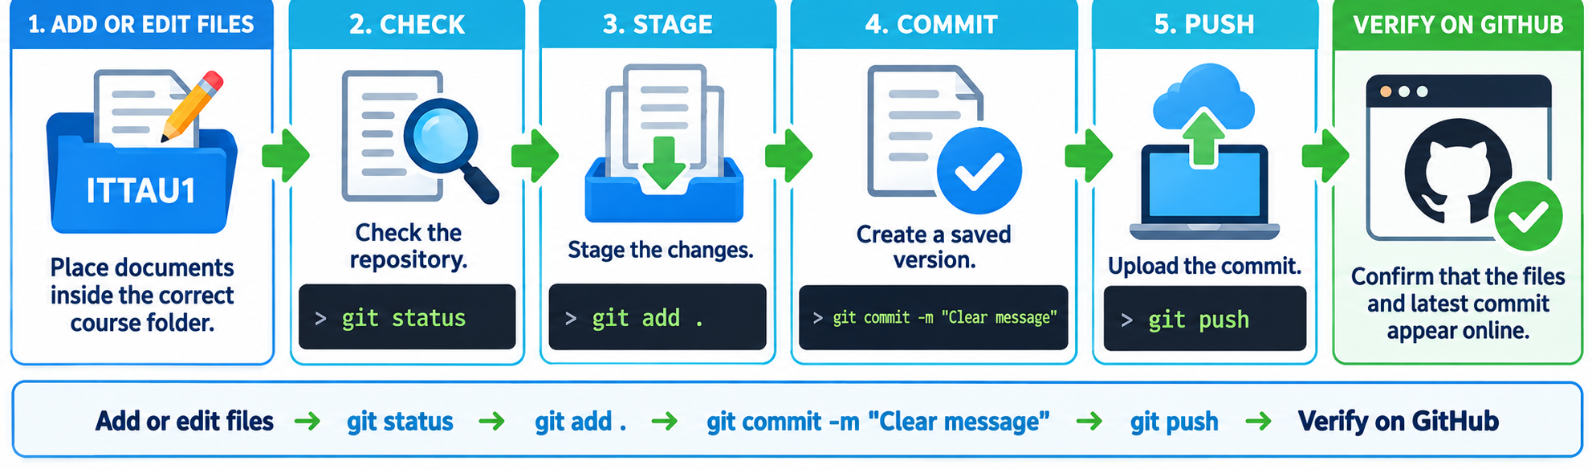
A12 Final Practical Challenge
Work individually · approximately 10 minutes
Complete this task as independently as possible. Use the workflow image if you need help, but do not copy commands without understanding them.
- Create a file named: git-notes.md
- Place the file inside: Week_02_Git_and_GitHub
- Add the following content:
# Git Notes

## Git

Git records changes made to files inside a repository.

## GitHub

GitHub hosts Git repositories online.

## Important Commands
- git status
- git add
- git commit
- git log
- git push

- Complete the Git workflow.
  - check the repository status;
  - stage the new file;
  - create a commit with a meaningful message;
  - upload the commit to GitHub.
- Open your repository on GitHub and confirm that:
  - git-notes.md is inside Week_02_Git_and_GitHub;
  - the file contains the correct Markdown content;
  - the latest commit has a meaningful message;
  - the complete folder structure is still correct.
Evidence
Take one screenshot showing:
- the repository name;
- the Week_02_Git_and_GitHub folder;
- the git-notes.md file;
- the latest commit message.
Paste the screenshot below and upload the same screenshot to Moodle.
Screenshot :

Check your Progress
Tick each statement that you can complete independently.
☐ I can explain the difference between Git and GitHub.
☐ I can explain the difference between a local and a remote repository.
☐ I can manage a local Git repository.
☐ I can connect it to GitHub and upload my work.
☐ I can verify my files and commits on GitHub.

Next Session
You have created a local Git repository, connected it to GitHub and uploaded your first course documents.
In the next session, you will continue working with Git and GitHub. You will practise retrieving changes, working with additional files and resolving common Git problems.
Next step: Continue managing a version-controlled course repository.

