Employee - User Manual
of
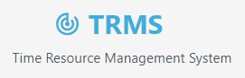
for


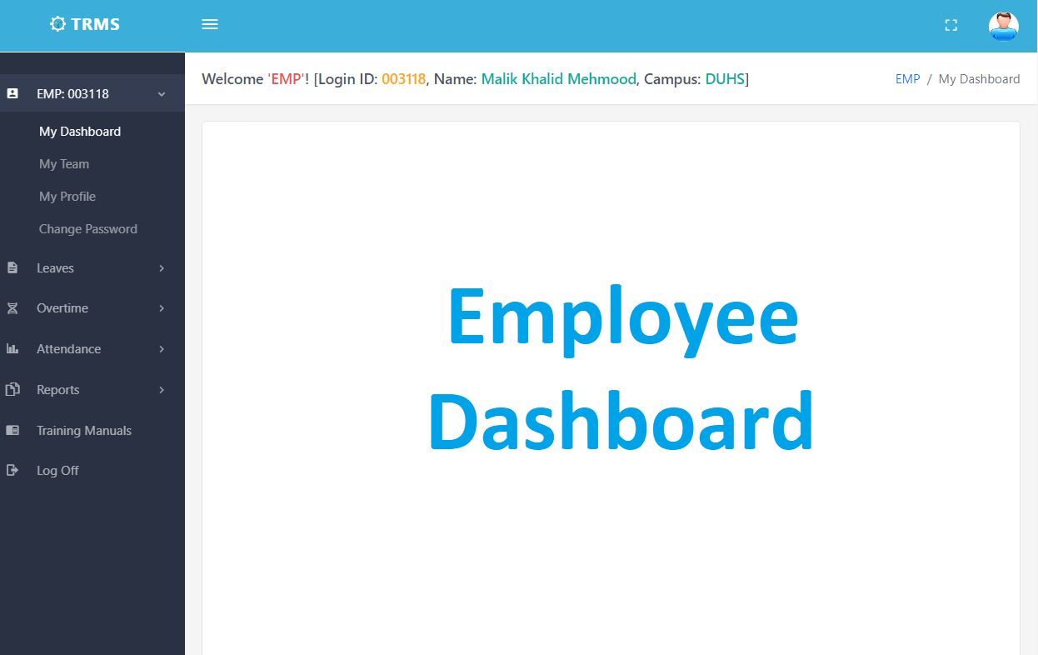
/Dashboard/Home | Screen Shot Detail (given in LEFT column)
In the top BLUE bar:
- On most LEFT, the TRMS logo is shown.
- Beside ‘Menu Icon’ is given which could be used to expand/collapse left side navigation
- On right, icons for FULL Screen, Notifications. Count for Incomplete Users & Leaves Approval and User Photo
- Welcome BAR shows Logged-In User Code, Name and Campus

Under HR Dashboard, the boxes shows logged-in User:
- Percentage for ‘Present’, ‘Leave’ and ‘Absent’
- Percentage for ‘Late’ and ‘Early Out’
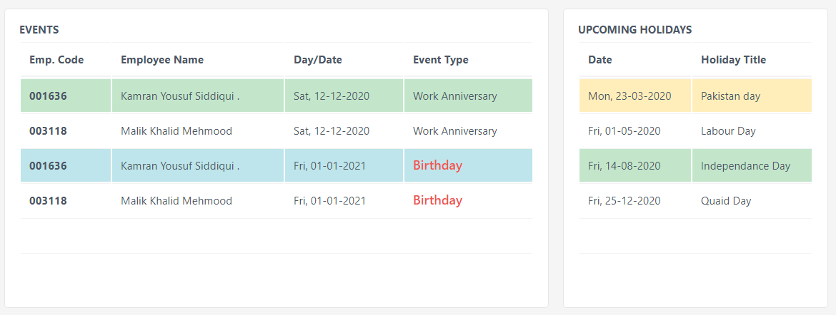 | ‘Events’ – Grid Block  - The Grid shows the list of Users  - Employee Code and Employee Name along with  - Date of Birth and Work Anniversary Event Type  ‘Upcoming Holidays’ - Grid Block  - Date with  - Gazatted Holidays
‘Leaves Summary’ – Column Chart Block
- Leaves Applied and Approval Status by Months

‘Presence’ – Pie Chart Block
- ‘Present’, ‘Leave’ and ‘Absent’ by Percentage

‘Punctuality’ – Pie Chart Block
- Showing ‘Late’ and ‘Early Out’ by Percentage

Footer shows the Year and Rights Reserved

/Dashboard/My Team | Screen Shot Detail (given in LEFT column)
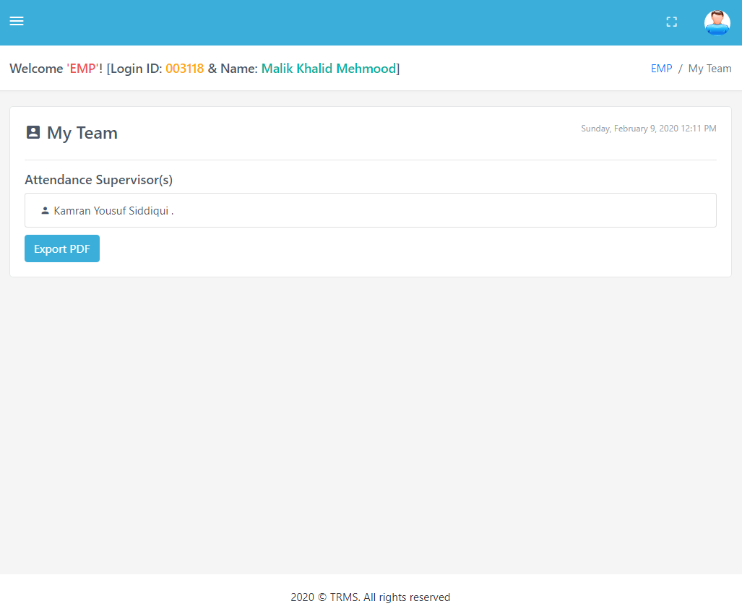 | Grid:  - Employee Name  - Export to PDF button

/Dashboard/User Profile
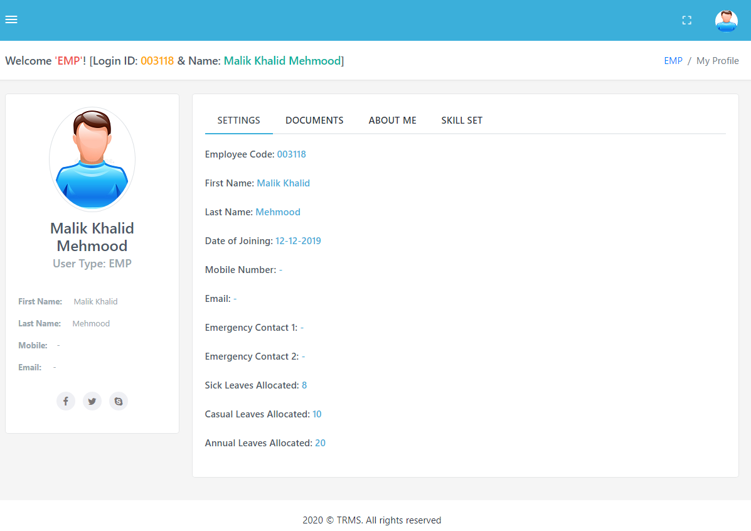 | In the top BLUE bar:  - On most LEFT, the TRMS logo beside that ‘Menu Icon’ given use to expand/collapse left-side ‘navigation menus-bar’  - On most Right, icons for FULL Screen, Count and User Photo  - Welcome BAR shows Logged-In User Code, Name and Campus  User Profile Tabs:  - SETTINGS  - DOCUMENTS  - ABOUT ME

/Dashboard/Change Password
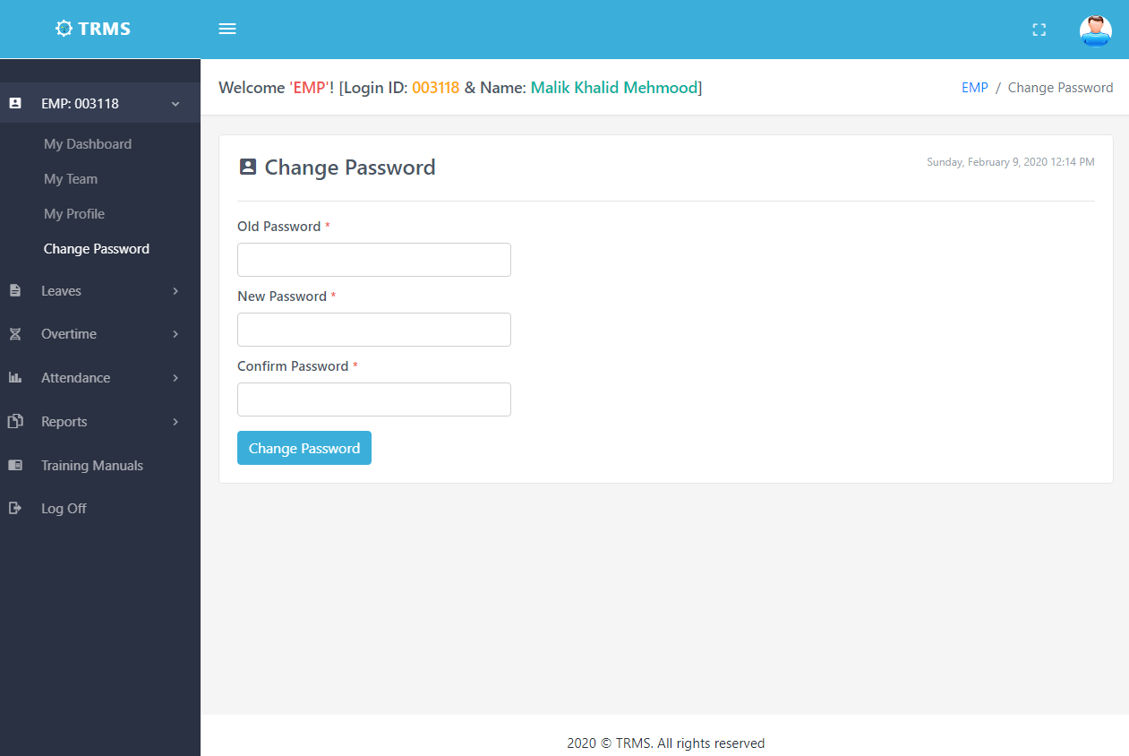
In the top BLUE bar:
- On most LEFT, the TRMS logo beside that ‘Menu Icon’ given use to expand/collapse left-side ‘navigation menus-bar’
- On most Right, icons for FULL Screen, Count and User Photo
- Welcome BAR shows Logged-In User Code, Name and Campus

Under Change Password Section, On submitting this Form, the logged-in ‘User’ can:
- Change its own current Password
- After Current Password and NEW Password Twice
- NEW Password must contains – At least ONE Upper, ONE Lower, ONE Numeric and a special character

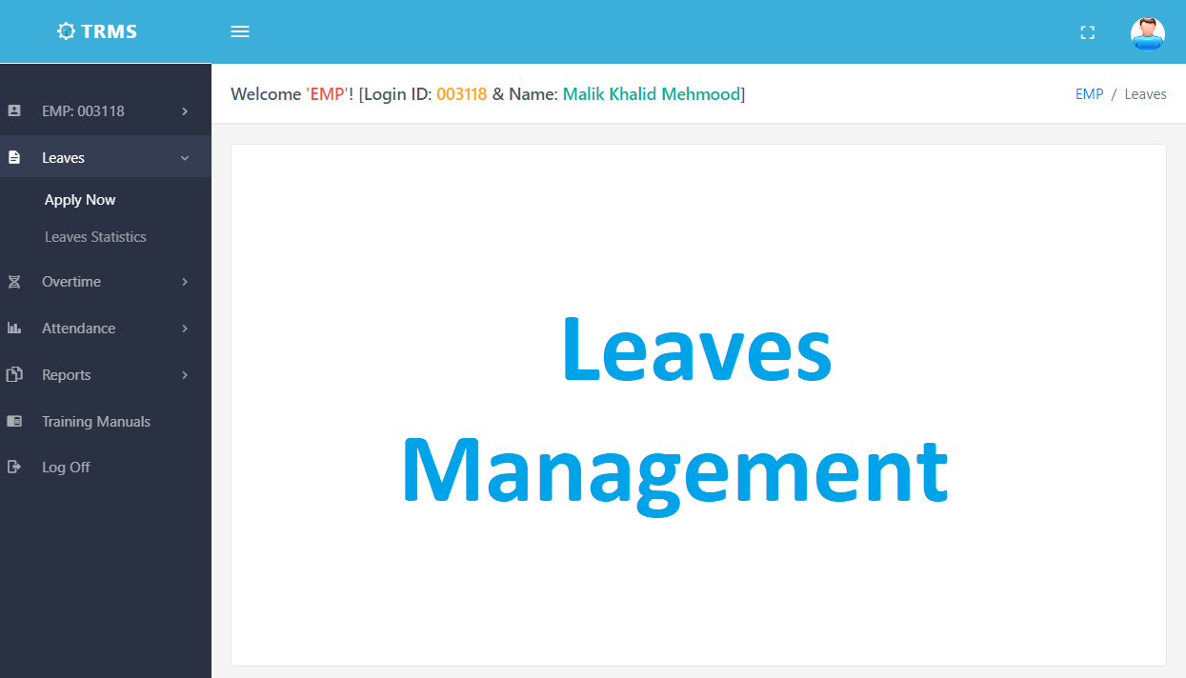

/Reports/Leave Application
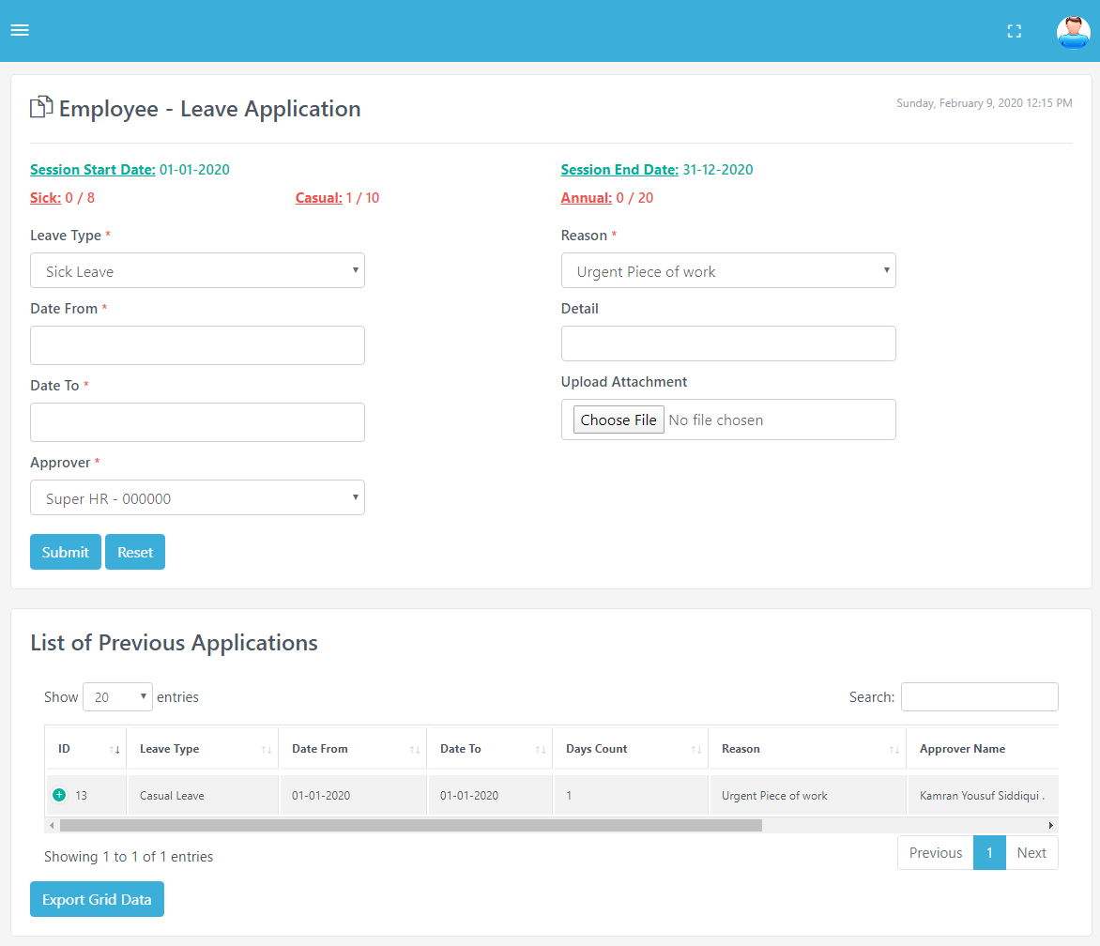 | Leave Applications:  Title:  - Showing Leaves Counts  - Current Session Dates  Form:  - Select the Leave Type  - Select Date Range  - Select Approver  - Select Reason  Grid – Shows Data:  - Grid Shows the current data  - Show number of entries by selecting count on top left of grid  - Search text by typing in the text box on top right of the grid  - Pagination count shows down the grid and go to that page  - ‘Export Grid Data’ button is used to download CSV file of visible columns data

/Reports/Leave Statistics Report – 1/2
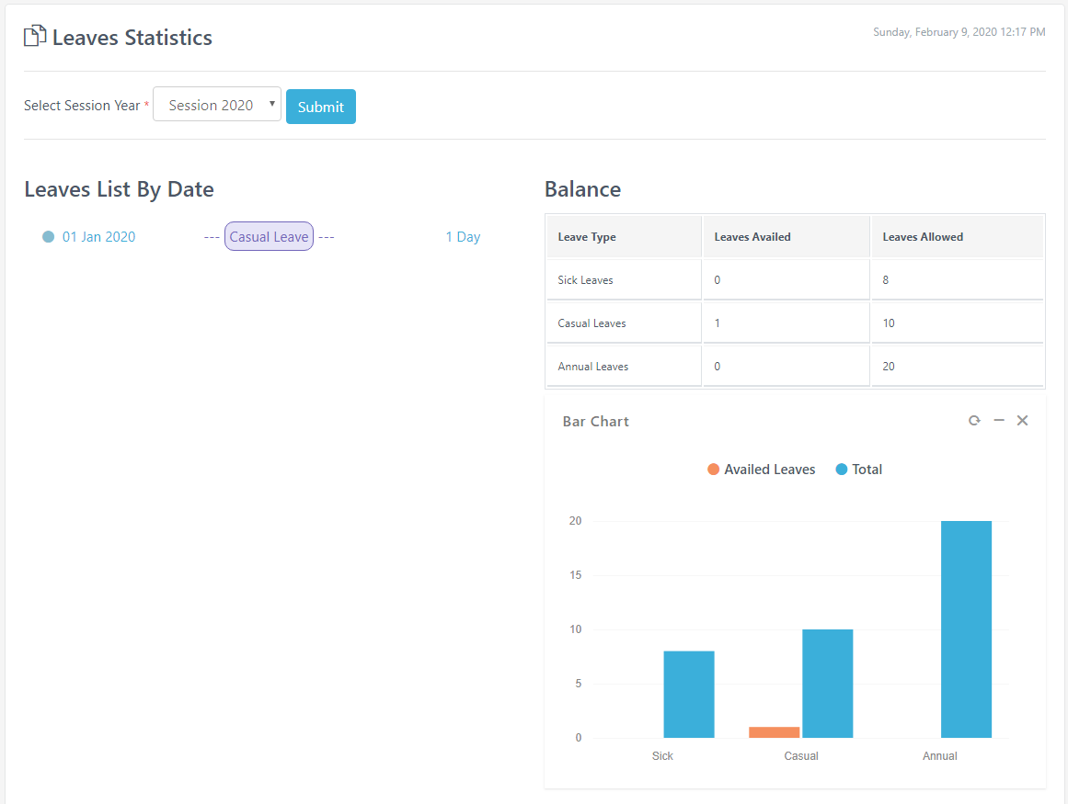 | Leaves Statistics:  Form:  - Select Year – 2020  Grid – Balance Count:  - Sick Leaves  - Casual Leaves  - Annual Leaves  Bar Chart – Shows Data:  - Sick Leave Bars  - Casual Leave Bars  - Annual Leave Bars

/Reports/Leave Statistics Report – 2/2
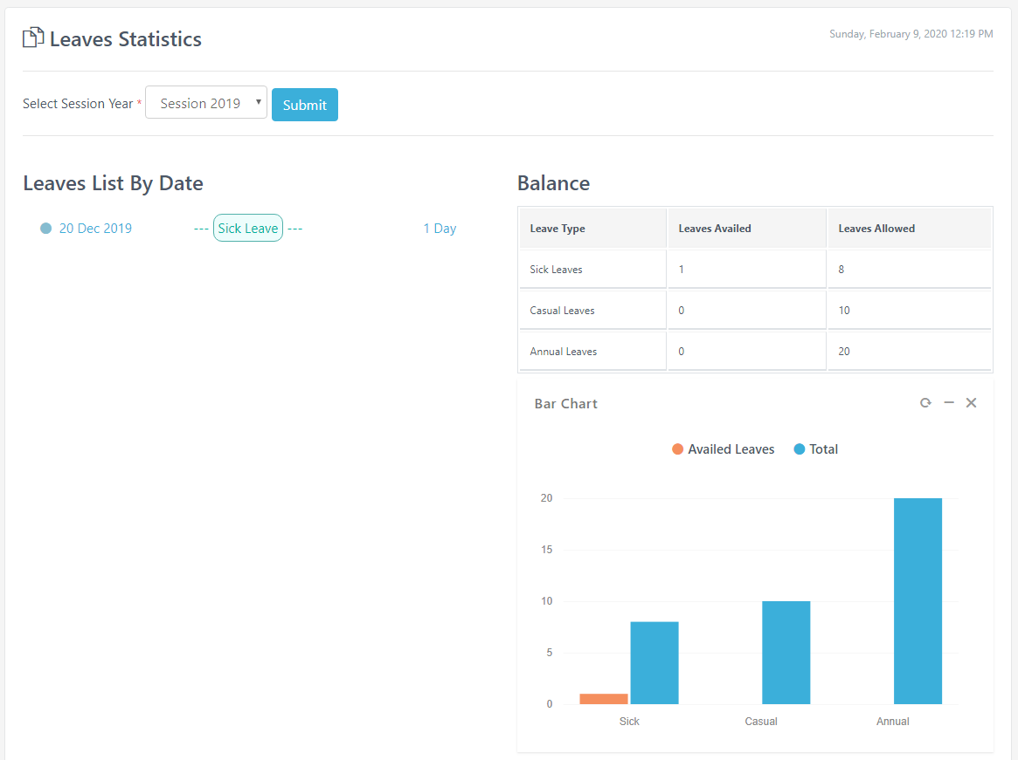 | Leaves Statistice:  Form:  - Select Year - 2019  Grid – Balance Count:  - Sick Leaves  - Casual Leaves  - Annual Leaves  Bar Chart – Shows Data:  - Sick Leave Bars  - Casual Leave Bars  - Annual Leave Bars

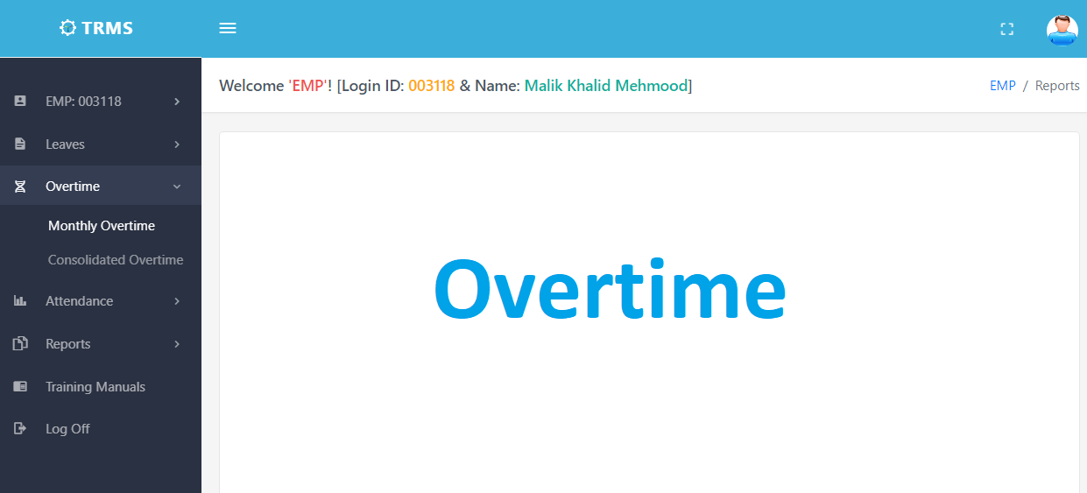

/Reports/Monthly Overtime Report
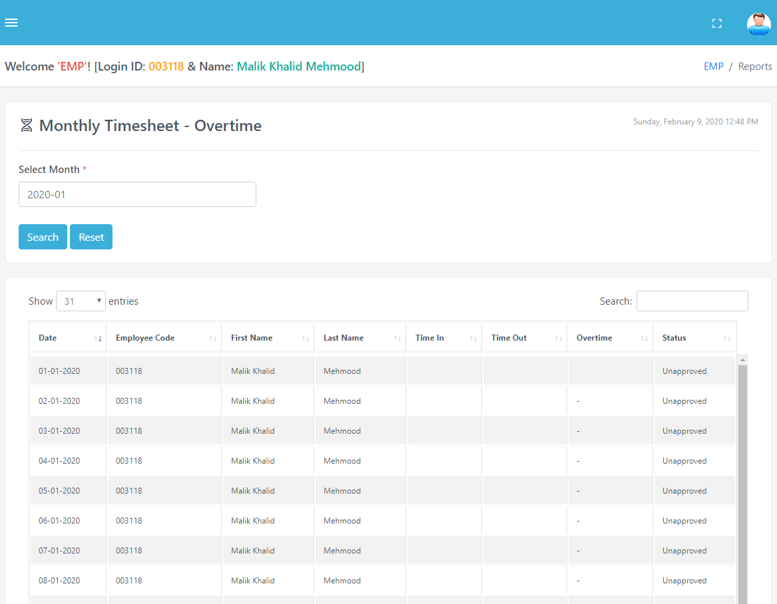 | Overtime Report:  Form:  - Select Month  Grid – Shows Data:  - Grid Shows the current data  - Show number of entries by selecting count on top left of grid  - Search text by typing in the text box on top right of the grid  - Pagination count shows down the grid and go to that page  - ‘Export Grid Data’ button is used to download CSV file of visible columns data

/Reports/Consolidated Overtime Report
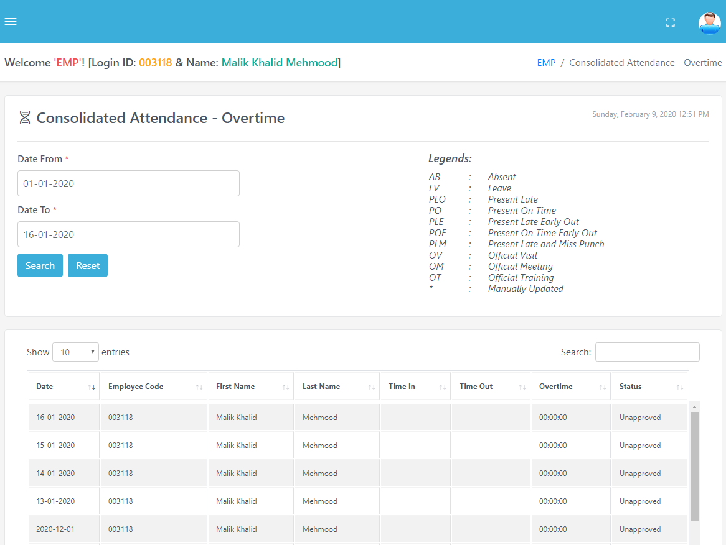 | Consolidated Overtime Report:  Form:  - Select Date Range  Grid – Shows Data:  - Grid Shows the current data  - Show number of entries by selecting count on top left of grid  - Search text by typing in the text box on top right of the grid  - Pagination count shows down the grid and go to that page  - ‘Export Grid Data’ button is used to download CSV file of visible columns data  - ‘Download Excel’ button is used to download Excel file

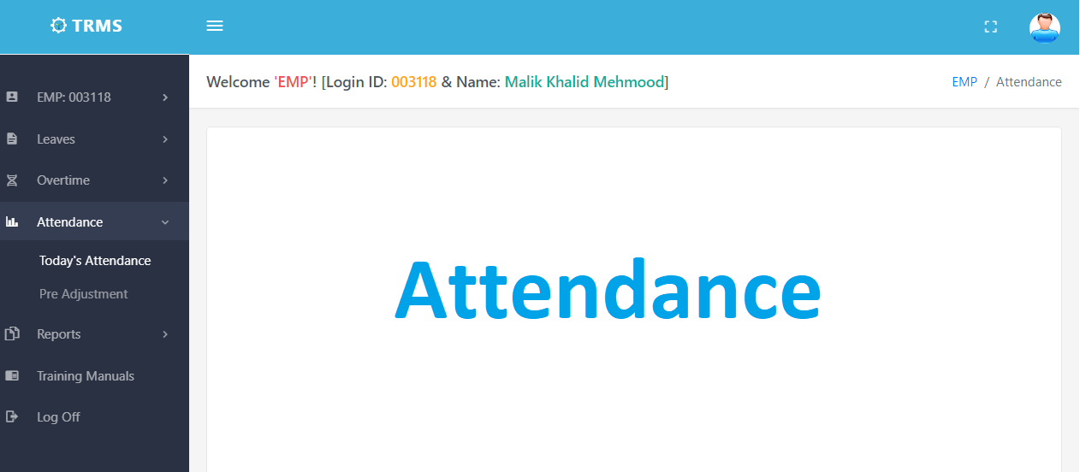

/Attendance/Todays Attendance
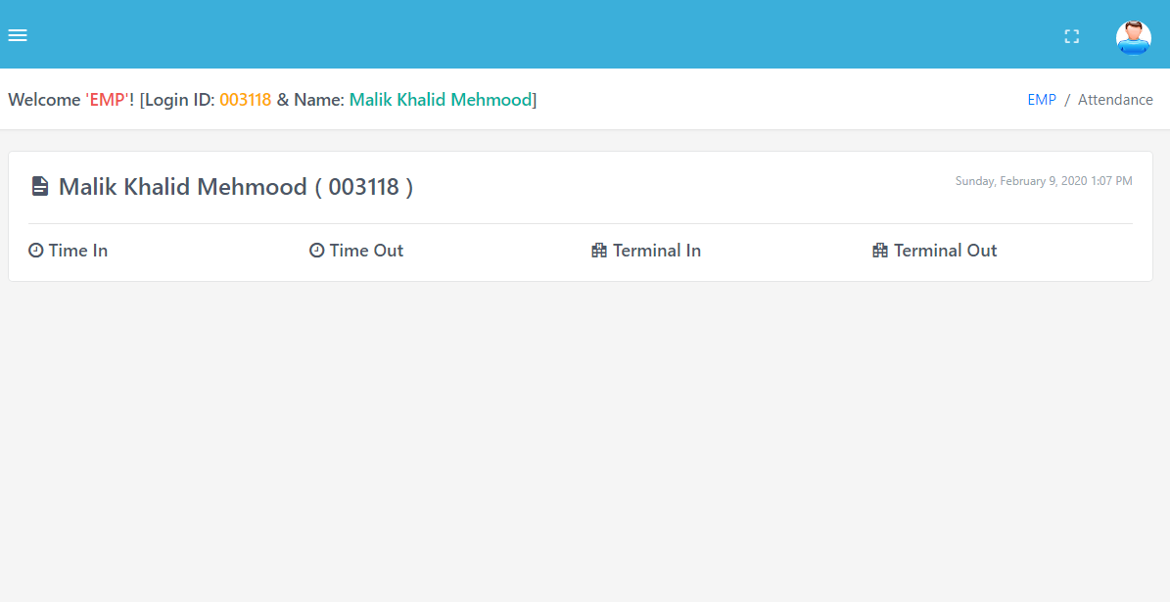
Today’s Attendance:

Shows Data:
- Time In
- Time Out
- Terminal In
- Terminal Out

/Attendance/Pre Adjustment
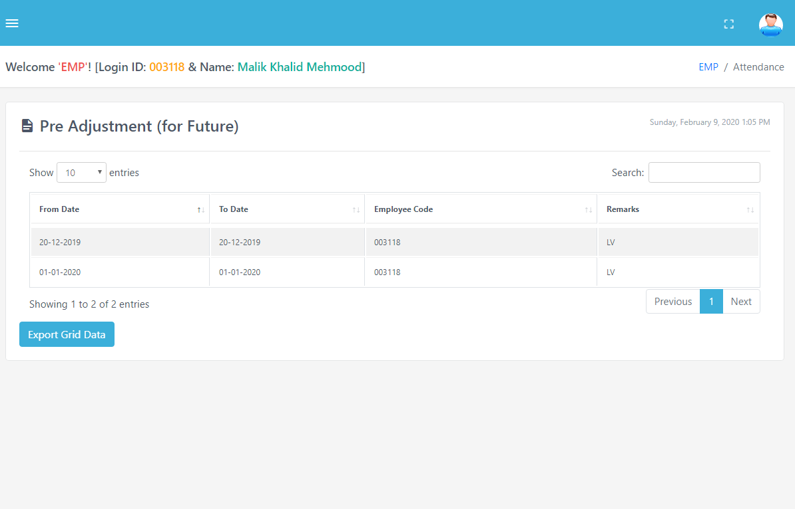 | Pre Adjustments:  Grid – Shows Data:  - Grid Shows the current data  - Show number of entries by selecting count on top left of grid  - Search text by typing in the text box on top right of the grid  - Pagination count shows down the grid and go to that page  - ‘Export Grid Data’ button is used to download CSV file of visible columns data  - ‘Download Excel’ button is used to download Excel file

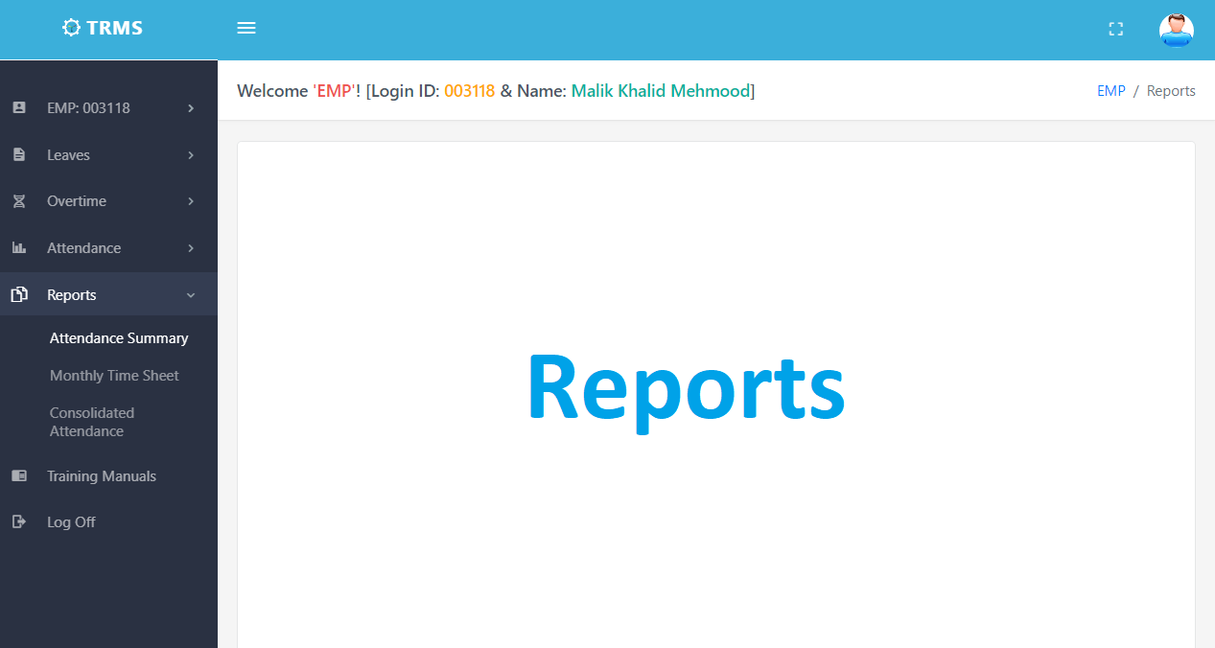

/Reports/Attendance Summary
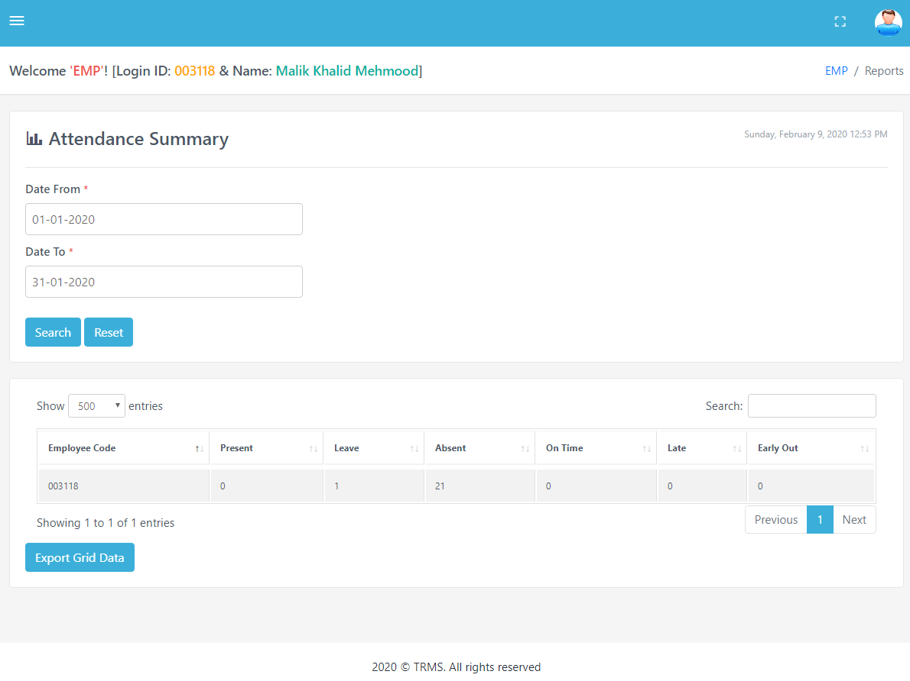 | Attendance Summary:  Form:  - Select the Date Range and submit using ‘Search’ button to view attendance data  - ‘Reset’ button could be used to reload the page  Grid – Count Data:  - Grid Shows the current data  - Count of Present, Leave, Absent, Late and Early Out  - Show number of entries by selecting count on top left of grid  - Search text by typing in the text box on top right of the grid  - Pagination count shows down the grid and go to that page  - ‘Export Grid Data’ button is used to download CSV file of visible columns data  Footer shows the Year and Rights Reserved

/Reports/Monthly Timesheet – 1/2
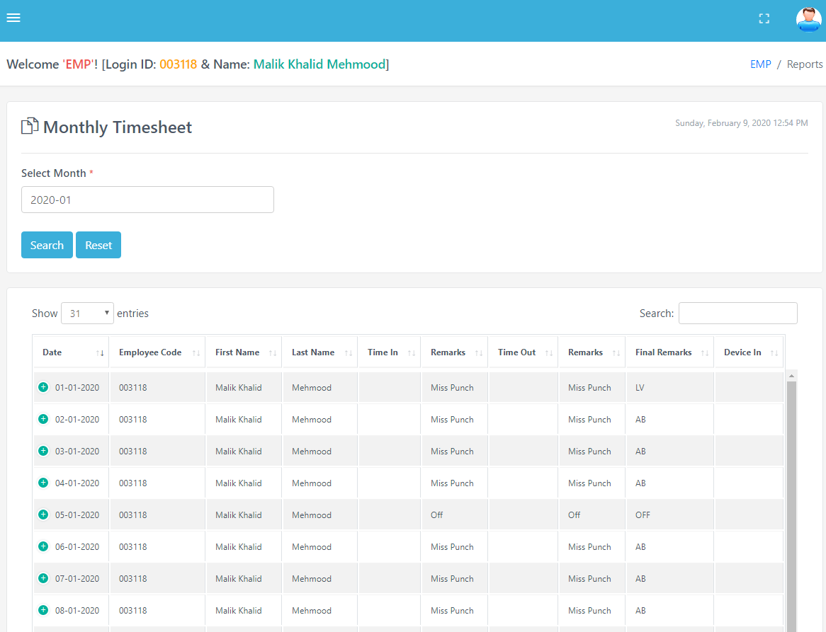 | Monthly Timesheet:  Form:  - Select Month and Employee Code and submit to view data in the grid  - ‘Reset’ button could be used to reload the page  Grid - Attendance Data:  - Grid Shows the attendance data  - + Icon to expand/collapse hidden columns data  - Show number of entries by selecting count on top left of grid  - Search text by typing in the text box on top right of the grid  - Pagination count shows down the grid and go to that page  - ‘Export Grid Data’ button is used to download CSV file of visible columns data  - ‘Export PDF’ button is used to download PDF version  Footer shows the Year and Rights Reserved

/Reports/Monthly Timesheet Report – 2/2
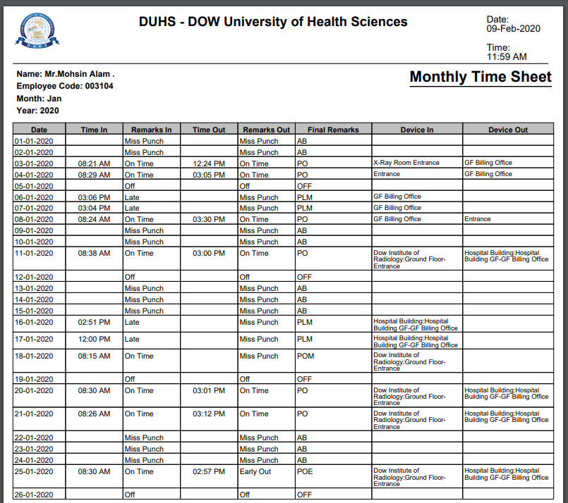 | Monthly Timesheet – PDF Format:  - Organization Logo (on top left)  - Organization Title  - Download Date Time Stamp  Personal and Organizational Info  - Report Title (on right)  - Employee Name  - Employee Code  - Month (selected by user)  - Year (selected by user)  Grid Data:  - Date  - Time In  - Remarks In  - Time Out  - Remarks Out  - Final Remarks  - Device In/Terminal In  - Device Out/Terminal Out  Summary Count:  - Present & Late Count  - Absent & Leave Count  - Early Count  - Total Days  Legends

/Reports/Consolidated Attendance Report
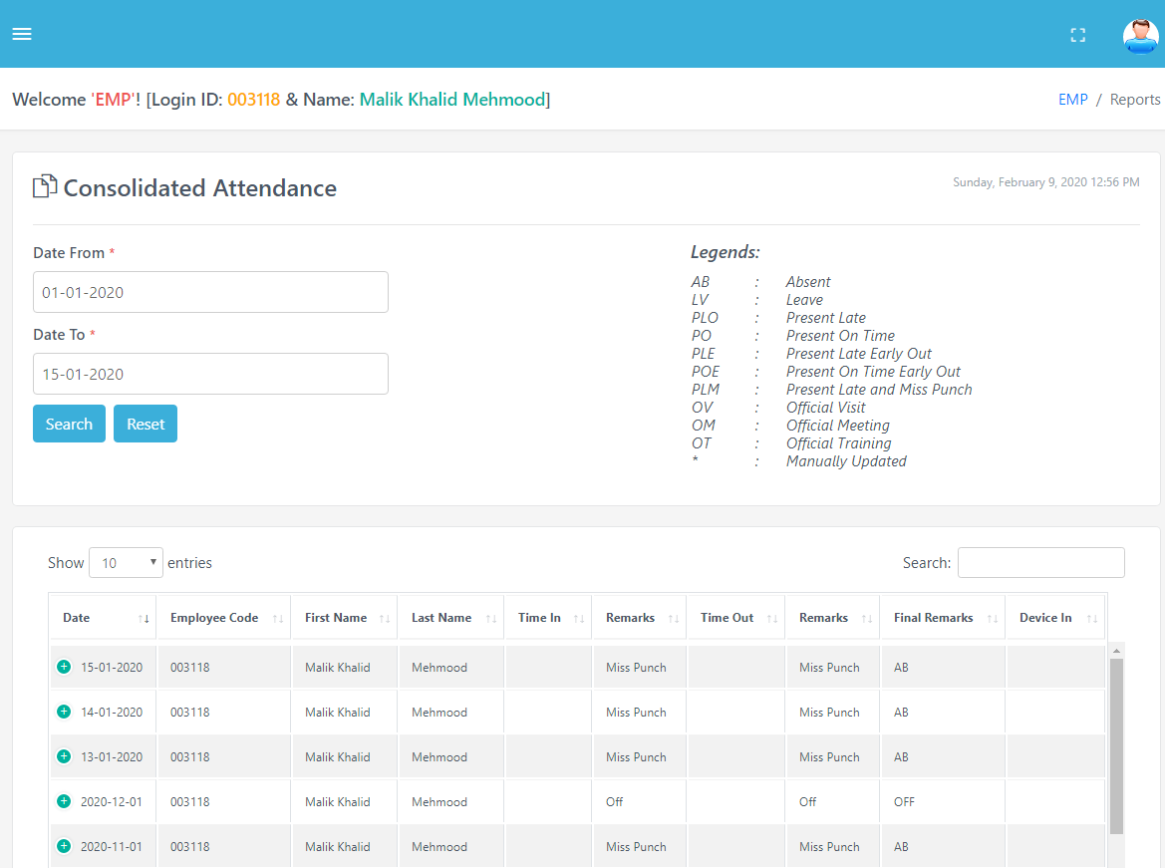 | Consolidated Attendance Report:  Form:  - Select Date Range  - ‘Reset’ button could be used to reload the page  Grid - Attendance Data:  - Grid Shows the attendance data  - + Icon to expand/collapse hidden columns data  - Show number of entries by selecting count on top left of grid  - Search text by typing in the text box on top right of the grid  - Pagination count shows down the grid and go to that page  - ‘Export Grid Data’ button is used to download CSV file of visible columns data  - ‘Export Excel Data’ button is used to download XLS file

