QUIZ SYSTEM

Subject: Computer Organization & Assembly Language

GROUP MEMBERS:
Tayyub Naveed (19P-0108)
Umar Aslam (19P-0103)
Zohaib Khan (19P-0095)

Objective:
The main objective of this project is to design a multiple-choice question paper using the assembly language.

Project Explanation:

The Quiz system is a game concept.

In this game, we have set 10 questions.

One mark will be increased for each right answer, and one mark will be increased and for each wrong answer, 1 mark will be decreased from the total points for each wrong answer.

At the end of the quiz, the total marks will be shown to the user.

Now, we will discuss some important parts of our project code.
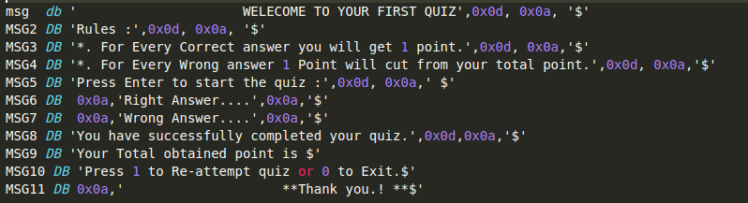

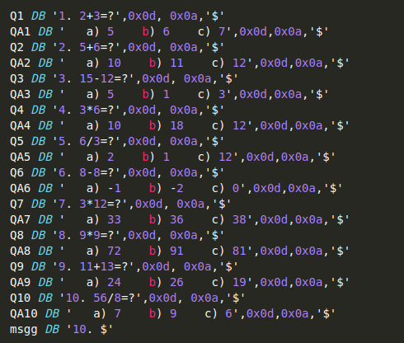

we have set 11 variables from msg 1 to msg11 for printing our desired strings, and we have used Q1-Q10 and QA1-QA10 for printing our desired questions and their options.
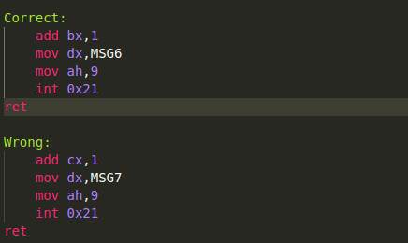

First, we have two Functions named “Correct” and “Wrong”. If the answer is correct, the “Correct” function will be called and it will add one point and print the “MSG6” message, which is “Right Answer…”. If the answer is wrong, the “Wrong” function will be called, and it will reduce one point in cx and print the “MSG7” message.
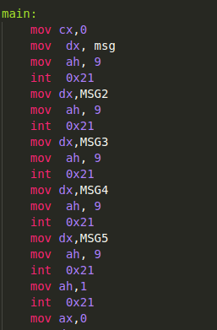

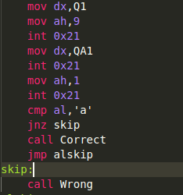

Now we will go to question 1 level and 1 input will be taken and it will be compared to the correct answer. If it is equal then it will go to the “correct” function, otherwise, it will reach the “skip” level and the “wrong” function will be called.

We do the same process till Question 10.
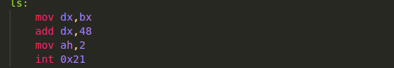

In the exit level, we have added 48 with dx to convert our ASCII to decimal. So, that the user may easily understand the obtained marks.

OUTPUT:

