Overview:

* Introduced N-Tier / distributed architecture
* Introduced dependency injection using Autofac
* Introduced AutoMapper
* Introduced Repository pattern
* Introduced service based communication between the API project and other layers

Database project:

* Introduced Entity Framework 6
* Consists of Model classes generated from database
* All model classes inherit from a base Entity class

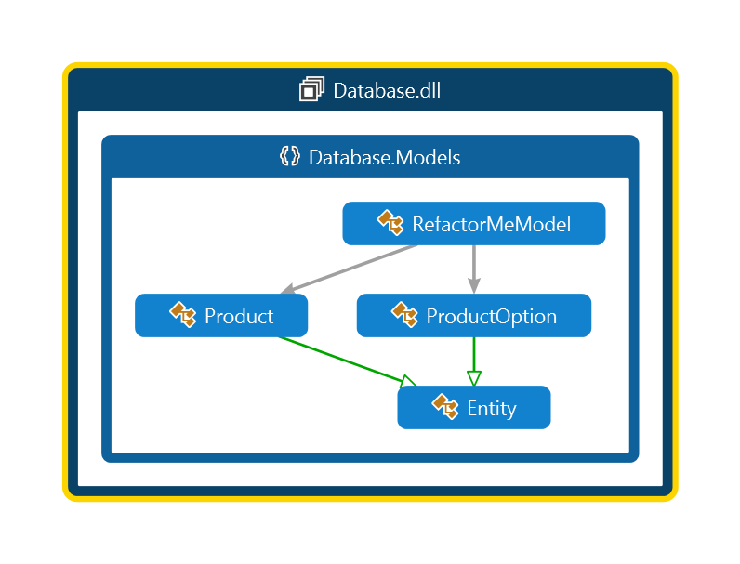

DAL (Data Access Layer):

* Introduced Repository pattern
* The repository provides a set of basic CRUD and fetch operations
* DAL directly talks to the “Database”

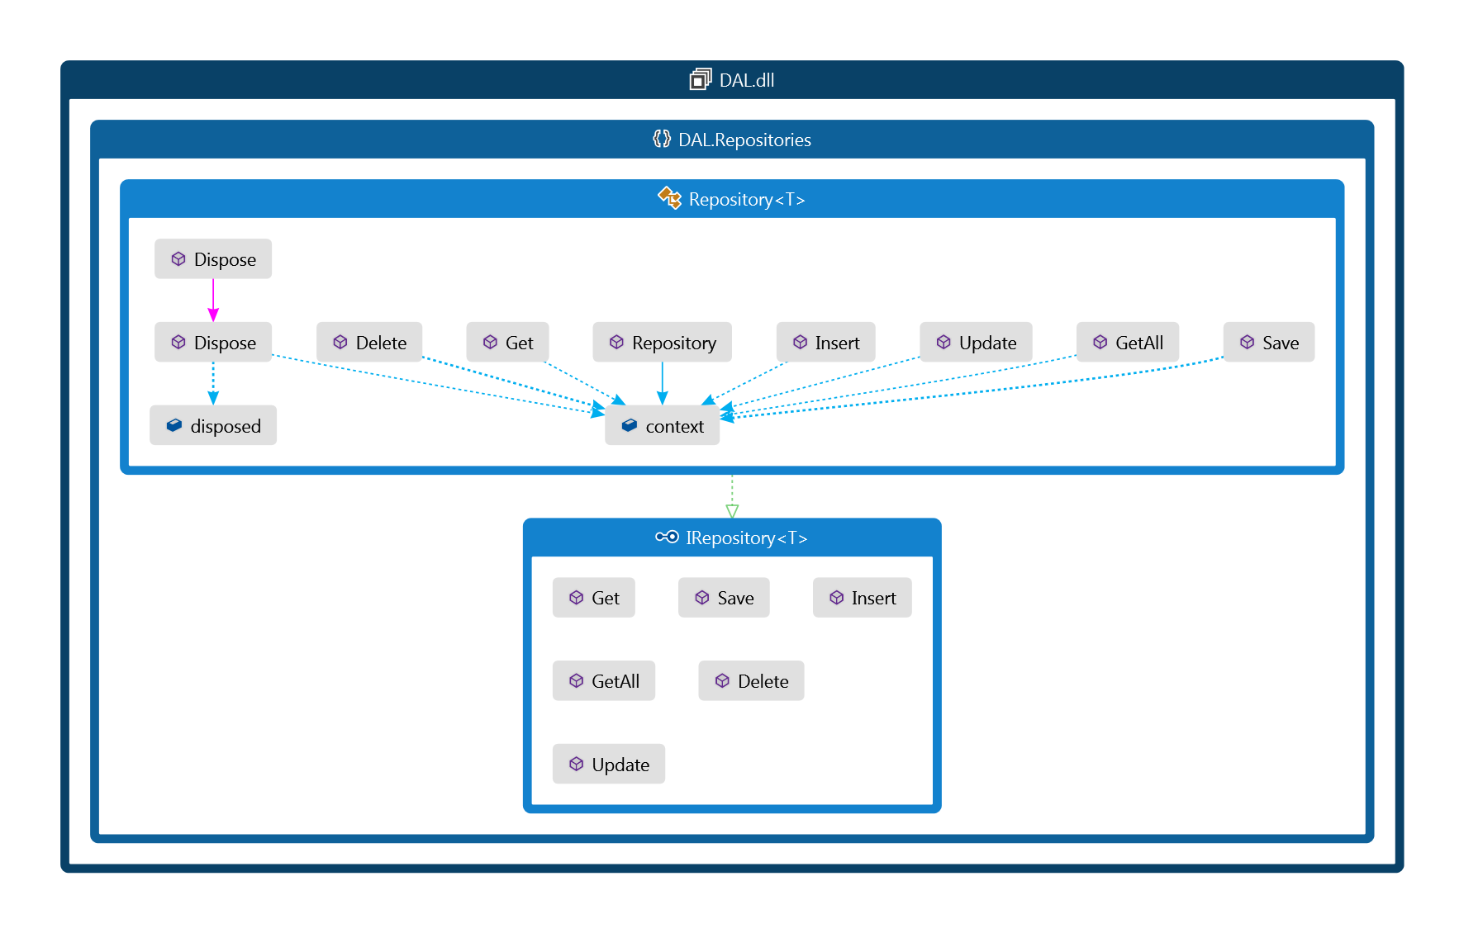

Services:

* All the entities in the database have a corresponding service interface.
* Each interface is inherited from a base IService interface that provides signatures for basic CRUD operations.
* Any special operation specific to an entity is then exposed in the interface specific to that entity.

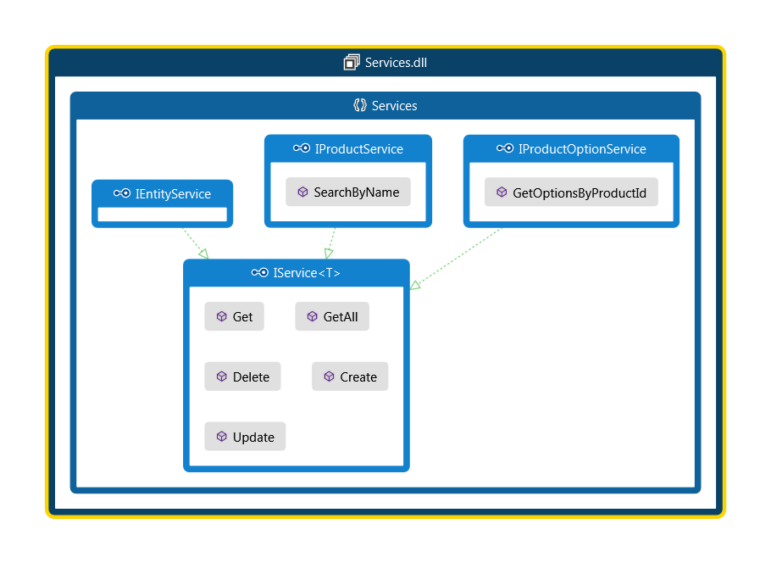

BAL (Business Access Layer):

* The services’ interfaces are implemented in the BAL.
* BAL talks to DAL which in turn talks to database to perform the relevant operations.

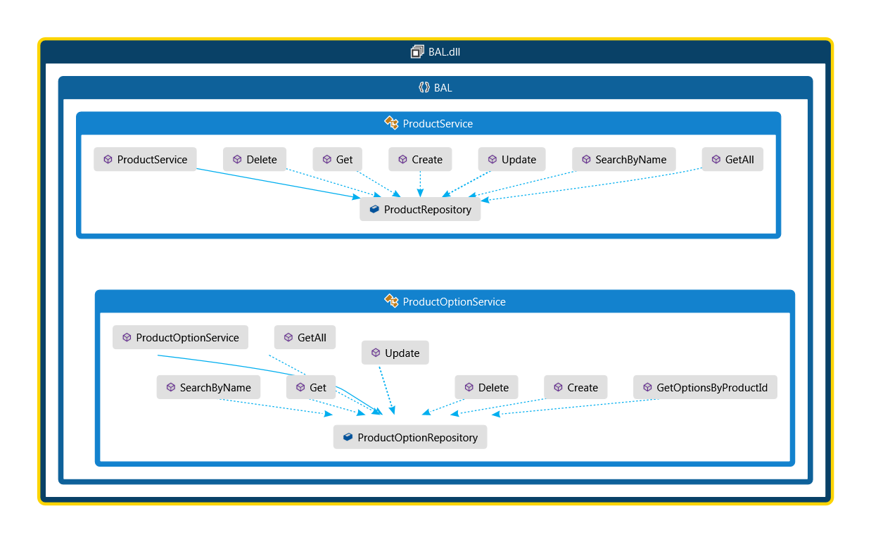

Web API (Refactor-Me):

* The main Web API project now only talks to BAL via the service interfaces that are injected dynamically through Autofac to perform the operations.

