
COMSATS Institute of Information & Technology, Lahore.

Advance Digital Design

(Lab 10)

FSM – D Design

Name ___________________________

Regd. Number_____________________

Instructor Signature_________________

Date______________

Advance Digital Design
COMSTATS Institute of Information Technology
Department of Computer Engineering
Spring 2006

PreLab10

Important Note: If you are unable to complete this questionnaire, do not come to lab and you will be marked absent. Get your questionnaire signed by your instructor before entering the lab.

Book: VHDL Programming by Example Douglas L. Perry (Ch.9)

Answer the following questions:
- What is synthesis, describe net list?
- What is meant by register transfer level description?
- What are constraints, describe their usage?
- What are timing and clock constraints?
- Describe attributes, and their usage?
- What is intrinsic, wire, loading delays?
- What are the steps in conversion from RTL to gate level?
- Why we need intermediate form in translation?
- Show graphically the synthesis process?
- What is Boolean optimization?
- Describe flattening, what is pla structure?
- What is factoring?

Lab 10

FSM – D Designs

Part 1: Design of a Multiplier

Multiply Hardware Version 1
- 64-bit Multiplicand register 64-bit ALU, 64-bit Product register,
32-bit multiplier register
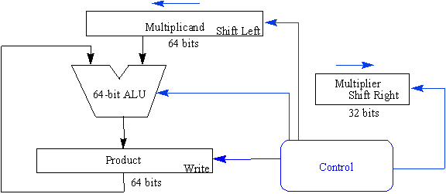

Multiply Algorithm Version 1
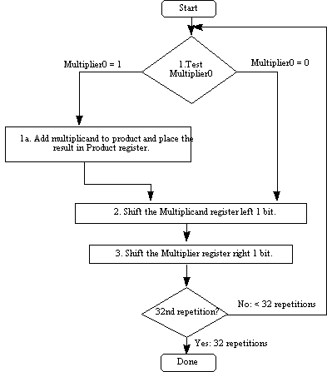

Code:
Write VHDL code for above multiplier.

Test Bench
Write a test bench to simulate and verify the above design.

Simulation:
Simulate the design for all possible values and attach the waveforms.

FPGA Implemtation:
Implement the design on FPGA.

Improvements:
Refer to arithmetic (ch 4 of Henessy) and draw the architecture and flow chart of improved algorithm. Write VHDL code and test bench and simulate it.

