Advance Digital Design
COMSTATS Institute of Information Technology
Department of Computer Engineering
Spring 2006

Lab 14

System Design

Part 1: FSM with a Datapath: the Microcontroller

Objectives: Model a subset of a RISC processor (MIPS) in VHDL.

1. Introduction
The purpose of this lab is to introduce the concept of FSMs with a datapath, and to study the usage of more complex test benches. Also, we enforce a rudimentary design methodology by assuming that the students are part of a bigger project, and have no knowledge of the VHDL-implementation of the datapath (made by a hypothetical other group) other than its predefined Entity Interface until they come to the lab. The rest of this document is structured as follows: Section 2 describes some preliminary reading and exercises that should be done before the lab. Section 3 details the design tasks that should be carried out to pass this lab.

Preparation
In “The Designer’s Guide to VHDL” by P. Ashenden - browse through chapter 18. This covers file I/O. You can also consult other books and read about I/O files.

2. The datapath
2.1.1 Study the datapath in Figure 1.
The datapath has a generic bit width. The datapath consists of one input mux, one register,
one ALU, one shifter, and one tri-state output. During every cycle it is possible to
read two data from and write one data to the register file. It is NOT possible to read a
data from the register if the data is written in the same clock cycle. The input mux controls
whether it is the input or the result of an ALU+Shift operation that should be
stored.
The VHDL code for the datapath entity interface is given in the appendix. Just as in a
real-life project, the datapath has been prepared by a colleague of yours (in this case, an
assistant). In many cases the source code of an component is not always available since
companies want to protect thei intelectueal properties rights. Therefore you will only
receive a compiled version of the datapath in form of a MODELSIM library.
Your task is to design a controller for the datapath performing the functionality
described in the next section.

Processor Architecture: Main Features
- Number of registers: 32, named $1, $2, ……..$31. Each register is 32 bit wide.
- A special register called Program Counter (PC) stores the address of next instruction to be fetched from instruction memory.
- Instructions are three operand instructions
- Operands of arithmetic and logical operations are all in registers
- There are only two instructions (load and store) to read or write data from/into memory.
- Processor architecture is Harvard architecture, which implies there is a separate memory for storing instructions (program) and a separate memory for storing data.

Instruction Sub-set
The following table gives the sub-set of MIPS instructions, which the processor design must be able to execute. We assume one important simplification regarding memory addressing. We assume that the memory is organized as 32-bit words and one full word
is accessed by one memory access.

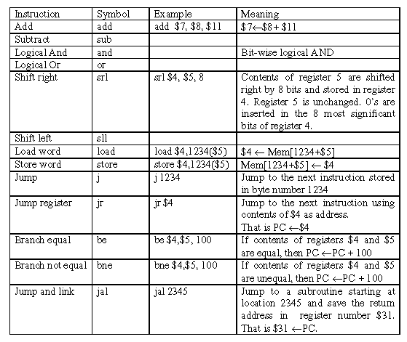
Instruction formats
For the sake of convenience, we describe the formats of various instructions in MIPS
here. The reference text book [1] has more details for the format.
The instructions follow one of the three formats:
- R-Format Instructions (add, sub, and, or, slr, sll, be bne, jr)

The opcode field distinguishes R-format instructions from other instructions. The format can specify three registers as operands (rs, rt, and rd) and shift amount (shamt) for shift instructions. All arithmetic and logical operations have same opcode value but are distinguished by 6 bit functional code (funct). Read the reference book for actual codes of various instructions.

(ii) Load/Store Instruction Format (load, store)
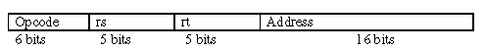

One of the register is used for data and the other register is used for calculating the address for memory along with the 16 bit offset from the Address field. ( 16 bit offset is
sign extended to make a 32 bit number).

(iii) Jump Instruction Format (j and jr)
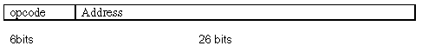
Six most significant bits of PC are appended to 26 bits of address in the instruction to
generate 32 bit effective address.

Processor Implementation
We will use Single Cycle Datapath design described in chapter 6 of [1] and implement the processor. The block diagram of the implementation is shown in Fig. 1. The four steps are named Instruction Fetch (IF), Instruction Decode and Operand Fetch (ID), Execute (EXEC) and result Write Back (WB).The complete description of each step is provided in the [1] and we have studied it in detail in the class.

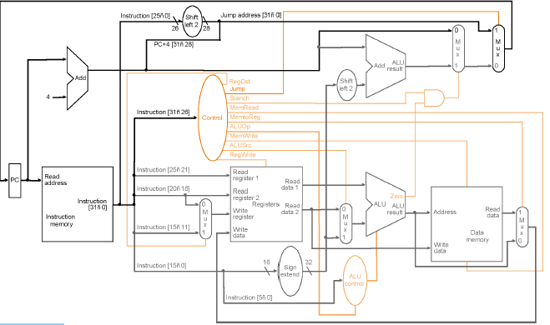
Figure 7.1: Single Cycle MIPS
Code:
Write VHDL code for above multiplier.

Test Bench
Write a test bench to simulate and verify the above design.

Simulation:
Simulate the design for all possible values and attach the waveforms.

FPGA Implementation:
Implement the design on FPGA.

Reference
[1] David A. Patterson and John L. Hennessy, Computer Organization and Design: The Hardware/Software Interface( 2nd Edition), Morgan Kaufmann Publishers, Inc., 1998, ISBN 1-55860-428-6 and ISBN 1-55860-491-X.

