
COMSATS Institute of Information & Technology, Lahore.

Advance Digital Design

(Lab 2)

FPGA Implementation of
Combinational Components

Name ___________________________

Regd. Number_____________________

Instructor Signature_________________

Date______________

Advance Digital Design
COMSTATS Institute of Information Technology
Department of Computer Engineering
Summer 2006

PreLab 2

Important Note: Download the datasheet of the FPGA from the manufacturer’s website and answer the following questions. If you are unable to complete this questionnaire, do not come to lab and you will be marked absent. Get your questionnaire signed by your instructor before entering the lab.

Answer the following questions:
- What is the name of FPGA board we will be using in lab2?
- What is the name of FPGA used?
- What is the number of FPGA being used?
- Give the meaning of each letter of the number of FPGA being used?
- What is the speed of FPGA used?
- What is the total number of I/O pins available?
- How many pins are routed to expansion slot?
- What is the rating of power supply required by the FPGA board?
- How many oscillator slots are there on the FPGA board?
- Write the number of pins connected to oscillator or clocks?
- How many pushbuttons and slide switches are there on the FPGA board?
- How many LEDs are there on the FPGA board?
- FPGA board contains seven-segment display. It is of how many digits?
- Is it anode or cathode?
- Write input to be given to seven segment to display number
- How many ports are available on the board?
- Define system bus?
- Define module bus?

Lab 2

FPGA Implementation of Combinational Components

FPGA Implentation

Creating a New Project
A project in ISE is a collection of all files necessary to create and download a design to the selected device. To create a new project for this tutorial:
1. Select File . New Project.
2. In the New Project Wizard dialog box, type the desired location in the Project Location field, or browse to the directory under which you want to create your new project directory using the browse button next to the Project Location field.
3. add your files and.vhd to project.

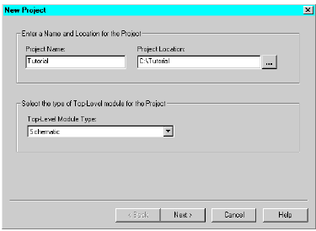

Figure 1: New Project Wizard Dialog Box
5. Click Next
6. In the New Project Wizard Device and Design Flow dialog box, use the pull-down arrow to select the Value for each Property Name. Click in the field to access the pulldown list.
Change the values as follows:
. Device Family: spartan
. Device: xcv50
. Package: 208
. Speed Grade: -6
. Synthesis Tool: XST (VHDL/Verilog)
. Simulator: Modelsim
. Generated Simulation Language: VHDL
7. Click Next.
Next, you can create a VHDL module for a and gate. To create a and module:
8. Click New Source in the New Project Wizard Create a New Source Dialog box to add one new source to your project.
9. In the New Source dialog box, select VHDL Module as the source type.
10. Type in the file name ‘and’.
11. Verify that the “Add to Project” checkbox is selected.
12. Click Next.
13. Click Next in the Define VHDL Source dialog box.

We do not need to perform step 8 to 13 as we have already created the source. We only need to add them.
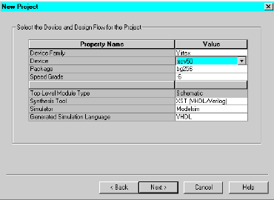

Figure 2: New Project Wizard Device and Design Flow Dialog Box

Note: You have the option of defining and adding ports from this dialog box. In this example,
you will use pre-defined ports supplied in the Language Template.
14. Click Finish to complete the new source file template.
15. Click Next in the New Project Wizard Create a New Source dialog box.
16. Click Next in the New Project Wizard Add Existing Sources dialog box.
17. Click Finish in the New Project Wizard Summary dialog box.
ISE creates and displays the new project in the Sources in Project window, and opens the
*.vhd file in ISE Text Editor.

Design Entry (VHDL)

*.vhd, which is displayed in the ISE Text Editor window, contains the library
declaration and use statements along with the empty entity and architecture pair for the
counter you have just created. The file (when correctly placed in your design) is all you
need to create a counter module. ISE Text Editor is designed for editing HDL source files.

Design Implementation
For this tutorial, design implementation covers two tasks: running the Implement Design process in Project Navigator, and viewing the resulting placed and routed design in Floorplanner.
Design Implementation
Running Implement Design
First, run all processes (Synthesis through Place & Route) associated with the counter. To
do so, run Implement Design on the schematic file:
1. Select top (top.sch) in the Sources in Project window.
2. Double-click Implement Design in the Processes for Source “top” window.
This runs all processes.
A check mark in the Processes for Source window denotes a process that was run successfully. An exclamation mark indicates that the process was run and that there is a warning for the process. More information about warnings can be obtained in the Transcript window.

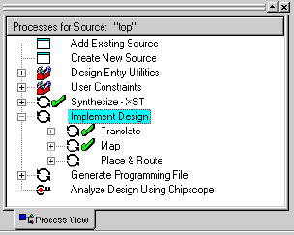
Figure 3: Implement Design processes

Viewing the Design in Floorplanner
Now, you can view the implemented design in Floorplanner. The Floorplanner is a graphical tool in which you can view and change the design hierarchy, floorplan, and perform design rule checks.
1. In Project Navigator, select top (top.sch) in the Sources in Project window.
2. In the Processes for Source window, click the + sign beside Implement Design and the
+ sign beside Place & Route.
3. Double-click View/Edit Placed Design (Floorplanner). The Floorplanner tool is launched and displays the placement of the design for the project. To view the implemented design results in a more meaningful way, you can display and zoom in on the input/output signals.

1. In the top.fnf Design Hierarchy window (View . Hierarchy), select (highlight) the
top-level hierarchy, ‘top (22 IOBs, 13 FGs, 8 CYS, 8 DFFs, 1 BUFG)’, to show the signals
in the Placement window.
Note: Alternatively, you can draw a rectangle around the design area in the Placement window
to show the signals.
2. Select View . Zoom . In or click the Zoom In icon.
3. Verify that all the I/Os are accounted for by holding the cursor over each of the pads and reading the pad name in the lower left corner of the Floorplanner window.
Note: Alternatively, you can view isolated signals in the placement window by selecting individual signals from the list in the top.fnf Design Hierarchy window. The placement in Floorplanner should look like the following.

When you have finished viewing the implemented design:
1. Save the Floorplanner design view using File . Save.
2. Save top.fnf and then save the top.ucf file, created by ISE.
Note: top.ucf is a constraints file. It ensures that any constraints you have specified are saved
in case of a subsequent implementation run.
3. Exit Floorplanner.

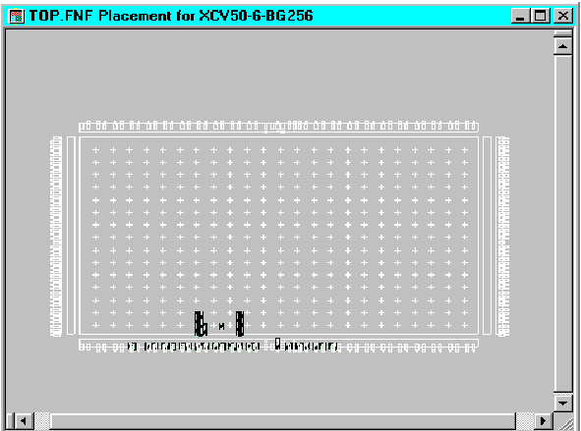
Figure 4: I/O Connections in Floorplanner

Design Implementation
Next, implement the design and use FPGA Editor to view the placed and routed design.

Running Implement Design
To run design implementation on the design:
1. Select the EDIF file ‘mf.edn’ from the Sources in Project window.
2. Double-click Implement Design in the Processes for Source window. This runs all processes (Translate through Place & Route) required to implement the design. You will subsequently open the implemented design in FPGA Editor.
A check mark in the Processes for Source “mf.edn” window denotes a process that was run
successfully. An exclamation mark indicates that the process was run and that there is a warning for the process. More information about warnings can be obtained in the Transcript window.

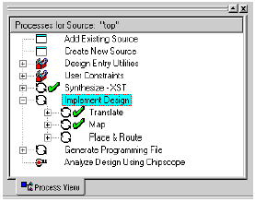
Figure 5: Implement Design processes
Viewing the Design in FPGA Editor
FPGA Editor is a graphical application used to display and configure FPGAs. To view the
design from ‘mf.edn’ in FPGA Editor:
1. When implementation is finished, in the Processes for Source “mf.edn” window, click
the + sign beside Implement Design and click the + sign beside Place & Route.
2. Double-click View/Edit Routed Design (FPGA Editor). The placed design, mf.ncd, is automatically displayed in FPGA Editor.
3. Click on the Type column header in the List1 window to list all components by type. Resize the table and the columns as desired to read the column names clearly. Verify that all 26 I/Os are accounted for as IOBs in the Type column.
Note: Clock I/Os will be listed under the GCLK type, not the IOB type.
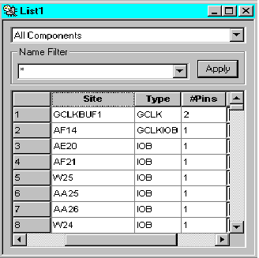
Figure 6: Listing all components by type
When finished viewing the design, exit FPGA Editor.

Downloading a configuration (.bit) file to the FPGA on the Pegasus board
1. Plug in the 5v power supply of the Pegasus board. The green LED (LD8) near the power connector will turn on.
2. Without using the Project Navigator, from the Start menu select Programs->Xilinx ISE 6->Accessories->iMPACT.
3. You will be asked what you want to do. Select Configure Device and then Next.
4. Select Boundary-Scan Mode and then Next.
5. Select Automatically connect to cable .... and then Finish.
It should report that it found two devices. (If not you probably forgot to plug in the power supply on the Pegasus board.)
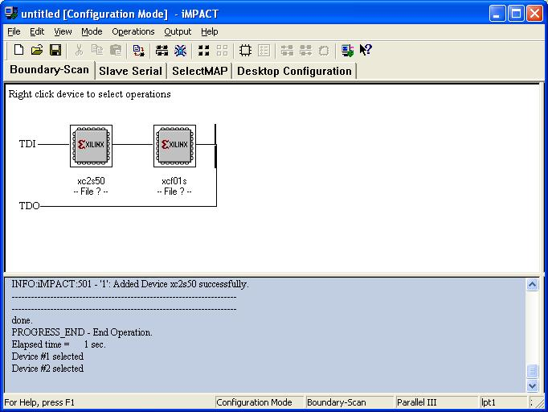
Figure 7: Devices detected

1. Click OK and then you will be asked to select a configuration file for the first device (the FPGA). Find the file C:\CE100\ce100.bit that you fetched earlier and click Open. You'll get a warning about the Startup clock; just click OK.
2. You will then be asked to select a configuration file for the second device (the flash memory). Select Bypass since we are not using the flash memory to configure the FPGA. You should now have the screen below.
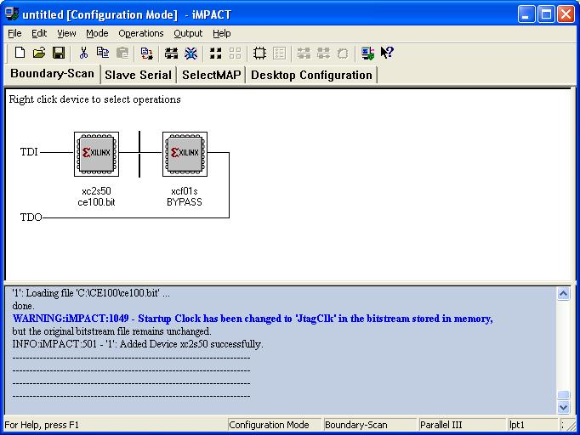
Figure 8: Selecting configuration file

1. Select the first device (the FPGA) and it will turn green.
2. Right click on the first device and select Program from the menu. Click on OK at the bottom of the Program Options menu.
If all went well you should have the screen below and the green LED (LD9) near the ROG pushbutton should have turned on. If so you have successfully configured the
FPGA. 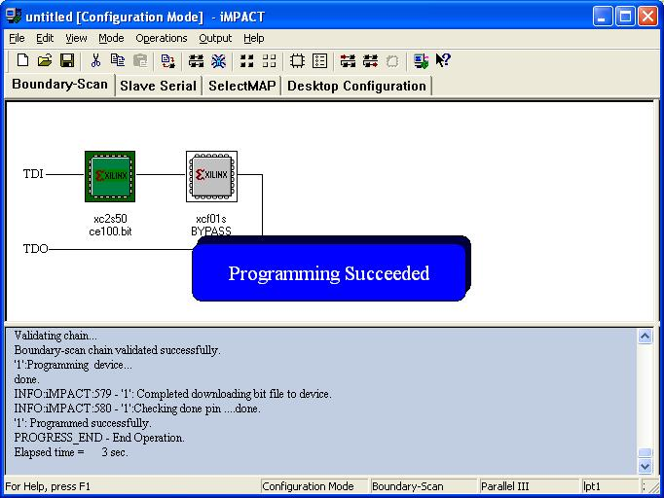
Figure9: Programming the device

If instead you have a red box indicating that the programming failed, check that you have the correct files for the two devices, press the PROG pushbutton and try again. If this fails ask for help.
Important Please remember to unplug the power connector of Pegasus board when you are done.

