SQL DDL Intro Assignment – Task 3

3.1 INSERT INTO Department(deptno, deptname) VALUES

(30, 'Management')

3.2 INSERT INTO Employee(empno, empname, deptno) VALUES

(4, 'Athena', 30)

3.3 SELECT empname FROM Employee

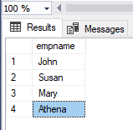

3.4 SELECT empname FROM Employee WHERE empno = 2

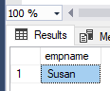

3.5 SELECT empname FROM Employee WHERE deptno = 10

