4.1a CREATE TABLE Team

(

teamNumber INTEGER NOT NULL,

teamName VARCHAR (50) NOT NULL,

CONSTRAINT PK_Team PRIMARY KEY(teamNumber)

)

CREATE TABLE Cyclist

(

cyclistNumber INTEGER NOT NULL,

familyName VARCHAR (50) NOT NULL,

givenName VARCHAR(50) NOT NULL,

teamNumber INTEGER NOT NULL,

CONSTRAINT PK_Cyclist PRIMARY KEY(cyclistNumber),

CONSTRAINT FK_Team_Cyclist FOREIGN KEY(teamNumber) REFERENCES Team(teamNumber)

)

4.1b 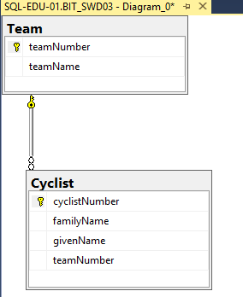

4.2 INSERT INTO Cyclist (cyclistNumber, familyName, givenName, teamNumber) VALUES

(27, 'Tariq', 'Zubair', 1),

(33, 'Shahid', 'Naveed', 1),

(55, 'Jalal', 'Hamza', 1)

INSERT INTO Team ( teamNumber, teamName) VALUES

(1, 'Falcons'),

(2, 'Eagles')

4.3 INSERT INTO Cyclist (cyclistNumber, familyName, givenName, teamNumber) VALUES

(27, 'Busse', 'Marius', 1)

(Violation of Primary Key)

4.4 SELECT teamName FROM Team ORDER BY teamName;

4.5 SELECT familyName, givenName FROM Cyclist;

4.6 SELECT Cyclist.familyName, Cyclist.givenName, Cyclist.teamNumber, Team.teamName

FROM Cyclist

INNER JOIN Team ON Cyclist.teamNumber=team.teamNumber