**EXERCISES**

1. **Warm-up by interpreting an ER diagram**

**Are the statements below true or false? Give arguments!**

* **There can be a crew of 10 sailors.**

True because there is no maximum limited of crew.

* **The minimum size of a crew is one.**

False because there should be 1 captain and 1 engineer too so minimum member could be 2.

* **'John Smith' (snn: '123') cannot be a captain in two different crews.**

False because he can be captain in more crews

* **There can be a crew of 6 sailors that consists of the captain and 5 crew members.**

False because there should be at least 1 captain and 1 engineer also.

* **There can be a sailor who has not joined to any crew yet.**

True there can be a sailor who has not joined to any crew yet.

* **'John Smith' (snn: '123') can be a member in two different crews that sail on 20.3.2016**

False because there can’t be more than 1 crew cruise in 1 day.

1. **More warm-up with multiplicity constraints**

**Determine multiplicity constraints for the relationship types below. Mark the constraints (min..max)**

**to the diagrams.**

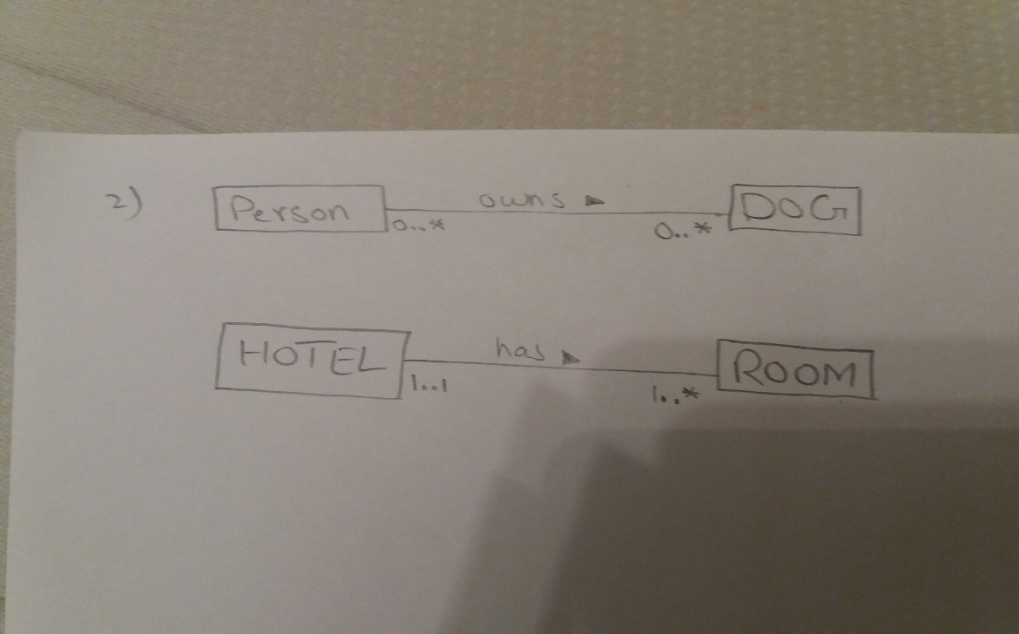

1. **Clubs**

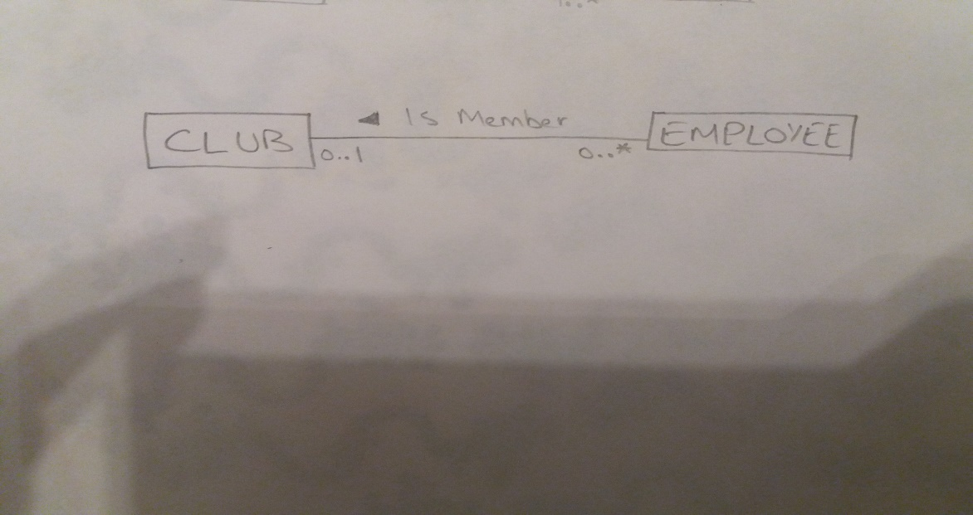

1. **Company**

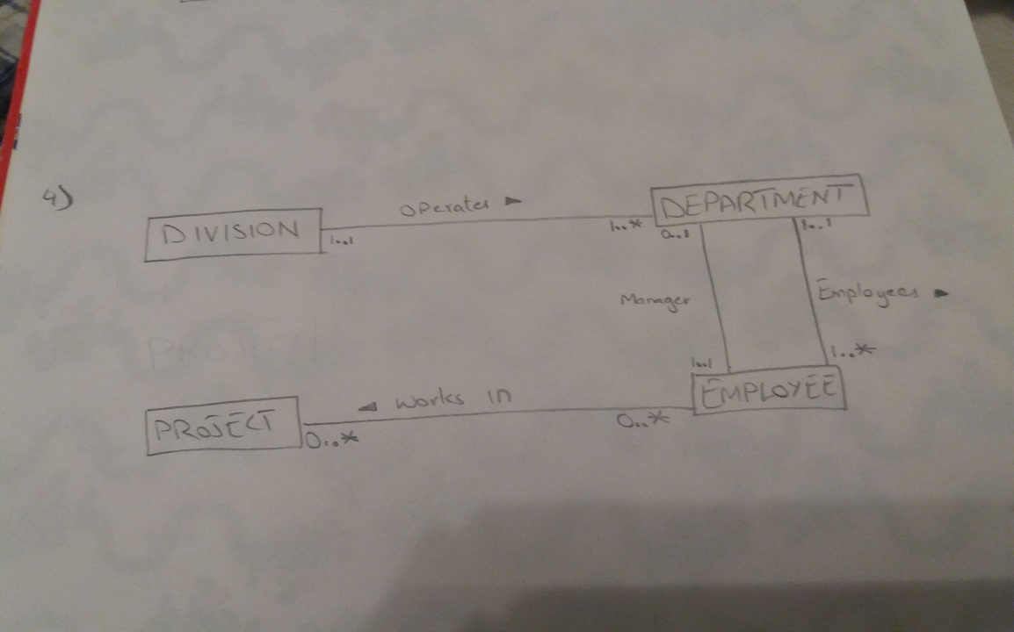

1. **Orchestra**

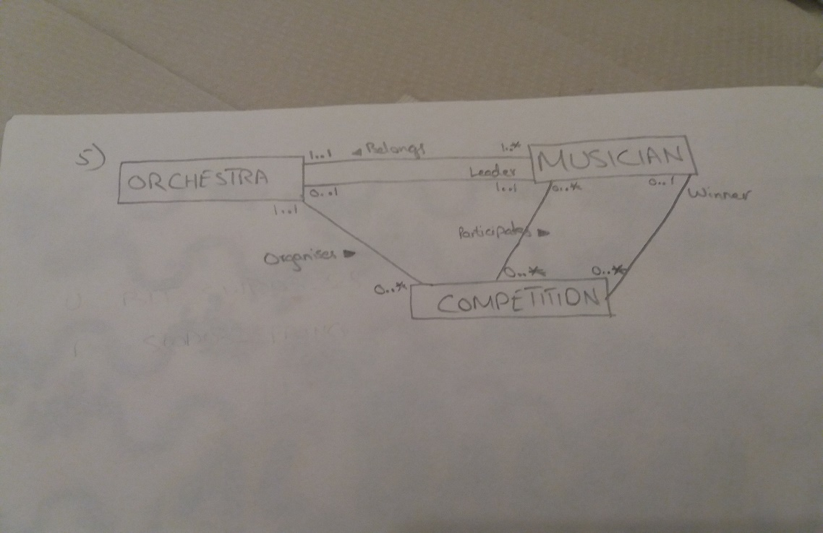

1. **Simple Library**