**RDB_Diagram**

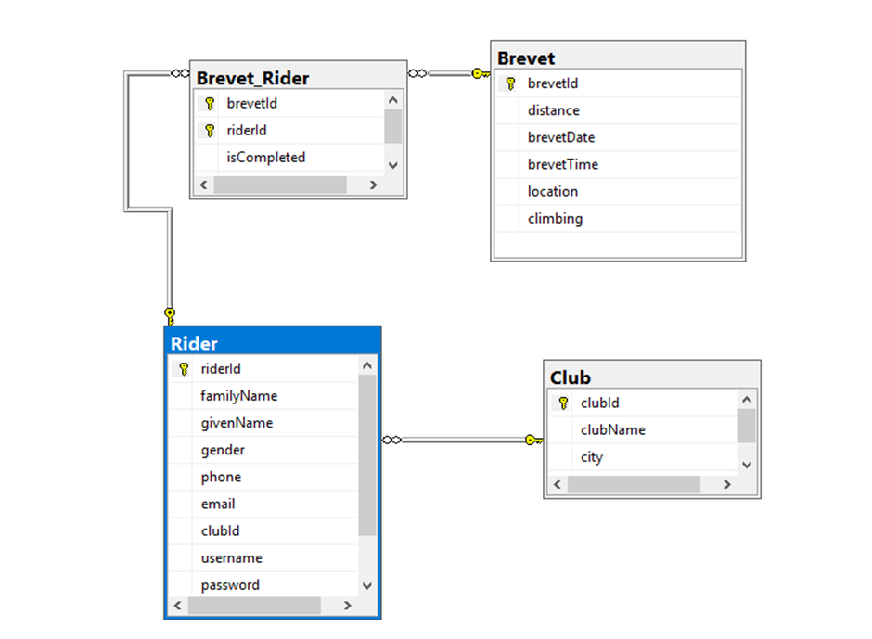

1. **Creating tables**

CREATE TABLE Brevet (

brevetId INTEGER NOT NULL IDENTITY,

distance INTEGER NOT NULL,

brevetDate DATE NOT NULL,

brevetTime TIME NOT NULL,

location VARCHAR(50) NOT NULL,

climbing INTEGER NOT NULL,

CONSTRAINT pk_Brevet PRIMARY KEY(brevetId),

CONSTRAINT ck_Brevet_distance CHECK(distance IN (200, 300, 400, 600, 1000, 1200)),

CONSTRAINT ck_Brevet_climbing CHECK(climbing BETWEEN 0 AND 99999)

);

CREATE TABLE Club (

clubId INTEGER NOT NULL IDENTITY,

clubName VARCHAR(50) NOT NULL,

city VARCHAR(50) NOT NULL,

email VARCHAR(50) NOT NULL,

CONSTRAINT pk_Club PRIMARY KEY(clubId),

CONSTRAINT u_Club UNIQUE(clubName)

) ;

CREATE TABLE Rider (

riderId INTEGER NOT NULL IDENTITY,

familyName VARCHAR(50) NOT NULL,

givenName VARCHAR(50) NOT NULL,

gender CHAR(1) NOT NULL,

phone VARCHAR(20),

email VARCHAR(50),

clubId INTEGER NOT NULL,

username VARCHAR(50) NOT NULL,

password VARCHAR(50) NOT NULL,

role VARCHAR(5) NOT NULL,

CONSTRAINT pk_Rider PRIMARY KEY(riderId),

CONSTRAINT fk_Rider_Club FOREIGN KEY(clubId) REFERENCES Club(clubId),

CONSTRAINT u_Rider UNIQUE(username),

CONSTRAINT ck_Rider_gender CHECK(gender IN ('F', 'M')),

CONSTRAINT ck_Rider_role CHECK(role IN ('user', 'admin'))

) ;

CREATE TABLE Brevet_Rider (

brevetId INTEGER NOT NULL,

riderId INTEGER NOT NULL,

isCompleted CHAR(1) NOT NULL,

finishingTime TIME NOT NULL,

CONSTRAINT PK_Brevet_Rider PRIMARY KEY(brevetId, riderId),

CONSTRAINT fk_Brevet_Rider_Brevet FOREIGN KEY(brevetId) REFERENCES Brevet(brevetId),

CONSTRAINT fk_Brevet_Rider_Rider FOREIGN KEY(riderId) REFERENCES Rider(riderId),

CONSTRAINT ck_Brevet_Rider CHECK(isCompleted IN ('N', 'Y'))

);

1. **Inserting Data**

insert into Brevet (distance, brevetDate, brevetTime, location, climbing)

values ('200', '2018-12-12', '14:00', 'Helsinki', '1200');

insert into Brevet (distance, brevetDate, brevetTime, location, climbing)

values ('300', '2018-10-02', '09:00', 'Porvoo', '12800');

insert into Brevet (distance, brevetDate, brevetTime, location, climbing)

values ('400', '2018-02-16', '17:00', 'Espoo', '4200');

insert into Club (clubName, city, email)

values ('ABClub', 'Helsinki', 'abclub@hotmail.com');

insert into Club (clubName, city, email)

values ('CrazyMonkey', 'Moscow', 'crazymonkey@hotmail.ru');

insert into Club (clubName, city, email)

values ('SuomiSport', 'Turku', 'suomisport@hotmail.fi');

insert into Rider (familyName, givenName, gender, phone, email, clubId, username, password, role)

values ('Johnson', 'John', 'M', '+12345678', 'johnjohnson@hotmail.com', '1', 'JohnJohson', '1q2w3e4r', 'user');

insert into Rider (familyName, givenName, gender, phone, email, clubId, username, password, role)

values ('Poppins', 'Mary', 'F', '+87654433', 'marypoppins@hotmail.uk', '3', 'Sweetheart', 'milkyway2018', 'admin');

insert into Brevet_Rider (brevetId, riderId, isCompleted, finishingTime)

values ('1', '2', 'Y', '19:45');

insert into Brevet_Rider (brevetId, riderId, isCompleted, finishingTime)

values ('2', '2', 'N', '17:55');

insert into Brevet_Rider (brevetId, riderId, isCompleted, finishingTime)

values ('1', '1', 'Y', '13:45');

1. **Checking constraints out**

--invalid data--

insert into Brevet (distance, brevetDate, brevetTime, location, climbing)

values ('700', '2018-12-12', '14:00', 'Helsinki', '1200');

insert into Rider (familyName, givenName, gender, phone, email, clubId, username, password, role)

values ('Johnson', 'John', 'W', '+12345678', 'johnjohnson@hotmail.com', '1', 'MaryJohson', '1q2w3e4r', 'user');

insert into Brevet (distance, brevetDate, brevetTime, location, climbing)

values ('700', '2018-12-12', '14:00', 'Helsinki', '1000000');

insert into Rider (familyName, givenName, gender, phone, email, clubId, username, password, role)

values ('Johnson', 'John', 'M', '+12345678', 'johnjohnson@hotmail.com', '1', 'LeenaJohson', '1q2w3e4r', 'guest');

insert into Brevet_Rider (brevetId, riderId, isCompleted, finishingTime)

values ('3', '4', 'W', '19:45');