1. SELECT * FROM Campus;

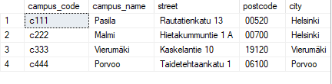

1. SELECT city, campus_name FROM Campus ORDER BY city, campus_name;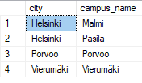
2. SELECT * FROM SanctionType ORDER BY sanction_code DESC;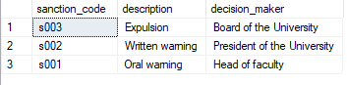
3. SELECT description FROM MisconductType ORDER BY description ASC;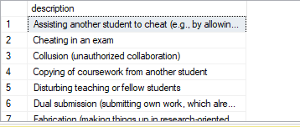
4. SELECT surname, first_name, teacher_number FROM Teacher ORDER BY surname, first_name, teacher_number ASC;

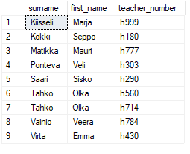

1. SELECT student_number, surname, first_name, birth_date, gender FROM Student WHERE gender = 'F' ORDER BY student_number ASC;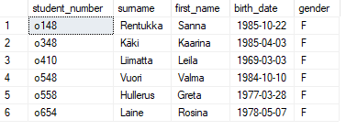
2. 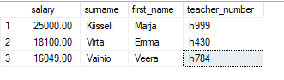SELECT salary, surname, first_name, teacher_number FROM Teacher WHERE salary > 16000 ORDER BY salary DESC;
3. SELECT teacher_number, first_name, surname FROM Teacher WHERE first_name = 'Veera';
4. 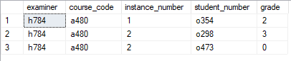SELECT examiner, course_code, instance_number, student_number, grade FROM CourseGrade WHERE examiner = 'h784' ORDER BY course_code, instance_number, student_number ASC;
5. SELECT start_date, end_date, course_code, instance_number FROM CourseInstance WHERE start_date >= '2007-01-01' AND end_date <= '2007-12-30' ORDER BY start_date, end_date, course_code, instance_number ASC;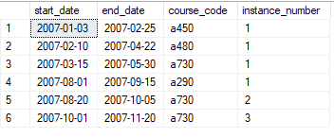
6. SELECT gender, birth_date, surname, first_name FROM Student WHERE surname BETWEEN 'A' AND 'L' ORDER BY gender DESC;