4.1 SELECT SUM(participants) AS "Number of Participants", course_code

FROM CourseInstance

GROUP BY course_code

ORDER BY "Number of Participants" DESC, course_code ASC

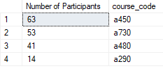

4.2 SELECT COUNT(grade) AS "Number of grades", student_number

FROM CourseGrade

WHERE grade > 0

GROUP BY student_number

ORDER BY "Number of grades" DESC, student_number ASC

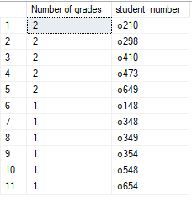

4.3(a) SELECT AVG(grade) AS "Average Grade", student_number

FROM CourseGrade

GROUP BY student_number

ORDER BY student_number ASC

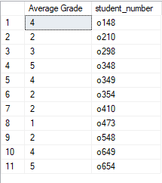

4.3(b) SELECT CAST(AVG(grade * 1.0) AS DECIMAL(4,2)) AS "Average Grade", student_number

FROM CourseGrade

GROUP BY student_number

ORDER BY student_number ASC

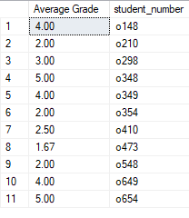

4.4 SELECT COUNT(instance_number) AS "Number of Course Instances", teacher_number

FROM CourseInstance

WHERE teacher_number is not NULL

GROUP BY teacher_number

ORDER BY teacher_number

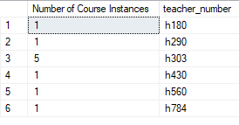

4.5 SELECT COUNT(DISTINCT(course_code)) AS "Number of Different Courses", teacher_number

FROM CourseInstance

WHERE teacher_number is not NULL

GROUP BY teacher_number

ORDER BY "Number of Different Courses" DESC, teacher_number ASC

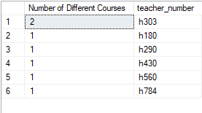

4.6