5.1

SELECT teacher.teacher_number, surname, first_name, CourseInstance.instance_number, CourseInstance.course_code

FROM Teacher

JOIN CourseInstance ON (CourseInstance.teacher_number = Teacher.teacher_number)

ORDER BY surname, first_name, course_code, instance_number;

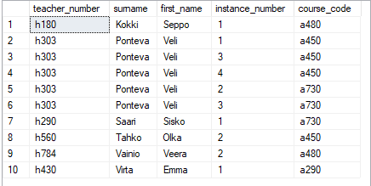

5.2

SELECT course_code, course_name, CONCAT (Teacher.surname, ', ', Teacher.first_name) AS "Person in Charge"

FROM Course

JOIN Teacher ON (Teacher.teacher_number = Course.person_in_charge)

ORDER BY course_code ASC;

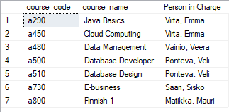

5.3

SELECT surname, first_name, Student.student_number, CAST(AVG(grade * 1.0) AS DECIMAL(4,2)) AS "Grade Point Average"

FROM Student

JOIN CourseGrade ON (CourseGrade.student_number = Student.student_number)

GROUP BY Student.student_number, Student.first_name, Student.surname

ORDER BY surname, first_name, student_number ASC;

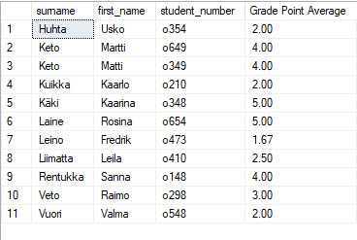

5.4a

SELECT surname, first_name, AcademicAdvisor.teacher_number, AcademicAdvisor.start_date, AcademicAdvisor.end_date

FROM Teacher

JOIN AcademicAdvisor ON (AcademicAdvisor.teacher_number = Teacher.teacher_number)

WHERE AcademicAdvisor.end_date IS NULL

ORDER BY surname, first_name, teacher_number ASC;

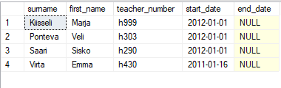

5.4b

SELECT surname, first_name, AcademicAdvisor.teacher_number, AcademicAdvisor.start_date, AcademicAdvisor.end_date

FROM Teacher

JOIN AcademicAdvisor ON (AcademicAdvisor.teacher_number = Teacher.teacher_number)

ORDER BY surname, first_name, teacher_number ASC;

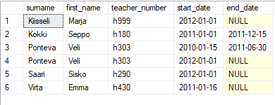

5.5

SELECT description AS "Misconduct occured this far"

FROM MisconductType

JOIN MisconductIncident ON ( MisconductIncident.misconduct_code = MisconductType.misconduct_code )

WHERE decision_date IS NOT NULL

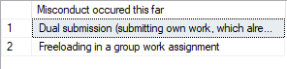

5.6