Hi Naeem, I tried to email you but realise the pages I want to send over is very blur.

For the Dashboard, can we do something like the one below?

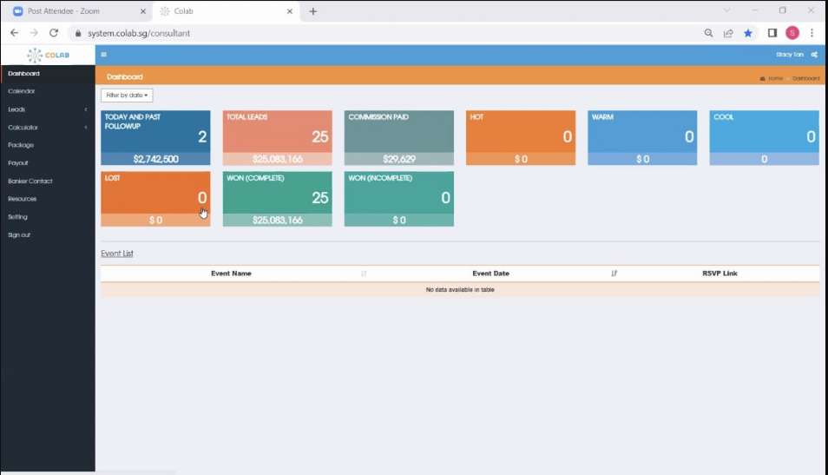

I don’t want the calendar as per the screenshot above.

Others in the column, can we add in? I cannot copy exactly the same as this is what my competitor company firm is using.

But the idea of the system I will like to have is the same.

This is how the leads will be displayed

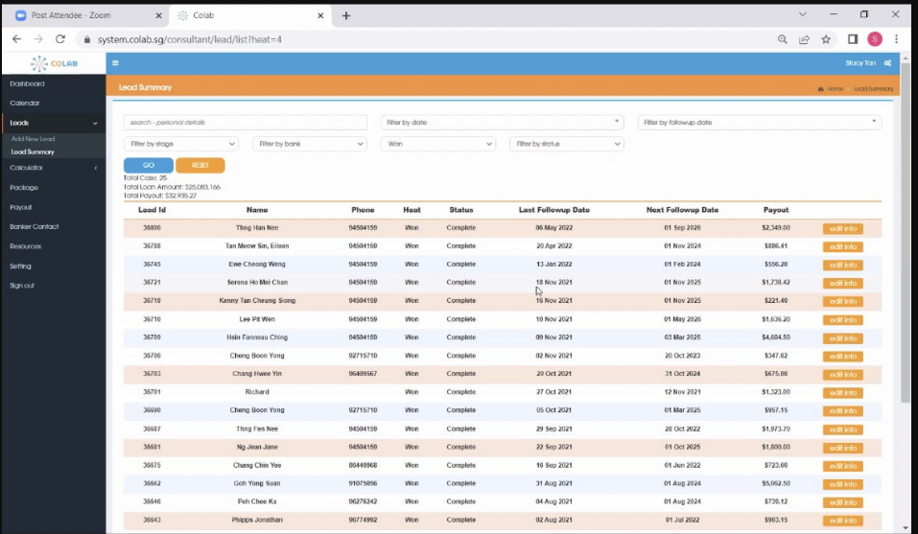

The word “won” means closed.

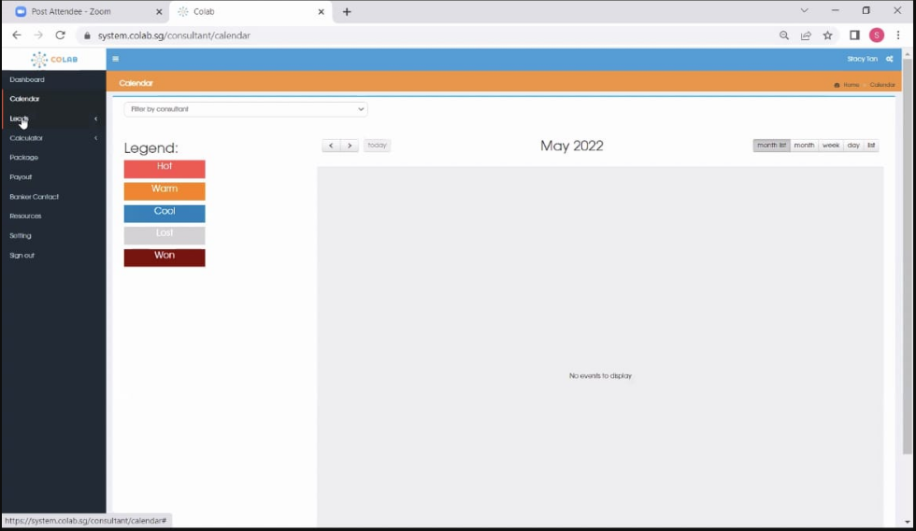

These are the information needed for the staff to key in for a new lead / new case.

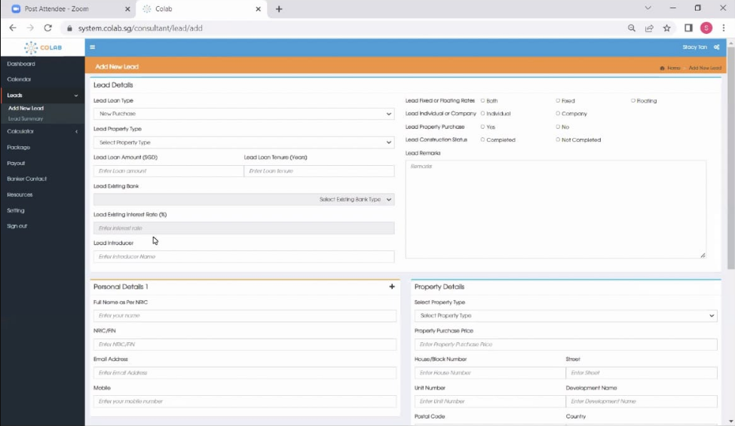

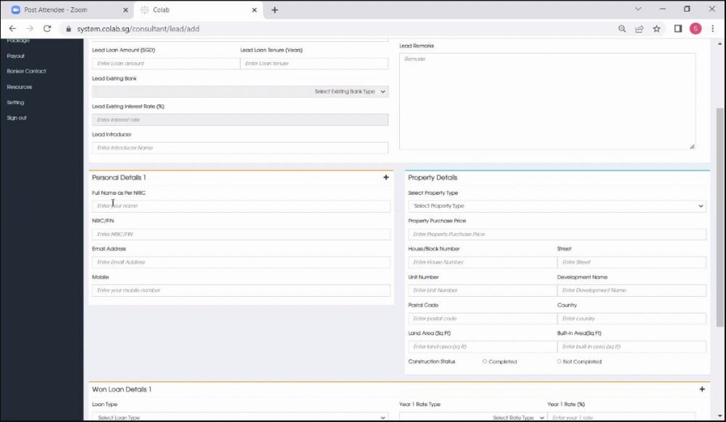

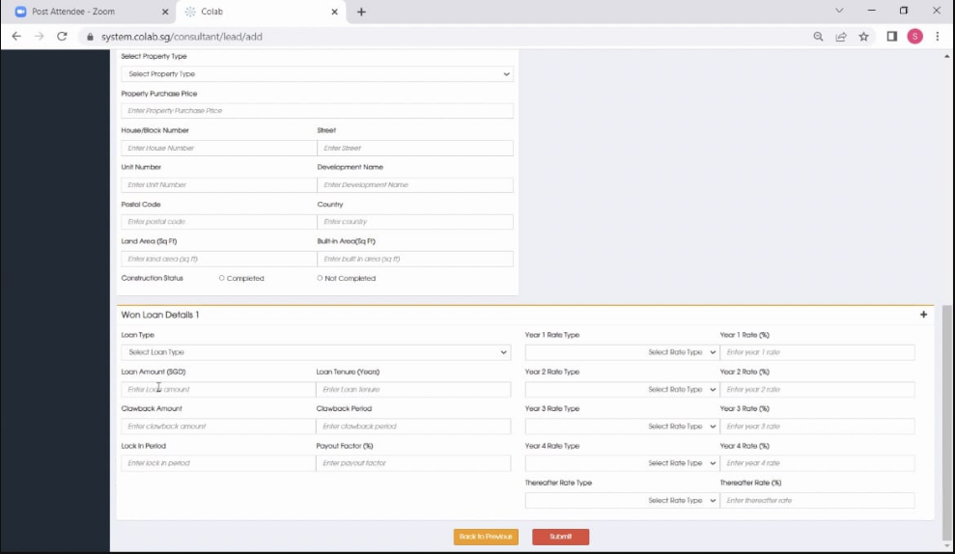

This is the home loan calculator that the system is inbuilt to tabulate whether client can take up how much loan or totally not eligible.

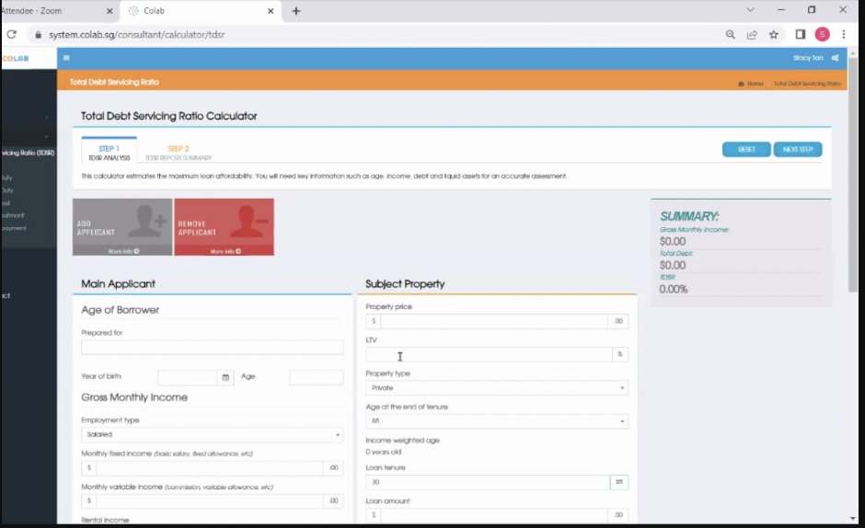

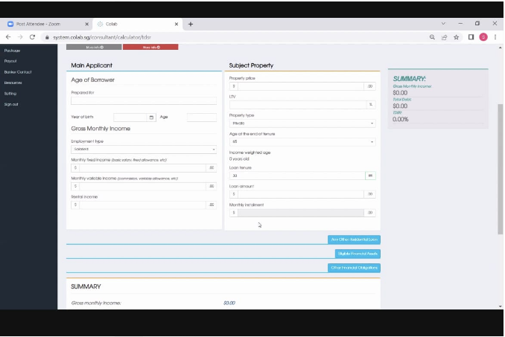

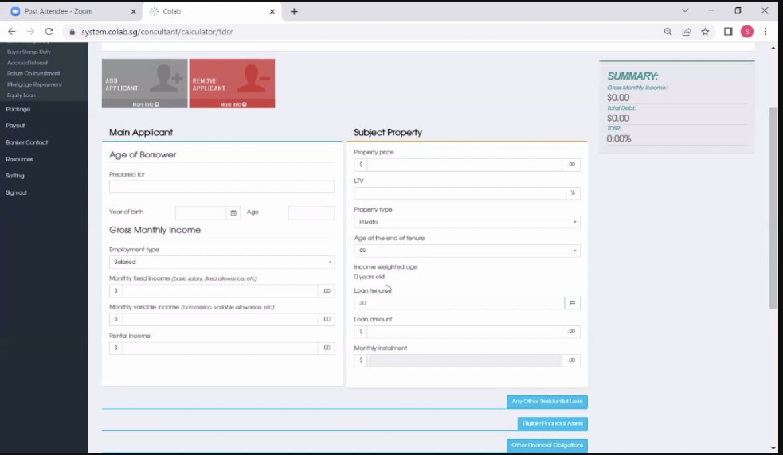

This is the one where all the 16 banks home loan rates and commecial loans rates are seen and can be filtered.

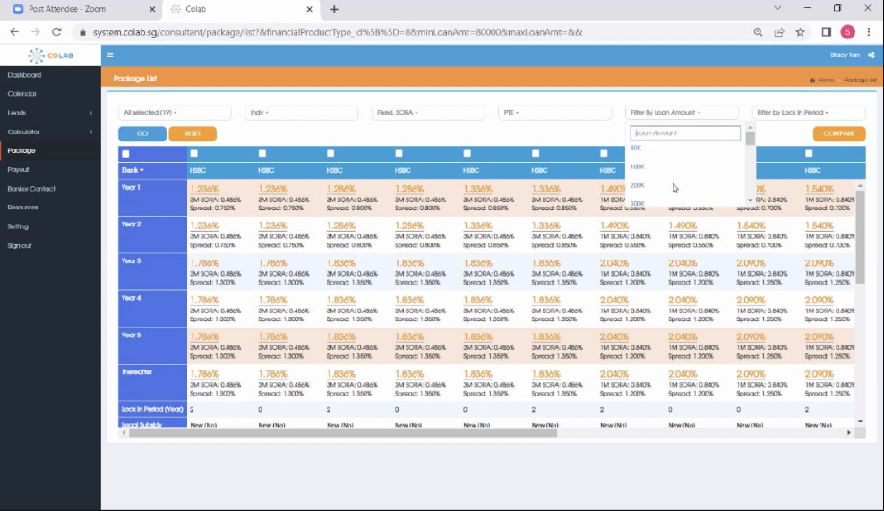

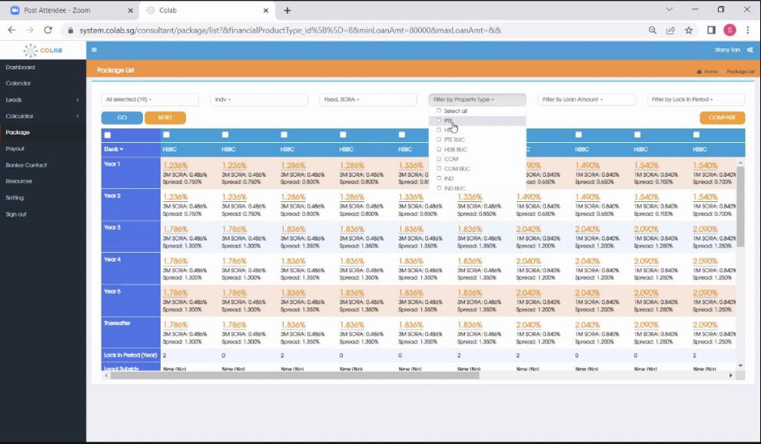

Once you select the packages you want to email the customer, the box like this will pop out and auto generate into an email for you to prepare your contents before sending.

