**TASK 03**

**DOCKER IMAGE DEPLOYMENT USING KUBERNETES AIM:**

**Navaneethakrishnan MK**

**22ISR031**

The objective is to push a Docker image to Docker Hub and deploy it on Minikube to ensure that the application runs successfully in a Kubernetes environment. This involves:

**Building & Pushing Docker Image:**

Creating a Docker image of the application.

Pushing the image to Docker Hub for accessibility.

CREATING A MINIKUBE SERVICE TO HANDLE CONTAINERS

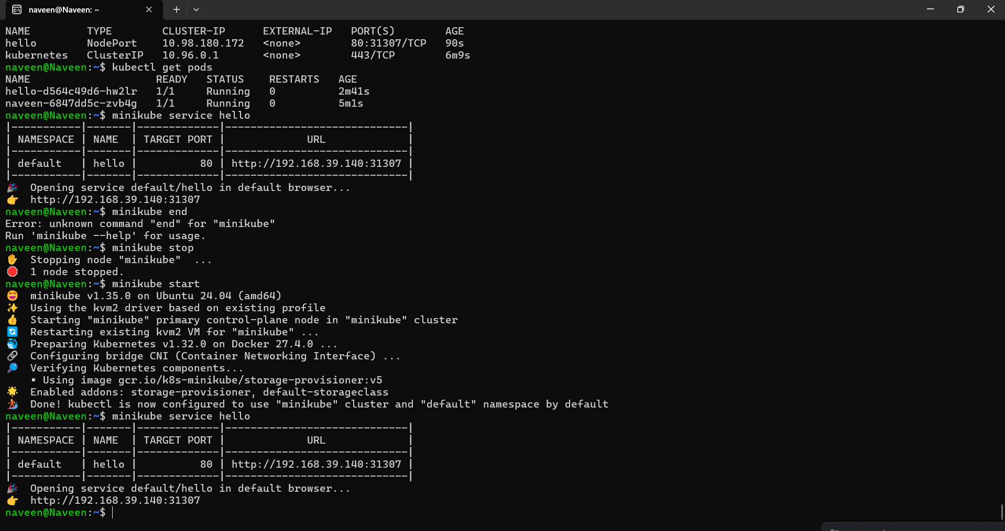

Creating a deployment



To expose deployment



To get the service

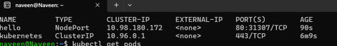

Opening the minikube service

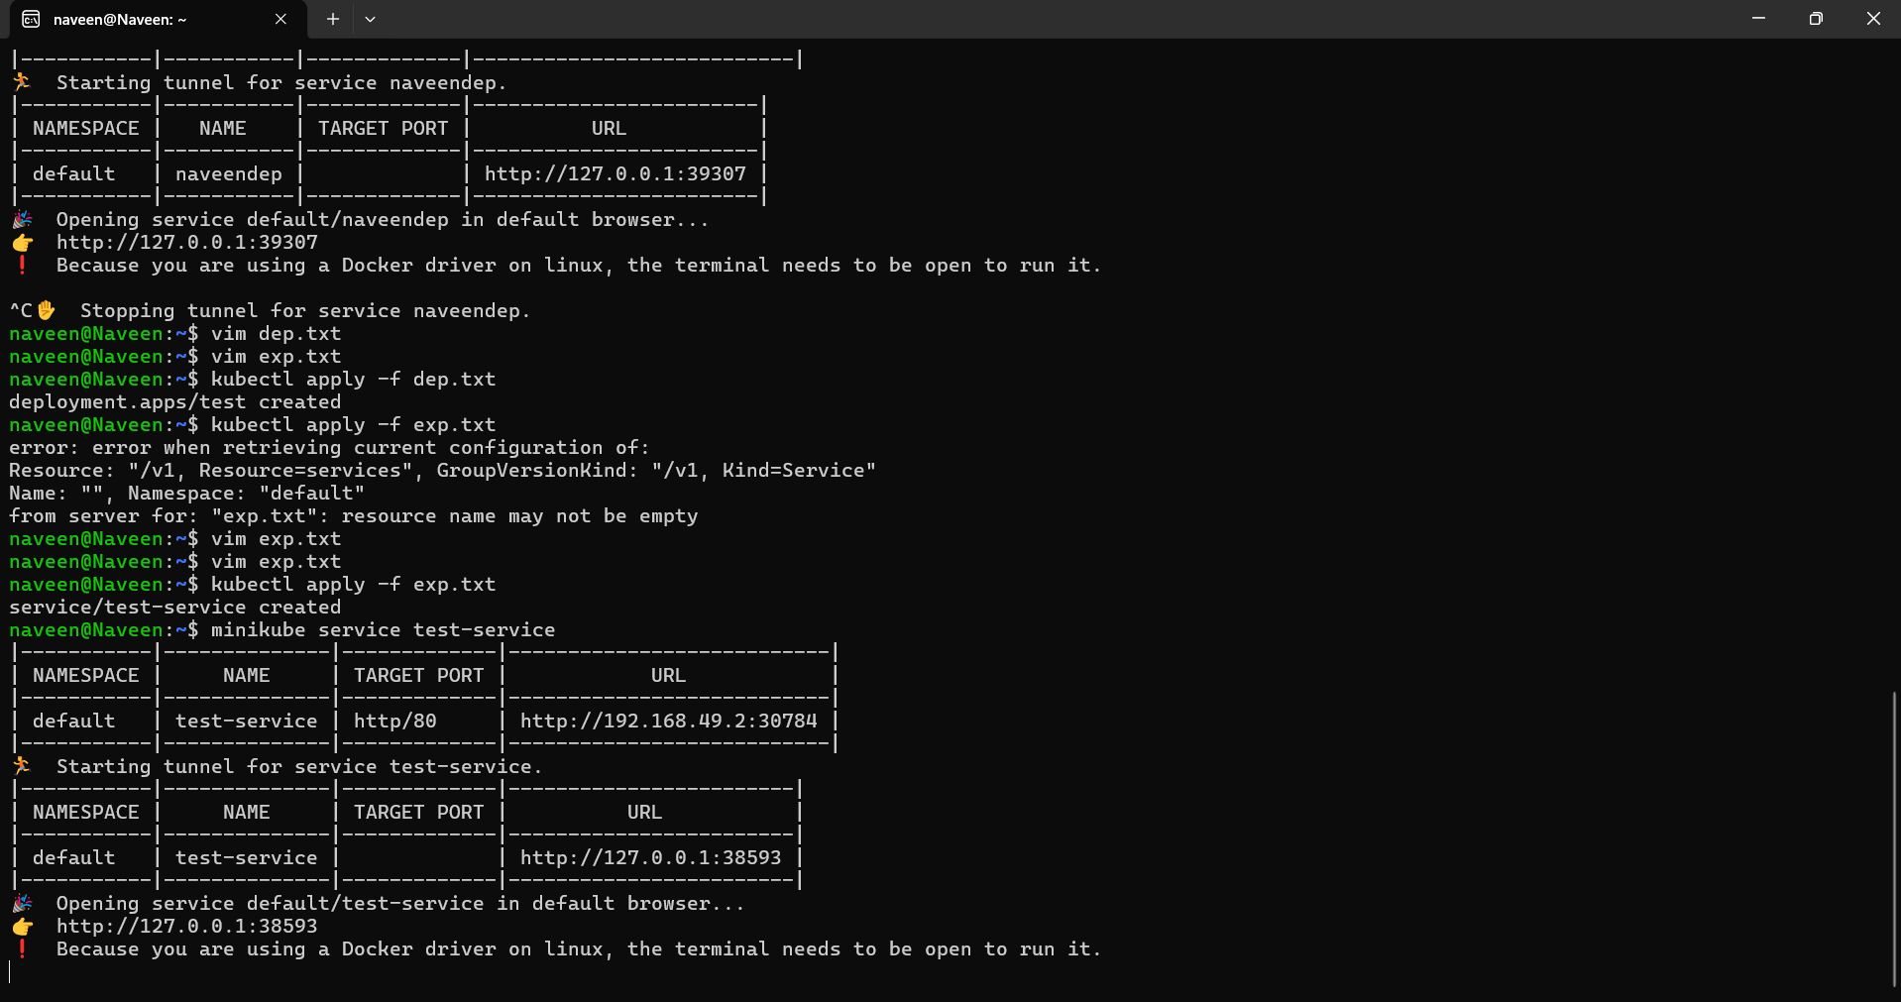

Localhost output

