**Task – 4 Navaneethakrishnan MK**

**22ISR031**

Deploying a sample application using Kubernetes

Introduction

This guide outlines the steps to deploy a sample application using Kubernetes. It

covers setting up a Deployment and a Service configuration, applying them with

kubectl, and accessing the deployed application through Minikube. Additionally, it

includes best practices for monitoring, scaling, and troubleshooting Kubernetes

deployments.

● Set Up Kubernetes Environment – Install and start Minikube and kubectl.

● Create a Deployment – Define a YAML file to manage application pods.

● Expose the Application – Configure a Service to enable network access.

● Apply Configurations – Use kubectl apply to deploy resources.

● Verify Deployment – Check pod status, logs, and resource utilization.

● Access the Application – Retrieve the Minikube service URL for

interaction.

● Scale the Deployment – Adjust replicas for better availability and load

balancing.

● Monitor and Troubleshoot – Use kubectl logs, kubectl describe, and

dashboards to resolve issues.

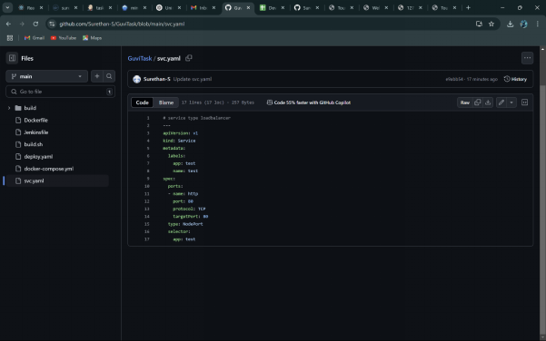

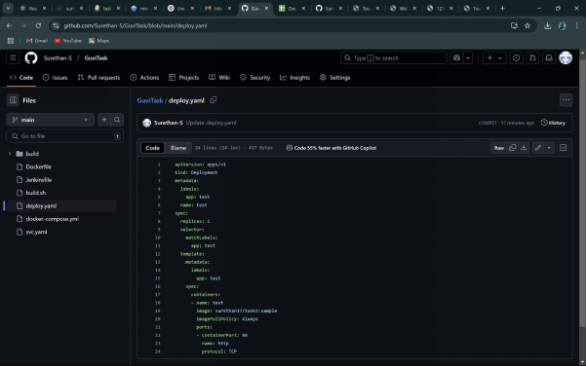

Deployment text file



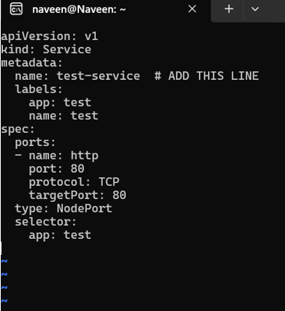

Expose file



