1. Write a C++ program to find the largest and smallest element of a given array of integers.

Code:

//862041_Naveen Kumar Tyagi_Section F

#include<iostream>

using namespace std;

int main(){

cout<<"862041_Naveen Kumar Tyagi\n";

int n; //n is to store size of array

cout<<"Enter size of array: ";

cin>>n;

int arr[n]; //declaration of arr array

cout<<"Enter elements of array: ";

//to store elements in array arr

for(int i=0;i<n;i++){

cin>>arr[i];

}

int max=arr[0],min=arr[0]; /*assuming first element of array be maximum and minimum*/

//to find the greatest and smallest number in array

for(int i=1;i<n;i++){

/*compare each element with the max and if element is greater then it store to max

. Then the max will compare to rest elements*/

if(max<arr[i]){

max=arr[i];

}

/*compare each element with the min and if element is smaller then it store to min

. Then the min will compare to rest elements*/

if(min>arr[i]){

min=arr[i];

}

}

cout<<"Maximum Element: "<<max<<"\n"

<<"Minimum Element: "<<min;

return 0;

}

Output:

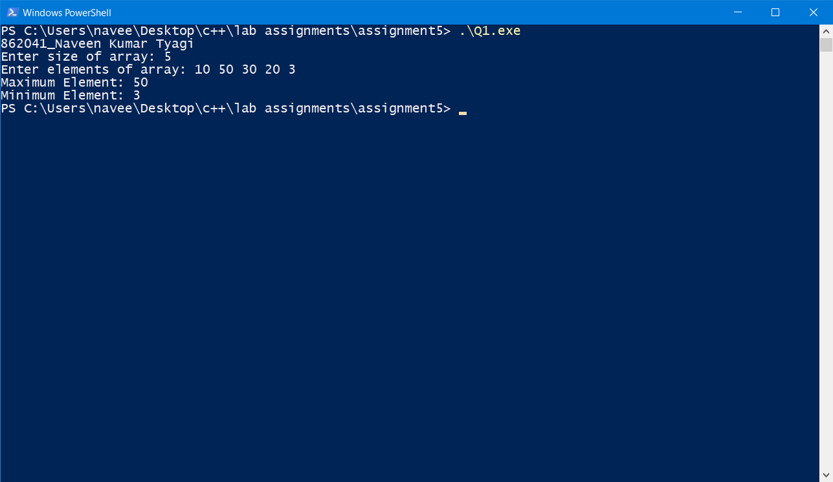

1. Write a program to find the frequency of a element in an array

Code:

//862041_Naveen Kumar Tyagi_Section F

#include<iostream>

using namespace std;

int main(){

cout<<"862041_Naveen Kumar Tyagi\n";

int n,k,counter=0;

cout<<"Enter size of array: ";

cin>>n; //n stores size of array

int arr[n]; //declaration of array

cout<<"Enter array Elements: ";

//to store elements of array

for(int i=0;i<n;i++){

cin>>arr[i];

}

cout<<"Enter element of which frequency want to find: ";

cin>>k; //element ,of which frequency we want to find

//for loop to count the frequency of k

for(int i=0;i<n;i++){

if(arr[i]==k){ //increase counter by one if k found

counter++;

}

}

cout<<k<<" occurs "<<counter<<" times.";

return 0;

}

Output:

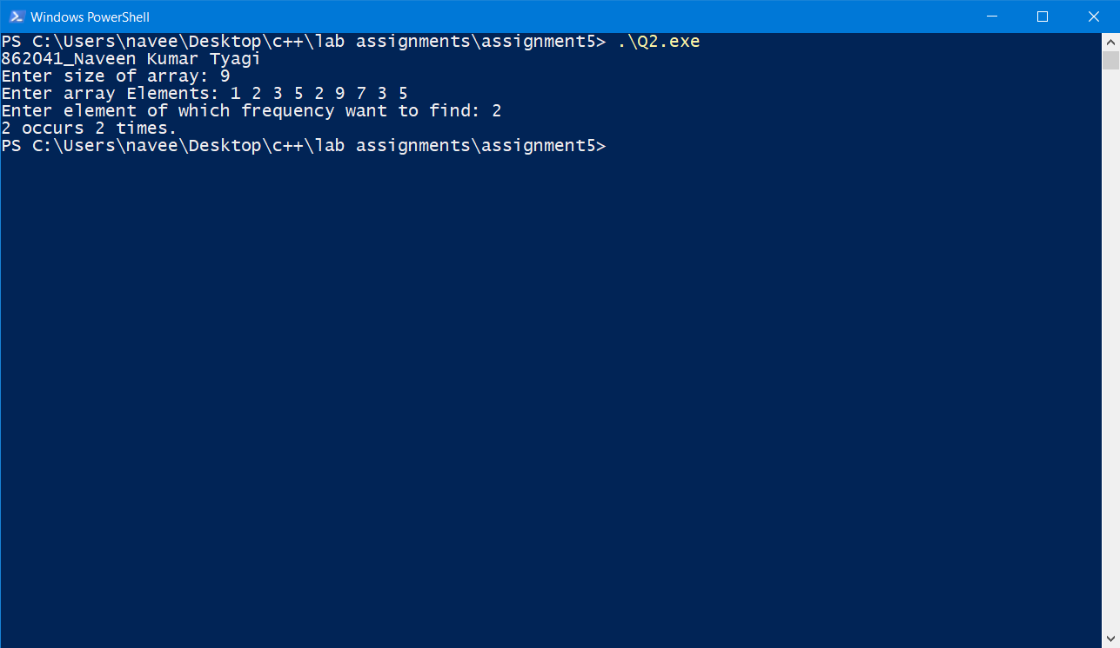

1. Write a C++ program to separate even and odd numbers of an array of integers. Put all even numbers first, and then odd numbers.

Code:

//862041_Naveen Kumar Tyagi_Section F

#include<iostream>

using namespace std;

int main(){

cout<<"862041_Naveen Kumar Tyagi\n";

int n;

cout<<"Enter size of array: ";

cin>>n; //n store size of array

int arr[n];

cout<<"Enter elements of array: ";

//to take input from user

for(int i=0;i<n;i++){

cin>>arr[i];

}

cout<<"Even numbers of the array: ";

//for loop to print out even numbers

for(int i=0;i<n;i++){

if(arr[i]%2==0){

cout<<arr[i]<<" ";

}

}

cout<<"\nOdd numbers of the array: ";

//for loop to print out odd numbrs

for(int i=0;i<n;i++){

if(arr[i]%2==1){

cout<<arr[i]<<" ";

}

}

return 0;

}

Output:

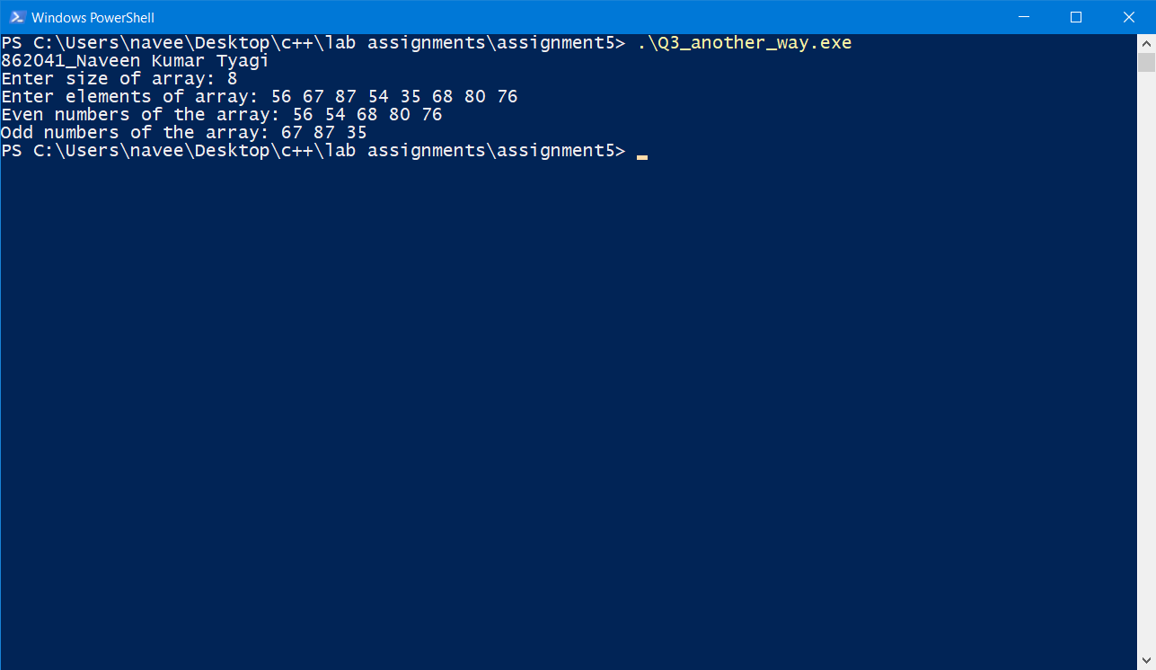

1. Write a C++ program to find kth largest elements in a given array of integers.

Code:

//862041_Naveen Kumar Tyagi_Section F

#include<iostream>

using namespace std;

int main(){

cout<<"862041_Naveen Kumar Tyagi\n";

int n,k;

cout<<"This program will print K th largest element.\n";

cout<<"Enter size of array: ";

cin>>n; // n store size of array

int arr[n];

cout<<"Enter elements of array: ";

//for loop to take input from user

for(int i=0;i<n;i++){

cin>>arr[i];

}

cout<<"Enter k: ";

cin>>k;

//selection sort to sort the array

for(int i=0;i<n-1;i++){

int min=arr[i];

int loc=i;

for(int j=i+1;j<n;j++){

if(min>arr[j]){

min=arr[j];

loc=j;

}

}

//swapping minimum term with the first of unsorted subarray

int temp=arr[i];

arr[i]=arr[loc];

arr[loc]=temp;

}

//printing k largest

cout<<arr[n-k];

return 0;

}

Output:

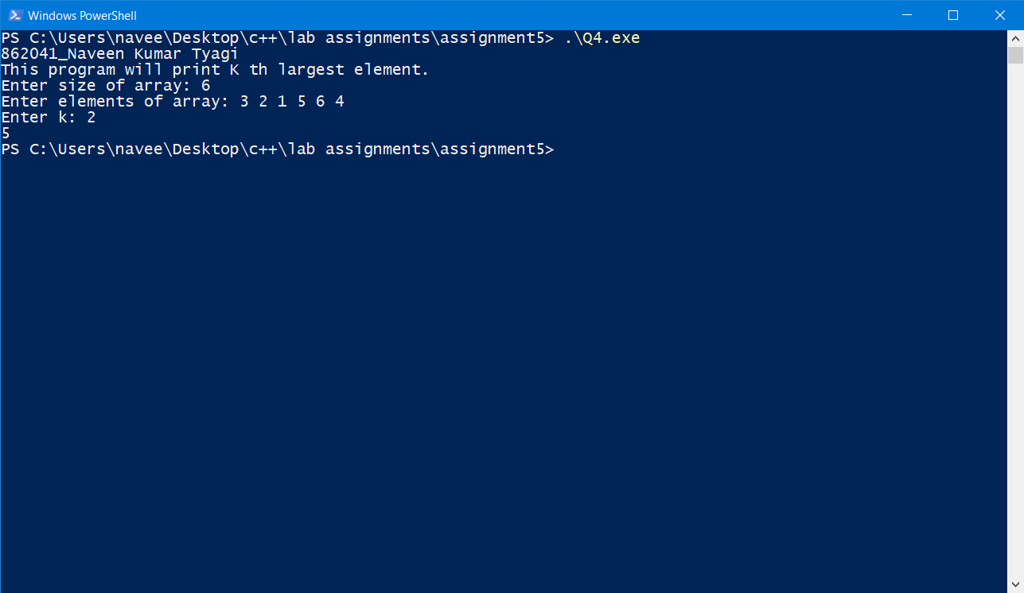

1. Write a c++ Program to Insert an Element in an Array

Code:

//862041_Naveen Kumar Tyagi_Section F

#include<iostream>

using namespace std;

int main(){

cout<<"862041_Naveen Kumar Tyagi\n";

int n,in,pos;

cout<<"Enter number of elements in array: ";

cin>>n; //n store number of elements of array the user will enter

int arr[n+1]; //declaration of array of size one greater than n

//to insert a element in the array later

cout<<"Enter array elements: ";

//for loop to take input and store elements in array

for(int i=0;i<n;i++){

cin>>arr[i];

}

cout<<"Enter element to insert: ";

cin>>in; //in store element which is to be inserted

cout<<"At what position: ";

cin>>pos; //store position at which element is to be inserted

//for loop to shift those elements to right by one

//which are at specified position and right of it

//so that element can be inserted at the required position

for(int i=n;i>pos-1;i--){

arr[i]=arr[i-1];

}

//inserting the element in array

arr[pos-1]=in;

cout<<"The New Array is: ";

for(int i=0;i<n+1;i++){

cout<<arr[i]<<" ";

}

return 0;

}

Output:

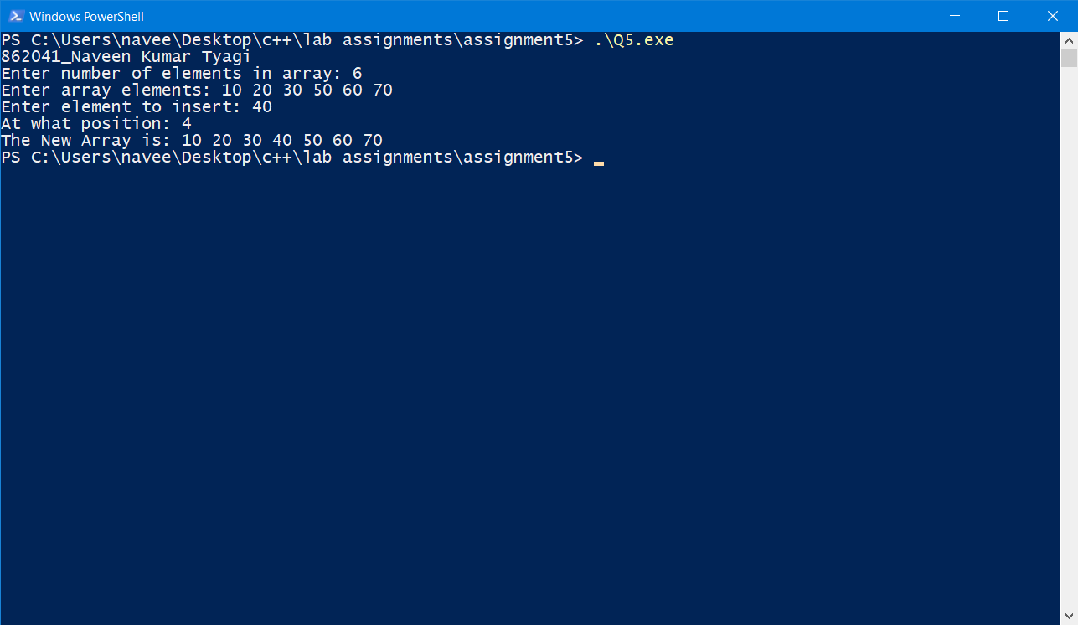

1. Write a C++ program to delete an element from an array

Code:

//862041_Naveen Kumar Tyagi

#include<iostream>

using namespace std;

int main(){

cout<<"862041_Naveen Kumar Tyagi\n";

int n,pos;

cout<<"Enter size of array: ";

cin>>n; // n store size of array

int arr[n];

cout<<"Enter array elements: ";

//for loop to take input from user

for(int i=0;i<n;i++){

cin>>arr[i];

}

//sorting the array by selection sort

for(int i=0;i<n-1;i++){

int min=arr[i];

int loc;

//find minimum element in unsorted subarray

for(int j=i;j<n;j++){

if(min>arr[j]){

min=arr[j];

loc=j;

}

}

//swapping minimum term with the first of unsorted subarray

int temp=arr[i];

arr[i]=arr[loc];

arr[loc]=temp;

}

cout<<"Sorted Array: ";

//for loop to print out the sorted array

for(int i=0;i<n;i++){

cout<<arr[i]<<" ";

}

cout<<"\nEnter position of element to delete: ";

cin>>pos;

//shifting elements by one to position specified

//in this way value at specified position by element

//which is at right of it

//we lost the value in other words we deleted that

for(int i=pos;i<n-1;i++){

arr[i]=arr[i+1];

}

//printing out the array

cout<<"New data in Array: ";

for(int i=0;i<n-1;i++){

cout<<arr[i]<<" ";

}

return 0;

}

Output:

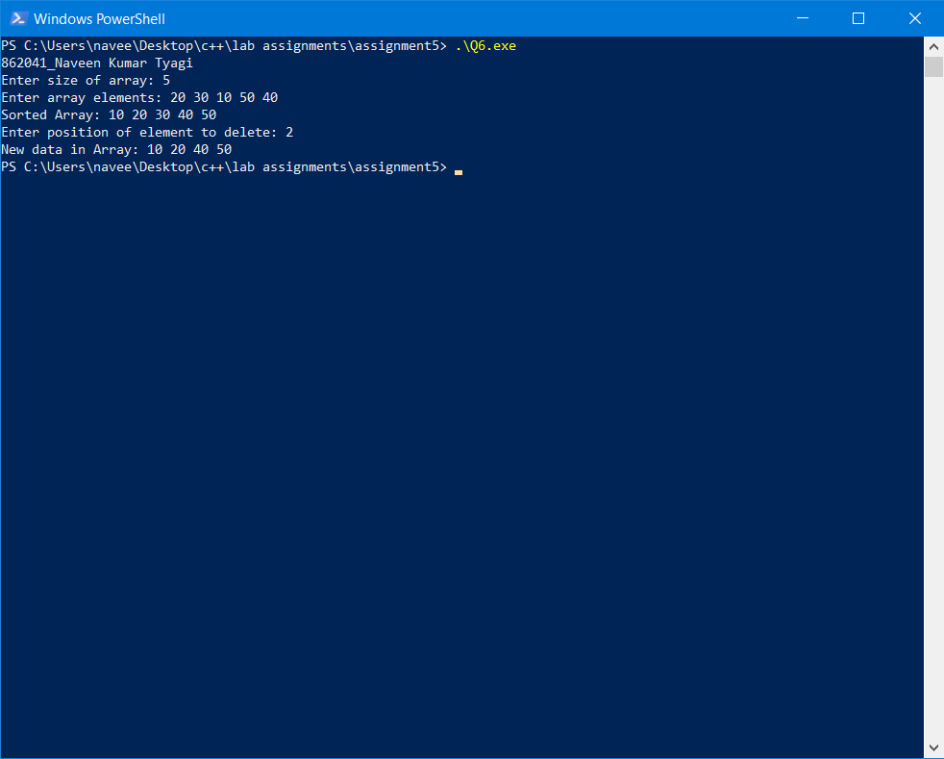

1. Write a program to read an Array and Search for an Element in the array and display the position of the element.

Code:

//862041_Naveen Kumar Tyagi

#include<iostream>

using namespace std;

int main(){

cout<<"862041_Naveen Kumar Tyagi\n";

int n,k;

cout<<"Enter size of array: ";

cin>>n; //store size of array

int arr[n];

cout<<"Enter elements of array: ";

//for loop to take input from user

for(int i=0;i<n;i++){

cin>>arr[i];

}

cout<<"Enter element to search: ";

cin>>k; // store element which is to be store

//for loop to search by linear search method

for(int i=0;i<n;i++){

// if element found it will show the index and break the loop

if(k==arr[i]){

cout<<k<<" is found at position "<<i+1;

break;

}

}

return 0;

}

Output:

