NAME: Naveen Kumar Tyagi
Roll No: 862041 Section: F

Q1. Write a C++ program to take the month in number and print the name of the month.

Code:

//862041_Naveen Kumar Tyagi
#include<iostream>
using namespace std;
int main(){
int num; //declaration of variable that will be used to store month number

cout<<"Enter month in number: "<<endl;
cin>>num; // store entered number in num

//switch statement to print month name corresponding to number
switch(num){
case 1:cout<<"January";
break;
case 2:cout<<"February";
break;
case 3:cout<<"March";
break;
case 4:cout<<"April";
break;
case 5:cout<<"May";
break;
case 6:cout<<"June";
break;
case 7:cout<<"July";
break;
case 8:cout<<"August";
break;
case 9:cout<<"September";
break;
case 10:cout<<"October";
break;
case 11:cout<<"November";
break;
case 12:cout<<"December";
break;
}
return 0;

}
Output:
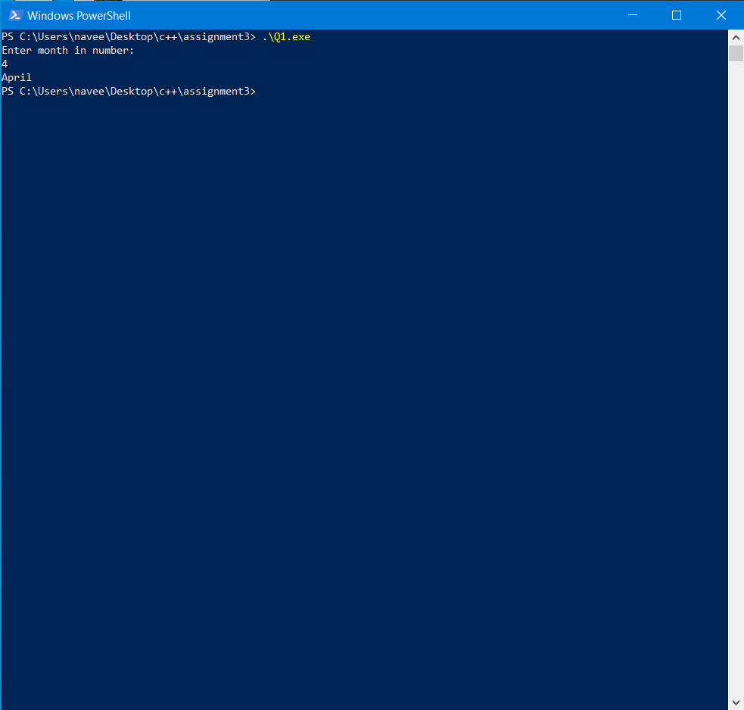

Q2. Any character is entered through the keyboard, write a program to determine whether the character entered is a capital letter, a small case letter, a digit or a special symbol.

The following table shows the range of ASCII values for various characters.

A - Z = 65 -90
a - z = 97 - 122
0 - 9 = 48 - 57
special symbols = 0 - 47, 58 - 64, 91 - 96, 123 - 127
Code:
//862041_Naveen Kumar Tyagi
#include<iostream>
using namespace std;

int main (){
char ch; //declaration of variable ch with datatype character
cout<<"Enter any character:";
cin>>ch; //store entered value in ch

//if statement to tell entered character is a special symbol
if ((ch>0 && ch<=47)||(ch>=58 && ch<=64)||(ch>=91 && ch<=96)||(ch>=123 && ch<=127)){
cout<<"\nCharacter is a special symbol";
}

// else if statement to tell entered Character is a digit
else if (ch>=48 && ch<=57){
cout<<"\nCharacter is a digit";
}

// else if statement to tell entered Character is a capital letter
else if (ch>=65 && ch<=90){
cout<<"\nCharacter is a capital letter";
}

// else if statement to tell entered Character is a small letter
else if (ch>=97 && ch<=122){
cout<<"\nCharacter is a small letter";
}

return 0;
}

Output:
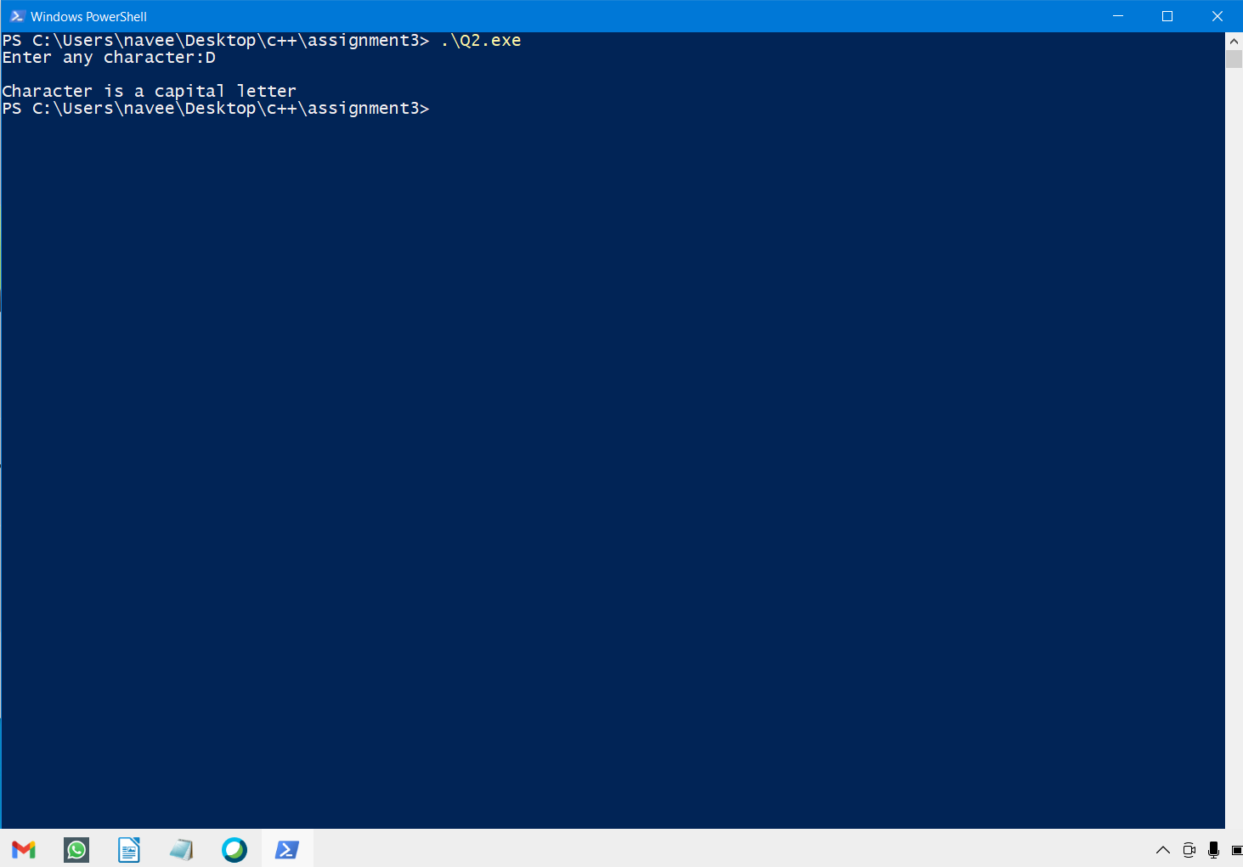

Q3. A certain grade of steel is graded according to the following conditions:
(i) Hardness must be greater than 50
(ii) Carbon content must be less than 0.7
(iii) Tensile strength must be greater than 5600

The grades are as follows:
Grade is 10 if all three conditions are met
Grade is 9 if conditions (i) and (ii) are met
Grade is 8 if conditions (ii) and (iii) are met
Grade is 7 if conditions (i) and (iii) are met
Grade is 6 if only one condition is met
Grade is 5 if none of the conditions are met

Write a program, which will require the user to give values of hardness, carbon content and tensile strength of the steel under consideration and output the grade of the steel
Code:
//862041_Naveen Kumar Tyagi
#include<iostream>
using namespace std;
int main(){
float hardness,c_content,ten_str; //declaration of required variables in this context
cout<<"This program is to determine grade of steel.";
cout<<"\nEnter hardness: ";
cin>>hardness; //store steel hardness in var. hardness

cout<<"\nEnter carbon content: ";
cin>>c_content; //store steel carbon content in var. c_content

cout<<"\nEnter tensile strength: ";
cin>>ten_str; //store steel tensile strength in var. ten_str

// if statements to print grade of steel corresponds to conditions satisfied

if((hardness>50)&&(c_content<0.7)&&(ten_str>5600)){
cout<<"\nGrade is "<<10;
}
else if((hardness>50)&&(c_content<0.7)){
cout<<"\nGrade is "<<9;
}
else if((c_content<0.7)&&(ten_str>5600)){
cout<<"\nGrade is "<<8;
}
else if((hardness>50)&&ten_str>5600){
cout<<"\nGrade is "<<7;
}
else if((hardness>50)||(c_content<0.7)||(ten_str>5600)){
cout<<"\nGrade is "<<6;
}
else{
cout<<"\nGrade is "<<5;
}

return 0;
}
Output:
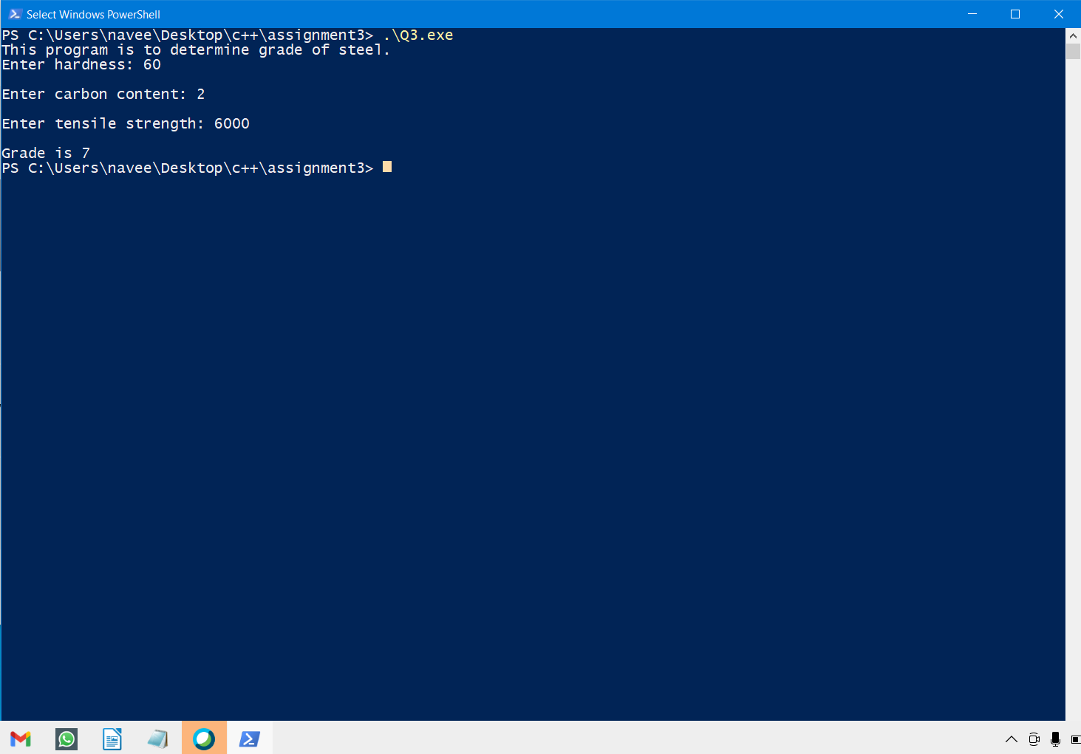

Q4. A library charges a fine for every book returned late. For the first 5 days the fine is 50 paise per day, for 6-10 days the fine is one rupee per day and above 10 days the fine is 5 rupees per day. If you return the book after 30 days your membership will be cancelled. Write a program to accept the number of days the member is late to return the book and display the fine or the appropriate message.

Code:
//862041_Naveen Kumar Tyagi
#include<iostream>
using namespace std;
int main(){
int days; //variable declaration
float fine;//variable declaration

cout<<"Enter number of days the member is late to return the book: ";
cin>>days; //store entered in number in days

//if statement to print fine and info about membership if if days<5
if(days<=5){
fine=0.5*days;
cout<<"\nFine is "<<fine<<" Rs.";
cout<<"\nMembership is not cancelled.";
}
//else if statement to print fine and info about membership if if 5<days<10
else if((days>=6)&&(days<=10)){
fine=0.5*5 +1*(days-5);
cout<<"\nFine is "<<fine<<" Rs.";
cout<<"\nMembership is not cancelled.";
}
//else if statement to print fine and info about membership if if 10<days<30
else if((days>=10)&&(days<=30)){
fine=0.5*5 +1*5 + 5*(days-10);
cout<<"\nFine is "<<fine<<" Rs.";
cout<<"\nMembership is not cancelled.";
}
//else statement to print fine and info about membership if if days>30
else{
fine=0.5*5 +1*5 + 5*(days-10);
cout<<"\nFine is "<<fine<<" Rs.";
cout<<"\nMembership is cancelled.";
}
return 0;
}

Output:
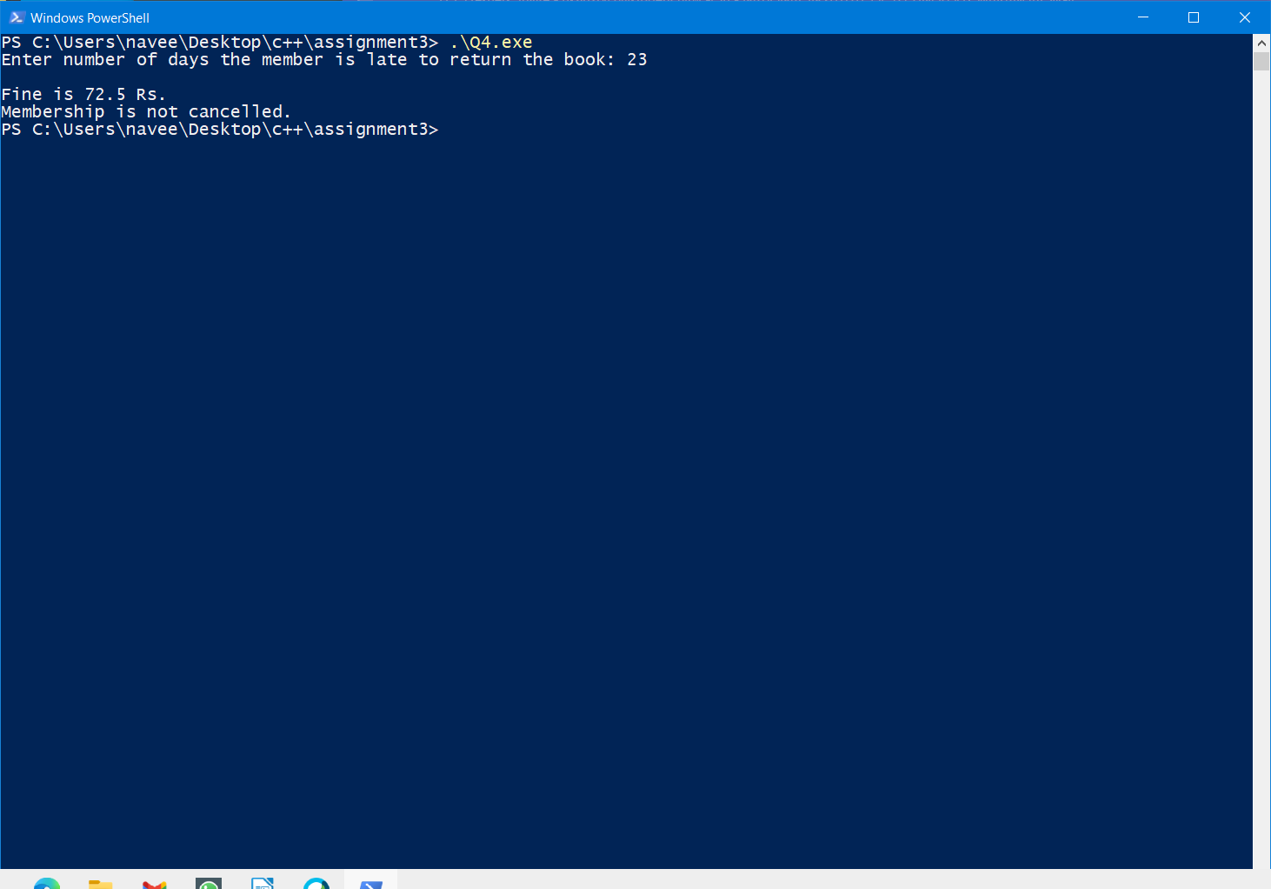

Q5. If a three digit number is input through the keyboard, write a C++ program to reverse the number. Find if the given number is a palindrome or not.
Code:

//862041_Naveen Kumar Tyagi
#include<iostream>
using namespace std;
int main(){
int num,d1,d2,d3,rev_num; //declaration of variables
cout<<"Enter a three digit number: ";
cin>>num; //store entered number in num

d1=num/100; //store first digit in d1
d2=(num/10)%10;// store second digit in d2
d3=num%10; //store third digit in d3

rev_num=d3*100+d2*10+d1; //store Reverse of given number in rev_num
cout<<"\nReverse of given number: "<<rev_num;

//if else statements to print whether the given number is palindrome or not
if(num==rev_num){
cout<<"\nGiven number is palindrome.";
}
else{
cout<<"\nGiven number is not palindrome.";
}
return 0;
}
Output:
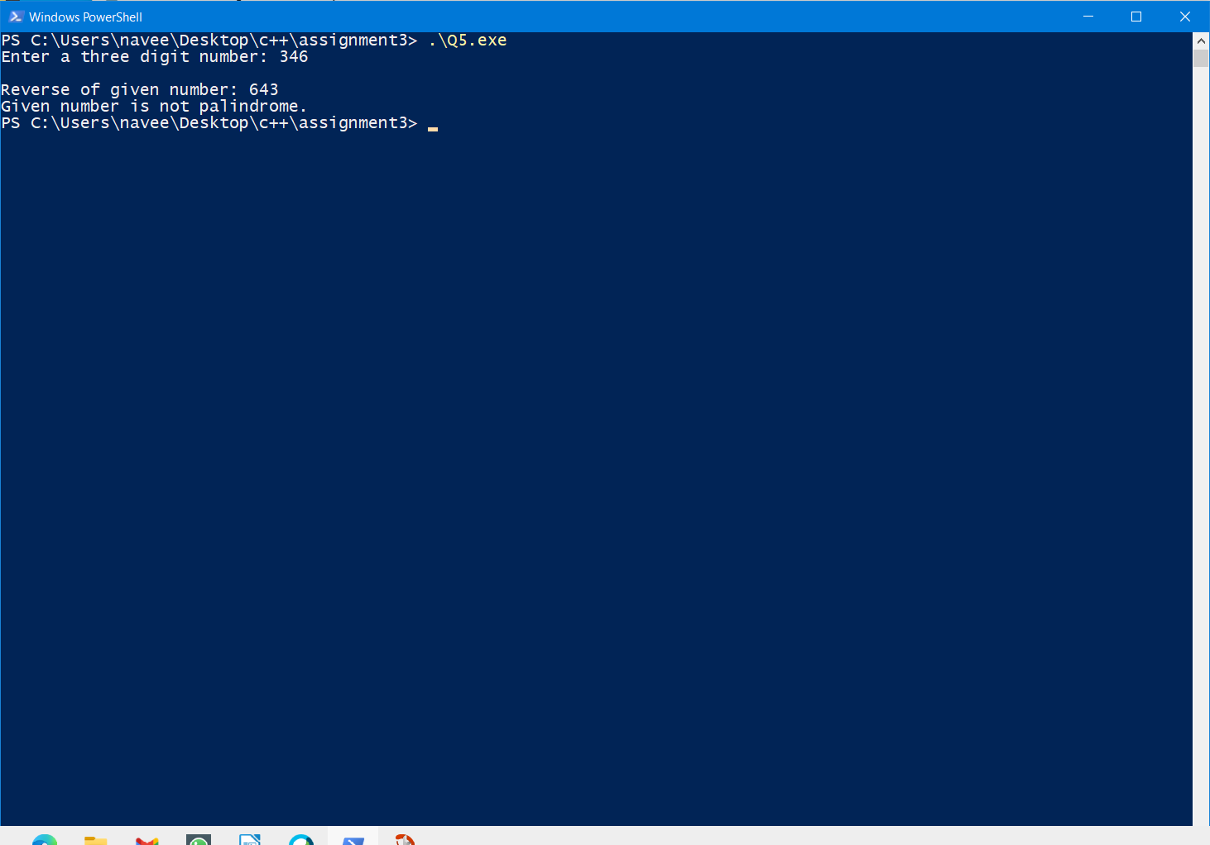

Q6. Write a program that reads an integer -n (decimal number system) and convert this decimal number to Binary, Octal, and Hexadecimal form.

Code:
//862041_Naveen Kumar Tyagi
#include<iostream>
using namespace std;
int main(){
int num,bin[100],i,num_bin;//declaration of variables,here bin[100] will store array of values
cout<<"Enter a number: ";
cin>>num; //store entered number in num
num_bin=num; // store num in num_bin so that num_bin can be used to get binary form without affecting num value

for(i=0;num_bin>0;i++){ //for loop to convert dec number in binary form
bin[i]=num_bin%2; //remainder will store in array
num_bin=num_bin/2;
}

cout<<"\nNumber in binary form: ";
for(i=i-1;i>=0;i--){ // for loop to print binary form of given number
cout<<bin[i];
}

cout<<"\nNumber in octal form: "<<std::oct<<num; //print given number in octal form
cout<<"\nNumber in hexadecimal form: "<<std::hex<<num; // print given number in hexadecimal form
return 0;
}

Output:
