RESULTS AND DISCUSSION
Figure 1: Energy and Actuation Characteristics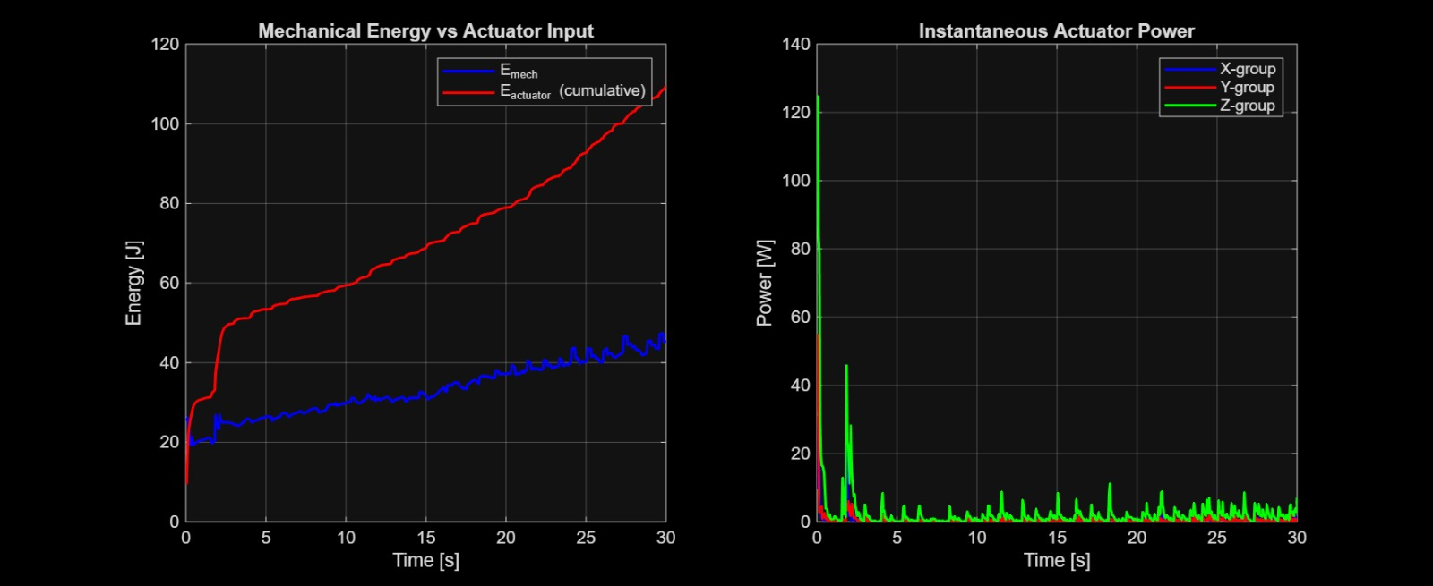
The energy characteristics of the system clearly distinguish between wind-driven propulsion and active control effort. The mechanical energy increases steadily over the simulation duration, indicating that the primary source of motion is the external wind acting on the structure. In contrast, the actuator energy remains significantly lower, with total control energy on the order of approximately 100-110 J over 30 s, confirming that actuation is not used for propulsion but for directional regulation. The instantaneous actuator power exhibits high peaks during the initial phase, corresponding to rapid structural adjustments required to initiate motion and bias the rolling direction, after which it reduces to low steady-state levels. This behavior indicates that the control strategy operates intermittently rather than continuously. Unlike conventional tensegrity robots that rely on sustained actuation for movement, the proposed system leverages environmental energy for propulsion while using minimal internal energy for control. This directly supports the core concept of the work, demonstrating that wind-driven locomotion combined with selective actuation can significantly reduce overall energy requirements while maintaining controllability.
Figure 2: Material Selection and Structural Efficiency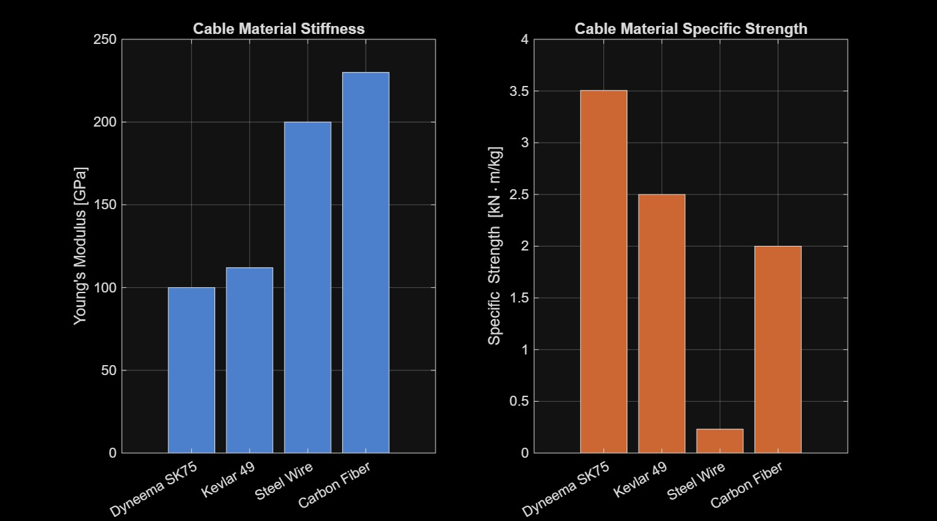
The material analysis highlights the importance of achieving a balance between structural strength and lightweight design. The results indicate that Dyneema SK75 provides an optimal combination of high specific strength and moderate stiffness, enabling it to sustain prestress levels of approximately 500 MPa while maintaining low mass. This selection contributes to an overall structural mass of approximately 1.44 kg, which is critical for enabling wind-induced motion. In comparison, heavier materials such as steel would increase inertia and reduce responsiveness to aerodynamic forces, thereby limiting locomotion capability. Consequently, the achieved material efficiency acts as a primary enabler for converting environmental wind energy into motion, fully validating the structural design choices for wind-driven locomotion.

Figure 3: Dynamic Behavior and Phase Response

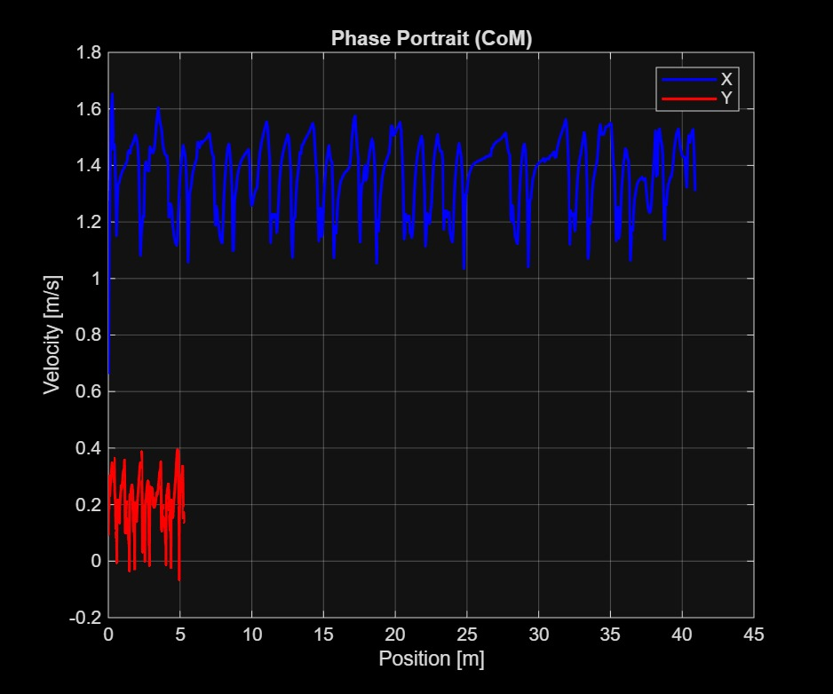
The dynamic response of the system is characterized by sustained forward motion with bounded oscillatory velocity behavior. The velocity along the primary direction varies approximately between 1.2 m/s and 1.6 m/s, indicating stable rolling motion under wind excitation. The phase characteristics show that the system transitions from an initial transient state to a periodic steady-state regime, reflecting consistent dynamic behavior over time. Lateral motion remains limited, suggesting that the structure and control inputs provide effective directional stability. These observations indicate that the robot maintains continuous locomotion without divergence or instability. This demonstrates that the proposed system is capable of sustaining wind-driven motion while maintaining controlled directional behavior, which is essential for practical deployment.

Figure 4: Deformation Characteristics
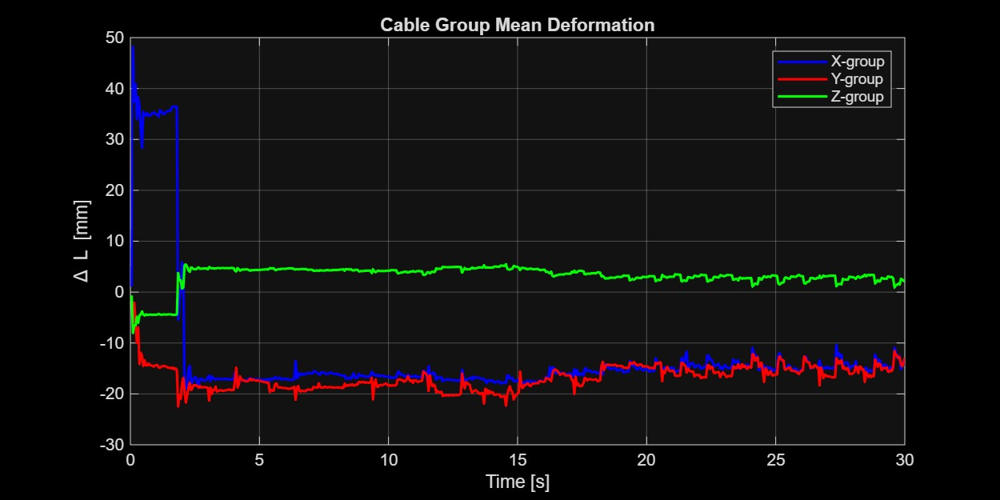
The deformation patterns demonstrate the role of internal structural reconfiguration in enabling locomotion. The cable groups exhibit significant initial deformation as the structure responds to wind loading and control inputs, followed by stabilized oscillatory behavior as the system reaches dynamic equilibrium. The deformation is coordinated across different cable groups, indicating effective redistribution of internal forces rather than random structural response. This confirms that locomotion is achieved through controlled deformation and shifting of the center of mass, rather than rigid-body translation. Ultimately, such behavior highlights the fundamental operating principle of tensegrity-based motion, proving that controlled internal actuation can successfully dictate global trajectory without relying on traditional rigid mechanisms.

Figure 5: Structural Integrity and Stress Distribution
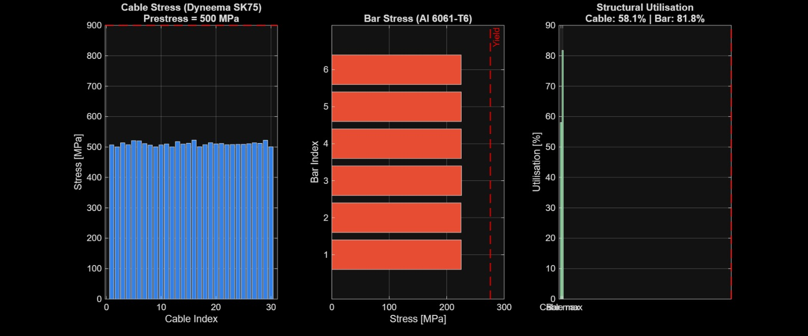
The stress analysis confirms that the structure remains within safe operating limits throughout the motion. Cable stresses are maintained around the prestress level of approximately 500 MPa, while bar elements experience lower stress levels that remain below critical thresholds. Structural utilization indicates efficient load sharing, with cables operating at roughly 58% and bars at approximately 80% of their allowable limits. Despite the high prestress required for maintaining structural stability, no failure conditions are observed during dynamic motion. This demonstrates that the proposed ultra-lightweight design successfully balances flexibility and strength. The results validate that the structure can sustain wind-driven locomotion without compromising integrity, addressing a critical requirement for real-world applications.
Figure 6: Structural Evolution and Final Configuration
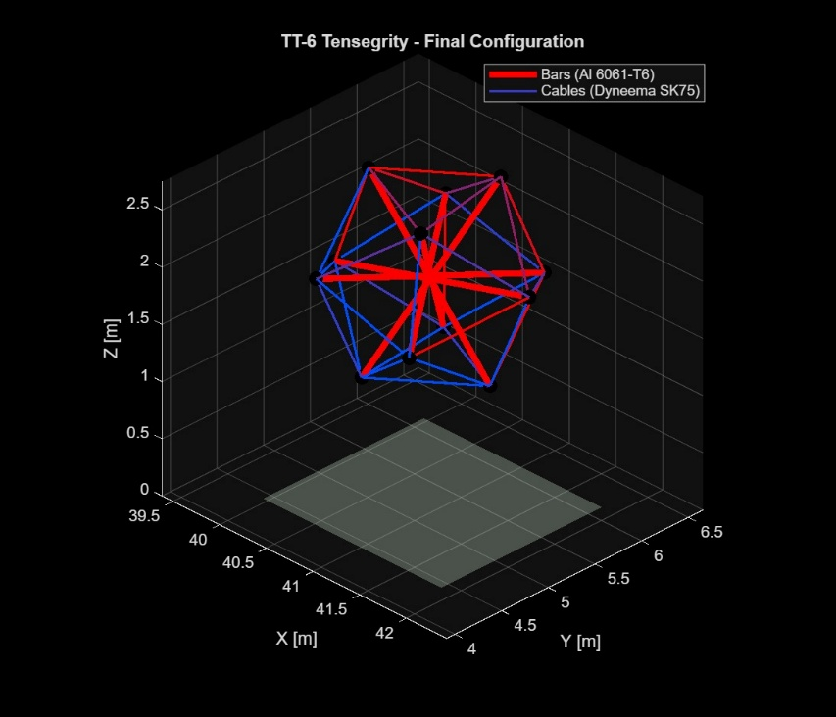
The evolution of the structure during motion illustrates how deformation translates into locomotion. The robot undergoes continuous shape adaptation while preserving its connectivity, resulting in forward rolling motion. The final configuration shows a deformed yet stable structure, indicating that the system dynamically adjusts its geometry to maintain motion. This adaptive behavior enables the robot to sustain locomotion without requiring rigid structural consistency. This adaptive reconfiguration—achieved without sacrificing overall structural stability—highlights a distinct advantage of tensegrity systems over conventional rigid robots, effectively utilizing structural flexibility as a fundamental mechanism for motion generation.

Figure 7: Trajectory, Control, and Estimation Performance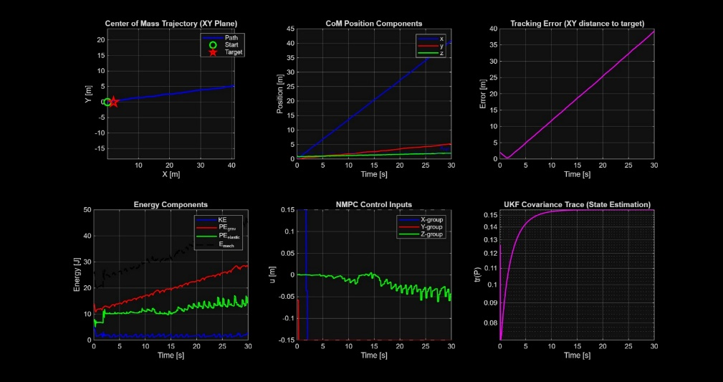
The trajectory results confirm that the robot achieves significant forward displacement of approximately 41 m over a 30 s duration, corresponding to an average speed of about 1.38 m/s. The motion remains consistent with limited deviation despite the presence of wind disturbances, indicating stable locomotion. The control inputs are smooth and bounded, reflecting stable operation of the nonlinear model predictive control framework without excessive actuation. The estimation process converges over time, as indicated by the stabilization of covariance, confirming reliable state estimation under uncertainty. These results demonstrate that the control framework effectively enables directional locomotion in a wind-driven system. This directly validates the primary objective of the work, showing that controlled locomotion can be achieved even when propulsion is dominated by environmental forces.

Overall Discussion
The results collectively demonstrate that the proposed system successfully integrates wind-driven propulsion with controlled deformation to achieve efficient locomotion. The robot utilizes environmental wind as the primary energy source while employing minimal internal actuation for directional control, resulting in a low-energy operational mode. The lightweight tensegrity structure ensures both robustness and adaptability, enabling the system to withstand dynamic loading while maintaining motion. The achieved displacement of approximately 41 m and sustained velocity around 1.38 m/s confirm the feasibility of large-area coverage. In contrast to conventional fully actuated tensegrity robots, the present approach significantly reduces energy consumption by shifting the primary propulsion mechanism to environmental forces. This establishes a new paradigm of energy-assisted locomotion, where control is used selectively for guidance rather than continuous actuation, offering strong potential for robotic exploration in resource-constrained and challenging environments.

