LAB DOCUMENTATION
Creating and Managing a Pod in Google Kubernetes Engine (GKE)
Deploying an Nginx Pod, verifying it with port forwarding, and cleaning up the cluster
Prepared by
NaveenKumar.P

1. Aim
To create a basic Google Kubernetes Engine (GKE) cluster, deploy a single-container Nginx Pod, verify the application using port forwarding, and delete the cluster after completing the task.

2. Introduction
Google Kubernetes Engine (GKE) is a managed Kubernetes service provided by Google Cloud. It allows users to deploy, manage, and scale containerized applications.
A Pod is the smallest deployable unit in Kubernetes. It contains one or more containers that share resources such as networking and storage.
In this lab, an Nginx web server is deployed inside a Kubernetes Pod running on a GKE cluster.

3. Objectives
- Create minimal GKE infrastructure.
- Deploy a single-container Nginx Pod.
- Verify the Pod status.
- Access the Nginx web server using port forwarding.
- Test the application using the curl command.
- Delete the GKE cluster to clean up resources.

4. Requirements
- Google Cloud Skills Boost account.
- Temporary Google Cloud student credentials.
- Google Cloud Console.
- Cloud Shell terminal.
- Basic knowledge of Linux commands and Kubernetes.

5. Implementation Steps

Step 1: Start the Google Cloud Lab
- Open the Google Cloud Skills Boost lab.
- Click the Start Lab button.
- Open Google Cloud Console.
- Sign in using the temporary student credentials.
- Activate Cloud Shell from the Google Cloud Console.

Step 2: Set the Compute Zone
The compute zone specifies the geographical location where the GKE cluster will be created.
Command:
gcloud config set compute/zone europe-west4-b

Expected output:
Updated property [compute/zone].

Step 3: Create a GKE Cluster
Create a Kubernetes cluster named my-cluster.
Command:
gcloud container clusters create my-cluster

This command provisions the Kubernetes control plane and worker nodes.
Verify the cluster nodes:
kubectl get nodes

Expected result: The nodes should display a Ready status.
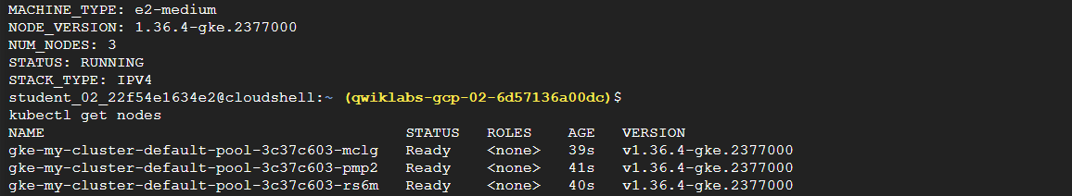
Figure 1: Cluster created (RUNNING) and all three nodes in Ready status

Step 4: Create the Nginx Pod Configuration
Create a YAML configuration file:
nano nginx-pod.yaml

Figure 2: Opening nginx-pod.yaml in the nano editor
Add the following configuration:
apiVersion: v1
kind: Pod
metadata:
name: nginx-test-pod
labels:
app: nginx
spec:
containers:
- name: nginx-container
image: nginx:latest
ports:
- containerPort: 80

Save and exit the file.

Step 5: Deploy the Pod
Execute the following command to create the Pod:
kubectl apply -f ./nginx-pod.yaml

Expected output:
pod/nginx-test-pod created

Figure 3: Pod nginx-test-pod created

Step 6: Verify the Pod Status
Check whether the Pod is running:
kubectl get pods

Expected result:
NAME READY STATUS RESTARTS
nginx-test-pod 1/1 Running 0

The Running status indicates that the Nginx container is running successfully.
Figure 4: nginx-test-pod is 1/1 Running with 0 restarts

Step 7: Configure Port Forwarding
Forward local port 8080 to port 80 inside the Pod.
Command:
kubectl port-forward nginx-test-pod 8080:80

Expected output:
Forwarding from 127.0.0.1:8080 -> 80

Keep this terminal session running.
Figure 5: Port forwarding from local port 8080 to Pod port 80

Step 8: Test the Nginx Application
Open another Cloud Shell terminal tab and execute:
curl http://localhost:8080

Expected result: The command displays the default Nginx welcome page in HTML format. The following title confirms successful execution:
<title>Welcome to nginx!</title>

This verifies that the Nginx web server is running and responding to requests.
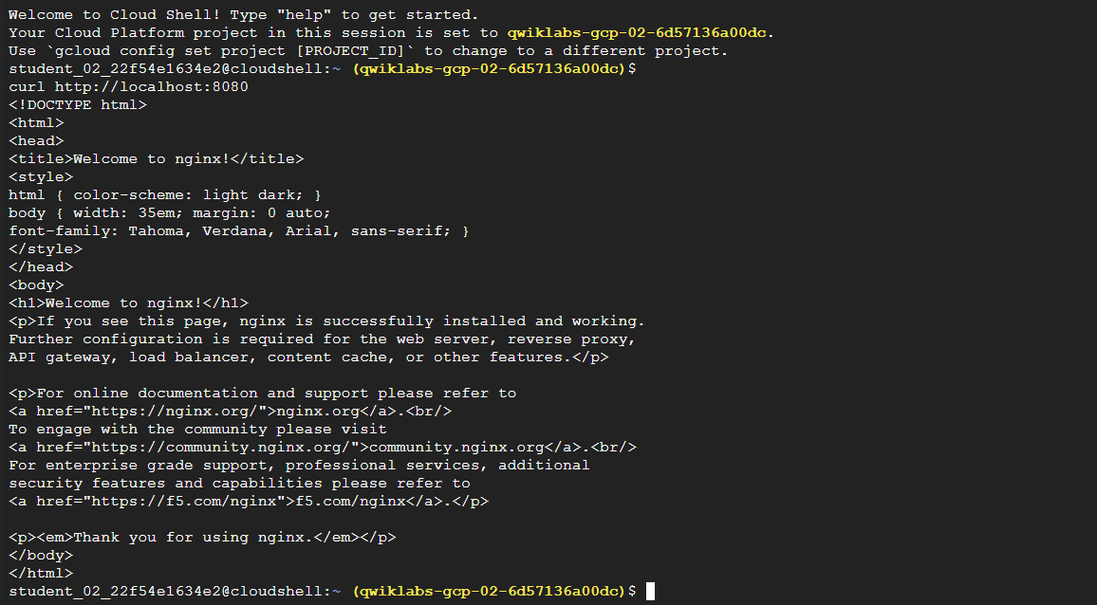
Figure 6: curl output showing the "Welcome to nginx!" page

Step 9: Delete the GKE Cluster
After testing the application, stop port forwarding using CTRL + C.
Delete the cluster using:
gcloud container clusters delete my-cluster --zone europe-west4-b

Enter Y when prompted to confirm deletion. This removes the cluster and its associated resources.
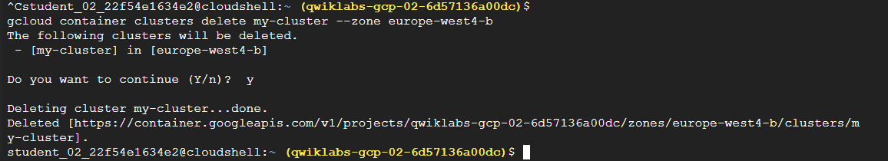
Figure 7: Port forwarding stopped (Ctrl + C) and my-cluster deleted

6. Important Commands
Command | Description
gcloud config set compute/zone europe-west4-b | Sets the compute zone
gcloud container clusters create my-cluster | Creates a GKE cluster
kubectl get nodes | Displays cluster nodes
nano nginx-pod.yaml | Creates the YAML file
kubectl apply -f nginx-pod.yaml | Deploys the Pod
kubectl get pods | Checks Pod status
kubectl port-forward nginx-test-pod 8080:80 | Forwards network traffic
curl http://localhost:8080 | Tests the Nginx server
gcloud container clusters delete my-cluster --zone europe-west4-b | Deletes the cluster

7. Result
Successfully created a Google Kubernetes Engine cluster, deployed an Nginx application inside a single-container Pod, verified its running status, accessed the application using port forwarding, and tested the web server using the curl command.
Finally, the GKE cluster was deleted successfully to clean up the cloud resources.

8. Conclusion
This lab provided practical knowledge of Google Kubernetes Engine and Kubernetes Pods. It demonstrated how to create a cluster, deploy a containerized application, verify its execution, access the application through port forwarding, and clean up cloud resources.
The lab helped develop a basic understanding of container orchestration and application deployment using Kubernetes.

