LAB DOCUMENTATION

Docker Fundamentals
Build, Run, Debug and Publish Docker Images
Google Cloud Platform | Cloud Shell | Artifact Registry
Prepared by
NaveenKumar.P

1. Aim
To understand Docker fundamentals and gain practical experience in building, running, debugging, and publishing Docker containers using Google Cloud Artifact Registry.

2. Objectives
- Build, run, and debug Docker containers.
- Pull Docker images from Docker Hub.
- Create custom Docker images using Dockerfiles.
- Push Docker images to Google Artifact Registry.
- Pull and run Docker images from Google Artifact Registry.

3. Tools and Technologies Used
- Google Cloud Platform (GCP)
- Google Cloud Shell
- Docker
- Node.js
- Docker Hub
- Google Artifact Registry
- Linux command line

4. Introduction
Docker is an open-source platform used to develop, package, and run applications inside containers. Containers provide a consistent environment for applications, making them portable across different systems.
A Docker image is a blueprint used to create containers. A Docker container is a running instance of an image.
Docker simplifies application deployment by packaging application code and its dependencies together.

5. Procedure

Task 1: Run a Hello World Container
The following command downloaded the Hello World image from Docker Hub and executed it inside a Docker container.
docker run hello-world
Commands used to inspect the result:
- docker images – Displays downloaded Docker images.
- docker ps – Displays running containers.
- docker ps -a – Displays all containers, including stopped containers.
Result: Successfully executed the Hello World Docker container.

Task 2: Build a Docker Image
Created a directory named test and entered it.
mkdir test && cd test
Created a Dockerfile with the following configuration:
FROM node:22-slim
WORKDIR /app
ADD . /app
EXPOSE 80
CMD ["node", "app.js"]
Created a Node.js application named app.js using the HTTP module. The application listens on port 80 and returns the message "Hello World". The Docker image was then built:
docker build -t node-app:0.1 .
Verified the image using:
docker images
Result: Successfully created the Docker image node-app:0.1.

Task 3: Run Docker Containers
Started the first container:
docker run -p 4000:80 --name my-app node-app:0.1
Tested the application:
curl http://localhost:4000
Output:
Hello World
Modified the application response to "Welcome to Cloud" and built the second image:
docker build -t node-app:0.2 .
Started the second container:
docker run -p 8080:80 --name my-app-2 -d node-app:0.2
Tested both versions:
- curl http://localhost:4000 returned Hello World.
- curl http://localhost:8080 returned Welcome to Cloud.
Result: Successfully ran two different versions of the application simultaneously.

Task 4: Debug Docker Containers
The following commands were used to inspect and debug containers:
- docker logs my-app – Displays container logs.
- docker logs -f my-app – Follows live container logs.
- docker exec -it my-app bash – Opens an interactive shell inside the container.
- ls – Lists files inside the container.
- docker inspect my-app – Displays detailed container information.
Result: Successfully examined container logs, accessed the container environment, and inspected container configuration.

Task 5: Publish Docker Image to Google Artifact Registry
A Docker repository was created in Google Artifact Registry with the following configuration:
- Repository name: my-repository
- Format: Docker
- Location: europe-west4
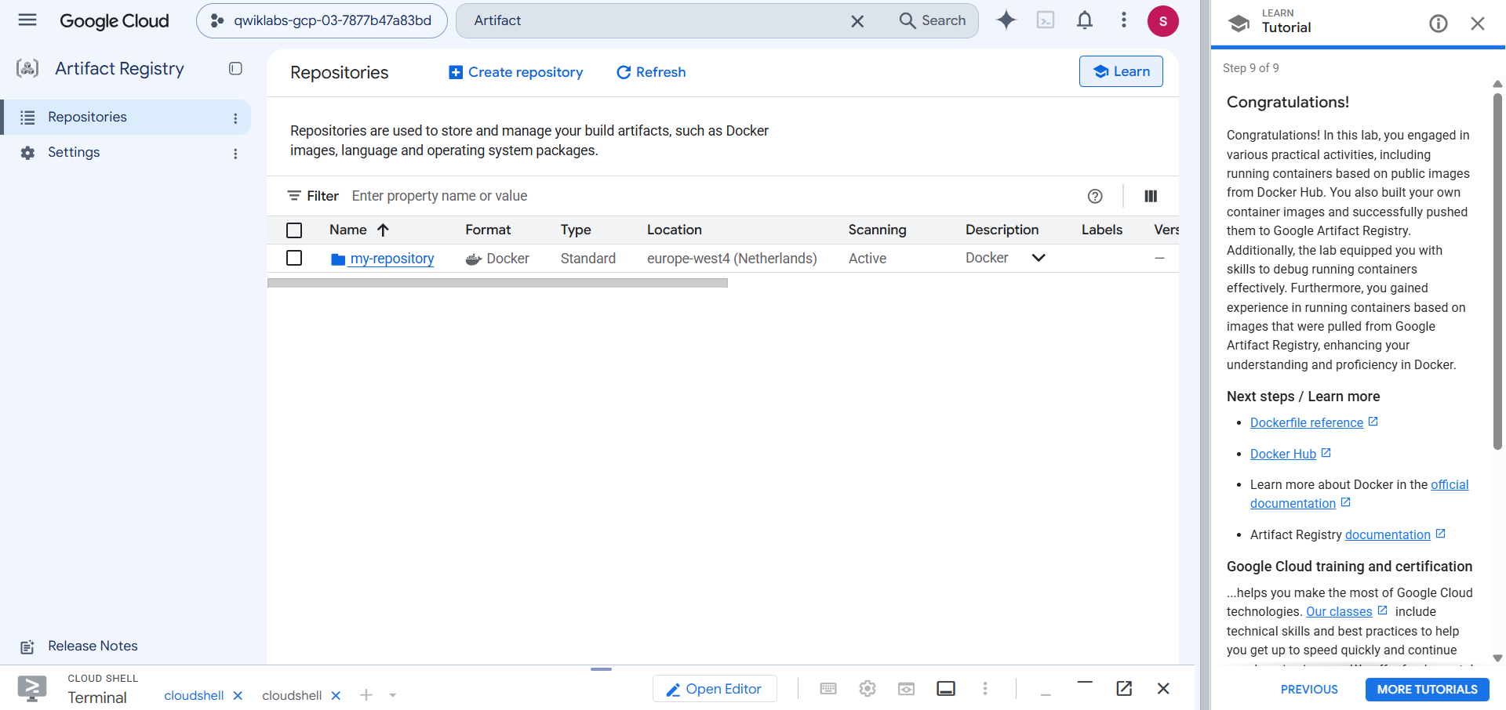
Figure 1: Repository my-repository (Docker, Standard, europe-west4) listed in Artifact Registry
Configured Docker authentication:
gcloud auth configure-docker europe-west4-docker.pkg.dev
Built and tagged the image:
docker build -t europe-west4-docker.pkg.dev/qwiklabs-gcp-03-7877b47a83bd/my-repository/node-app:0.2 .
Pushed the image:
docker push europe-west4-docker.pkg.dev/qwiklabs-gcp-03-7877b47a83bd/my-repository/node-app:0.2
After the push, the repository details page shows the node-app image that was uploaded.
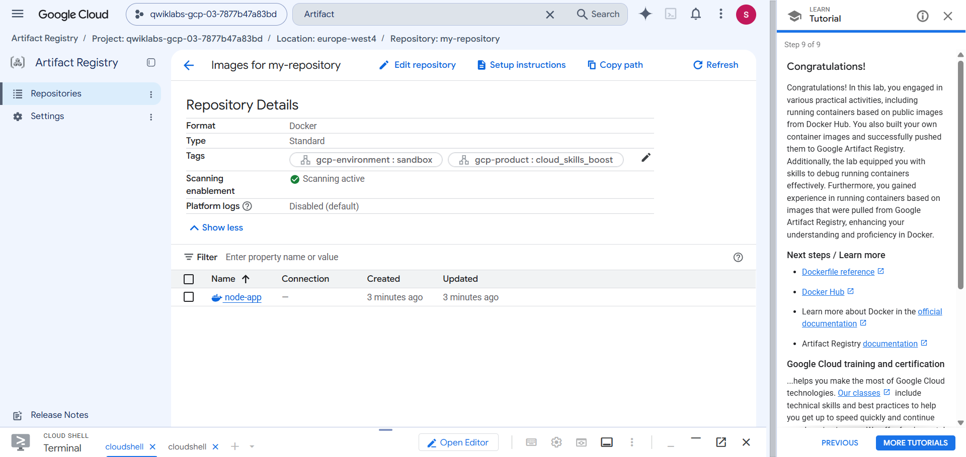
Figure 2: Repository details showing the pushed node-app image
Opening node-app lists its digests. The image appears with the tag 0.2, together with its platform-specific manifest.
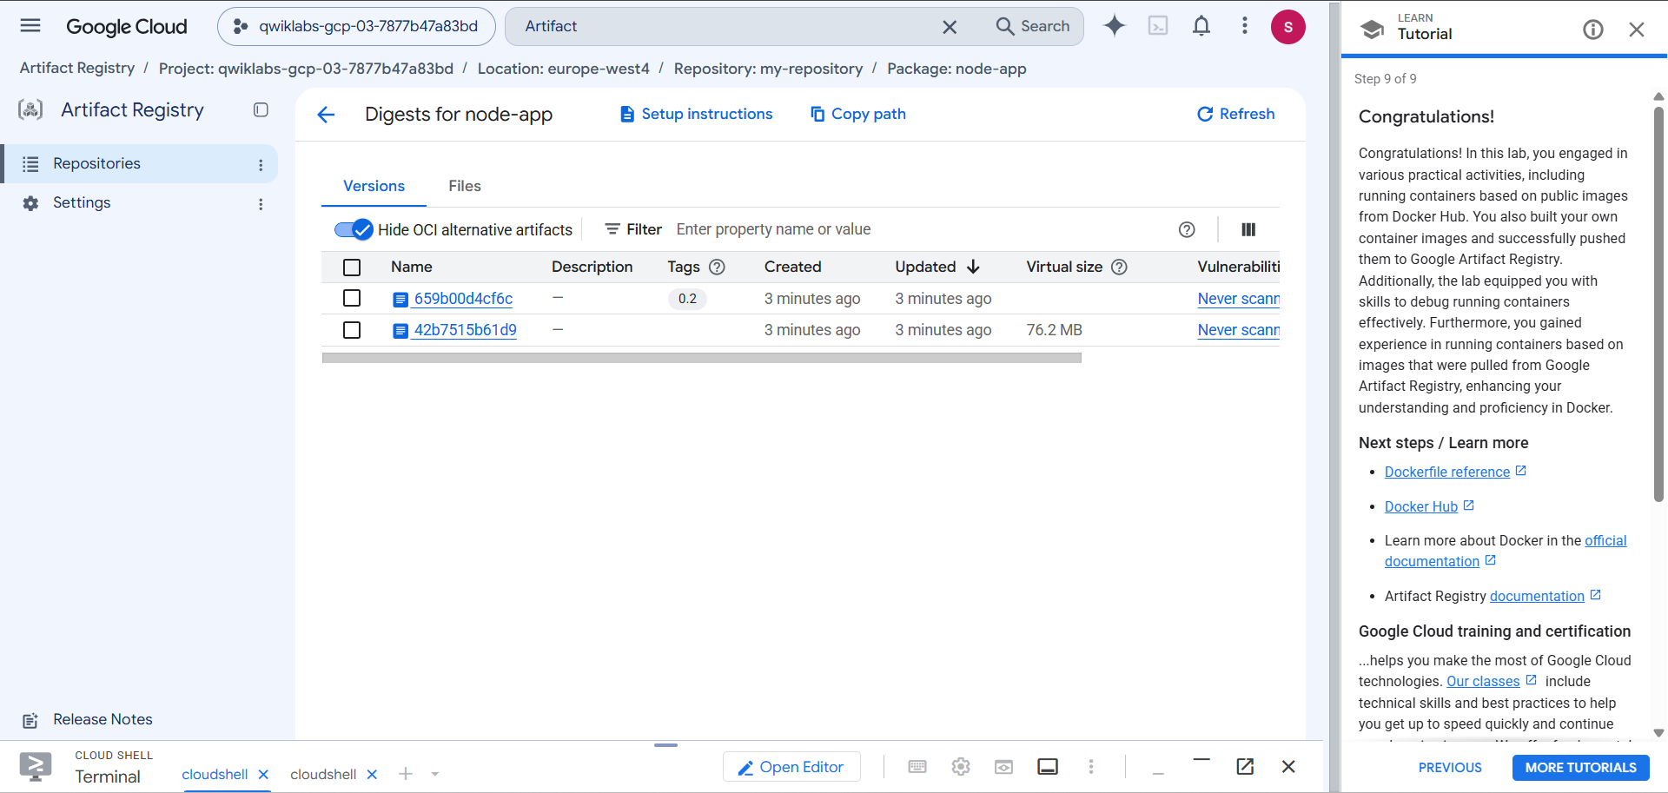
Figure 3: Digests for node-app with version tag 0.2
The image index (tagged 0.2) is stored as an OCI image index, and it references the image manifest below.
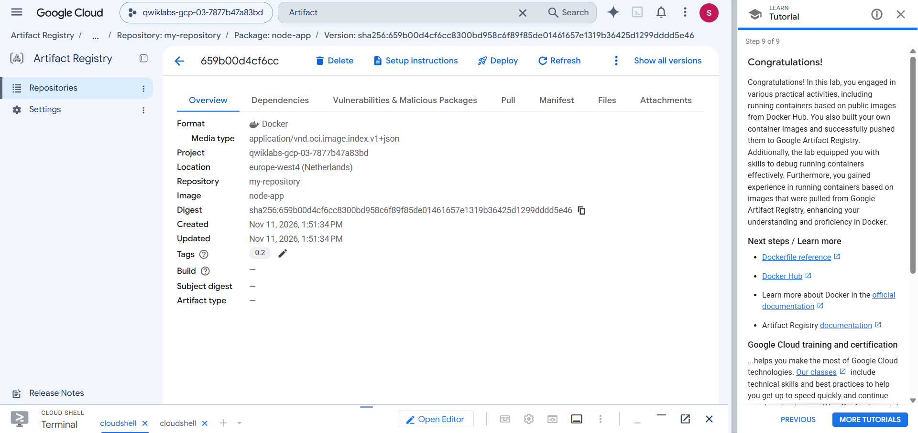
Figure 4: Image index overview for digest 659b00d4cf6c (tag 0.2)
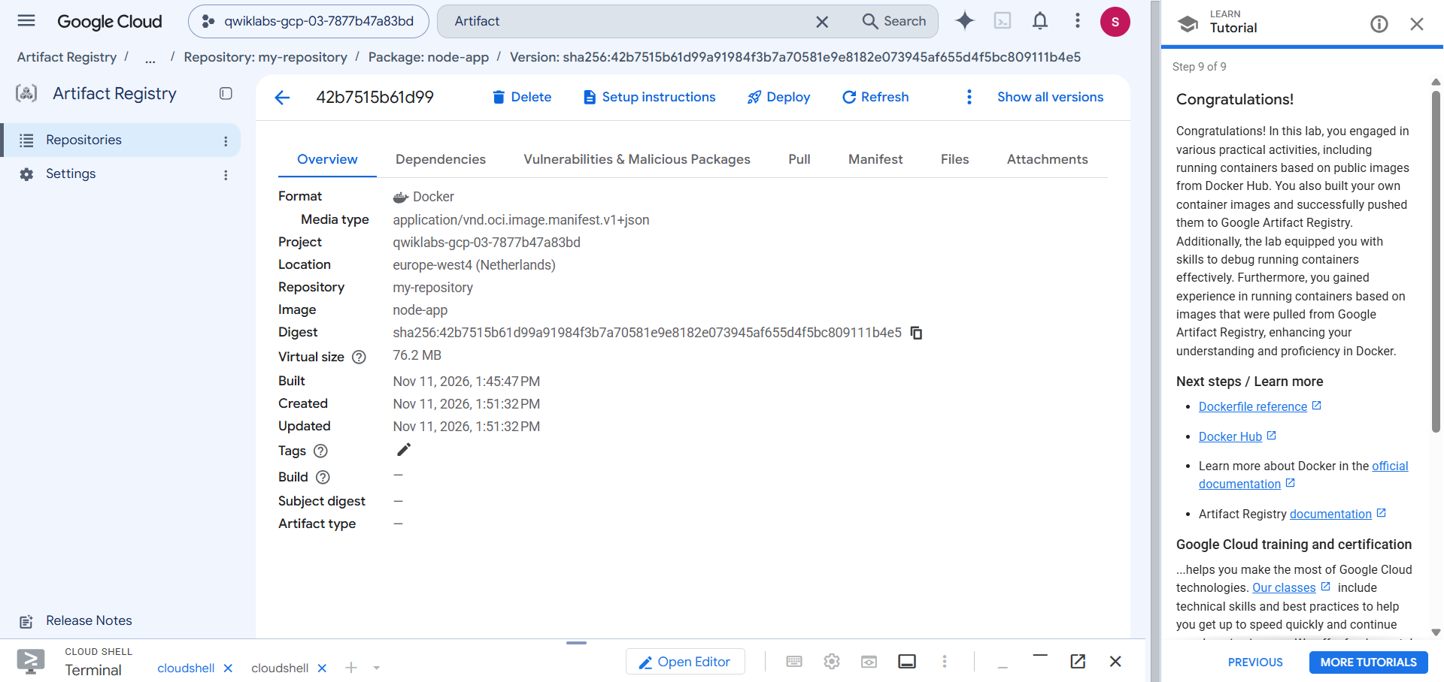
Figure 5: Image manifest overview for digest 42b7515b61d9 (76.2 MB)
Result: Successfully uploaded the Docker image to Google Artifact Registry.

Task 6: Pull and Test the Published Image
Existing containers and local Docker images were removed to simulate a fresh environment. The image was then pulled from Google Artifact Registry and started:
docker run -p 4000:80 -d europe-west4-docker.pkg.dev/qwiklabs-gcp-03-7877b47a83bd/my-repository/node-app:0.2
Tested the application:
curl http://localhost:4000
Output:
Welcome to Cloud
The running container was verified using docker ps. The terminal output below shows the local images being removed, the image being pulled from Artifact Registry, the application response, and the running container.
docker ps
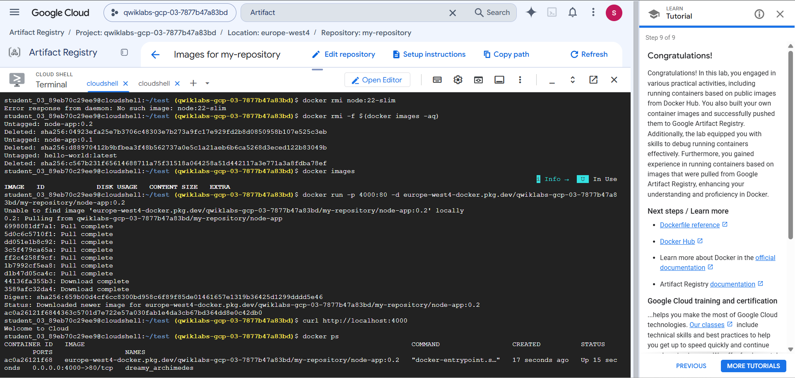
Figure 6: Pulling the image from Artifact Registry, testing with curl, and verifying with docker ps
Result: Successfully pulled and executed the Docker image from Google Artifact Registry.

6. Important Docker Commands
Command | Purpose
docker run | Runs a container
docker build | Builds a Docker image
docker images | Lists Docker images
docker ps | Lists running containers
docker ps -a | Lists all containers
docker stop | Stops a container
docker rm | Removes a container
docker logs | Displays container logs
docker exec | Executes commands inside a container
docker inspect | Displays container details
docker push | Uploads an image to a registry
docker pull | Downloads an image from a registry

7. Results and Observations
The Docker fundamentals lab was successfully performed. The following activities were completed:
- Executed a Hello World container using Docker Hub.
- Created a custom Node.js application.
- Built Docker images with different versions.
- Ran multiple containers using different port mappings.
- Debugged containers using Docker commands.
- Published a Docker image to Google Artifact Registry.
- Pulled the published image and executed it successfully.

8. Conclusion
This lab provided practical knowledge of Docker containerization and image management. We learned how to build custom Docker images, execute containers, debug running applications, and publish images to Google Artifact Registry.
The lab demonstrated the portability of Docker containers, as the application was successfully downloaded and executed again from a private cloud registry.
Thus, the objectives of the Docker Fundamentals lab were achieved.

