GOOGLE CLOUD | HANDS-ON LAB DOCUMENTATION
Creating a Network Load Balancer on Google Cloud
Distributing traffic across three Compute Engine web servers using a target pool, health check and forwarding rule

PREPARED BY
NaveenKumar.P

1. Introduction
This document describes, step by step, how to build and test a Network Load Balancer on Google Cloud. Three Apache web servers are created on Compute Engine, and a load balancer is placed in front of them so that incoming requests are shared between the servers.
Think of the Network Load Balancer as a traffic officer: when visitors reach the website, it directs each request to one of the three available servers.

1.1 Objectives
- Create three Compute Engine virtual machines (www1, www2 and www3) running Apache.
- Configure a firewall rule that allows HTTP traffic on port 80.
- Reserve a static external IP address for the load balancer.
- Create a legacy HTTP health check, a target pool and a forwarding rule.
- Send continuous traffic to the load balancer and confirm that responses come from all three servers.

1.2 Lab Configuration
Item | Value
Region | us-central1
Zone | us-central1-a
Web servers | www1, www2, www3 (e2-small, Debian 12, Apache2)
Network tag | network-lb-tag
Firewall rule | www-firewall-network-lb (tcp:80)
Static IP address | network-lb-ip-1
Health check | basic-check
Target pool | www-pool
Forwarding rule | www-rule

1.3 Architecture
Requests from internet users arrive at the forwarding rule and are spread across the servers in the target pool.
Internet users
|
v
Network Load Balancer
|
Forwarding Rule
|
----------------------
| | |
v v v
www1 www2 www3
Server Server Server

1.4 Task Overview
Task | Description | Section
Task 1 | Set the default region and zone | Section 2
Task 2 | Create three web servers and a firewall rule | Section 3
Task 3 | Create a static IP address and a health check | Section 4
Task 4 | Create the target pool and forwarding rule | Section 5
Task 5 | Test the load balancer | Section 6

2. Getting Started

2.1 Start the Lab and Open the Console
- Open the Google Cloud Skills Boost lab page and click Start Lab. Wait until the lab has started.
- On the right side of the lab page, click Open Google Cloud console.
- If asked to choose an account, select Use Another Account.
- Sign in with the temporary username and password shown in the lab access panel.
- Accept the terms and conditions and wait for the Google Cloud Console to open.
Important: Use only the temporary student account. Do not use a personal Google account and do not sign up for a free trial.

2.2 Activate Cloud Shell
- In the top-right area of the console, click the Activate Cloud Shell (terminal) icon.
- Click Continue and Authorize if prompted.
- Wait for the terminal to appear at the bottom of the console. A prompt similar to the one below is displayed.
Welcome to Cloud Shell!

your-project-id:~$

3. Task 1: Set the Default Region and Zone
A region is similar to a city and a zone is a specific area within that city. All resources in this lab are created in region us-central1 and zone us-central1-a.
SET THE DEFAULT REGION
gcloud config set compute/region us-central1
EXPECTED OUTPUT
Updated property [compute/region].
SET THE DEFAULT ZONE
gcloud config set compute/zone us-central1-a
EXPECTED OUTPUT
Updated property [compute/zone].

4. Task 2: Create Three Web Servers
A virtual machine (VM) is a computer running inside Google’s cloud. Three VMs are created, and each one installs Apache and serves a page that displays its own name. All three VMs share the network tag network-lb-tag, which the firewall rule uses later.

4.1 Create the First Server (www1)
gcloud compute instances create www1 \
--zone=us-central1-a \
--tags=network-lb-tag \
--machine-type=e2-small \
--image-family=debian-12 \
--image-project=debian-cloud \
--no-service-account \
--no-scopes \
--metadata=startup-script='#!/bin/bash
apt-get update
apt-get install apache2 -y
service apache2 restart
echo "Web Server: www1" | tee /var/www/html/index.html'
EXPECTED OUTPUT
Created [....www1].

4.2 Create the Second Server (www2)
gcloud compute instances create www2 \
--zone=us-central1-a \
--tags=network-lb-tag \
--machine-type=e2-small \
--image-family=debian-12 \
--image-project=debian-cloud \
--no-service-account \
--no-scopes \
--metadata=startup-script='#!/bin/bash
apt-get update
apt-get install apache2 -y
service apache2 restart
echo "Web Server: www2" | tee /var/www/html/index.html'
EXPECTED OUTPUT
Created [....www2].

4.3 Create the Third Server (www3)
gcloud compute instances create www3 \
--zone=us-central1-a \
--tags=network-lb-tag \
--machine-type=e2-small \
--image-family=debian-12 \
--image-project=debian-cloud \
--no-service-account \
--no-scopes \
--metadata=startup-script='#!/bin/bash
apt-get update
apt-get install apache2 -y
service apache2 restart
echo "Web Server: www3" | tee /var/www/html/index.html'
EXPECTED OUTPUT
Created [....www3].

4.4 Create a Firewall Rule
The firewall rule acts as a security guard. It allows HTTP traffic (TCP port 80) to reach every VM that carries the network-lb-tag tag.
gcloud compute firewall-rules create www-firewall-network-lb \
--target-tags network-lb-tag \
--allow tcp:80
EXPECTED OUTPUT
Created [....www-firewall-network-lb].

4.5 Confirm That All Three Servers Exist
gcloud compute instances list
The list should show the three servers below, each with an address in the EXTERNAL_IP column.
Name | Zone | External IP
www1 | us-central1-a | Assigned
www2 | us-central1-a | Assigned
www3 | us-central1-a | Assigned

4.6 Test Each Server Directly
Each command looks up the external IP address of one server and requests its web page.
WWW1
curl http://$(gcloud compute instances describe www1 --zone=us-central1-a \
--format="get(networkInterfaces[0].accessConfigs[0].natIP)")
EXPECTED OUTPUT
Web Server: www1
WWW2
curl http://$(gcloud compute instances describe www2 --zone=us-central1-a \
--format="get(networkInterfaces[0].accessConfigs[0].natIP)")
EXPECTED OUTPUT
Web Server: www2
WWW3
curl http://$(gcloud compute instances describe www3 --zone=us-central1-a \
--format="get(networkInterfaces[0].accessConfigs[0].natIP)")
EXPECTED OUTPUT
Web Server: www3

4.7 Verify Progress
Return to the lab instructions page and click Check my progress under Task 2. Wait for the green tick or completion message.

5. Task 3: Configure the Load Balancing Service

5.1 Create a Static External IP Address
This reserves the public IP address of the load balancer, which works like its own phone number.
gcloud compute addresses create network-lb-ip-1 \
--region us-central1
EXPECTED OUTPUT
Created [...network-lb-ip-1].

5.2 Create a Health Check
A health check regularly tests whether each server is responding, so traffic is only sent to healthy servers.
gcloud compute http-health-checks create basic-check
EXPECTED OUTPUT
Created [...basic-check].
Return to the lab page and click Check my progress under Task 3.

6. Task 4: Create the Target Pool and Forwarding Rule

6.1 Create the Target Pool
A target pool is a group of instances that receive traffic from the load balancer. It uses the health check created earlier.
gcloud compute target-pools create www-pool \
--region us-central1 \
--http-health-check basic-check
EXPECTED OUTPUT
Created [...www-pool].

6.2 Add the Servers to the Pool
gcloud compute target-pools add-instances www-pool \
--instances www1,www2,www3 \
--instances-zone us-central1-a \
--region us-central1
Expected result: an operation confirming that the three instances were added to the pool.

6.3 Create the Forwarding Rule
The forwarding rule tells Google Cloud to send any request that arrives at the load balancer’s IP address on port 80 to the target pool.
gcloud compute forwarding-rules create www-rule \
--region us-central1 \
--ports 80 \
--address network-lb-ip-1 \
--target-pool www-pool
EXPECTED OUTPUT
Created [...www-rule].
Return to the lab page and click Check my progress under Task 4.

7. Task 5: Test the Load Balancer

7.1 Find the Load Balancer IP Address
gcloud compute forwarding-rules describe www-rule \
--region us-central1
Look for the IPAddress field in the output. This is the public IP address of the load balancer.
IPAddress: XX.XX.XX.XX

7.2 Save the IP Address in a Variable
IPADDRESS=$(gcloud compute forwarding-rules describe www-rule \
--region us-central1 --format="json" | jq -r .IPAddress)
Display the stored address to confirm it was captured:
echo $IPADDRESS

7.3 Send Continuous Traffic
The loop below sends a request to the load balancer repeatedly. If errors appear at first, wait about 30 seconds for the load balancer to become ready.
while true; do curl -m1 $IPADDRESS; done
Responses start arriving from different servers (www1, www2 and www3). Figure 1 shows the Cloud Shell output while the loop is running: requests are shared across all three web servers.
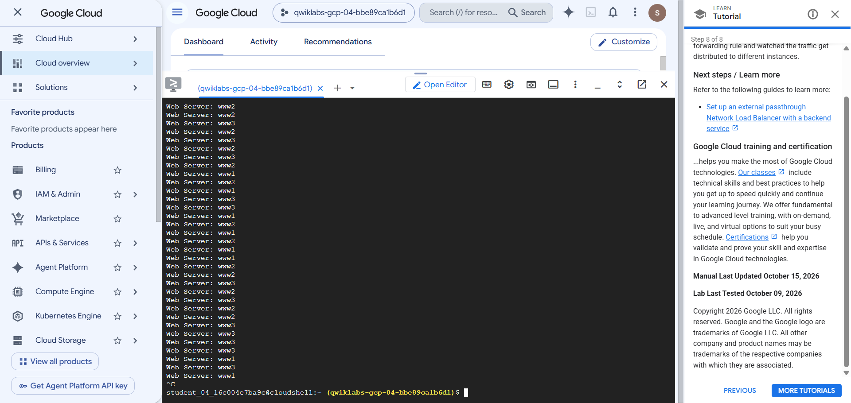
Figure 1: Cloud Shell output showing requests distributed across www1, www2 and www3

7.4 Result
The output confirms that the load balancer is working. What happened:
- A request reached the load balancer.
- The load balancer forwarded it to one of the three servers.
- That server returned its unique message (for example, Web Server: www2).
- The next request could be served by a different server.

7.5 Stop the Continuous Traffic
Press CTRL + C in Cloud Shell to stop the loop. The ^C marker is visible at the end of Figure 1.

8. Conclusion
In this lab, the following was accomplished:
- Created Compute Engine virtual machines and installed Apache web servers.
- Configured a firewall rule for HTTP traffic.
- Reserved a static external IP address.
- Configured a Network Load Balancer with a health check, target pool and forwarding rule.
- Verified that incoming traffic is distributed across three servers.

