GOOGLE CLOUD HANDS-ON LAB
Google Cloud Pub/Sub
Creating a Topic and Subscription, Publishing a Message, and Pulling it with gcloud

Prepared by
NaveenKumar.P

1. Objective
This document records the steps performed in the Google Cloud Skills Boost (Qwiklabs) lab on Cloud Pub/Sub. The lab demonstrates the basic messaging workflow: creating a topic, attaching a pull subscription to it, publishing a message, and retrieving that message from the command line.

2. Key Concepts
Term | Description
Topic | A named resource to which publishers send messages. Think of it as a mailbox address.
Subscription | A named resource that represents the stream of messages from a topic to a subscriber. Think of it as an inbox.
Publish | The action of sending a message to a topic.
Pull | A delivery type where the subscriber requests messages from the subscription.
Acknowledge (ack) | A signal to Pub/Sub that a message was received and processed, so it is not delivered again.

3. Lab Environment
Item | Value
Platform | Google Cloud Skills Boost / Qwiklabs
Project ID | qwiklabs-gcp-01-6569939aefe7
Account type | Temporary student account provided by the lab
Topic name | MyTopic
Subscription name | MySub (Delivery type: Pull)
Test message | Hello World
Tools used | Google Cloud console, Cloud Shell, gcloud CLI

4. Procedure

4.1 Start the Lab and Sign In
- Open the lab page and click Start Lab. Wait for the lab to start (the timer cannot be paused).
- In the Lab details panel, click Open Google Cloud console.
- Choose Use another account and sign in with the temporary username and password shown in the lab panel.
- Accept the terms if prompted, and skip recovery options, two-factor setup and free trials.
Note: Use only the temporary student account supplied by the lab, never a personal Google account.

4.2 Open Cloud Shell
- Click the Activate Cloud Shell icon (>_) at the top of the console.
- Click Continue and Authorize if prompted.
- Wait for the terminal to open. It shows the active project, qwiklabs-gcp-01-6569939aefe7.

4.3 Task 1: Create the Topic "MyTopic"
- Open the Navigation menu (☰) and select Pub/Sub, then Topics.
- Click Create topic.
- In the Topic ID field, enter MyTopic and leave all other settings at their defaults.
- Click Create.
MyTopic now appears in the Topics list, as shown below. The lab's Check my progress button for Task 1 can then be used.
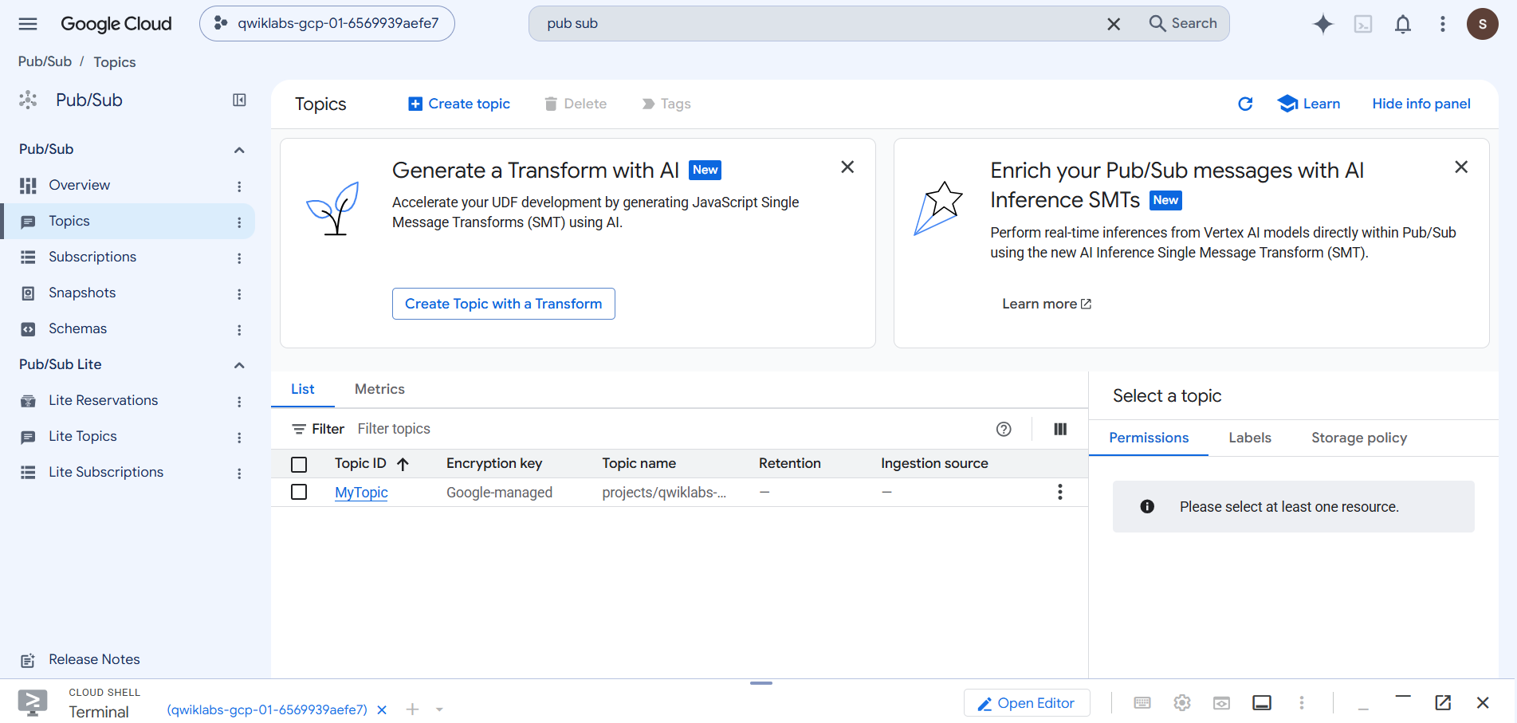
Figure 1: Pub/Sub Topics page showing MyTopic

4.4 Task 2: Create the Subscription "MySub"
- On the Topics page, click the three-dot menu (⋮) on the MyTopic row and select Create subscription.
- Set Subscription ID to MySub.
- Select MyTopic as the topic (projects/<PROJECT_ID>/topics/MyTopic).
- Set Delivery type to Pull and keep the remaining defaults.
- Click Create.
MySub is listed on the Subscriptions page with delivery type Pull and a green (active) state. The list also shows MyTopic-sub, a default subscription that Pub/Sub creates automatically with the topic; it is not used in this lab.
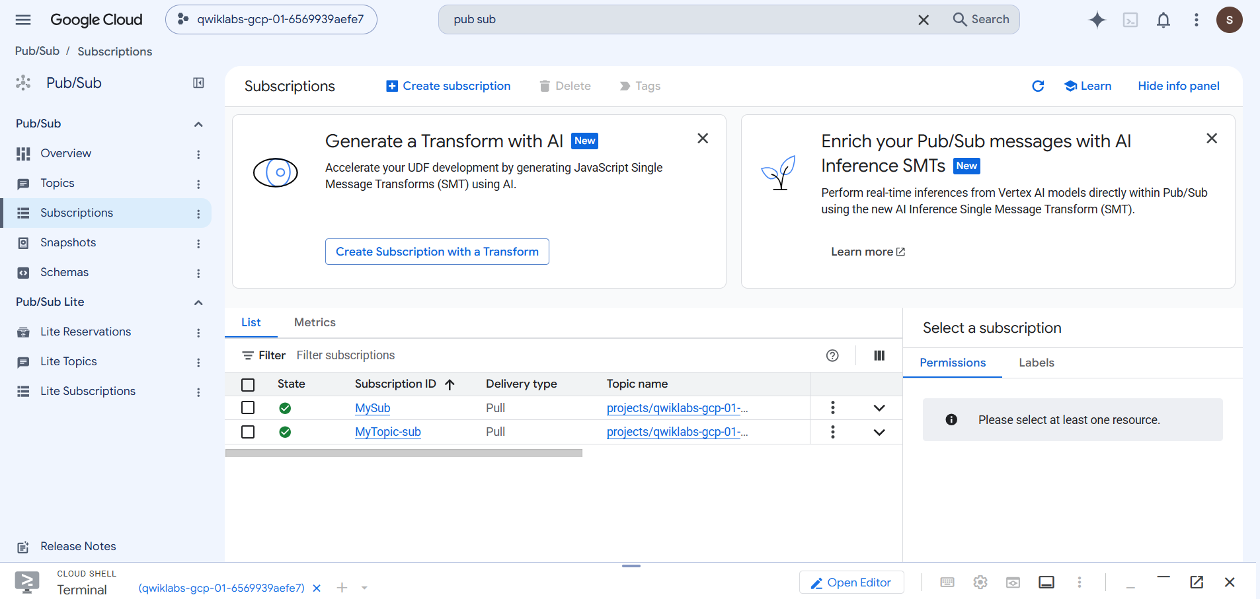
Figure 2: Pub/Sub Subscriptions page showing MySub (Pull)

4.5 Task 3: Publish the Message "Hello World"
- Go to Pub/Sub, Topics, and click MyTopic.
- Open the Messages tab and click Publish message.
- In the Message body field, type Hello World. Leave other fields at their defaults.
- Click Publish.
Note: Publishing does not read the message. It stays queued in MySub until it is pulled.

4.6 Task 4: Pull and Read the Message
In Cloud Shell, run the following command:
gcloud pubsub subscriptions pull --auto-ack MySub
The --auto-ack flag acknowledges the message automatically once it has been pulled. The output is shown below.
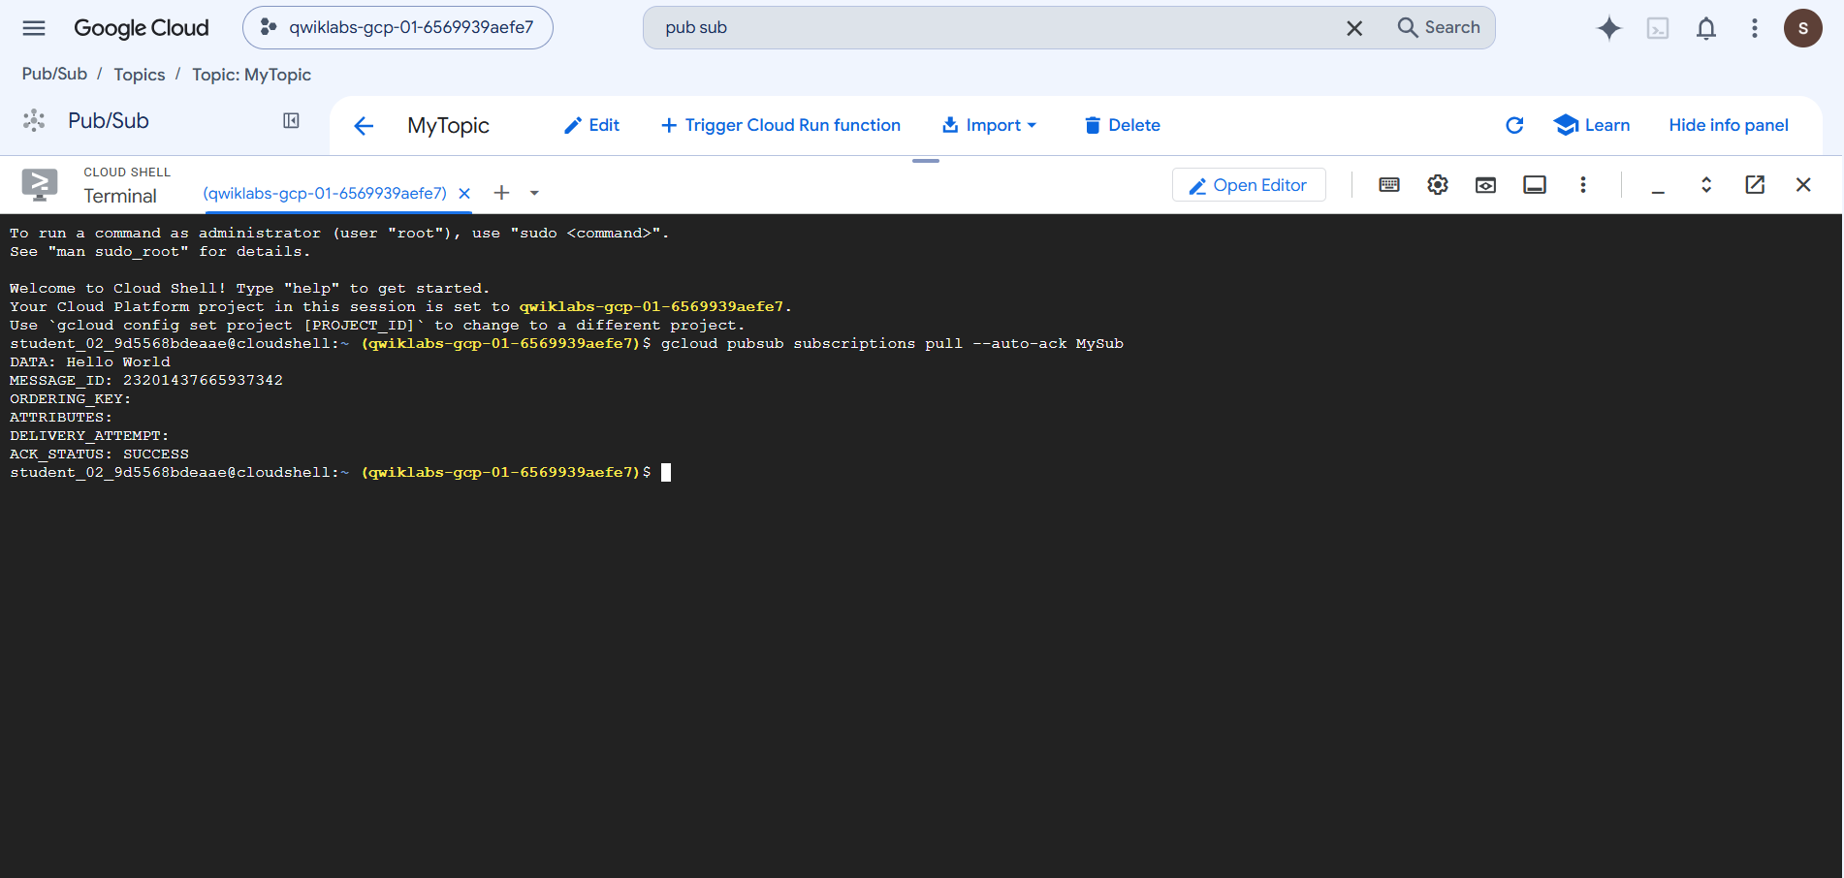
Figure 3: Cloud Shell output of the pull command

5. Results
The command returned the published message and confirmed the acknowledgement:
Output field | Value
DATA | Hello World
MESSAGE_ID | 23201437665937342
ORDERING_KEY | (empty)
ATTRIBUTES | (empty)
DELIVERY_ATTEMPT | (empty)
ACK_STATUS | SUCCESS

The message published to MyTopic was delivered through MySub and acknowledged successfully, confirming the end-to-end workflow.

6. Troubleshooting
If the message does not appear after running the pull command, check the following:
- The message Hello World was published to MyTopic.
- The subscription name is exactly MySub (names are case-sensitive).
- The command was run in the correct lab project.
- The message was not already pulled and acknowledged. If it was, publish another message and pull again.

7. Conclusion
The lab was completed successfully. A topic (MyTopic) and a pull subscription (MySub) were created in the Google Cloud console, the message "Hello World" was published, and it was retrieved and acknowledged using the gcloud CLI. This covers the core Pub/Sub flow of publish, pull and acknowledge, which is the foundation for decoupled, asynchronous messaging between services.

