L A B D O C U M E N T A T I O N

Working with Cloud Storage using Google APIs Explorer
Creating, copying and deleting Cloud Storage buckets and objects with the Cloud Storage JSON API
Prepared by
NaveenKumar.P

1. Overview
Google APIs Explorer is an interactive tool that allows users to explore and execute requests to Google APIs. It provides information about available API methods, supported parameters, authentication, and API responses.
Google Cloud Storage is a service used to store and retrieve files, images, documents, backups, and other data over the internet.
In this lab, Google APIs Explorer was used to create and delete Cloud Storage buckets, upload image files, copy objects between buckets, and delete objects using the Cloud Storage JSON API.

2. Objectives
- To explore Google Cloud APIs using APIs Explorer.
- To create Cloud Storage buckets using the buckets.insert method.
- To upload image files to a Cloud Storage bucket.
- To copy an image between buckets using the objects.copy method.
- To delete image files using the objects.delete method.
- To delete an empty Cloud Storage bucket using the buckets.delete method.

3. Tools and Technologies Used
- Google Cloud Platform (GCP)
- Google Cloud Storage
- Google Cloud Storage JSON API
- Google APIs Explorer
- Google Cloud Console
- Web browser

4. Procedure

Step 1: Set Up the Lab Environment
- Started the Google Cloud Skills Boost lab.
- Opened the Google Cloud Console using the temporary student credentials provided by the lab.
- Navigated to APIs & Services → Library.
- Searched for the Google Cloud Storage JSON API.
- Enabled the API if it was not already enabled.

Step 2: Create the First Cloud Storage Bucket
- Opened the Cloud Storage JSON API reference for the buckets.insert method.
- Entered the Google Cloud project ID in the project field.
- Provided a globally unique bucket name in the request body.
- Selected the required authentication options.
- Executed the API request.
The API returned a bucket resource containing details such as the bucket name, project number, creation time, location, and storage class.
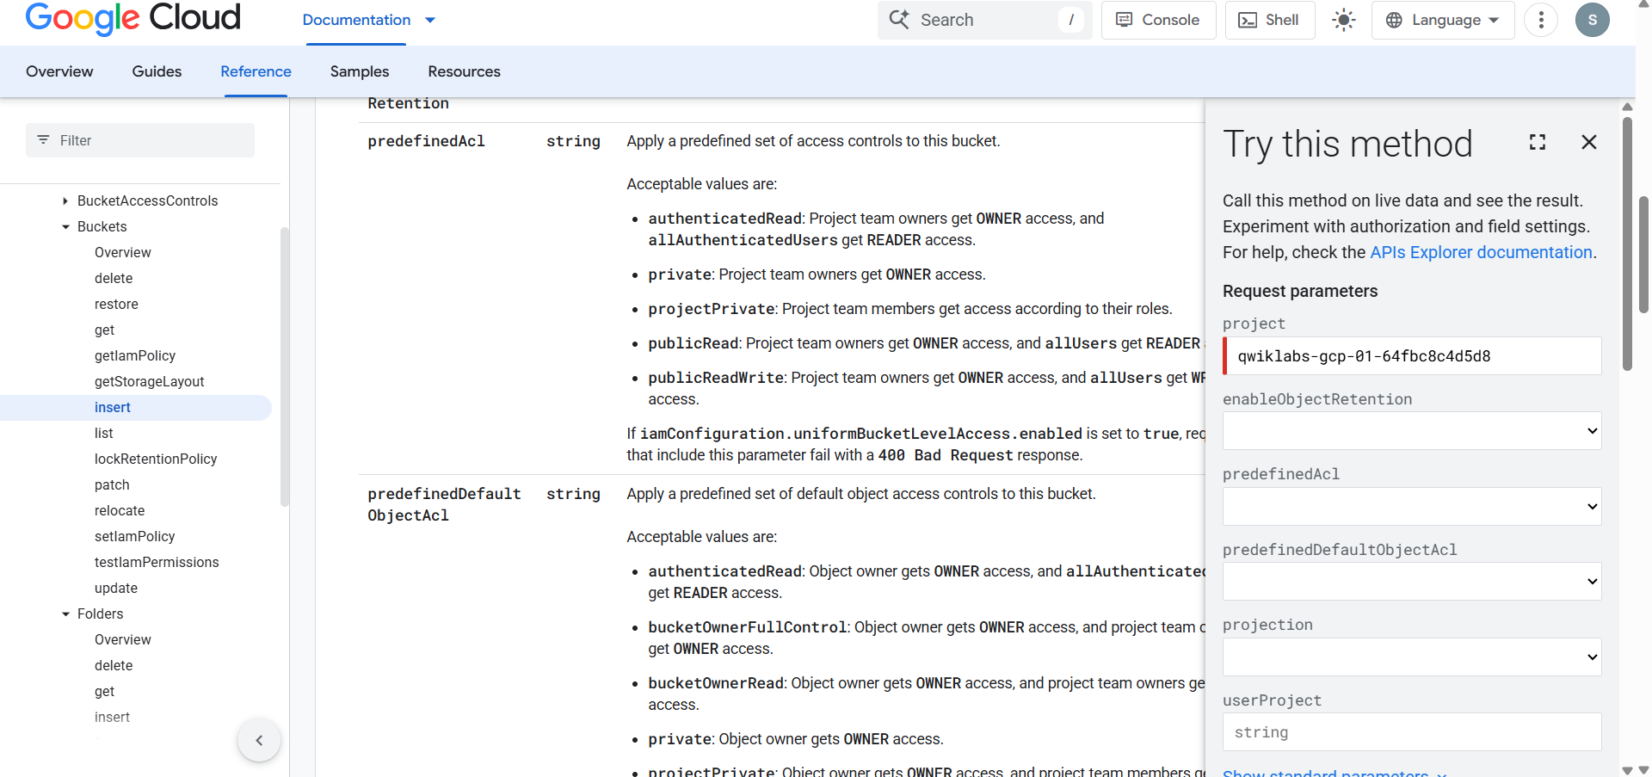
Figure 1: The buckets.insert method in APIs Explorer, with the lab project ID entered in the project request parameter.

Step 3: Create the Second Cloud Storage Bucket
- Used the same buckets.insert method.
- Entered the same project ID.
- Provided a different, globally unique name for the second bucket.
- Executed the request.
- Verified the successful response from the API.
Two Cloud Storage buckets were created for practicing file operations between storage locations.
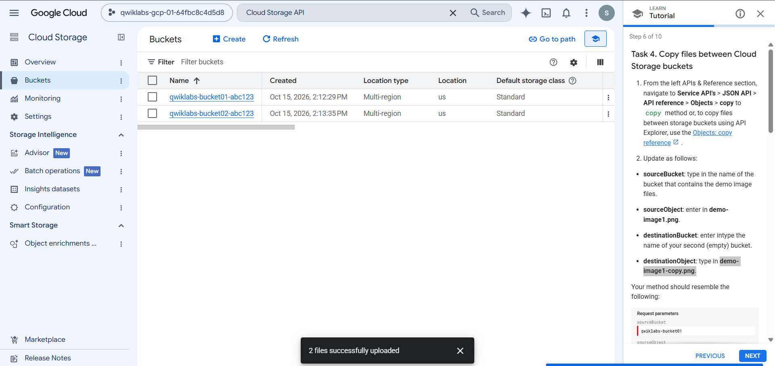
Figure 2: Cloud Storage Buckets page listing both newly created buckets, qwiklabs-bucket01-abc123 and qwiklabs-bucket02-abc123 (Multi-region, us, Standard).

Step 4: Upload Image Files
- Opened Cloud Storage → Buckets in the Google Cloud Console.
- Selected the first bucket.
- Clicked Upload → Upload files.
- Selected the following image files from the local computer: demo-image1.png and demo-image2.png.
- Waited for the upload process to finish.
- Verified that both files appeared in the bucket's Objects list.
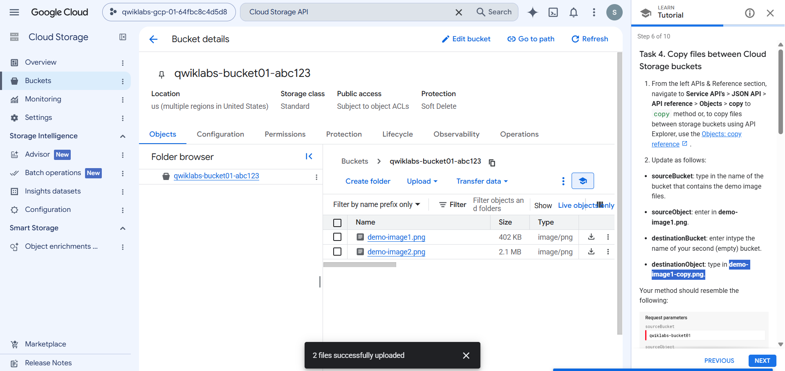
Figure 3: First bucket (qwiklabs-bucket01-abc123) showing demo-image1.png and demo-image2.png after the "2 files successfully uploaded" confirmation.

Step 5: Copy an Image Between Buckets
- Opened the Cloud Storage JSON API reference for the objects.copy method.
- Entered the source bucket name.
- Specified demo-image1.png as the source object.
- Entered the second bucket name as the destination bucket.
- Specified demo-image1-copy.png as the destination object.
- Executed the API request.
- Verified the response and checked the second bucket for the copied image.
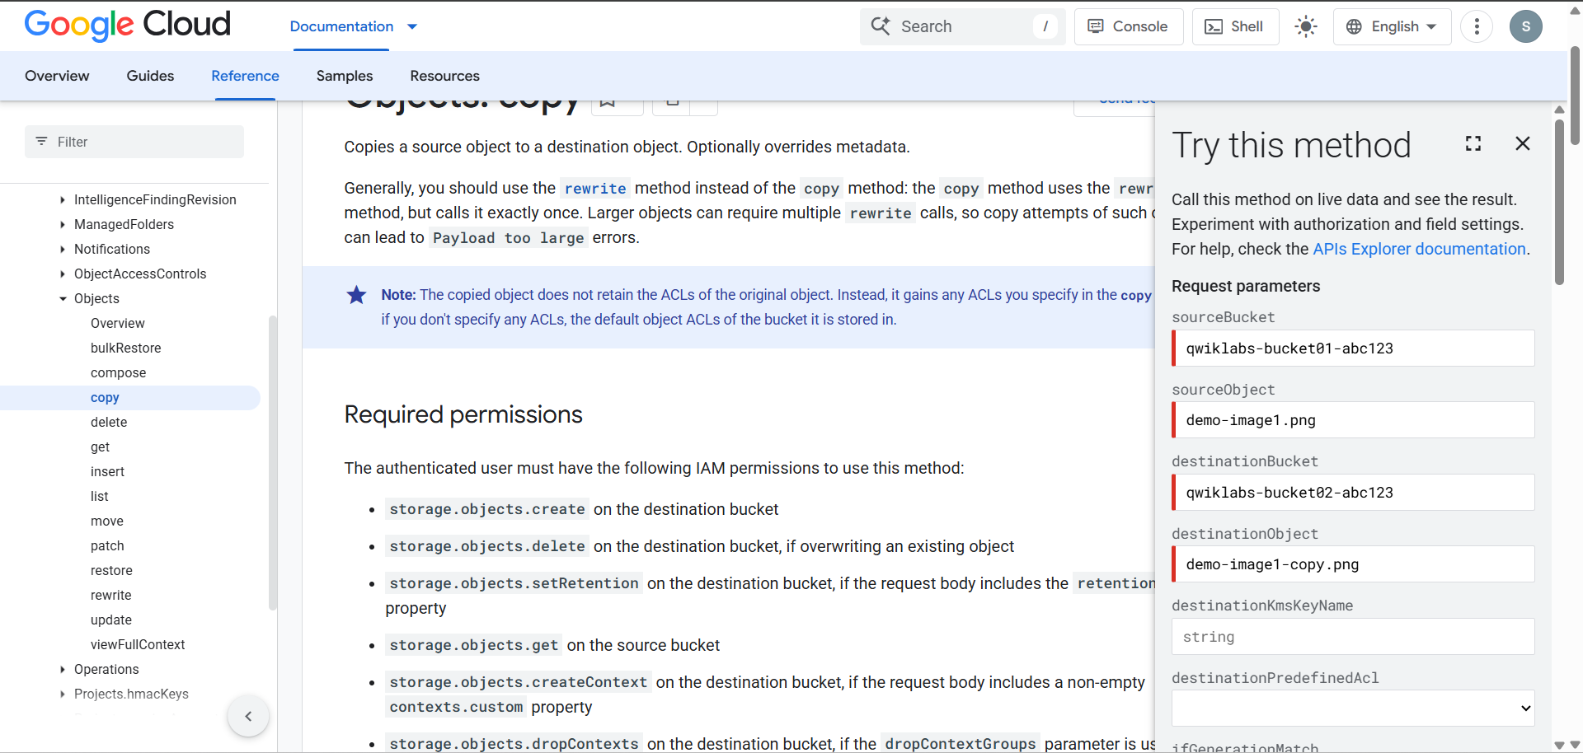
Figure 4: objects.copy request parameters: sourceBucket, sourceObject, destinationBucket and destinationObject.
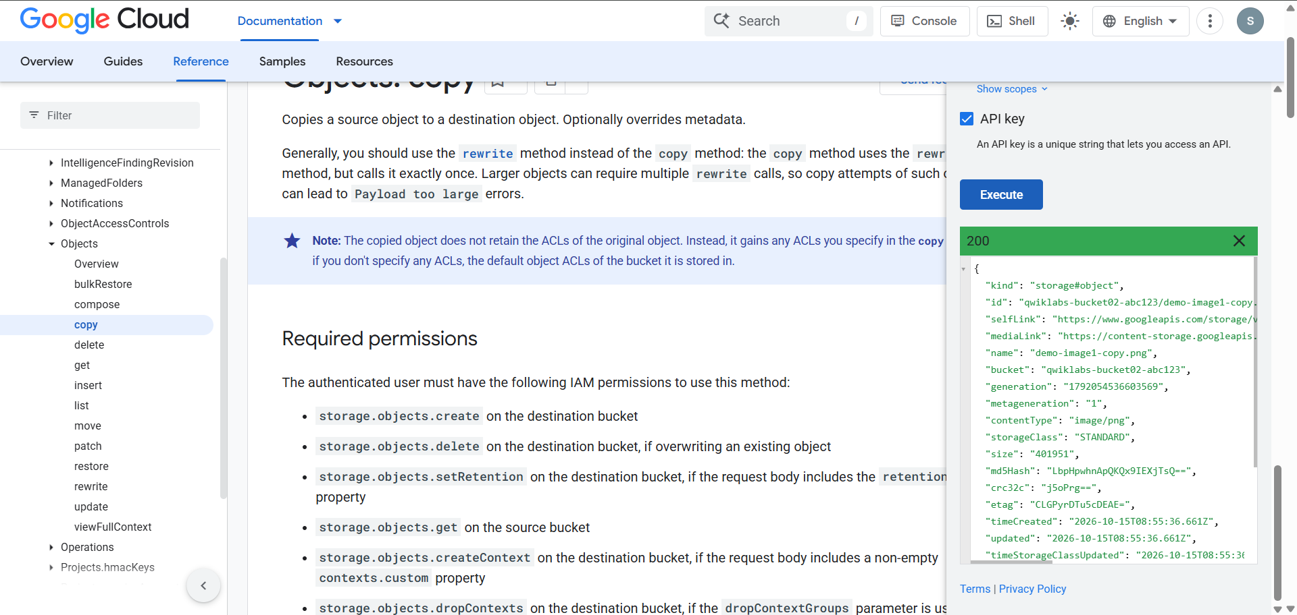
Figure 5: Successful 200 response from objects.copy, returning the new object demo-image1-copy.png in qwiklabs-bucket02-abc123.
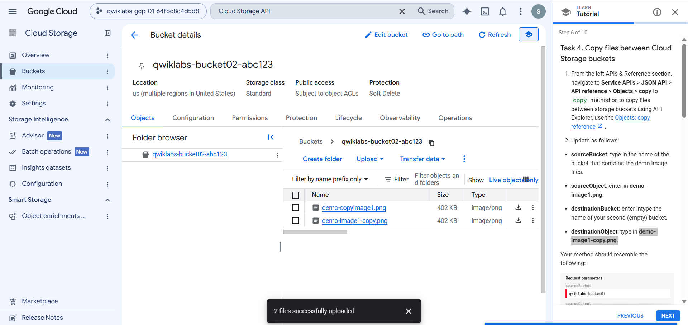
Figure 6: Second bucket (qwiklabs-bucket02-abc123) containing the copied image demo-image1-copy.png.
The image was copied to the second bucket while the original remained in the first bucket.

Step 6: Delete Image Files
- Opened the objects.delete API method.
- Entered the first bucket name and the object name demo-image1.png.
- Executed the request.
- Repeated the operation for demo-image2.png.
- Verified that the requests completed successfully.
The two original image files were removed from the first bucket. The copied image in the second bucket remained available.

Step 7: Delete the First Bucket
- Opened the Cloud Storage JSON API reference for the buckets.delete method.
- Entered the name of the first bucket.
- Confirmed that the bucket was empty.
- Executed the deletion request.
- Returned to the Cloud Storage bucket list and verified that the first bucket was removed.
The second bucket was retained with the copied image.

5. API Methods Used
API Method | Purpose
buckets.insert | Creates a new Cloud Storage bucket.
objects.copy | Copies an object from one bucket to another.
objects.delete | Deletes an object from a bucket.
buckets.delete | Deletes an empty Cloud Storage bucket.

6. Observations
- Google APIs Explorer provides a convenient interface for executing API requests without writing a complete application.
- The buckets.insert method requires a valid project ID and a unique bucket name.
- Cloud Storage bucket names must follow the service's naming rules and be globally unique.
- The objects.copy method allows files to be copied between buckets by specifying source and destination details.
- The objects.delete method removes individual objects from a bucket.
- A bucket must be empty before it can be deleted.
- Successful API responses provide information that can be used to verify whether an operation completed.

7. Result
The lab demonstrated how to manage Google Cloud Storage resources using Google APIs Explorer. Two buckets were created, two image files were uploaded to the first bucket, one image was copied to the second bucket, the original image files were deleted, and the first bucket was removed.

8. Conclusion
This lab provided practical experience with the Google Cloud Storage JSON API and Google APIs Explorer. It demonstrated how API methods can be used to create and manage storage resources, transfer files between buckets, and remove objects and buckets when they are no longer required.
The exercise also improved understanding of API request parameters, authentication, response verification, and basic cloud storage management.

