GOOGLE CLOUD SELF-PACED LAB
Cloud Storage: Qwik Start
Project Documentation
Prepared by
NaveenKumar.P

1. Introduction
This document describes the step-by-step procedure followed in the Google Cloud Storage Qwik Start lab (GSP073). Cloud Storage is Google Cloud’s object storage service, used to store and serve unstructured data such as images, documents and backups.

Objectives
- Create a Cloud Storage bucket.
- Upload an object (kitten.png) to the bucket.
- Create folders and subfolders to organize objects.
- Make an object publicly accessible.

Summary of Tasks
Task | Title | Description
Task 1 | Create a bucket | Create the storage container in Google Cloud.
Task 2 | Upload an object | Upload the file kitten.png.
Task 3 | Create folders | Organize objects using folders and subfolders.
Task 4 | Public access | Configure public access for the uploaded object.

2. Task 1: Create a Bucket
A bucket is the basic container that holds data in Cloud Storage. Bucket names must be globally unique, so the lab’s Project ID is used as the name.

Procedure
- Open Cloud Storage: Start the lab, wait for the temporary credentials, open the Google Cloud Console and sign in with the lab-provided student account. Then open Navigation menu → Cloud Storage → Buckets.
- Click + Create and enter the settings listed below.
Setting | Value
Bucket name | Your lab’s Project ID
Location type | Region
Location | us-east1
Default storage class | Standard
Access control | Uniform
Enforce public access prevention | Unchecked

- Finish creating the bucket: leave the remaining settings at their defaults and click Create. If prompted about public access prevention, confirm that you want to disable it for this lab bucket.
- Check progress: return to the lab page and click Check my progress for Task 1.
Important: Bucket names must be globally unique. Using the exact Project ID, as the lab suggests, is a convenient option.

Result
The Buckets page lists the new bucket in region us-east1 with the Standard storage class.
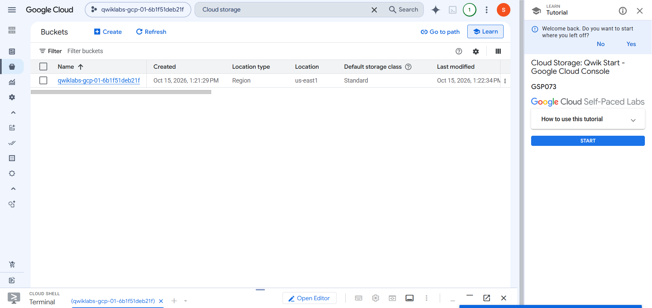
Figure 1: Buckets page showing the newly created bucket (us-east1, Region, Standard).

3. Task 2: Upload kitten.png

Procedure
- Download the image: on the lab page, right-click the kitten image, choose Save image as… and save it as kitten.png. If it cannot be found, use the kitten image provided in the lab.
- Open the bucket: go to Cloud Storage → Buckets and click the newly created bucket.
- Upload: open the Objects tab, click Upload → Upload files, select kitten.png and wait for the upload to complete.
- Verify: confirm that kitten.png appears in the object list. If the filename differs, rename it from the object’s three-dot menu.
- Check progress: return to the lab and click Check my progress for Task 2.

Result
The Objects tab shows kitten.png (image/png, 41.3 KB) stored in the bucket.
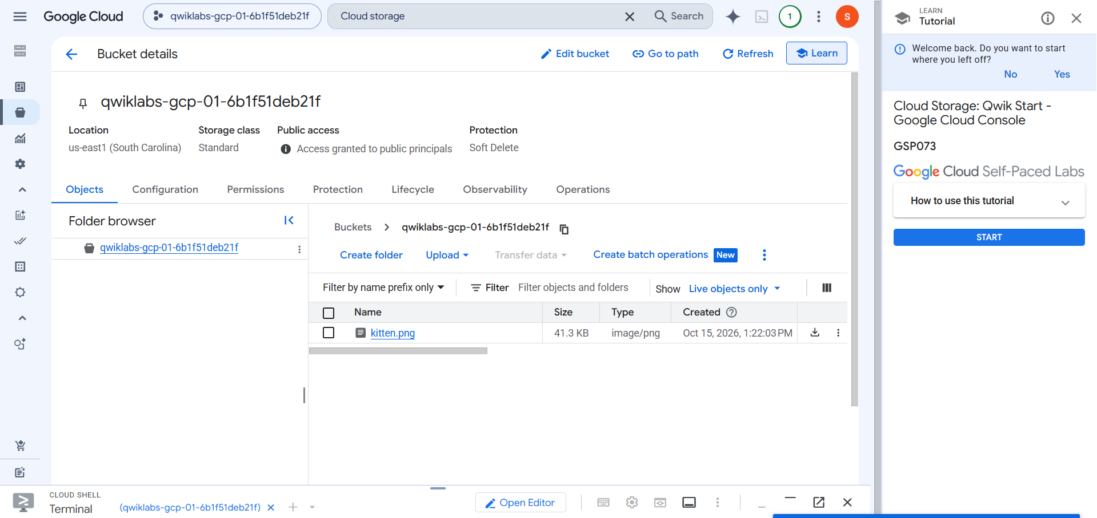
Figure 2: Objects tab of the bucket showing the uploaded kitten.png.

4. Task 3: Create Folders and Subfolders
Cloud Storage stores objects rather than traditional folders, but the console lets you organize objects using folder-like paths.

Procedure
- Open your bucket.
- Click Create folder (highlighted in Figure 3).
- Enter images and create the folder.
- Open the images folder.
- Click Create folder again, enter animals and create it.
Figure 3: Objects tab of the bucket – the Create folder option is located above the object list.

Resulting Structure
Bucket (qwiklabs-gcp-01-6b1f51deb21f)
├── kitten.png
└── images/
└── animals/
Note: This creates the folder structure. The original kitten.png remains at the bucket’s root unless you move it.

5. Task 4: Make an Object Publicly Accessible
To let anyone on the internet view kitten.png, the special principal allUsers is granted the Storage Object Viewer role.

Procedure
- Open the bucket and select kitten.png (or open the bucket’s Permissions tab).
- Open Permissions / the access-management option.
- Click Grant access (or Add principal, depending on the console interface).
- Enter allUsers as the principal.
- Assign the Storage Object Viewer role.
- Save the change and confirm the public-access change if prompted.
- Open the object’s details, locate its public URL and open it in a new browser tab to test access.
- Return to the lab and click the relevant Check my progress button.

Verification: Public Access Status
After the change, the bucket header shows “Access granted to public principals”. The Permissions tab explains that bucket-level permissions grant access to everyone on the internet (allUsers), and offers a Prevent public access option.
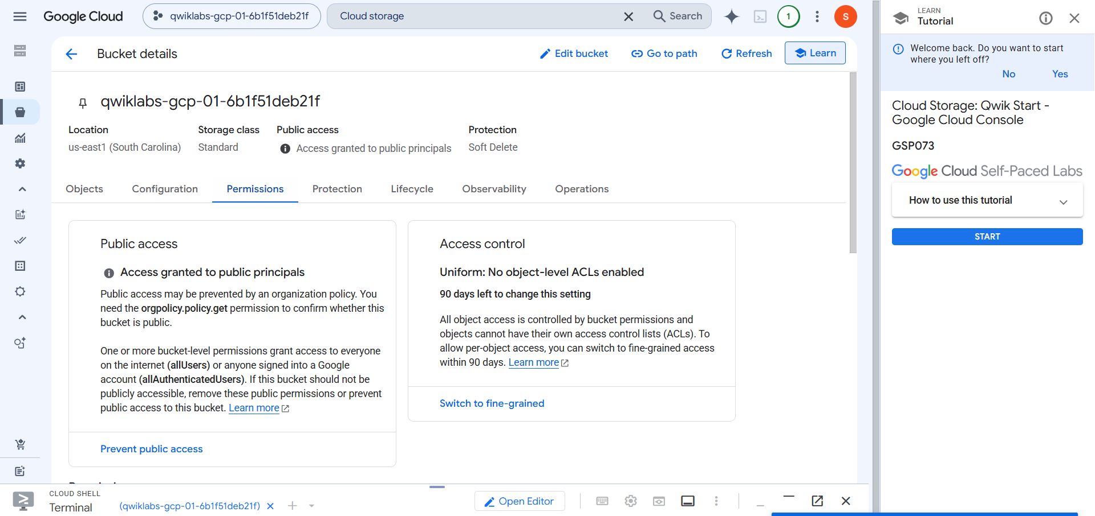
Figure 4: Permissions tab showing public access granted and Uniform access control.

Verification: Principal and Role
Under View by principals, the allUsers principal appears with the Storage Object Viewer role, confirming the objects are publicly readable.
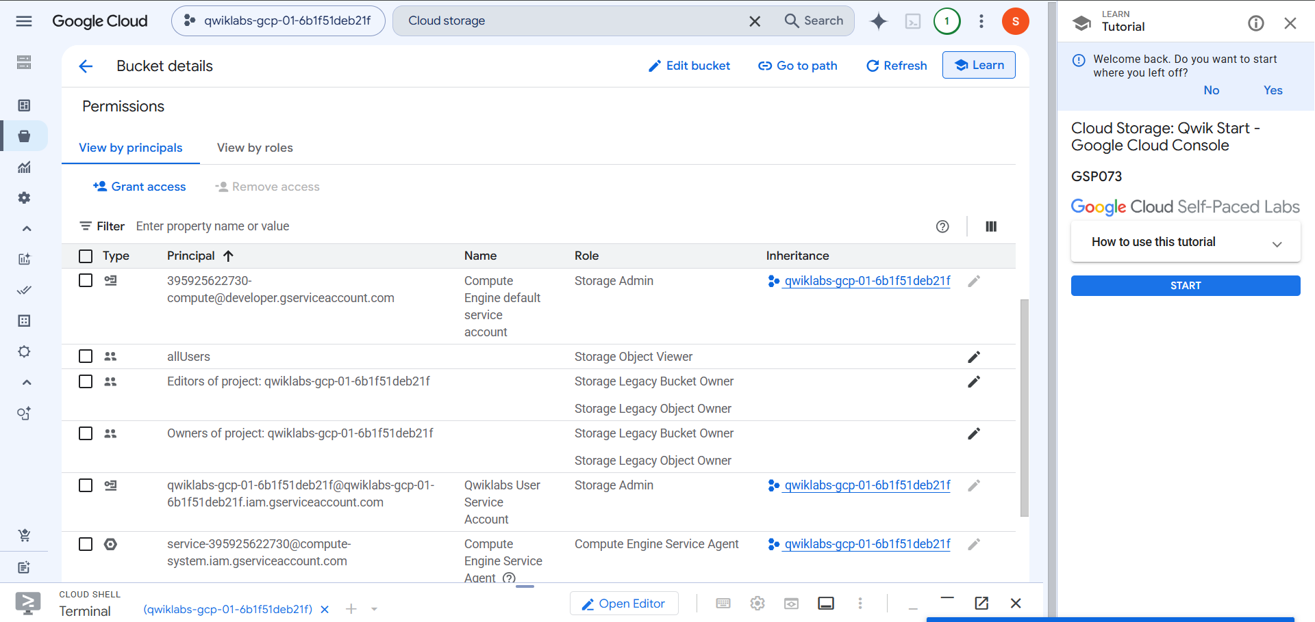
Figure 5: Permissions list showing allUsers with the Storage Object Viewer role.

6. Conclusion
In this lab, a Cloud Storage bucket was created in us-east1 with the Standard storage class and Uniform access control. The kitten.png image was uploaded, a folder hierarchy (images/animals) was set up for organization, and public read access was granted by assigning the Storage Object Viewer role to allUsers. Each task was verified through the Google Cloud Console and the lab’s progress checks.
Security note: Granting access to allUsers makes content readable by anyone on the internet. Use it only for lab or intentionally public content, and use Prevent public access for private data.

