GOOGLE CLOUD | CLOUD STORAGE
Google Cloud Storage:
Retention Policy and Object Holds
Lab Documentation
Prepared by
NaveenKumar.P

1. Objective
The objective of this lab is to configure a Google Cloud Storage bucket with a retention policy, lock the policy, and manage temporary and event-based holds on storage objects. The lab also verifies the storage of a transaction record object.

2. Prerequisites
- An active Google Cloud project.
- Access to Google Cloud Shell.
- The Google Cloud CLI (gcloud) installed and configured.
- Appropriate permissions to manage Cloud Storage buckets and objects.

3. Create a Storage Bucket
Set the bucket name using the current project ID:
export BUCKET=$(gcloud config get-value project)
Create the bucket in the us-west1 region:
gcloud storage buckets create gs://$BUCKET --location=us-west1
If the bucket already exists, do not create it again. Verify it using:
gcloud storage buckets list

4. Set Up the Retention Policy
Configure a retention period of 10 seconds:
gcloud storage buckets update gs://$BUCKET --retention-period=10s
Verify the retention policy:
gcloud storage buckets describe gs://$BUCKET --format="default(retention_policy)"
The output should include the retention period:
retention_policy:
effectiveTime: ...
retentionPeriod: '10'
The retention policy prevents objects from being deleted or replaced until their retention period expires.

5. Lock the Retention Policy
Lock the retention policy to prevent it from being removed or reduced:
gcloud storage buckets update gs://$BUCKET --lock-retention-period
Confirm the operation when prompted. Then verify the locked policy:
gcloud storage buckets describe gs://$BUCKET --format="default(retention_policy)"
Expected output includes:
retention_policy:
isLocked: true
retentionPeriod: '10'
Important: Locking a retention policy is permanent. A locked policy cannot be unlocked or removed, so verify the configuration before proceeding.

6. Upload a Transaction Record Object
Copy the sample transaction record into the bucket:
gcloud storage cp gs://spls/gsp297/dummy_transactions gs://$BUCKET/
Verify that the object exists:
gcloud storage ls gs://$BUCKET/
Inspect its metadata:
gcloud storage ls -L gs://$BUCKET/dummy_transactions
The output should display the object name, creation time, content length, and retention expiration.

7. Set Up a Temporary Hold
Apply a temporary hold to the transaction record:
gcloud storage objects update gs://$BUCKET/dummy_transactions --temporary-hold
Verify the object's metadata:
gcloud storage ls -L gs://$BUCKET/dummy_transactions
Remove the temporary hold when appropriate:
gcloud storage objects update gs://$BUCKET/dummy_transactions --no-temporary-hold
A temporary hold prevents deletion or replacement while the hold remains active.
The screenshot below shows the detailed object listing for the transaction record in Cloud Shell. The object is 45 bytes in size, and the metageneration value of 3 reflects the successive metadata updates (object creation, temporary hold applied, and temporary hold removed). The ACL lists the project owners, editors, viewers, and the lab user.
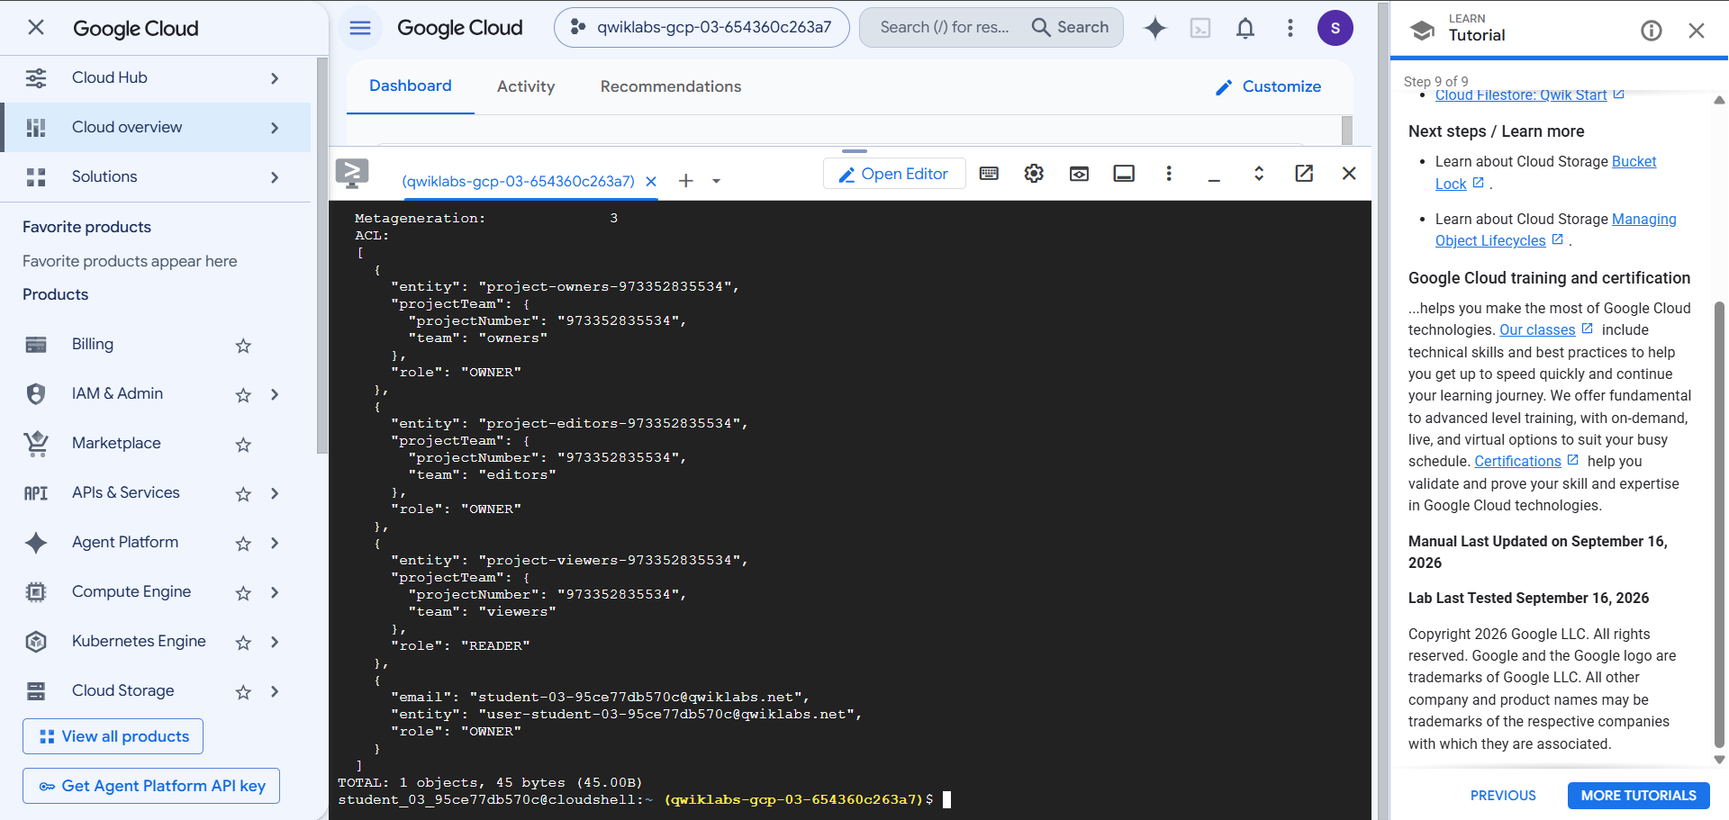
Figure 1: Object metadata of dummy_transactions displayed using gcloud storage ls -L

8. Create Event-Based Holds
Enable default event-based holds for newly uploaded objects:
gcloud storage buckets update gs://$BUCKET --default-event-based-hold
Upload the sample loan record:
gcloud storage cp gs://spls/gsp297/dummy_loan gs://$BUCKET/
Verify the event-based hold:
gcloud storage ls -L gs://$BUCKET/dummy_loan
The output should include:
Event-Based Hold: True
Remove the event-based hold:
gcloud storage objects update gs://$BUCKET/dummy_loan --no-event-based-hold
After the hold is removed, the object's retention period must still expire before deletion is permitted.

9. Verify the Transaction Record
Check that the transaction record exists:
gcloud storage ls gs://$BUCKET/dummy_transactions
If the lab checker still reports that the transaction record is missing, confirm that the bucket name and project are correct and that the object is present. Do not repeatedly upload the same object while a hold is active.

10. Troubleshooting
Error | Resolution
404 Not Found | Verify the bucket name and confirm that the bucket exists using gcloud storage buckets list.
409 Already Own | The bucket already exists. Use the existing bucket instead of recreating it.
403 Object is under active hold | Remove the applicable hold before attempting deletion or replacement.
Object matched no objects | The object may already have been deleted. Verify the bucket contents before retrying.
Transaction record not detected | Verify that dummy_transactions exists in the expected bucket and rerun the lab's progress checker.

11. Conclusion
This lab demonstrates how to create a Google Cloud Storage bucket, configure and lock a retention policy, upload a transaction record, and manage temporary and event-based holds. These features help preserve important records and support data retention requirements.
Successful completion should be verified using the bucket metadata, object metadata, and the lab's progress checker.

