PROJECT DOCUMENTATION
Virtual Private Cloud (VPC) Networking
Auto Mode, Custom Mode and Multi-Network Connectivity on Google Cloud
PROJECT TOPIC
Creating, Converting and Testing VPC Networks, Firewall Rules and VM Connectivity in Google Cloud
PREPARED BY
NaveenKumar.P

Table of Contents
1. Project Overview
2. Objectives
3. Lab Environment and Prerequisites
4. Target Architecture
5. Task 1: Explore and Delete the Default Network
6. Task 2: Create the Auto Mode Network and Two VMs
7. Task 3: Create Two Custom VPC Networks
8. Task 4: Explore Connectivity Across VPC Networks
9. Results Summary
10. Key Learnings
11. Conclusion

1. Project Overview
A Virtual Private Cloud (VPC) network is similar to a physical network, except that it is virtualized within Google Cloud. A VPC network is a global resource that consists of a list of regional virtual subnetworks (subnets) in data centers, all connected by a global wide area network (WAN). VPC networks are logically isolated from each other in Google Cloud.
In this project, an auto mode VPC network is created with firewall rules and two VM instances. The auto mode network is then converted to a custom mode network, and additional custom mode networks are created. Connectivity across the networks is tested using both external and internal IP addresses.

2. Objectives
- Explore the default VPC network, its subnets, routes and firewall rules, and then delete it.
- Create an auto mode VPC network (mynetwork) with firewall rules and two VM instances.
- Convert mynetwork from auto mode to custom mode.
- Create two custom mode VPC networks (managementnet and privatenet) with their subnets and firewall rules.
- Deploy VM instances in the custom networks.
- Test and compare external IP and internal IP connectivity between VMs in different VPC networks.

3. Lab Environment and Prerequisites
Item | Details
Platform | Google Cloud Skills Boost (temporary lab project)
Project ID | qwiklabs-gcp-03-4ec548265ebf
Tools used | Google Cloud Console, Cloud Shell (gcloud CLI)
Primary regions | us-east4 and asia-south1
Boot image | Debian GNU/Linux 12 (bookworm)
Account | Temporary student account supplied by the lab (no personal account used)

Important: Complete the tasks in order, because later tasks depend on earlier ones. Do not delete resources other than those the lab specifically requests.

4. Target Architecture
The completed environment contains three custom mode VPC networks and four VM instances.

VPC networks
Network | Mode | Subnet(s) | Region / IP range
mynetwork | Custom (converted from Auto) | Auto-created subnets | us-east4 and asia-south1 (auto-assigned ranges)
managementnet | Custom | managementsubnet-us | us-east4 / 10.240.0.0/20
privatenet | Custom | privatesubnet-us ; privatesubnet-notus | us-east4 / 172.16.0.0/24 ; asia-south1 / 172.20.0.0/20

VM instances
VM name | Zone | Network | Machine type
mynet-us-vm | us-east4-b | mynetwork | e2-medium
mynet-notus-vm | asia-south1-c | mynetwork | e2-medium
managementnet-us-vm | us-east4-b | managementnet | e2-micro
privatenet-us-vm | us-east4-b | privatenet | e2-micro

5. Task 1: Explore and Delete the Default Network
The project starts with a default network. Each default subnet has an IP range and a region. In this task the default network is inspected, then removed so that the rest of the lab starts from a clean environment.

5.1 Open the VPC networks page
- Open the Google Cloud Console and click the Navigation menu (☰).
- Select VPC network → VPC networks.
- Click the network named default to inspect its subnets.

5.2 View routes
- In the left pane, click Routes.
- Set Network to default and Region to us-east4, then click View.
- Confirm the subnet routes and the default internet gateway route (0.0.0.0/0).

5.3 Delete the default firewall rules
- Go to VPC network → Firewall.
- Locate the four default rules: default-allow-icmp, default-allow-rdp, default-allow-ssh and default-allow-internal.
- Select only the rules that belong to the default network, click Delete and confirm.

5.4 Delete the default network
- Go to VPC network → VPC networks and click default.
- Click Delete VPC network, enter default when prompted and confirm.
- Wait until the network disappears from the list.
Expected result: the default network, its subnets and its associated routes are removed.

5.5 Verify that a VM cannot be created without a network
This is an intentional test. Go to Compute Engine → VM instances, click Create instance, leave the defaults and click Create. The console reports a networking error (for example, no more networks available under Network interfaces) because no VPC network exists. Click Cancel; do not attempt to fix this error.
Result: The deletion is confirmed in Figure 4 later in this document, where the VPC networks list no longer contains the default network.

6. Task 2: Create the Auto Mode Network and Two VMs

6.1 Enable the required APIs
Activate Cloud Shell (the terminal icon at the top-right of the console), click Continue if prompted, and run:
gcloud services enable \
iap.googleapis.com \
networkmanagement.googleapis.com

6.2 Create mynetwork
- Go to VPC network → VPC networks and click Create VPC network.
- Set Name to mynetwork and Subnet creation mode to Automatic.
- Under Firewall rules, select all available standard firewall rules.
- Leave the other settings at their defaults and click Create.
Automatic mode creates one subnet in each Google Cloud region. After creation, open mynetwork → Subnets to find the ranges for us-east4 and asia-south1.
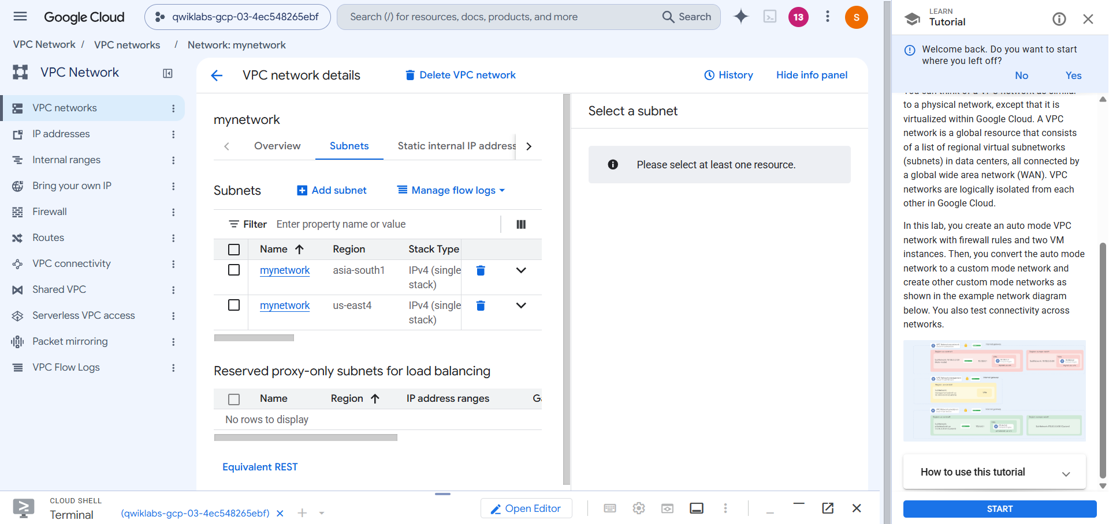
Figure 1: mynetwork subnets in asia-south1 and us-east4

6.3 Create the IAP SSH firewall rule
This rule allows SSH connections through Identity-Aware Proxy (IAP). Go to VPC network → Firewall, click Create firewall rule and enter:
Setting | Value
Name | allow-iap-ssh
Network | mynetwork
Priority | 1000
Direction of traffic | Ingress
Action on match | Allow
Targets | Specified target tags
Target tags | iap-gce
Source filter | IPv4 ranges
Source IP ranges | 35.235.240.0/20
Protocols and ports | Specified protocols and ports → TCP 22

Note: The VMs created next must carry the network tag iap-gce for this rule to apply to them.

6.4 Create mynet-us-vm
Go to Compute Engine → VM instances, click Create instance and enter:
Setting | Value
Name | mynet-us-vm
Region / Zone | us-east4 / us-east4-b
Series / Machine type | E2 / e2-medium
Boot image | Debian GNU/Linux 12 (bookworm)
Network tag (Networking section) | iap-gce
Network interface | mynetwork (subnet auto-selected for the region)

Click Create and wait for the VM to finish provisioning.

6.5 Create mynet-notus-vm
Repeat the same process with these differences:
Setting | Value
Name | mynet-notus-vm
Region / Zone | asia-south1 / asia-south1-c
Series / Machine type | E2 / e2-medium
Boot image | Debian GNU/Linux 12 (bookworm)
Network tag | iap-gce
Network interface | mynetwork (subnet auto-selected for the region)

6.6 Record the VM IP addresses
On Compute Engine → VM instances, record the internal and external IP addresses of both VMs. They are needed for the connectivity tests.

6.7 Connect to mynet-us-vm using IAP
gcloud compute ssh mynet-us-vm \
--zone=us-east4-b \
--tunnel-through-iap
- If prompted to continue connecting, type Y and press Enter.
- If prompted to create an SSH key, follow the prompt; press Enter twice to leave the passphrase empty.

6.8 Test connectivity to the second VM
From the SSH session, replace each placeholder with the real IP address from the VM instances page:
ping -c 3 SECOND_VM_INTERNAL_IP
ping -c 3 SECOND_VM_EXTERNAL_IP
Both tests should succeed because the corresponding firewall rules are in place. Then leave the SSH session:
exit

6.9 Convert mynetwork to custom mode
- Go to VPC network → VPC networks and click mynetwork.
- Click Edit and change Subnet creation mode from Automatic to Custom.
- Click Save, then return to the VPC networks list.
- Refresh if necessary and wait until the mode shows Custom.
The existing auto-created subnets remain. Changing the mode only prevents new regional subnets from being created automatically.
Return to the lab instructions and click Check my progress for this objective.

7. Task 3: Create Two Custom VPC Networks
In this task, managementnet and privatenet are created, firewall rules are configured, and one VM is deployed in each network.

7.1 Create managementnet (Console)
- Go to VPC network → VPC networks and click Create VPC network.
- Set Name to managementnet and Subnet creation mode to Custom.
- Under New subnet, enter Name managementsubnet-us, Region us-east4 and IPv4 range 10.240.0.0/20, then click Done.
- Click Create.
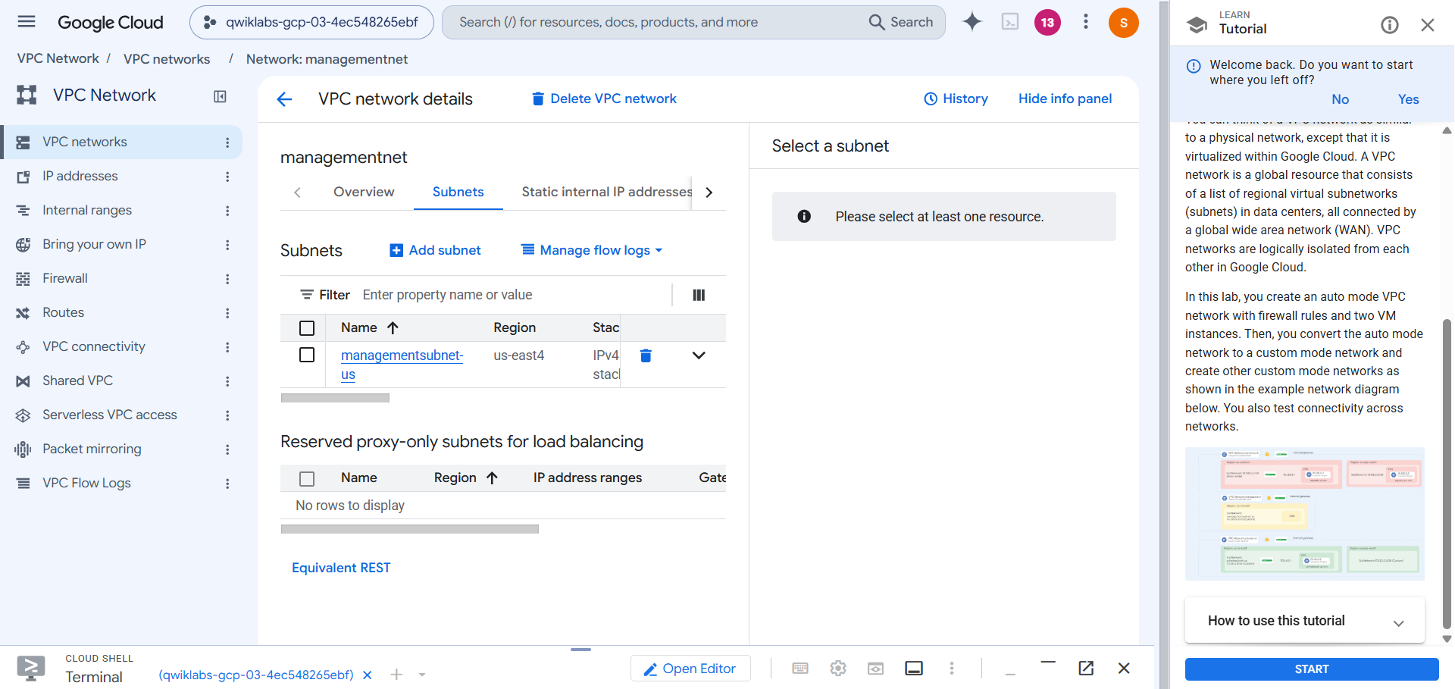
Figure 2: managementnet with its single subnet, managementsubnet-us, in us-east4

7.2 Create privatenet (Cloud Shell)
Return to Cloud Shell and run the following commands one at a time.

Create the VPC network
gcloud compute networks create privatenet \
--subnet-mode=custom

Create the US subnet
gcloud compute networks subnets create privatesubnet-us \
--network=privatenet \
--region=us-east4 \
--range=172.16.0.0/24

Create the Asia subnet
gcloud compute networks subnets create privatesubnet-notus \
--network=privatenet \
--region=asia-south1 \
--range=172.20.0.0/20
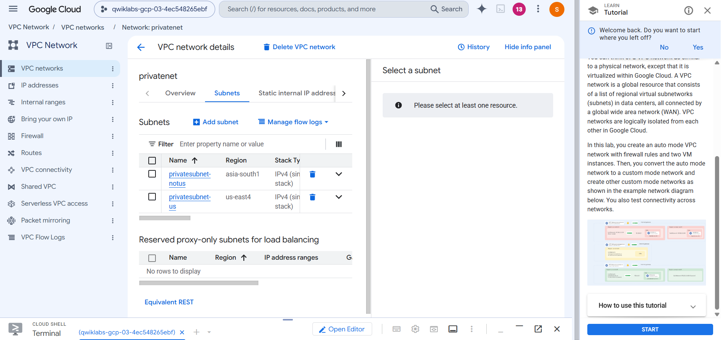
Figure 3: privatenet subnets: privatesubnet-notus (asia-south1) and privatesubnet-us (us-east4)

7.3 Verify the networks and subnets
gcloud compute networks list
gcloud compute networks subnets list --sort-by=NETWORK
Three networks should be listed: mynetwork, managementnet and privatenet. The two custom networks contain only the subnets created explicitly, while mynetwork retains its automatically created subnets.
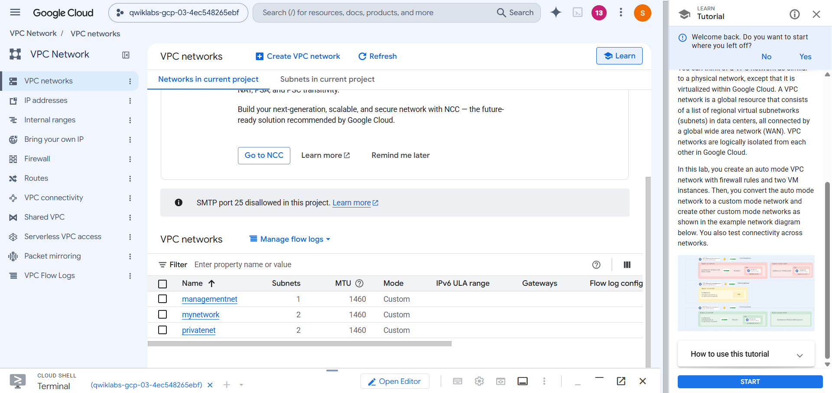
Figure 4: VPC networks list showing managementnet, mynetwork and privatenet, all in Custom mode

7.4 Create the managementnet firewall rule (Console)
Go to VPC network → Firewall, click Create firewall rule and enter:
Setting | Value
Name | managementnet-allow-icmp-ssh-rdp
Network | managementnet
Priority | 1000
Direction | Ingress
Action | Allow
Targets | All instances in the network
Source filter / ranges | IPv4 ranges / 0.0.0.0/0
Protocols and ports | TCP 22 and 3389; Other protocols: icmp

Security note: This rule permits SSH, RDP and ICMP from any IPv4 source. The broad source range is intentional for this lab only; production rules should be restricted to trusted sources.

7.5 Create the privatenet firewall rule (Cloud Shell)
gcloud compute firewall-rules create privatenet-allow-icmp-ssh-rdp \
--direction=INGRESS \
--priority=1000 \
--network=privatenet \
--action=ALLOW \
--rules=icmp,tcp:22,tcp:3389 \
--source-ranges=0.0.0.0/0

7.6 Verify the firewall rules
gcloud compute firewall-rules list --sort-by=NETWORK
The list should include managementnet-allow-icmp-ssh-rdp, privatenet-allow-icmp-ssh-rdp, mynetwork-allow-custom, mynetwork-allow-icmp, mynetwork-allow-rdp, mynetwork-allow-ssh and the allow-iap-ssh rule created earlier.
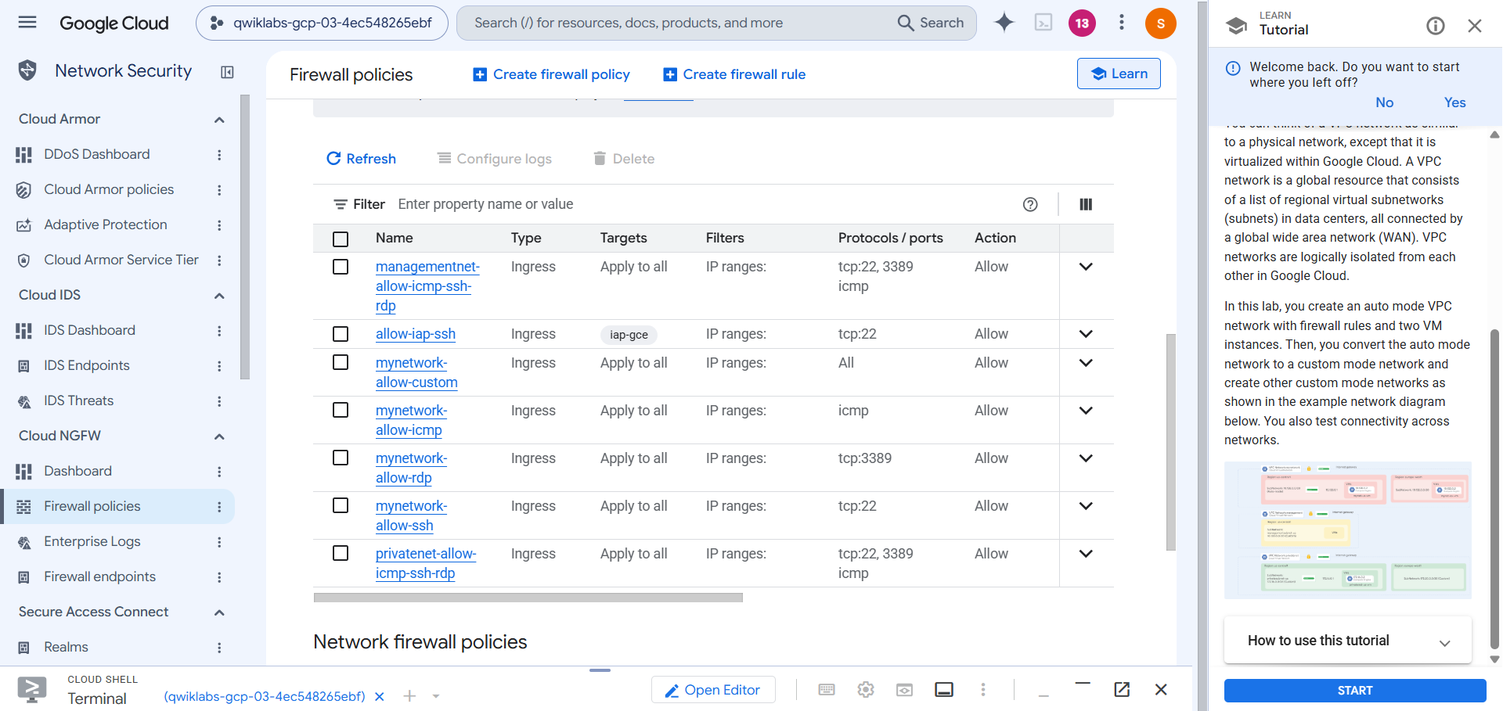
Figure 5: Firewall policies page listing the VPC firewall rules for managementnet, mynetwork and privatenet
Click Check my progress for the firewall objective.

7.7 Create managementnet-us-vm (Console)
Setting | Value
Name | managementnet-us-vm
Region / Zone | us-east4 / us-east4-b
Series / Machine type | E2 / e2-micro
Boot image | Debian GNU/Linux 12 (bookworm)
Network | managementnet
Subnetwork | managementsubnet-us

Expand Networking → Network interfaces, set the network and subnetwork as shown, click Done and then Create.

7.8 Create privatenet-us-vm (Cloud Shell)
gcloud compute instances create privatenet-us-vm \
--zone=us-east4-b \
--machine-type=e2-micro \
--subnet=privatesubnet-us \
--image-family=debian-12 \
--image-project=debian-cloud \
--boot-disk-size=10GB \
--boot-disk-type=pd-standard \
--boot-disk-device-name=privatenet-us-vm

7.9 Verify all VM instances
gcloud compute instances list --sort-by=ZONE
Four VMs should be running: mynet-us-vm, mynet-notus-vm, managementnet-us-vm and privatenet-us-vm.
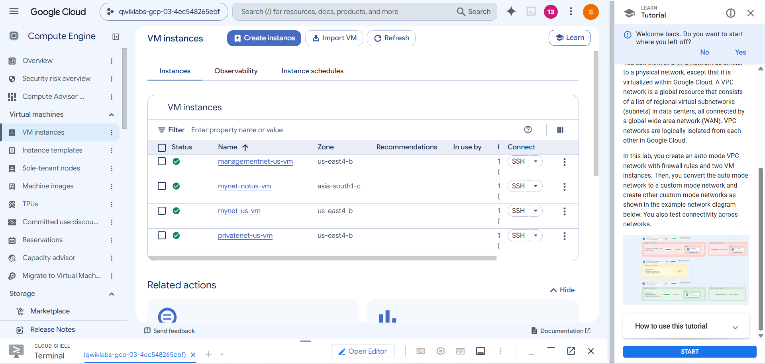
Figure 6: VM instances page showing all four VMs running
Click Check my progress for the VM instance objective.

8. Task 4: Explore Connectivity Across VPC Networks
This task demonstrates the difference between external IP connectivity and internal IP connectivity.
- VMs in the same VPC can communicate over internal IPs when firewall rules allow it, even across regions.
- VMs in different VPC networks cannot communicate directly over internal IPs unless connectivity such as VPC Network Peering or VPN is configured.
- External IP connectivity depends on firewall rules, routing and other applicable network policies.

8.1 Record the IP addresses
On Compute Engine → VM instances, record the internal and external IP addresses of mynet-notus-vm, managementnet-us-vm and privatenet-us-vm.

8.2 SSH into mynet-us-vm
gcloud compute ssh mynet-us-vm \
--zone=us-east4-b \
--tunnel-through-iap

8.3 Ping the external IP addresses
ping -c 3 MYNET_NOTUS_EXTERNAL_IP
ping -c 3 MANAGEMENTNET_EXTERNAL_IP
ping -c 3 PRIVATENET_EXTERNAL_IP
Expected result: the external IP pings succeed because the ICMP ingress rules allow the packets. If one fails, verify the external IP and that the destination VM’s firewall rule allows ICMP.

8.4 Ping the internal IP addresses
ping -c 3 MYNET_NOTUS_INTERNAL_IP
ping -c 3 MANAGEMENTNET_INTERNAL_IP
ping -c 3 PRIVATENET_INTERNAL_IP
Target (internal IP) | Expected | Reason
mynet-notus-vm | Succeeds | Same VPC (mynetwork); internal firewall rule permits traffic
managementnet-us-vm | Fails (100% loss) | Different, isolated VPC network
privatenet-us-vm | Fails (100% loss) | Different, isolated VPC network

Being in the same zone does not make private addresses reachable across isolated VPC networks.

8.5 Observed test output
The terminal capture below shows the results obtained from mynet-us-vm: the external IP pings returned replies with 0% packet loss, the internal IP of the second mynetwork VM (10.150.0.2) replied with 0% packet loss, and the internal IP 10.240.0.2, which lies in the managementnet subnet range (10.240.0.0/20), returned 100% packet loss. The session was then closed with exit.
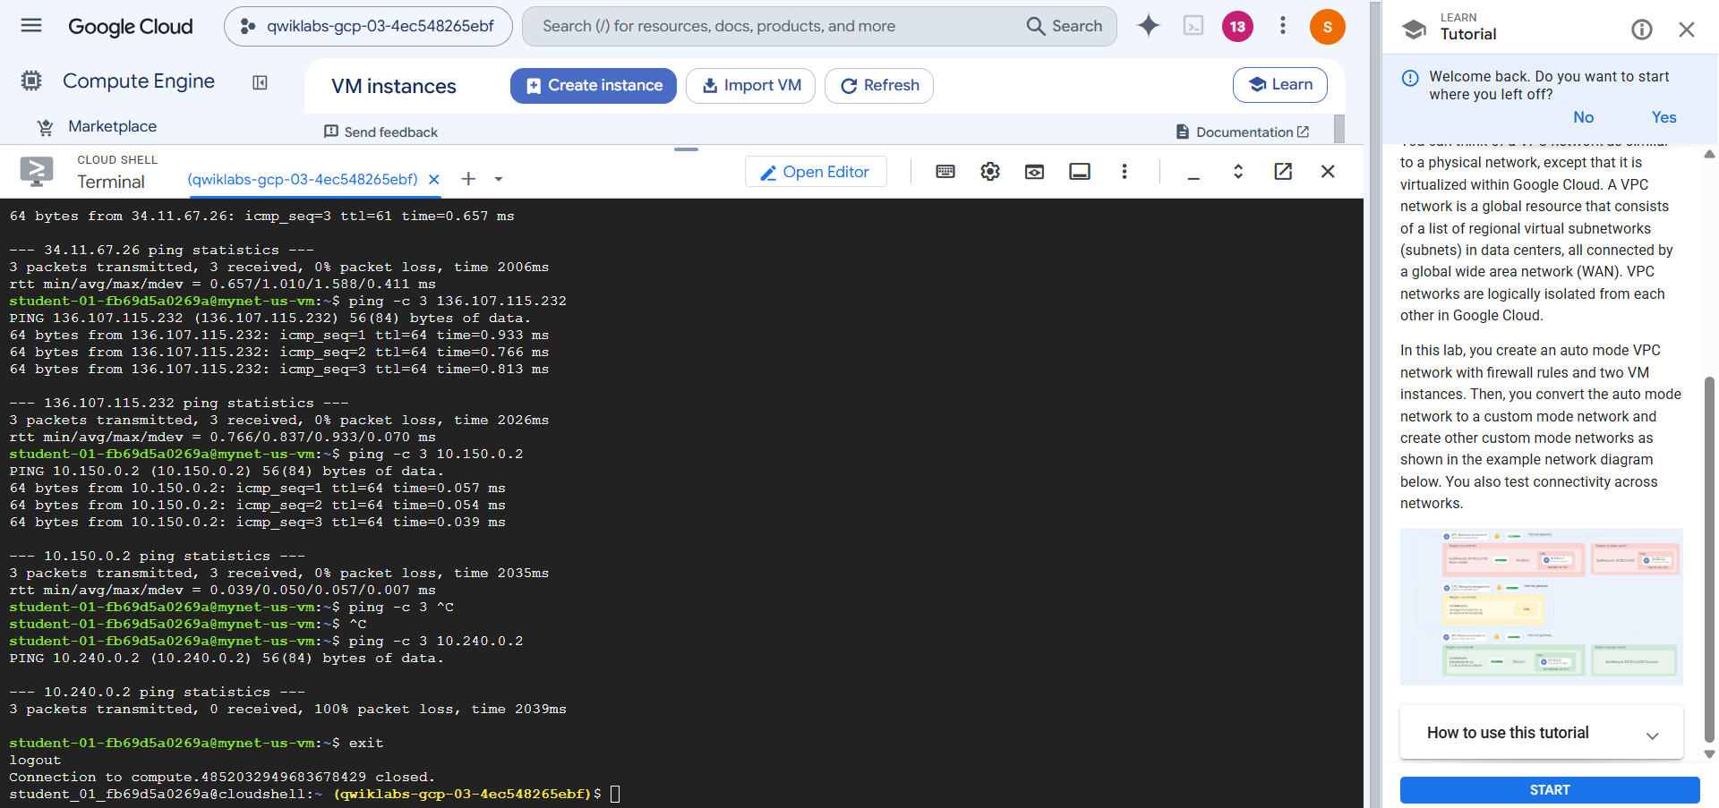
Figure 7: Cloud Shell output of the ping tests from mynet-us-vm, followed by exit

8.6 Exit the SSH session
exit
You return to the Cloud Shell prompt.

9. Results Summary
Test (from mynet-us-vm) | Result | Observation
Ping external IPs of other VMs | Success | 0% packet loss; ICMP allowed by ingress rules
Ping internal IP of mynet-notus-vm | Success | 0% packet loss; same VPC across regions
Ping internal IP in managementnet (10.240.0.2) | Failure | 100% packet loss; separate VPC
Ping internal IP in privatenet | Failure (expected) | Separate VPC; no peering or VPN configured

10. Key Learnings
- Global VPCs: a VPC network is a global resource whose subnets are regional.
- Auto vs. custom mode: auto mode creates a subnet per region automatically; custom mode gives full control of subnets and IP ranges. An auto mode network can be converted to custom mode, but not back.
- Firewall rules: traffic is denied by default; ingress rules for ICMP, SSH and RDP must be created explicitly for each network.
- Isolation: separate VPC networks cannot reach each other over internal IPs without peering, VPN or similar connectivity.
- Secure access: IAP tunneling with the iap-gce network tag allows SSH without exposing broad SSH access.
- Least privilege: the 0.0.0.0/0 source ranges used here are for demonstration only and should be narrowed in production.

11. Conclusion
The lab successfully demonstrated how to remove the default network, build an auto mode network and convert it to custom mode, create additional custom networks with subnets, firewall rules and VMs, and verify connectivity behavior. The tests confirmed that VMs in the same VPC communicate across regions over internal IPs, while VMs in different VPC networks are isolated from one another at the internal-IP level.

