GOOGLE CLOUD HANDS-ON LAB DOCUMENTATION

Internal Application Load Balancer
Building a Secure Internal Service Tier with a Public-Facing Web Tier
Prepared by
NaveenKumar.P

1. Overview
An internal Application Load Balancer distributes network traffic inside a private cloud network without exposing virtual machines (VMs) to the public internet. This document describes the design, implementation and verification of a simplified but common two-tier architecture built on Google Cloud Compute Engine:
- Web Tier (frontend): a public-facing website that needs to ask another internal service for help.
- Internal Service Tier (backend): a prime number calculator running on a managed instance group of multiple VMs, reachable only through an internal load balancer.
Because the load balancer routes requests only to healthy machines, the internal service keeps running even if an individual backend VM becomes busy or fails.

1.1 Objectives
- Understand the components that make up an Internal Load Balancer.
- Create a group of backend machines (prime number calculator).
- Set up an internal load balancer to direct internal traffic to the backend machines.
- Test the internal load balancer from another internal machine.
- Set up a public-facing web server that consumes the internal service through the load balancer.

1.2 Prerequisites
- Basic familiarity with Google Cloud Compute Engine and VM instances.
- Basic networking concepts such as IP addresses.
- Basic Unix/Linux command-line usage.
- Understanding of Virtual Private Clouds (VPCs) and private networking.

2. Lab Environment
The lab runs in a temporary, real Google Cloud environment using a student account provisioned for the duration of the lab. All commands are executed from Cloud Shell, which is pre-authenticated and pre-configured with the gcloud CLI.
Item | Value
Project ID | qwiklabs-gcp-04-188ac095b3a2
Region | us-central1
Zone | us-central1-a
Network | default (auto mode VPC)
Tooling | Cloud Shell, gcloud CLI, Cloud Shell Editor

Set the default region and zone for the session (this must be repeated for every new Cloud Shell session):
gcloud config set compute/region us-central1
gcloud config set compute/zone us-central1-a

3. Architecture and Components
An Internal Load Balancer consists of three main parts, which work together to provide a single private virtual IP (VIP) entry point for the service.
Component | Purpose
Forwarding Rule | The private IP address (10.128.0.10) that internal clients send requests to. It forwards traffic to the backend service.
Backend Service | Defines how traffic is distributed to the VM instances and attaches the health check to the instance group.
Health Check | Continuously probes backend VMs; the load balancer only sends traffic to machines that are passing the check.

Traffic flow: Internet user → frontend VM (public IP, port 80) → internal load balancer VIP 10.128.0.10 → one of three backend VMs in the managed instance group (no external IP).

4. Implementation

Task 1. Create a Virtual Environment
A Python virtual environment isolates package installation from the system and ensures code runs with the specific tool versions it needs.
- Install virtualenv:
sudo apt-get install -y virtualenv
- Build the virtual environment:
python3 -m venv venv
- Activate the virtual environment:
source venv/bin/activate

Task 2. Create a Backend Managed Instance Group
A managed instance group lets Google Cloud automatically create and maintain identical copies of the service. If one copy fails, it is replaced, making the service more reliable.

2.1 Create the startup script
Each new VM in the group runs this script at boot. It starts a small Python web server on port 80 that reports whether a number is prime (True) or not (False). Create the file from Cloud Shell, then open the Cloud Shell Editor to add the content:
touch ~/backend.sh
Add the following to backend.sh and save the file (File > Save):
sudo chmod -R 777 /usr/local/sbin/
sudo cat << EOF > /usr/local/sbin/serveprimes.py
import http.server

def is_prime(a): return a!=1 and all(a % i for i in range(2,int(a**0.5)+1))

class myHandler(http.server.BaseHTTPRequestHandler):
def do_GET(s):
s.send_response(200)
s.send_header("Content-type", "text/plain")
s.end_headers()
s.wfile.write(bytes(str(is_prime(int(s.path[1:]))).encode('utf-8')))

http.server.HTTPServer(("",80),myHandler).serve_forever()
EOF
nohup python3 /usr/local/sbin/serveprimes.py >/dev/null 2>&1 &

2.2 Create the instance template
The template primecalc is the blueprint for the backend VMs. The --no-address flag means the VMs have no public IP, which keeps them private for security reasons.
gcloud compute instance-templates create primecalc \
--metadata-from-file startup-script=backend.sh \
--no-address --tags backend --machine-type=e2-medium

2.3 Open the firewall
A firewall rule allows TCP port 80 traffic from the subnet range 10.128.0.0/20 to the VMs tagged backend. This is required for the load balancer and health checks to communicate with the backends.
gcloud compute firewall-rules create http --network default --allow=tcp:80 \
--source-ranges 10.128.0.0/20 --target-tags backend

2.4 Create the instance group
Create the managed instance group backend with 3 instances:
gcloud compute instance-groups managed create backend \
--size 3 \
--template primecalc \
--zone us-central1-a
In the console, open Compute Engine > VM instances. Three backend VMs should appear, being created by the instance group. The backends are then ready to serve traffic.

Task 3. Set Up the Internal Load Balancer
This task creates the single, private VIP entrance to the service so that other internal applications can reach the prime number calculator reliably, without knowing which specific backend VM is active.

3.1 Create a health check
The health check ensures traffic is only sent to healthy instances. It requests the path /2 and expects an HTTP 200 OK response (2 is prime, so the backend returns a valid response).
gcloud compute health-checks create http ilb-health --request-path /2

3.2 Create a backend service
The backend service prime-service ties the health check to the load balancing configuration.
gcloud compute backend-services create prime-service \
--load-balancing-scheme internal --region=us-central1 \
--protocol tcp --health-checks ilb-health

3.3 Add the instance group to the backend service
This tells the load balancer which machines it should manage.
gcloud compute backend-services add-backend prime-service \
--instance-group backend --instance-group-zone=us-central1-a \
--region=us-central1

3.4 Create the forwarding rule
Create the forwarding rule prime-lb with the static internal IP 10.128.0.10. The internal prime number calculation service is now ready to be queried through this address.
gcloud compute forwarding-rules create prime-lb \
--load-balancing-scheme internal \
--ports 80 --network default \
--region=us-central1 --address 10.128.0.10 \
--backend-service prime-service

Task 4. Test the Load Balancer
The internal load balancer is only reachable from inside the VPC, not from Cloud Shell, which lives outside this network. A test VM in the same network is therefore created.
- Create the test instance:
gcloud compute instances create testinstance \
--machine-type=e2-standard-2 --zone us-central1-a
- SSH into the instance (type Y and press Enter twice if prompted):
gcloud compute ssh testinstance --zone us-central1-a
- Query the load balancer from inside the test instance:
curl 10.128.0.10/2
curl 10.128.0.10/4
curl 10.128.0.10/5
Expected output: True for 2, False for 4, True for 5. This confirms that the internal load balancer received the requests and forwarded them to a backend VM, which answered correctly (2 and 5 are prime, 4 is not).
user@testinstance:~$ curl 10.128.0.10/2
Trueuser@testinstance:~$ curl 10.128.0.10/4
Falseuser@testinstance:~$ curl 10.128.0.10/5
Trueuser@testinstance:~$ exit
- Leave the test instance and delete it, as it is no longer needed (type Y to confirm):
exit
gcloud compute instances delete testinstance --zone=us-central1-a

Task 5. Create a Public-Facing Web Server
This task shows how a public-facing application can use the internal service. The frontend web server calls the internal load balancer to display a matrix of numbers, coloured green for primes and red for non-primes.

5.1 Create the frontend startup script
touch ~/frontend.sh
Add the following to frontend.sh in the Cloud Shell Editor and save the file (File > Save). Note that PREFIX points to the internal load balancer IP.
sudo chmod -R 777 /usr/local/sbin/
sudo cat << EOF > /usr/local/sbin/getprimes.py
import urllib.request
from multiprocessing.dummy import Pool as ThreadPool
import http.server
PREFIX="http://10.128.0.10/" #HTTP Load Balancer
def get_url(number):
return urllib.request.urlopen(PREFIX+str(number)).read().decode('utf-8')
class myHandler(http.server.BaseHTTPRequestHandler):
def do_GET(s):
s.send_response(200)
s.send_header("Content-type", "text/html")
s.end_headers()
i = int(s.path[1:]) if (len(s.path)>1) else 1
s.wfile.write("<html><body><table>".encode('utf-8'))
pool = ThreadPool(10)
results = pool.map(get_url,range(i,i+100))
for x in range(0,100):
if not (x % 10): s.wfile.write("<tr>".encode('utf-8'))
if results[x]=="True":
s.wfile.write("<td bgcolor='#00ff00'>".encode('utf-8'))
else:
s.wfile.write("<td bgcolor='#ff0000'>".encode('utf-8'))
s.wfile.write(str(x+i).encode('utf-8')+"</td> ".encode('utf-8'))
if not ((x+1) % 10): s.wfile.write("</tr>".encode('utf-8'))
s.wfile.write("</table></body></html>".encode('utf-8'))
http.server.HTTPServer(("",80),myHandler).serve_forever()
EOF
nohup python3 /usr/local/sbin/getprimes.py >/dev/null 2>&1 &

5.2 Create the frontend instance
gcloud compute instances create frontend --zone=us-central1-a \
--metadata-from-file startup-script=frontend.sh \
--tags frontend --machine-type=e2-standard-2

5.3 Open the firewall for the frontend
Because this is a public-facing server, the firewall rule http2 allows TCP port 80 from anywhere on the internet (0.0.0.0/0) to VMs tagged frontend.
gcloud compute firewall-rules create http2 --network default --allow=tcp:80 \
--source-ranges 0.0.0.0/0 --target-tags frontend
After the rule is created, the instances can be listed with gcloud compute instances list (or in the console under Compute Engine > VM instances). The output below shows the firewall rule http2 being created, followed by the three backend VMs (internal IPs only) and the frontend VM, which has the external IP 34.56.51.65.
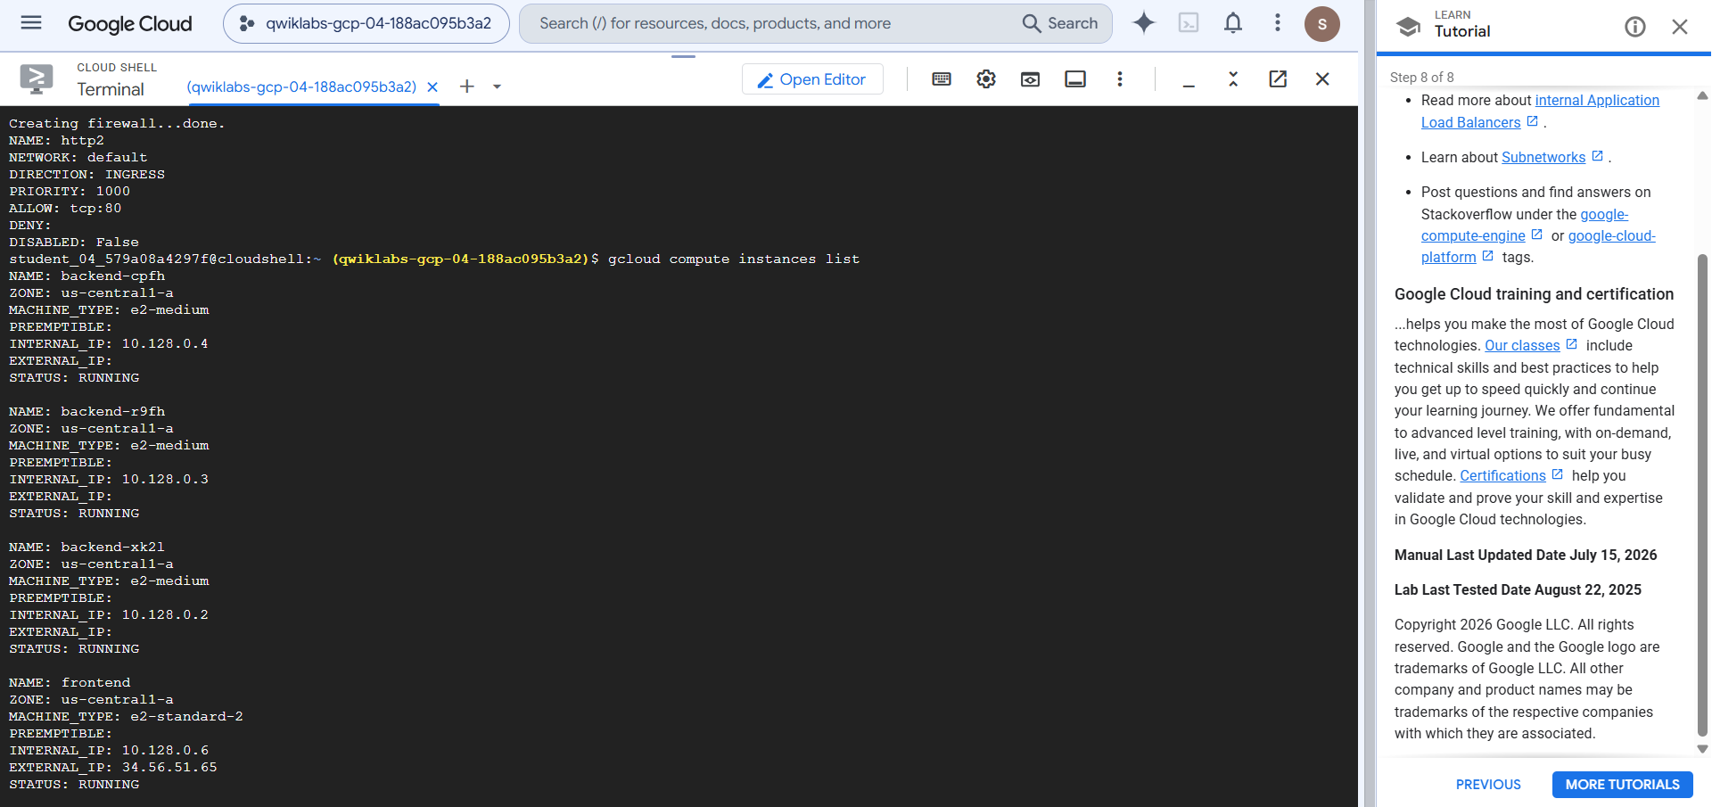
Figure 1: Firewall rule http2 created and VM instances listed in Cloud Shell

5.4 Access the web application
Open the External IP of the frontend VM in a browser (http://34.56.51.65). A matrix of numbers 1 to 100 is displayed, with prime numbers in green and non-primes in red.
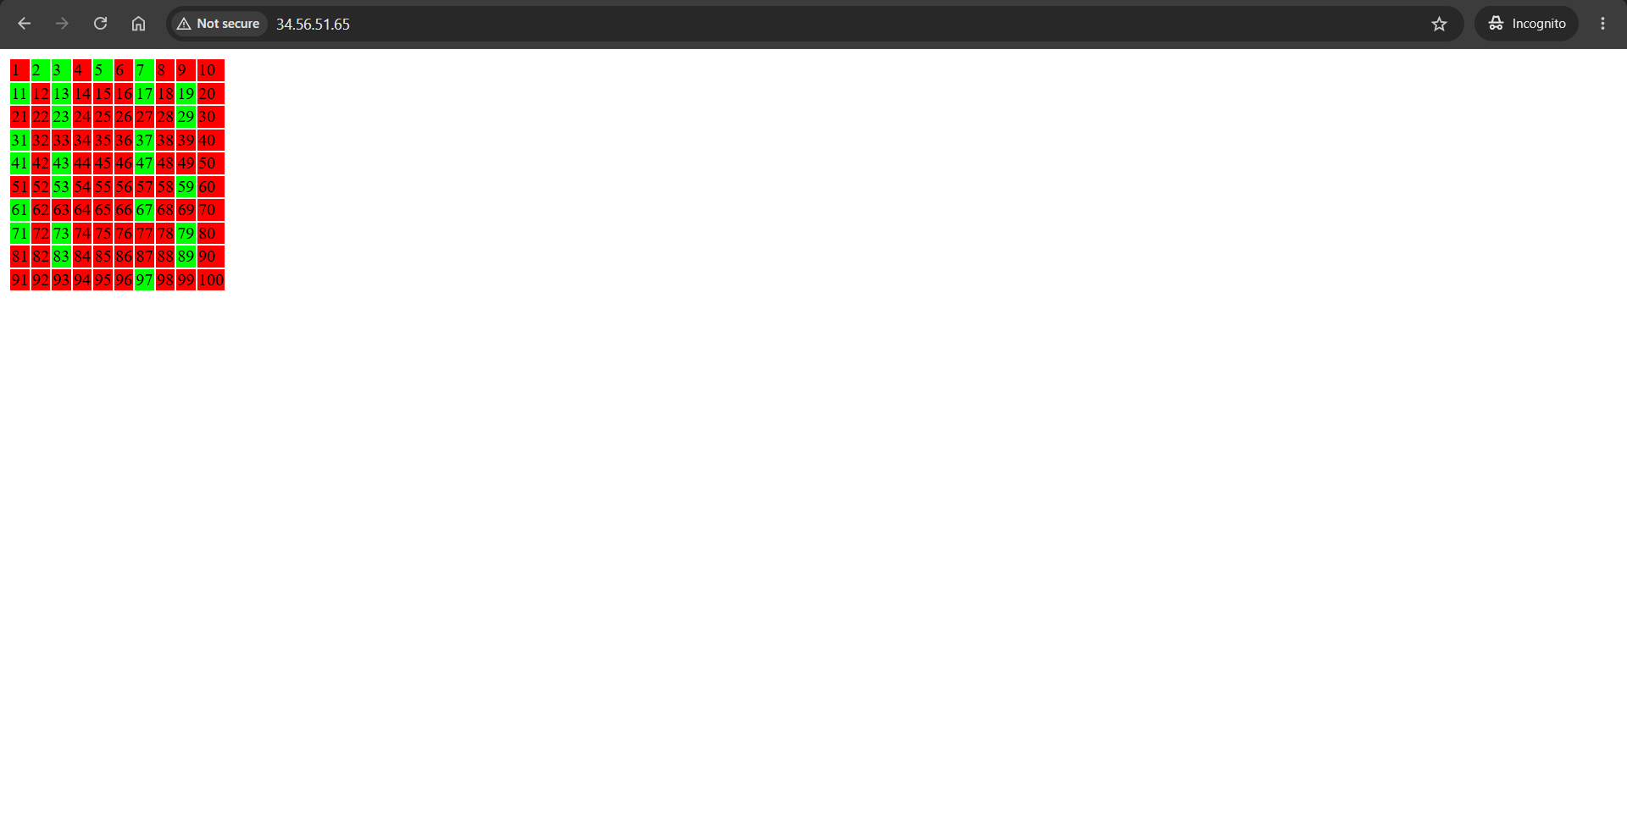
Figure 2: Prime number matrix (1–100) served by the frontend through the internal load balancer
Appending a number to the path, for example http://<external-ip>/10000, displays the prime numbers starting from that number.
Note: The example startup script is not an efficient prime calculator and has no error detection or correction. Very large numbers in the path will cause the service to time out.

5. Resource Summary
Resource | Type | Internal IP | External IP
backend-xk2l | e2-medium | 10.128.0.2 | None
backend-r9fh | e2-medium | 10.128.0.3 | None
backend-cpfh | e2-medium | 10.128.0.4 | None
frontend | e2-standard-2 | 10.128.0.6 | 34.56.51.65
prime-lb (forwarding rule) | Internal ILB | 10.128.0.10 | None

Firewall Rule | Port | Source → Target
http | tcp:80 | 10.128.0.0/20 → tag: backend
http2 | tcp:80 | 0.0.0.0/0 → tag: frontend

6. Conclusion
A reliable internal service was built using Google Cloud's internal Application Load Balancer, backed by a managed instance group of three private VMs with no public IP addresses. Testing from a VM inside the VPC confirmed correct load-balanced responses, and a public-facing web server successfully consumed the internal service through the load balancer VIP. This demonstrates a secure and scalable pattern: only the web tier is exposed to the internet, while the internal service tier remains private, health-checked and highly available.

