Implement DevOps Workflows in Google Cloud
Compute Engine VM, Persistent Disk Creation, Attachment, Formatting and Mounting
Project Documentation
Prepared by
NaveenKumar.P

1. Introduction
This document describes the procedure followed to complete the Google Cloud Skills Boost challenge lab GSP330, “Implement DevOps Workflows in Google Cloud”. The lab covers the end-to-end provisioning of a Compute Engine virtual machine with an additional persistent disk, which is attached, formatted, mounted and configured to mount automatically after a restart.

1.1 Objectives
- Configure the default region and zone for Google Cloud CLI (gcloud) commands.
- Create a Compute Engine virtual machine instance named gcelab.
- Create a 200 GB persistent disk named mydisk and attach it to the VM.
- Format the disk with the ext4 file system and mount it at /mnt/mydisk.
- Persist the mount across reboots by adding an entry to /etc/fstab.
- Identify the correct sequence for migrating persistent disk data to another region.

1.2 Resource Summary
Parameter | Value
Lab | Implement DevOps Workflows in Google Cloud: Challenge Lab (GSP330)
Region / Zone | europe-west1 / europe-west1-b
VM name | gcelab
Machine type | e2-standard-2
Boot image | debian-12 (project: debian-cloud)
Persistent disk | mydisk, 200 GB, pd-standard
Device ID | scsi-0Google_PersistentDisk_persistent-disk-1 (/dev/sdb)
Mount point | /mnt/mydisk (ext4)

Prerequisite: Use the temporary student credentials shown in the lab panel, not a personal Google account. The lab timer cannot be paused, so keep the lab instructions and the Cloud console open in separate browser tabs.

2. Environment Setup

2.1 Start the Lab
- Open the Google Cloud Skills Boost lab page containing the lab instructions.
- Click Start Lab and wait for the countdown timer to appear.
- Click Open Google Cloud console and sign in with the temporary student username and password from the lab panel.

2.2 Open Cloud Shell
Cloud Shell is a browser-based terminal used to manage Google Cloud resources.
- Click the Activate Cloud Shell icon (>_) at the top of the Google Cloud console.
- Click Continue and then Authorize if prompted.
- Wait until the terminal prompt appears at the bottom of the screen.

2.3 Set the Region and Zone
Set the default compute zone and region, then export them as shell variables for use in later commands.
gcloud config set compute/zone europe-west1-b
gcloud config set compute/region europe-west1
export REGION=europe-west1
export ZONE=europe-west1-b

3. Implementation Procedure

Task 1: Create the Virtual Machine
Create a VM named gcelab using the e2-standard-2 machine type and the Debian 12 image.
gcloud compute instances create gcelab \
--zone=$ZONE \
--machine-type=e2-standard-2 \
--image-family=debian-12 \
--image-project=debian-cloud

Expected result: the instance gcelab is listed in the europe-west1-b zone with machine type e2-standard-2 and status RUNNING. Click Check my progress under Task 1 in the lab page to validate. Do not delete the VM.

Task 2: Create the Persistent Disk
Create an additional 200 GB standard persistent disk named mydisk.
gcloud compute disks create mydisk --size=200GB --zone=$ZONE

Expected result: mydisk is listed with size 200 GB, type pd-standard and status READY. Click Check my progress for Task 2.
Note: If the command has already completed successfully, do not run it again; Google Cloud returns an error when a disk with the same name exists in the zone.

Task 3: Attach the Disk to the VM
Attach mydisk to the gcelab instance. A response beginning with “Updated” confirms success.
gcloud compute instances attach-disk gcelab --disk=mydisk --zone=$ZONE

Connect to the VM over SSH to prepare the disk. Accept the prompt with Y and leave the SSH key passphrase empty when asked.
gcloud compute ssh gcelab --zone=$ZONE

A Linux prompt such as student-xx-xxxx@gcelab:~$ confirms that the session is now inside the VM.

Task 4: Identify, Format and Mount the Disk

Step 4.1 – Identify the new disk
List the disk identifiers to locate the newly attached device.
ls -l /dev/disk/by-id/

The entry google-persistent-disk-1 resolves to ../../sdb, and the long-form identifier scsi-0Google_PersistentDisk_persistent-disk-1 refers to the same extra disk. The boot disk is /dev/sda.
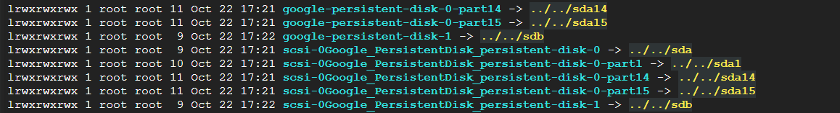
Figure 1: Output of ls -l /dev/disk/by-id/ showing persistent-disk-1 mapped to /dev/sdb
Caution: Never format /dev/sda, which is the VM boot disk. Only the extra disk (/dev/sdb) must be formatted.

Step 4.2 – Create the mount point and format the disk
Create the directory that will serve as the mount point, then format the disk with ext4. Formatting erases all existing data on the target device, so verify the device name first.
sudo mkdir /mnt/mydisk

sudo mkfs.ext4 -F -E lazy_itable_init=0,lazy_journal_init=0,discard \
/dev/disk/by-id/scsi-0Google_PersistentDisk_persistent-disk-1

The output reports the creation of the file system (52,428,800 4k blocks and 13,107,200 inodes) and finishes with Allocating group tables, Writing inode tables, Creating journal and Writing superblocks and filesystem accounting information, each marked done.
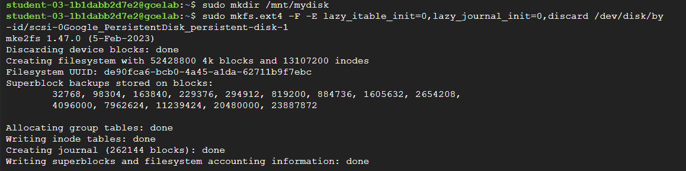
Figure 2: Creating the /mnt/mydisk mount point and formatting the disk with mkfs.ext4

Step 4.3 – Mount the disk and verify
sudo mount -o discard,defaults \
/dev/disk/by-id/scsi-0Google_PersistentDisk_persistent-disk-1 /mnt/mydisk

df -h /mnt/mydisk

The mount command produces no output on success. The df command shows /dev/sdb mounted on /mnt/mydisk with 196 GB total size and 186 GB available.
Figure 3: Mounting the persistent disk and verifying it with df -h

Step 4.4 – Configure automatic mounting
Open /etc/fstab, add the following entry as a new line at the end of the file, then save (Ctrl+O, Enter) and exit (Ctrl+X).
sudo nano /etc/fstab

/dev/disk/by-id/scsi-0Google_PersistentDisk_persistent-disk-1 /mnt/mydisk ext4 defaults 1 1

Validate the configuration by re-mounting all file systems listed in fstab and checking the mount again. No output from mount -a indicates that the entry is valid.
sudo mount -a
df -h /mnt/mydisk

The df output again lists /dev/sdb (196 GB) mounted on /mnt/mydisk, confirming that the configuration is correct. Click Check my progress for the disk formatting and mounting task.
Figure 4: Editing /etc/fstab, running mount -a and confirming the mount with df -h

4. Quiz: Migrating a Persistent Disk to Another Region
Question: For migrating data from a persistent disk to another region, reorder the steps in the order in which they should be performed.
Order | Step | Purpose
1 | Unmount file system(s) | Stop using the file system so the snapshot is consistent.
2 | Create snapshot | Snapshot the source disk.
3 | Create disk | Create a new disk in the destination region or zone from the snapshot.
4 | Create instance | Create the destination VM, if one is needed.
5 | Attach disk | Attach the new disk to the destination VM.

5. Completion Checklist
Item | Status
Task 1 – VM gcelab created (RUNNING) | Completed
Task 2 – Persistent disk mydisk created (READY) | Completed
Task 3 – Disk attached and formatted/mounted at /mnt/mydisk | Completed
Auto-mount configured in /etc/fstab and verified | Completed
Quiz answered | Completed

Return to the lab page, click any remaining Check my progress buttons, complete the quiz and confirm that every required task is marked as completed.

6. Conclusion
This lab demonstrated how to provision a Compute Engine VM with the gcloud CLI, create and attach a persistent disk, format it with ext4, mount it at /mnt/mydisk and make the mount persistent through /etc/fstab. The df -h output confirms that /dev/sdb is mounted and available, with about 196 GB of capacity.

Reference
- Google Cloud Persistent Disk documentation
- gcloud CLI documentation

Appendix A: Complete Console Screenshot
The screenshot below shows the full Cloud Shell session covering disk identification, mount point creation, formatting, mounting and fstab verification (Steps 4.1 to 4.4).
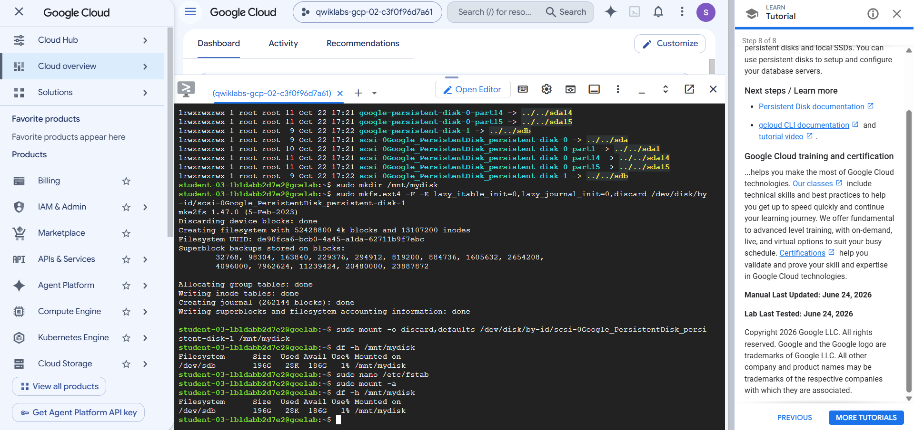
Figure 5: Full Cloud Shell session in the Google Cloud console

