GOOGLE CLOUD HANDS-ON LAB DOCUMENTATION

Setting Up a Layer 7 Application Load Balancer on Compute Engine
Managed instance group backends, health checks, URL map and global forwarding rule on Google Cloud
Prepared by
NaveenKumar.P

1. Overview
This document describes how to set up a Layer 7 (L7) Application Load Balancer on Google Cloud using Compute Engine virtual machines (VMs). L7 load balancers understand HTTP(S), so they can make routing decisions based on the URL, headers, cookies and content of a request. This improves application performance and responsiveness.
The lab builds an external Application Load Balancer, implemented on Google Front Ends (GFEs). GFEs are distributed globally and operate together using Google’s global network and control plane.

1.1 Objectives
- Configure the default region and zone for the resources.
- Create an Application Load Balancer.
- Test the traffic sent to the backend instances.

1.2 Environment
Item | Value
Platform | Google Cloud (Cloud Shell and Cloud Console)
Region / Zone | us-east4 / us-east4-a
Project ID | qwiklabs-gcp-04-1450974c1e85
Operating system image | Debian 12 (debian-cloud)
Web server | Apache2

1.3 Architecture Summary
Client requests reach a global static IPv4 address, which is the frontend of the load balancer. The request passes through the following chain of resources before reaching a backend VM:
- Global forwarding rule (http-content-rule) on port 80.
- Target HTTP proxy (http-lb-proxy).
- URL map (web-map-http) routing to the default backend service.
- Backend service (web-backend-service) with the http-basic-check health check.
- Managed instance group (lb-backend-group) created from lb-backend-template.

2. Prerequisites and Lab Access
- A standard internet browser (Chrome recommended), preferably an Incognito window.
- Temporary student credentials generated by the lab. Use only these credentials, not a personal Google Cloud account, to avoid unexpected charges.
- Sufficient lab time. The lab is timed and cannot be paused once started.
After signing in to the Google Cloud console, activate Cloud Shell using the Activate Cloud Shell icon at the top of the console. Authorize Cloud Shell when prompted. Cloud Shell is already authenticated and its project is preset to the lab Project ID. The following optional commands confirm the active account and project:
gcloud auth list
gcloud config list project

3. Implementation Steps

Task 1. Set the Default Region and Zone
Set the default region and zone so that subsequent commands apply to the correct location.
gcloud config set compute/region us-east4
gcloud config set compute/zone us-east4-a

Task 2. Create Multiple Web Server Instances
Three Compute Engine VM instances (www1, www2 and www3) are created with Apache installed. Each instance receives the network tag network-lb-tag, which lets a single firewall rule target all of them, and a unique home page.
Create www1:
gcloud compute instances create www1 \
--zone=us-east4-a \
--tags=network-lb-tag \
--machine-type=e2-small \
--image-family=debian-12 \
--image-project=debian-cloud \
--metadata=startup-script='#!/bin/bash
apt-get update
apt-get install apache2 -y
service apache2 restart
echo "
<h3>Web Server: www1</h3>" | tee /var/www/html/index.html'
Create www2 (same command, with the home page changed to www2):
gcloud compute instances create www2 \
--zone=us-east4-a \
--tags=network-lb-tag \
--machine-type=e2-small \
--image-family=debian-12 \
--image-project=debian-cloud \
--metadata=startup-script='#!/bin/bash
apt-get update
apt-get install apache2 -y
service apache2 restart
echo "
<h3>Web Server: www2</h3>" | tee /var/www/html/index.html'
Create www3 (same command, with the home page changed to www3):
gcloud compute instances create www3 \
--zone=us-east4-a \
--tags=network-lb-tag \
--machine-type=e2-small \
--image-family=debian-12 \
--image-project=debian-cloud \
--metadata=startup-script='#!/bin/bash
apt-get update
apt-get install apache2 -y
service apache2 restart
echo "
<h3>Web Server: www3</h3>" | tee /var/www/html/index.html'
Create a firewall rule that allows external HTTP traffic to the tagged instances:
gcloud compute firewall-rules create www-firewall-network-lb \
--target-tags network-lb-tag --allow tcp:80
List the instances and note the values in the EXTERNAL_IP column:
gcloud compute instances list
Verify that each instance is serving traffic, replacing [IP_ADDRESS] with the external IP of each VM:
curl http://[IP_ADDRESS]

Task 3. Create the Application Load Balancer
To use a Compute Engine backend, the VMs must belong to an instance group. A managed instance group (MIG) runs identical VMs and provides autoscaling, autohealing, regional deployment and automatic updating. In this lab the backends serve their own hostnames.

3.1 Create the Instance Template
gcloud compute instance-templates create lb-backend-template \
--region=us-east4 \
--network=default \
--subnet=default \
--tags=allow-health-check \
--machine-type=e2-medium \
--image-family=debian-12 \
--image-project=debian-cloud \
--metadata=startup-script='#!/bin/bash
apt-get update
apt-get install apache2 -y
a2ensite default-ssl
a2enmod ssl
vm_hostname="$(curl -H "Metadata-Flavor:Google" \
http://169.254.169.254/computeMetadata/v1/instance/name)"
echo "Page served from: $vm_hostname" | \
tee /var/www/html/index.html
systemctl restart apache2'

3.2 Create the Managed Instance Group
gcloud compute instance-groups managed create lb-backend-group \
--template=lb-backend-template --size=2 --zone=us-east4-a

3.3 Create the Health Check Firewall Rule
This ingress rule allows traffic from the Google Cloud health checking systems (130.211.0.0/22 and 35.191.0.0/16). The target tag allow-health-check identifies the VMs.
gcloud compute firewall-rules create fw-allow-health-check \
--network=default \
--action=allow \
--direction=ingress \
--source-ranges=130.211.0.0/22,35.191.0.0/16 \
--target-tags=allow-health-check \
--rules=tcp:80

3.4 Reserve a Global Static External IP Address
Reserve the address that customers use to reach the load balancer, then display it. Save this IP address, as it is needed later.
gcloud compute addresses create lb-ipv4-1 \
--ip-version=IPV4 \
--global
gcloud compute addresses describe lb-ipv4-1 \
--format="get(address)" \
--global

3.5 Create the Health Check
The health check ensures that only healthy backends receive traffic.
gcloud compute health-checks create http http-basic-check \
--port 80

3.6 Create the Backend Service and Add the Instance Group
gcloud compute backend-services create web-backend-service \
--protocol=HTTP \
--port-name=http \
--health-checks=http-basic-check \
--global
gcloud compute backend-services add-backend web-backend-service \
--instance-group=lb-backend-group \
--instance-group-zone=us-east4-a \
--global

3.7 Create the URL Map
A URL map routes requests to backend services or backend buckets. For example, /video can go to one backend service, /audio to another and /images to a Cloud Storage backend bucket, while all other requests go to the default backend service. Here, all requests go to the default backend service.
gcloud compute url-maps create web-map-http \
--default-service web-backend-service

3.8 Create the Target HTTP Proxy
gcloud compute target-http-proxies create http-lb-proxy \
--url-map web-map-http

3.9 Create the Global Forwarding Rule
A forwarding rule and its IP address together represent the frontend configuration of the load balancer.
gcloud compute forwarding-rules create http-content-rule \
--address=lb-ipv4-1 \
--global \
--target-http-proxy=http-lb-proxy \
--ports=80
The terminal output below shows the URL map details, the target HTTP proxy and the forwarding rule being created successfully. The forwarding rule list confirms the load balancer frontend IP address (34.149.16.69), protocol TCP and target http-lb-proxy.
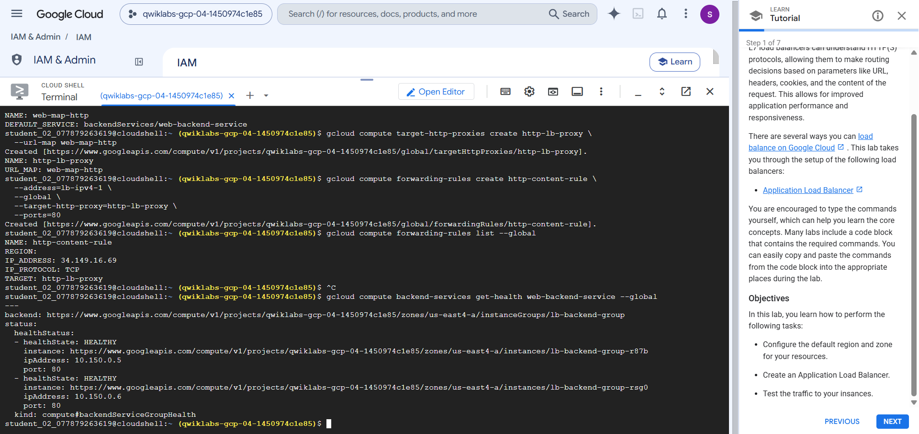
Figure 1: Cloud Shell output showing the target proxy, forwarding rule and backend health status

Task 4. Test Traffic Sent to the Instances
Verify the backend health, then test the load balancer from a browser.

4.1 Verify Backend Health
In the Google Cloud console, open Load balancing, select the load balancer web-map-http, and in the Backend section confirm that the VMs are Healthy. The same check can be made from Cloud Shell:
gcloud compute backend-services get-health web-backend-service --global
As shown in Figure 1, both instances in lb-backend-group report a healthState of HEALTHY on port 80:
Instance | Internal IP | Port | Health State
lb-backend-group-r87b | 10.150.0.5 | 80 | HEALTHY
lb-backend-group-rsg0 | 10.150.0.6 | 80 | HEALTHY

Note: If the instances are not yet healthy, wait a few moments and run the command again.

4.2 Test the Load Balancer in a Browser
Once the VMs are healthy, open http://IP_ADDRESS/ in a web browser, replacing IP_ADDRESS with the load balancer IP address saved earlier. It may take three to five minutes before the connection succeeds; if it fails, wait a minute and reload.
The browser renders a page showing the name of the instance that served the request. In this lab the load balancer IP was 34.149.16.69 and the response came from the backend instance lb-backend-group-r87b.
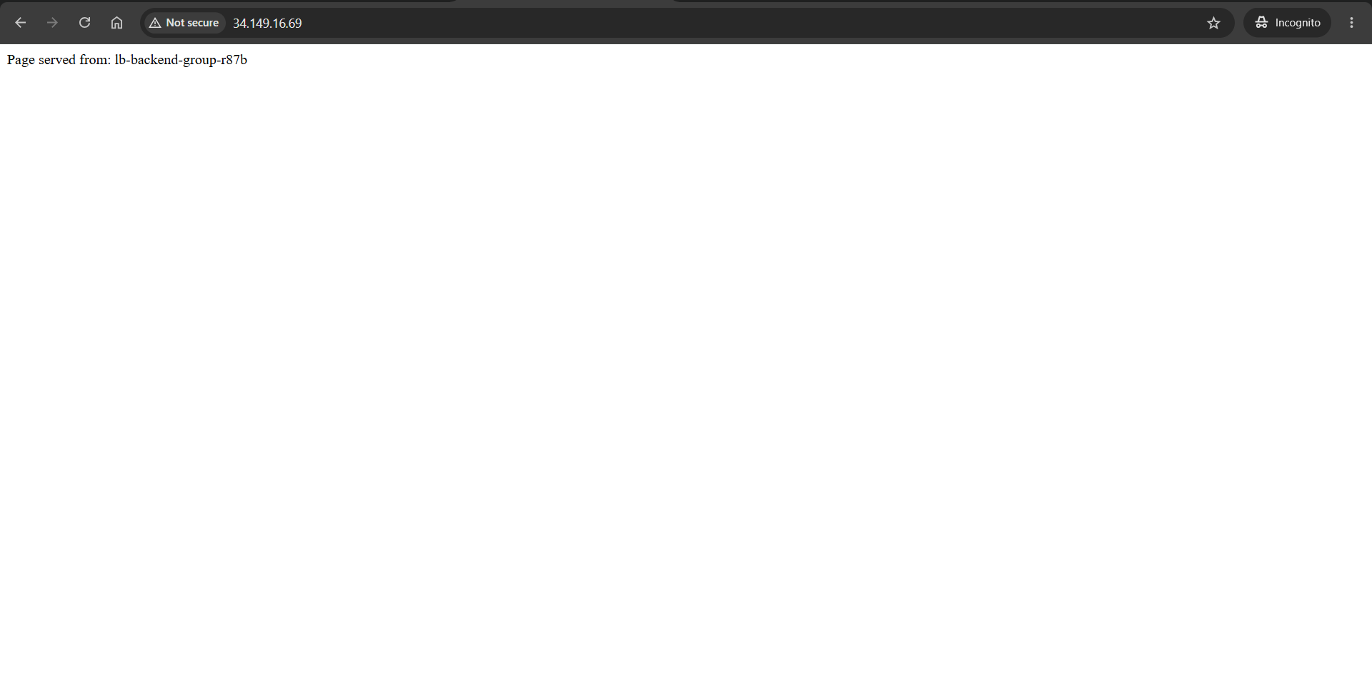
Figure 2: Browser response from the load balancer IP showing the serving backend instance

4. Results
Check | Result
Forwarding rule created (http-content-rule) | Successful, IP 34.149.16.69, TCP, target http-lb-proxy
Backend health (web-backend-service) | Both instances HEALTHY
Browser test at load balancer IP | Page served from: lb-backend-group-r87b

5. Conclusion
An external Application Load Balancer was built on Google Cloud using an instance template and a managed instance group as the backend. Health checks confirmed that both backend VMs were healthy, and a browser request to the global static IP address was served by a backend instance, which verifies that the load balancer routes traffic correctly.

