GOOGLE CLOUD | COMPUTE ENGINE
Creating a Windows Server Virtual Machine in Google Compute Engine
Step-by-Step Lab Documentation: VM Deployment and Remote Desktop (RDP) Access
Prepared by
NaveenKumar.P

1. Introduction

1.1 Purpose
This document describes the procedure for creating a Windows Server virtual machine (VM) in Google Compute Engine and connecting to it remotely using Remote Desktop Protocol (RDP). It was prepared from a Google Cloud Skills Boost (Qwiklabs) "Qwik Start" lab and includes screenshots captured during execution.

1.2 Key Concepts
Term | Description
Google Cloud | A set of cloud computing services hosted in Google data centers and accessed over the internet.
Virtual Machine (VM) | A computer rented from the cloud provider that runs inside Google’s infrastructure.
Windows Server | The Microsoft server operating system installed on the VM (Windows Server 2022 Datacenter in this lab).
RDP | Remote Desktop Protocol, used to view and control the VM’s Windows desktop from a local device.
Cloud Shell | A browser-based command-line environment with the gcloud CLI preinstalled.

1.3 Procedure Overview
- Start the lab and obtain temporary student credentials.
- Sign in to the Google Cloud Console.
- Create a Windows Server VM in the correct region and zone.
- Wait for Windows to finish initializing.
- Create a Windows password and connect through RDP.
- Verify the lab checkpoints.

1.4 Prerequisites
- Access to the Google Skills / Qwiklabs lab page.
- A modern web browser (an Incognito window is recommended).
- An RDP client supported by the local device (for example, Remote Desktop Connection on Windows, Microsoft Remote Desktop on macOS, or a browser-based client such as Spark View).
Security: Use only the temporary lab account. Never use a personal Google Cloud account for this exercise, and do not share the lab password or the generated VM password.

2. Start the Lab and Sign In

2.1 Start the Lab
- Open the Google Skills / Qwiklabs lab page.
- Click Start Lab.
- Wait for the lab to start. The Lab setup and access panel appears on the right side of the page.
Important: The lab timer starts as soon as the lab is started and cannot be paused.

2.2 Open the Google Cloud Console
- Click Open Google Cloud console and open it in a new tab or an Incognito window.
- If prompted with Choose an account, click Use another account.
- Enter the temporary username from the lab access panel and click Next.
- Enter the temporary password from the same panel and click Next.
- Accept the terms if prompted; skip recovery email and phone setup; do not enable two-factor authentication; do not sign up for a free trial.
- Wait until the Google Cloud Console loads.

3. Open Cloud Shell
Cloud Shell provides a command window for issuing instructions to Google Cloud.
- In the top-right area of the Console, click the Activate Cloud Shell icon (>_).
- If a welcome window appears, click Continue; if prompted, click Authorize.
- Wait for the terminal to appear at the bottom of the screen.
The terminal is ready when it displays a message similar to:
Your Cloud Platform project in this session is set to ...
No commands are required at this point; Cloud Shell is used later in Sections 5 and 6.

4. Create the Windows Virtual Machine

4.1 Open VM Instances
- In the Google Cloud Console, click the Navigation menu (☰) at the top left.
- Select Compute Engine > VM instances.
- Wait for the page to load, then click Create instance.

4.2 Name the Instance
In the Name field, enter windows-server. Use lowercase letters and hyphens only, and note the exact name because it is used in later commands.

4.3 Configure the Machine
Setting | Value
Region | us-east1
Zone | us-east1-c
Series | E2

4.4 Select Windows Server 2022
- In the OS and storage section, click Change next to the boot disk.
- For Operating system, select Windows Server.
- For Version, select Windows Server 2022 Datacenter.
- Click Select to return to the creation page.
Leave all other settings at their defaults unless the lab instructions state otherwise.

4.5 Create the VM
Scroll to the bottom of the page and click Create. Provisioning may take a few minutes. When the VM appears in the VM instances list with a green status icon, it has started. Windows may still need additional time to finish initializing.
Figure 1 shows the windows-server instance running in zone us-east1-c with a green status icon.
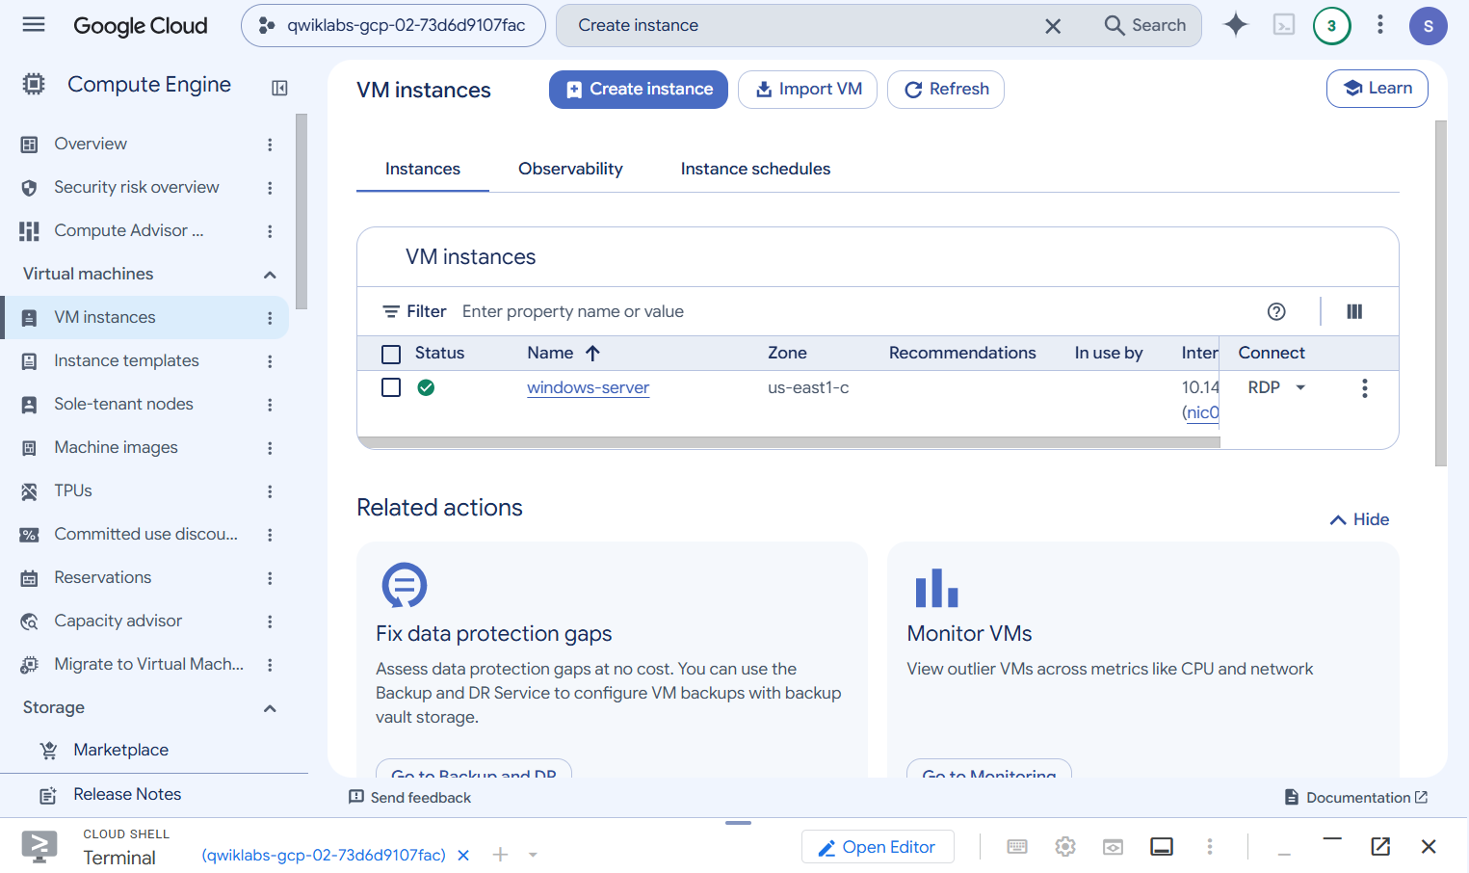
Figure 1: VM instance "windows-server" created and running in us-east1-c

4.6 Checkpoint 1: Verify VM Creation
Return to the lab instructions tab and click Check my progress under the VM creation task. If the check fails, confirm the VM was created with the correct region, zone, and Windows version, then try again.

5. Verify Windows Has Finished Starting
Before logging in, confirm that Windows has completed its first-boot setup. Open Cloud Shell and run the following command:
gcloud compute instances get-serial-port-output windows-server --zone=us-east1-c
- If you used a different VM name, replace windows-server with your VM name.
- If asked whether to continue, type N and press Enter.
- Search the output for the message below. If it is not present, wait a few minutes and run the command again.
Instance setup finished. instance is ready to use.
Note: Do not proceed to the next section until the ready message appears. The first command in Figure 2 is the serial-port check described here.

6. Create the Windows Login Password
Once Windows is ready, generate credentials for Remote Desktop by running:
gcloud compute reset-windows-password windows-server --zone=us-east1-c --user=admin
- Press Enter to run the command.
- When asked whether to set or reset the password for [admin], type Y and press Enter.
- Wait for the command to finish.
The output lists the VM’s external IP address, the username (admin), and a generated password. Record the password in a private location.
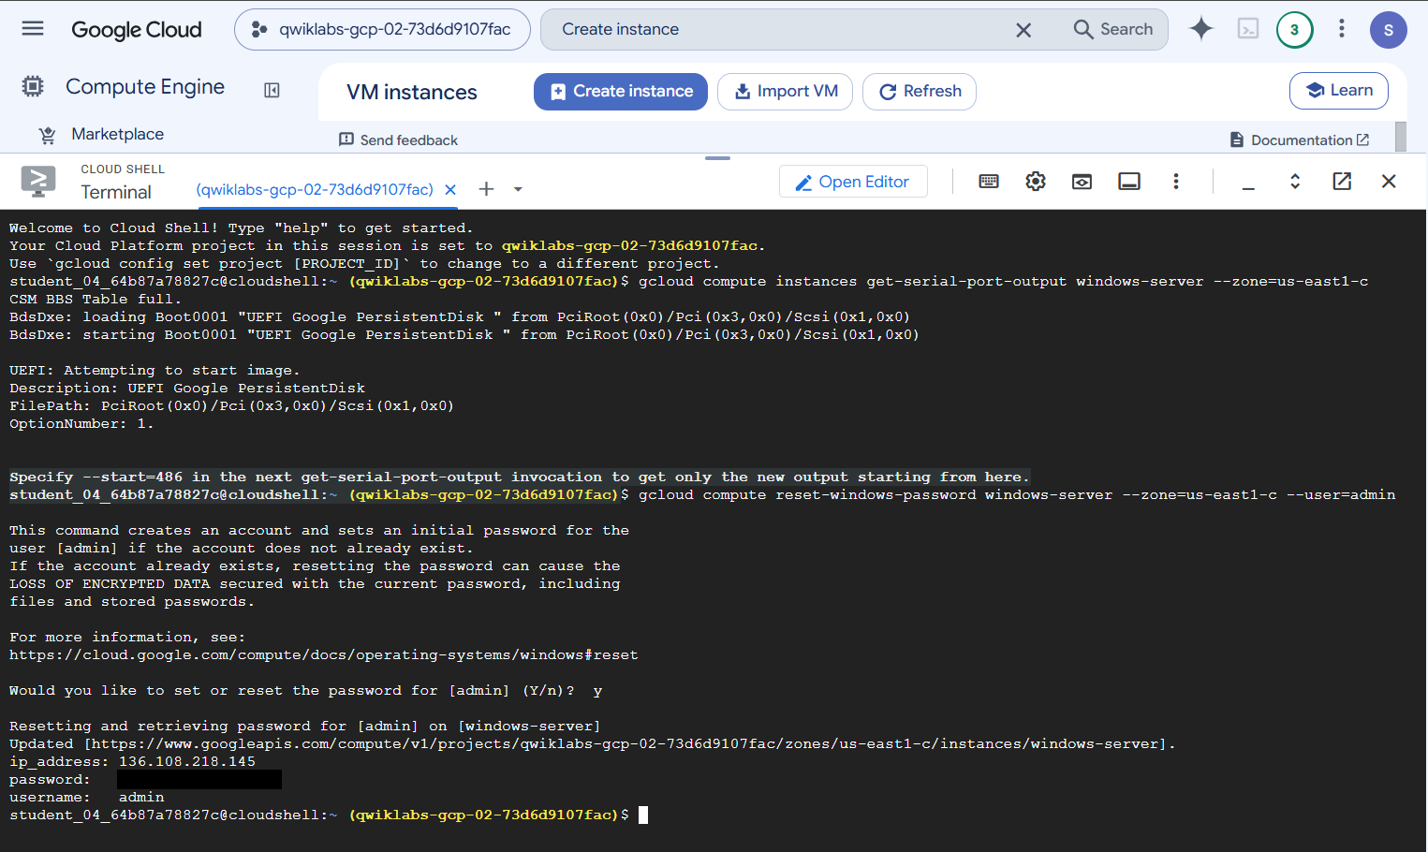
Figure 2: Cloud Shell showing the serial-port check and the password reset for user "admin" (password redacted)
Caution: Resetting the password of an existing account can cause loss of encrypted data secured with the previous password. If an error occurs, read the message carefully rather than resetting the password repeatedly. Do not use the temporary lab account password for Windows.

7. Locate the External IP Address
- Return to Compute Engine > VM instances.
- Locate the Windows VM in the list.
- Copy the address shown in the External IP column (format 34.xxx.xxx.xxx).
The external IP address is also returned in the ip_address field of the password-reset output (Figure 2). If the External IP column is empty, resolve this before continuing.

8. Connect Using Remote Desktop (RDP)
Use an RDP client appropriate for your device. In the VM instances list (Figure 1), the Connect column also provides an RDP option for the instance.
- Open the RDP client and start a new connection.
- Enter the VM’s external IP address as the server or computer name.
- Enter the username admin.
- Enter the generated Windows password.
- Click Connect.
A successful connection displays the Windows Server desktop, confirming that the VM running in Google Cloud is being controlled remotely. If a connection error occurs, record the exact error message first; the VM may still be initializing, or the RDP client or network configuration may need attention. Do not modify firewall settings before noting the error.

9. Checkpoint 2: Verify Remote Desktop Access
- Return to the lab instructions.
- Click Check my progress under the Remote Desktop task.
- Wait for the result; a pass confirms that the task is complete.
The multiple-choice questions mentioned in the lab are omitted from the supplied instructions and are therefore not covered here.

10. Completion and Cleanup
- Confirm that both checkpoints are marked complete.
- Follow any remaining instructions on the lab page.
- End the lab using its controls.
Resources created in this exercise belong to the temporary lab project. Do not keep cloud resources running in a personal project.

11. Summary of Configuration
Item | Value
Instance name | windows-server
Region / Zone | us-east1 / us-east1-c
Machine series | E2
Operating system | Windows Server 2022 Datacenter
Access method | RDP (username: admin)

