WEEK 2 PROJECT
Advanced Data Visualization
and Storytelling with Python
Superstore Sales & Profit Story
Transforming retail transaction data into a visual narrative for a non-technical audience.

Dataset | Sample Superstore
Records | 9,994 transaction records
Period | 2014–2017
Tools | Python, Pandas, NumPy, Matplotlib, Seaborn, Plotly

1. Introduction
This project explores the Sample Superstore retail dataset using Python-based data visualization and storytelling techniques. The goal is not only to calculate sales and profit metrics, but to communicate patterns, differences, anomalies and potential business implications through a sequence of complementary visualizations.
The analysis is designed for a non-technical audience. It begins with the overall time trend, then moves into category and regional performance, investigates the relationship between discount and profit, examines outliers, and concludes with interactive and correlation-based views.

2. Dataset Overview
The notebook loaded 9,994 records and 21 original columns. The dataset contains order dates, shipping information, customers, geographic fields, product categories, sales, quantity, discount and profit.
The order dates span from January 3, 2014 to December 30, 2017. The analysis found no missing values and no duplicate rows before feature engineering.

3. Methods
- Loaded the public Sample Superstore CSV into Pandas.
- Converted order and shipping dates into datetime values.
- Checked missing values and duplicate records.
- Created year, month, year-month, profit margin and shipping-day features.
- Calculated business KPIs including sales, profit, orders, customers and profit margin.
- Built static visualizations with Matplotlib and Seaborn.
- Built interactive visualizations with Plotly.
- Used grouped summaries, heatmaps, scatter plots and box plots to investigate different dimensions of the data.
- Generated automated insight summaries from the computed results.

4. Executive KPI Snapshot
Metric | Result
Total Sales | $2,297,200.86
Total Profit | $286,397.02
Total Orders | 5,009
Total Customers | 793
Total Quantity | 37,873
Average Order Value | $458.61
Overall Profit Margin | 12.47%

5. Visualization 1 — Monthly Sales and Profit Trend
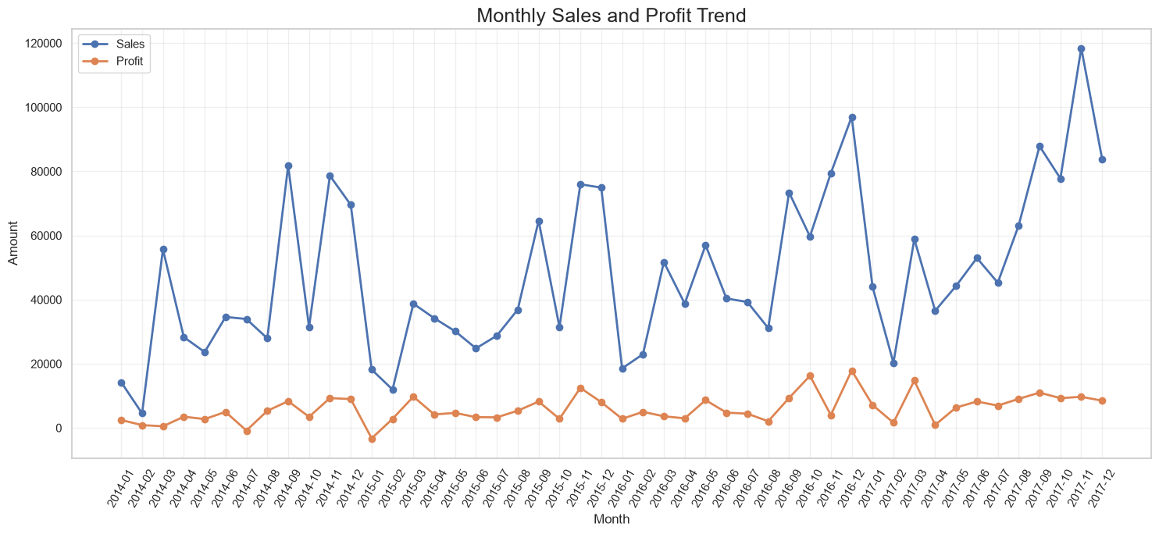
The time-series visualization establishes the overall business trajectory. It shows that sales and profit fluctuate over time rather than moving in a perfectly uniform pattern.
Key insight: The highest-sales month was November 2017, with sales of $118,447.82. The highest-profit month was December 2016, with profit of $17,885.31. The lowest-profit month was January 2015, when the analysis recorded a loss of $3,281.01.
Narrative contribution: This chart starts the story with the big picture: when business activity changed and whether profitability followed the same pattern.

6. Visualization 2 — Sales by Product Category
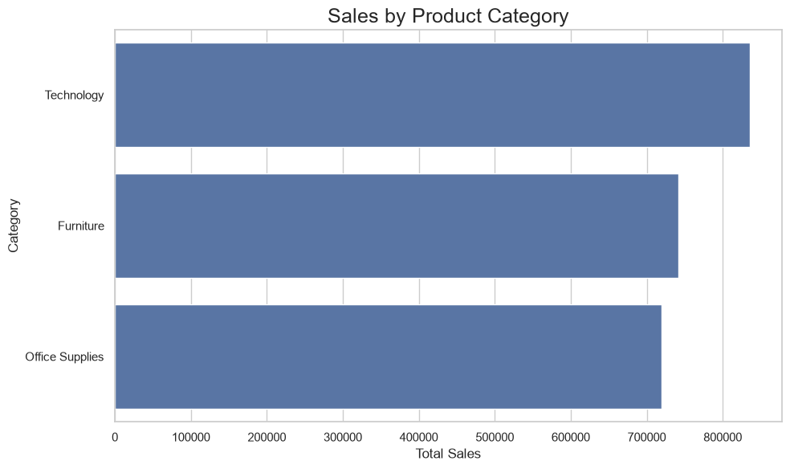
The category comparison identifies which broad product groups contribute most to revenue.
Key insight: Technology generated the highest category sales at $836,154.03, followed by Furniture at $741,999.80 and Office Supplies at $719,047.03.
Narrative contribution: A category-level view helps the audience understand where revenue is concentrated before moving to more detailed product-level analysis.

7. Visualization 3 — Profit by Product Category
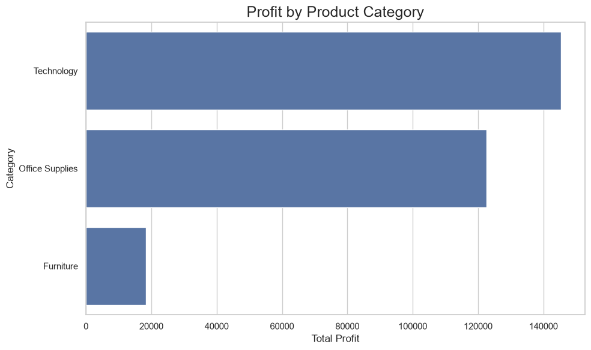
Looking at profit separately prevents a revenue-only interpretation of business performance.
Key insight: Technology generated the highest category profit at $145,454.95, while Office Supplies generated $122,490.80 and Furniture generated $18,451.27.
Narrative contribution: The comparison shows why sales and profit should be considered together: a category can contribute significant revenue without producing an equally large profit contribution.

8. Visualization 4 — Region × Category Profit Heatmap
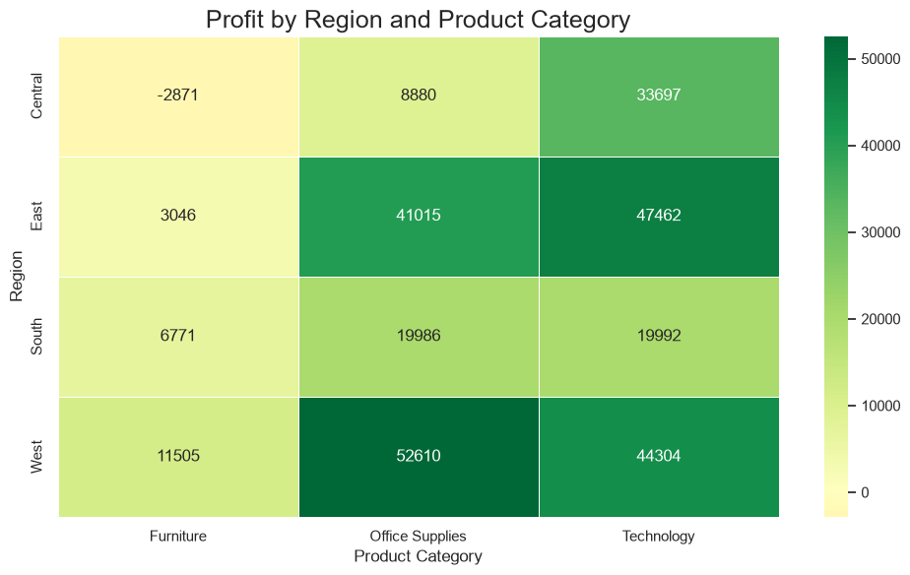
The heatmap combines two dimensions—region and category—to reveal combinations that perform differently.
Key insight: The West–Office Supplies combination recorded the highest profit at $52,609.85. The Central–Furniture combination recorded the lowest profit at -$2,871.05.
Narrative contribution: This view moves the narrative from 'which category?' to 'where does that category perform differently?'

9. Visualization 5 — Discount vs Profit
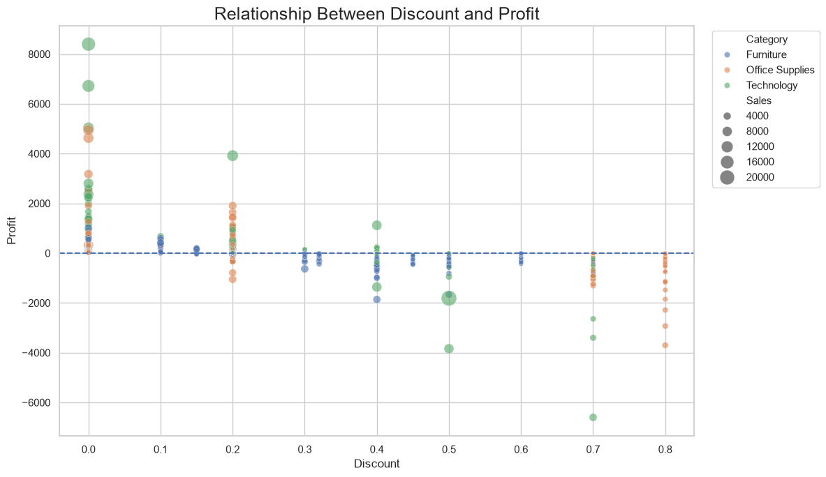
The scatter plot examines the relationship between discount and profit at the transaction level. Point size represents sales and color separates categories.
Key insight: The dataset shows substantial negative-profit observations at higher discount levels. The grouped discount analysis also shows total profit turning negative for the 21–30%, 31–50% and 50%+ discount bands.
Narrative contribution: The visualization supports an important analytical question about discounting. It shows association in the observed data, but does not by itself prove that discounting caused every loss.

10. Visualization 6 — Profit by Discount Level
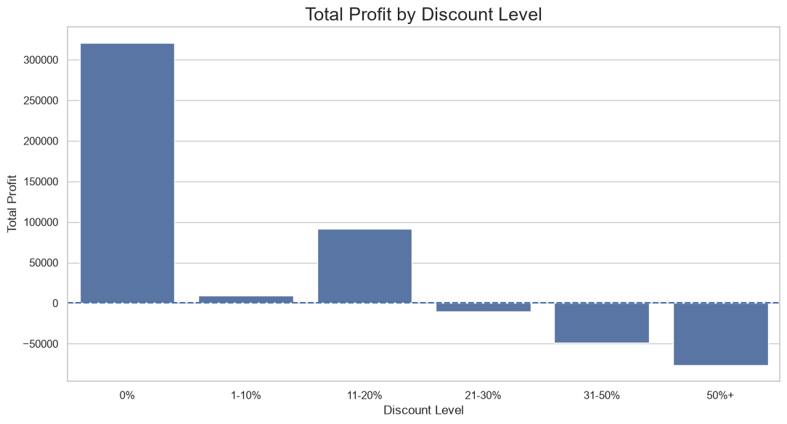
This bar chart aggregates transactions into discount bands, making the relationship easier for a non-technical audience to compare.
Key insight: The 0% discount group generated $320,987.60 profit, while the 21–30% group generated -$10,369.28, the 31–50% group generated -$48,447.73, and the 50%+ group generated -$76,559.05.
Narrative contribution: The chart translates a dense scatter plot into a clear business pattern and highlights discount ranges that deserve closer review.

11. Visualization 7 — Profit Distribution and Outliers
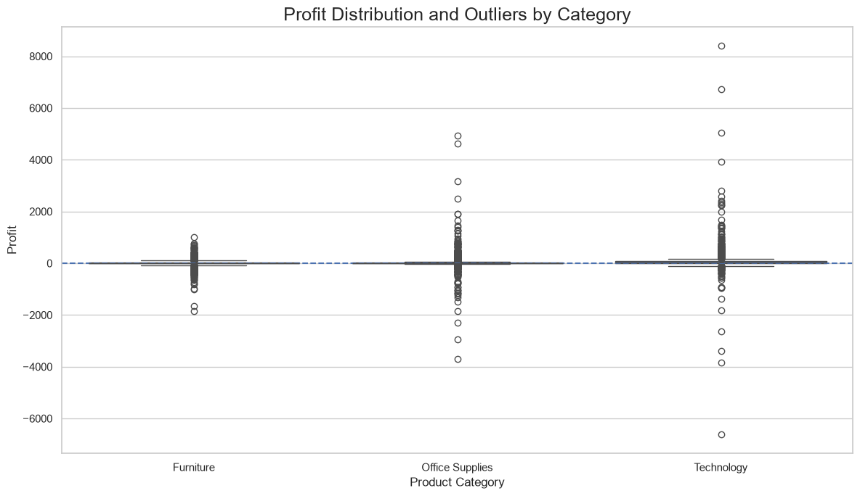
The box plot shows the distribution of profit within each category and makes extreme observations visible.
Key insight: Profit contains substantial variation, including both positive and negative outliers. The analysis identified 1,871 loss-making transaction records with a combined loss of $156,131.29.
Narrative contribution: This visualization adds the anomaly perspective required for advanced storytelling: averages alone do not describe the full range of outcomes.

12. Visualization 8 — Top 10 Sub-Categories by Profit
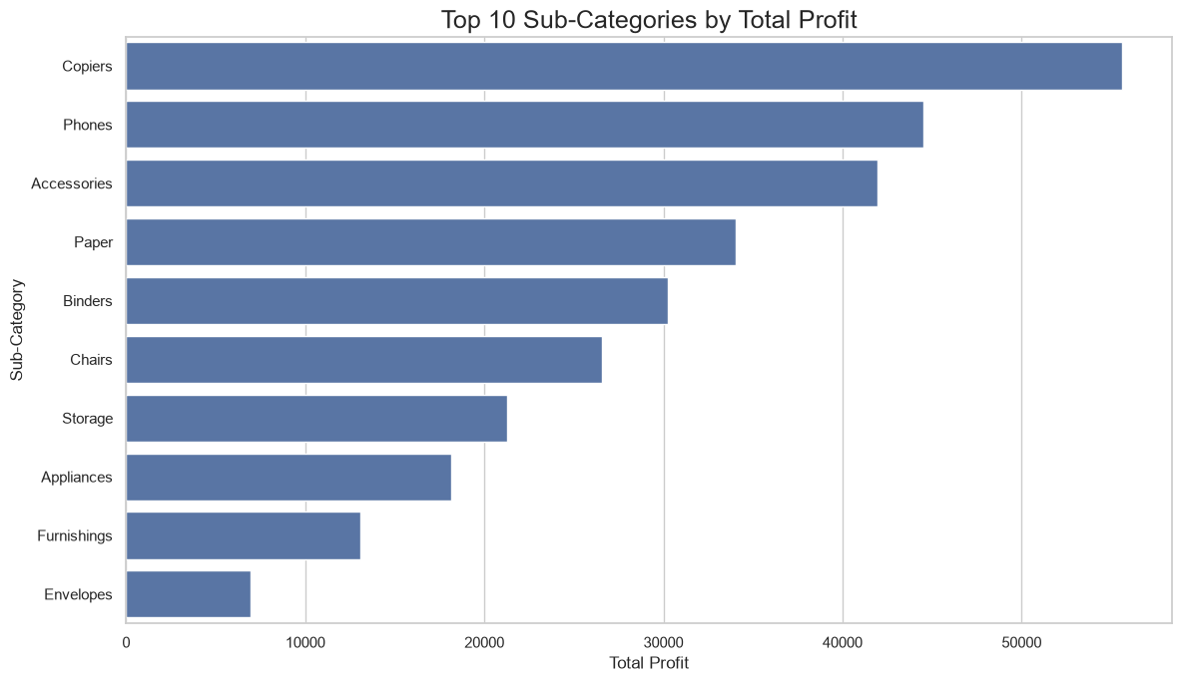
The ranked view identifies the sub-categories that contribute most strongly to profit.
Key insight: Copiers were the most profitable sub-category, with total profit of $55,617.82.
Narrative contribution: Ranking sub-categories makes the story more actionable by moving from broad categories to specific product groups.

13. Visualization 9 — Bottom 10 Sub-Categories by Profit
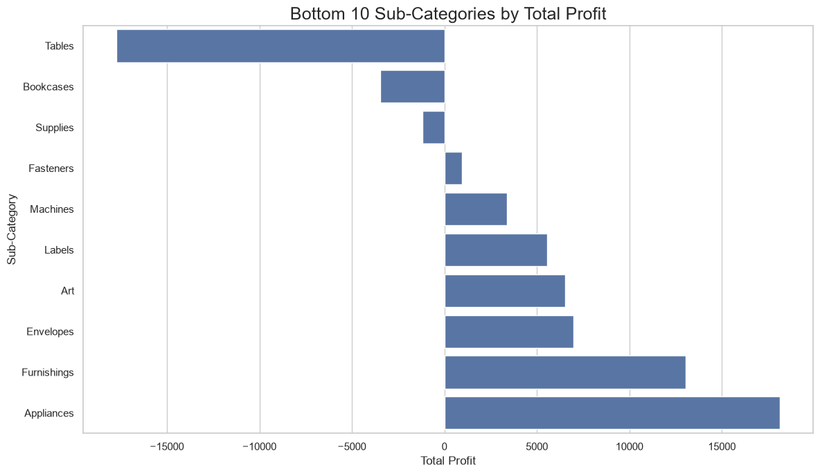
The complementary bottom-ranked view identifies areas where profitability is weakest.
Key insight: Tables were the lowest-profit sub-category, with total profit of -$17,725.48.
Narrative contribution: Showing both ends of the distribution avoids a one-sided success story and highlights areas for further investigation.

14. Visualization 10 — Correlation Between Key Variables
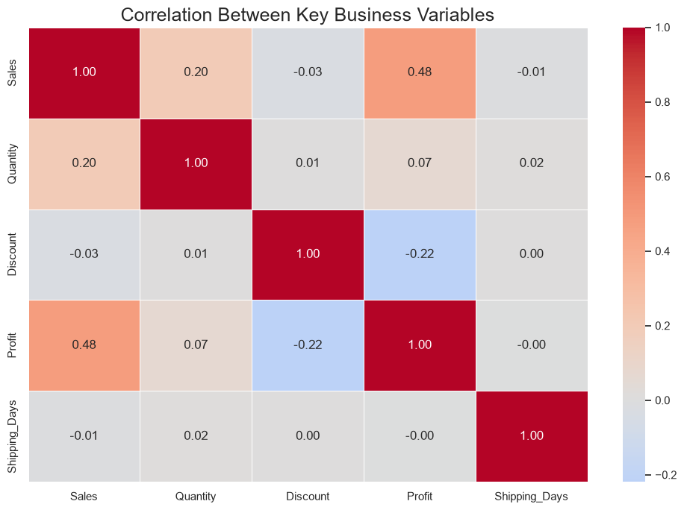
The correlation heatmap summarizes linear relationships among sales, quantity, discount, profit and shipping days.
Key insight: Correlation is useful for identifying relationships worth investigating, but it should not be interpreted as proof of causation.
Narrative contribution: This final analytical view connects individual visual findings into a broader multivariable perspective.

15. Regional Performance Summary
The regional aggregation shows West as the highest-profit region and Central as the lowest-profit region in this dataset.
Region | Sales | Profit | Profit Margin
Central | $501,239.89 | $39,706.36 | 7.92%
East | $678,781.24 | $91,522.78 | 13.48%
South | $391,721.91 | $46,749.43 | 11.93%
West | $725,457.82 | $108,418.45 | 14.94%

16. Year-over-Year Performance
Sales increased from $470,532.51 in 2015 to $609,205.60 in 2016 and $733,215.26 in 2017. The notebook calculates sales growth of 29.47% in 2016 and 20.36% in 2017. Profit growth was 32.74% in 2016 and 14.24% in 2017.

17. Potential Business Implications
- Review high-discount transactions carefully. The observed data contains negative total profit in the 21–30%, 31–50% and 50%+ discount bands.
- Investigate the Central region and the Central–Furniture combination because they show lower profitability than other regional/category combinations in this dataset.
- Technology is a major profit contributor, while the category also has the highest sales. Product-level analysis can help determine which technology sub-categories drive that result.
- Tables show negative total profit, so pricing, discounting, product cost or fulfillment economics for this sub-category could be examined further.
- Use monthly trends for planning and forecasting, particularly around periods with unusually high sales or profit.
- Treat the findings as diagnostic evidence rather than causal proof. Additional analysis would be needed to isolate the effects of discount, product mix, region, customer segment and other factors.

18. Limitations
- The analysis is descriptive and does not establish causal relationships.
- The dataset represents a historical retail sample; results may not generalize to other businesses or time periods.
- The discount-profit relationship may be affected by product mix, region, order size and other confounding factors.
- The report focuses on the fields available in the dataset and does not include costs beyond the provided profit field.

19. Conclusion
The analysis demonstrates how multiple visualization types can transform a retail dataset into a coherent data story. The overall dataset generated $2.30 million in sales and $286.40 thousand in profit, with an overall profit margin of 12.47%. The story becomes more informative when the aggregate figures are decomposed by time, category, region, discount and sub-category. Technology and the West region are prominent contributors to profit, while Tables and several high-discount bands show negative profitability. The combination of trend charts, comparisons, heatmaps, scatter plots, box plots and interactive views provides a balanced narrative for a non-technical audience.

20. Tools and References
Python libraries used: Pandas, NumPy, Matplotlib, Seaborn and Plotly. The dataset was loaded from a public Sample Superstore CSV source referenced directly in the project notebook.

