WEEK 3 ASSIGNMENT
STATISTICAL ANALYSIS AND
HYPOTHESIS TESTING IN PYTHON
Titanic Passenger Survival Analysis
Research Question:
Was passenger gender associated with survival status in the Titanic dataset?
Prepared using Python and scientific/statistical libraries

1. Abstract
This report presents a detailed statistical analysis of the Titanic passenger dataset to investigate whether passenger gender was associated with survival status. The workflow includes data inspection, preprocessing, descriptive statistics, exploratory visualization, inferential hypothesis testing, confidence-interval estimation, and interpretation. The primary analysis uses a Chi-Square Test of Independence because gender and survival are categorical variables. A Two-Proportion Z-Test is used as a complementary procedure to compare female and male survival proportions, and a 95% confidence interval quantifies the uncertainty around their difference. A one-way ANOVA is additionally applied to compare ticket fares across passenger classes. At α = 0.05, the gender-survival tests produce extremely small p-values, providing strong statistical evidence of an association in this dataset. The analysis is interpreted as evidence of association rather than proof of causation, because the dataset is observational and contains other potentially important variables.

2. Introduction
Hypothesis testing is a core component of statistical analysis because it provides a formal way to evaluate whether an observed pattern is compatible with a specified null hypothesis. Descriptive statistics and visualizations show what is present in the data, while inferential tests quantify the strength of evidence against a null model.
The Titanic dataset is suitable for demonstrating these ideas because it contains categorical variables such as gender, survival status, and passenger class as well as numerical variables such as age and fare. This report focuses on the relationship between gender and survival while also demonstrating an additional ANOVA analysis.
The analysis is observational. A statistically significant association between two variables does not automatically mean that one variable caused the other. Context, confounding variables, study design, and assumptions must therefore be considered alongside the p-values.

3. Problem Statement
Determine whether passenger gender and survival status are statistically associated in the Titanic dataset, using appropriate statistical tests, confidence intervals, visualizations, and clear interpretation of the results.

4. Research Question and Objectives
Research Question: Was passenger gender associated with survival status among passengers represented in the Titanic dataset?
- Inspect the dataset structure and identify missing values.
- Clean the data using transparent and reproducible preprocessing rules.
- Generate descriptive statistics for important variables.
- Visualize survival patterns by gender and passenger class.
- Test gender-survival independence using a Chi-Square Test.
- Compare female and male survival proportions using a Two-Proportion Z-Test.
- Estimate a 95% confidence interval for the female-minus-male survival difference.
- Demonstrate one-way ANOVA using ticket fare across passenger classes.
- Interpret statistical significance, effect direction, uncertainty, assumptions, and limitations.

5. Hypotheses
- H₀: Passenger gender and survival status are independent; there is no statistically significant association.
- H₁: Passenger gender and survival status are not independent; there is a statistically significant association.
Significance level: α = 0.05. Decision rule: reject H₀ when p < 0.05; otherwise, do not reject H₀.

6. Dataset Description
The supplied Titanic CSV contains 891 original observations and 15 columns. The analysis uses passenger-level records containing survival status, passenger class, gender, age, family counts, fare, embarkation information, and related descriptive fields.
Item | Value
Original rows | 891
Columns | 15
Rows analyzed | 891
Primary categorical variables | sex, survived, pclass, embarked
Primary numerical variables | age, fare, sibsp, parch

6.1 Key Variable Dictionary
Variable | Meaning
survived | 0 = did not survive; 1 = survived
pclass | Passenger class (1, 2, 3)
sex | Passenger gender
age | Age in years
sibsp | Siblings/spouses aboard
parch | Parents/children aboard
fare | Passenger fare
embarked | Port of embarkation

7. Data Cleaning and Preprocessing
Data quality was examined before inferential testing. Age is not required for the primary hypothesis, but it is used in exploratory analysis, so missing age values were replaced with the median age. Missing embarkation values were filled with the mode. Records missing either sex or survived were removed because they cannot contribute to the main hypothesis test. These rules were applied consistently before the statistical analysis.
Variable | Missing values
age | 177
embarked | 2
deck | 688
embark_town | 2
After preprocessing, 891 passenger records remained for the main analysis. The primary variables sex and survived contain usable values for these records.

8. Exploratory Data Analysis
The first descriptive comparison examines the number of passengers and survival rate within each gender group. This step is exploratory and does not replace formal hypothesis testing.
Gender | Passengers | Survived | Survival Rate
Female | 314 | 233 | 0.7420
Male | 577 | 109 | 0.1889
Female survival rate = 74.20%. Male survival rate = 18.89%. The observed difference is 55.31 percentage points. The inferential tests determine whether this observed difference is statistically significant.
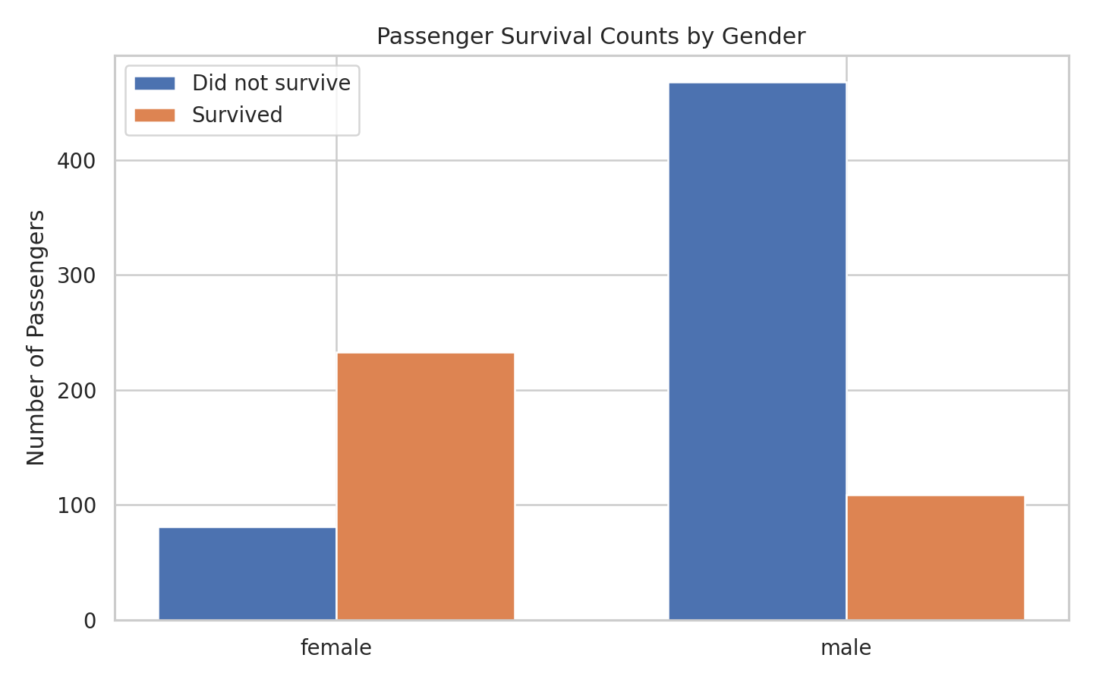
Figure 1. Passenger survival counts by gender.
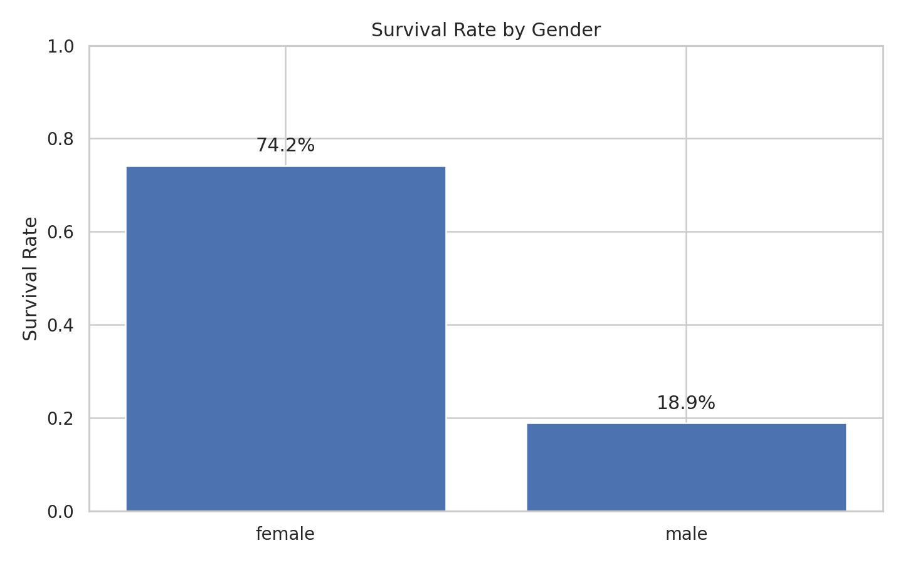
Figure 2. Survival rate by gender.
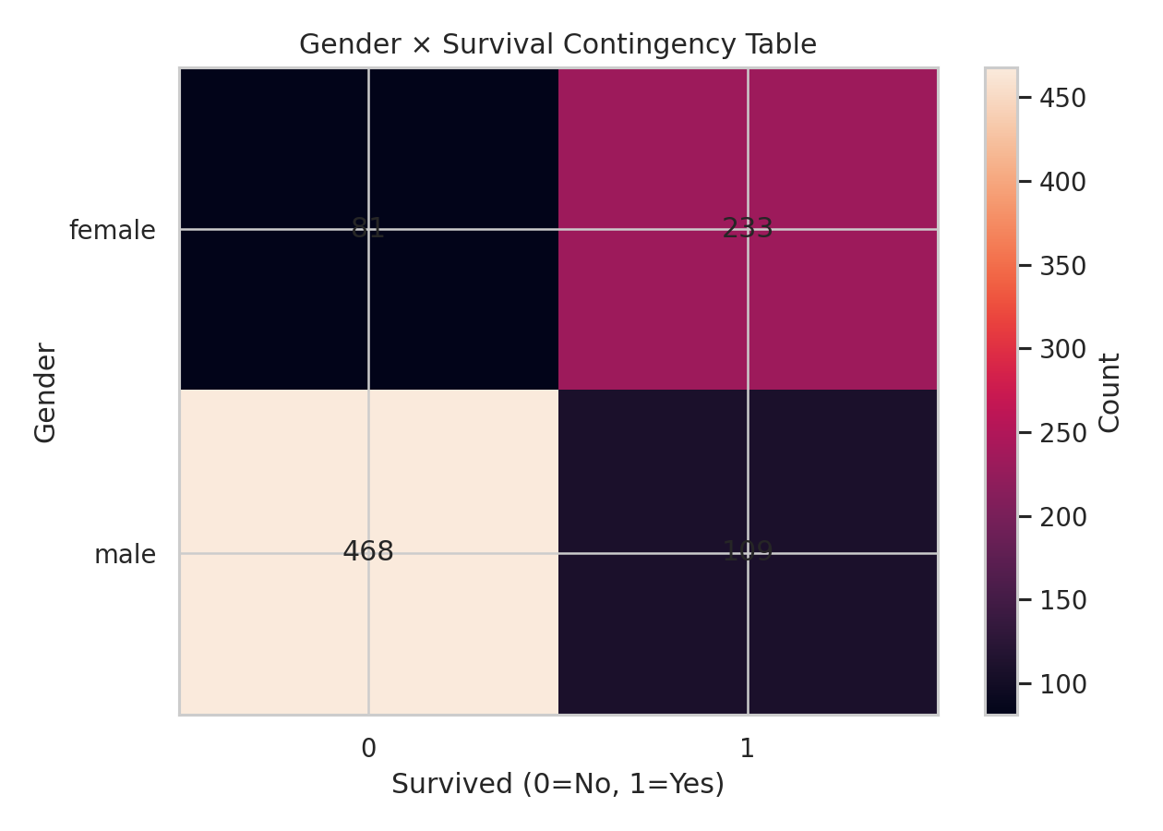
Figure 3. Gender × survival contingency table.
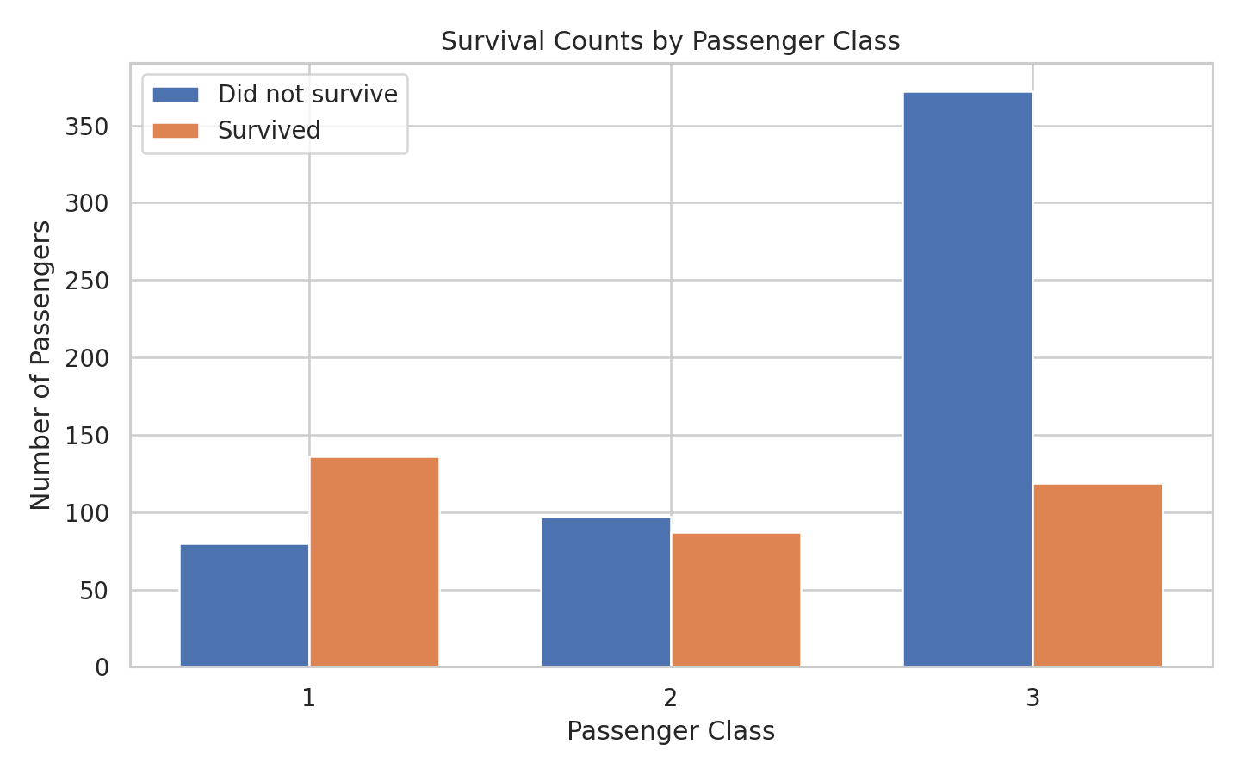
Figure 4. Passenger survival counts by class.
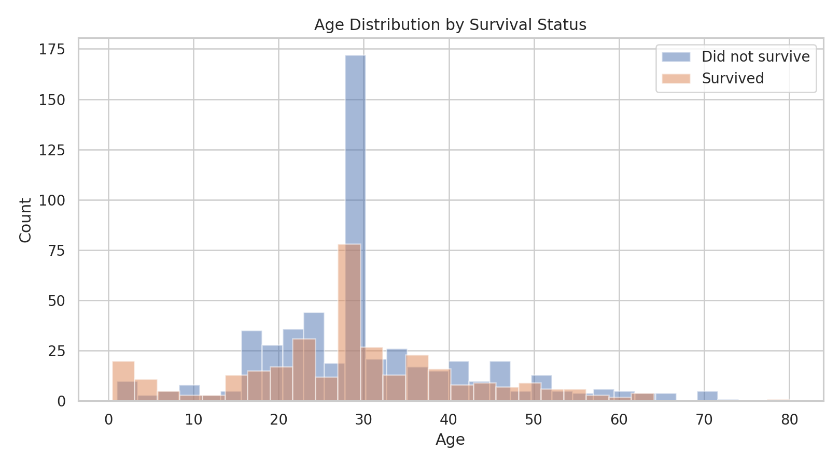
Figure 5. Age distribution by survival status.

9. Descriptive Statistics
Variable | count | mean | std | min | 25% | 50% | 75% | max
survived | 891.0000 | 0.3838 | 0.4866 | 0.0000 | 0.0000 | 0.0000 | 1.0000 | 1.0000
pclass | 891.0000 | 2.3086 | 0.8361 | 1.0000 | 2.0000 | 3.0000 | 3.0000 | 3.0000
age | 891.0000 | 29.3616 | 13.0197 | 0.4200 | 22.0000 | 28.0000 | 35.0000 | 80.0000
sibsp | 891.0000 | 0.5230 | 1.1027 | 0.0000 | 0.0000 | 0.0000 | 1.0000 | 8.0000
parch | 891.0000 | 0.3816 | 0.8061 | 0.0000 | 0.0000 | 0.0000 | 0.0000 | 6.0000
fare | 891.0000 | 32.2042 | 49.6934 | 0.0000 | 7.9104 | 14.4542 | 31.0000 | 512.3292
The descriptive table provides measures such as count, mean, standard deviation, minimum, quartiles, and maximum. These statistics help identify the scale and spread of numerical variables before applying inferential procedures.

10. Chi-Square Test of Independence
The Chi-Square Test of Independence is the primary test because both gender and survival status are categorical. The test compares observed frequencies with expected frequencies under the assumption that gender and survival are independent.

10.1 Contingency Table
sex | 0 | 1
female | 81 | 233
male | 468 | 109

10.2 Results and Decision
χ² = 260.7170; degrees of freedom = 1; p-value = 1.197357e-58.
Because the p-value is substantially below 0.05, the null hypothesis is rejected. There is strong statistical evidence of an association between gender and survival status in this dataset.

10.3 Expected Frequencies
Expected frequencies represent the counts that would be expected if gender and survival were independent.
sex | 0 | 1
female | 193.4747 | 120.5253
male | 355.5253 | 221.4747

11. Two-Proportion Z-Test
The Two-Proportion Z-Test independently examines whether the female and male survival proportions are equal. It is useful because it directly expresses the comparison in terms of survival rates.
Female survival proportion = 0.742038
Male survival proportion = 0.188908
z = 16.2188; two-sided p-value = 3.711748e-59.
Since the p-value is below 0.05, the null hypothesis of equal survival proportions is rejected. This result agrees with the Chi-Square test and indicates a statistically significant difference in observed survival proportions between the groups.

12. 95% Confidence Interval
The 95% confidence interval estimates the uncertainty around the female-minus-male survival proportion difference.
Estimated difference = 55.31 percentage points.
95% confidence interval = 49.51% to 61.11%.
The interval is entirely above zero. This is consistent with the hypothesis tests and indicates that the estimated female-minus-male survival difference is positive under the chosen interval method.

13. Additional Analysis: One-Way ANOVA
As an additional inferential exercise, one-way ANOVA was used to compare mean ticket fare across passenger classes. H₀ states that all class-specific mean fares are equal; H₁ states that at least one class mean differs.
pclass | count | mean | std | median
1.0000 | 216.0000 | 84.1547 | 78.3804 | 60.2875
2.0000 | 184.0000 | 20.6622 | 13.4174 | 14.2500
3.0000 | 491.0000 | 13.6756 | 11.7781 | 8.0500
F = 242.3442; p-value = 1.031376e-84.
The p-value is below 0.05, so the null hypothesis of equal mean fares across the three passenger classes is rejected. This secondary result indicates that passenger class is associated with differences in average ticket fare.

14. Statistical Assumptions
- Observations are treated as independent passenger records for these tests.
- Chi-Square expected frequencies should be sufficiently large; the expected-frequency table was inspected.
- The Two-Proportion Z-Test requires sufficiently large group counts for its normal approximation; both gender groups are large enough for this dataset.
- The confidence interval depends on the assumptions of the selected two-proportion interval method.
- ANOVA assumes independent observations, approximately normal residuals within groups, and reasonably comparable variances.
- Because this is observational historical data, statistical association should not be interpreted as proof of causality.

15. Understanding p-Values
A p-value measures how unusual the observed result would be under the null hypothesis and the assumptions of the test. A small p-value provides evidence against the null hypothesis. It does not represent the probability that the null hypothesis is true, nor does it measure the practical importance of a finding by itself.
Test | p-value | Decision at α=0.05
Chi-Square | 0.0000 | Reject H₀
Two-Proportion Z-Test | 0.0000 | Reject H₀
ANOVA | 0.0000 | Reject H₀

16. Comparison of Tests
Method | Question answered | Key output
Chi-Square Test | Are gender and survival independent? | χ², df, p
Two-Proportion Z-Test | Are two survival proportions equal? | z, p
95% CI | What range is plausible for the proportion difference? | Lower/upper bounds
One-Way ANOVA | Do mean fares differ across classes? | F, p
The methods are complementary rather than interchangeable. The Chi-Square test evaluates categorical association, the Z-Test focuses on the difference between two proportions, the confidence interval quantifies uncertainty, and ANOVA addresses a separate comparison of means.

17. Key Findings
- 891 passenger records were analyzed after preprocessing.
- Female survival rate was 74.20%, while male survival rate was 18.89%.
- The observed female-minus-male survival difference was 55.31 percentage points.
- Chi-Square: χ²=260.7170, p=1.197357e-58; H₀ rejected at α=0.05.
- Two-Proportion Z-Test: z=16.2188, p=3.711748e-59; H₀ rejected.
- 95% CI for the survival-rate difference: 49.51% to 61.11%.
- ANOVA: F=242.3442, p=1.031376e-84; evidence of differing mean fares across passenger classes.

18. Limitations
- The dataset describes a historical event and is not a random sample from a modern population.
- Association does not prove causation.
- Passenger class, age, fare, family structure, and other variables may influence survival outcomes.
- Median imputation for age is convenient but does not reconstruct the true missing values.
- Ticket fare is not necessarily normally distributed, so ANOVA assumptions should be checked before treating the result as definitive.
- Findings should be generalized only with appropriate caution.

19. Future Scope
- Use logistic regression to model survival using gender, class, age, fare, and family variables together.
- Calculate Cramér's V as an effect-size measure for the gender-survival association.
- Use ANOVA post-hoc comparisons to identify which passenger classes differ.
- Perform formal normality and variance diagnostics.
- Compare parametric results with non-parametric alternatives.
- Develop an interactive dashboard for filtering survival patterns.

20. Reproducibility and Python Code
The analysis uses Pandas for data handling, NumPy for numerical operations, SciPy for statistical tests, Statsmodels for proportion testing and confidence intervals, and Matplotlib for visualization. The following core code reproduces the main inferential analysis:
import pandas as pd
from scipy.stats import chi2_contingency, f_oneway
from statsmodels.stats.proportion import proportions_ztest
from statsmodels.stats.proportion import confint_proportions_2indep
df = pd.read_csv("../data/titanic.csv")
df["age"] = df["age"].fillna(df["age"].median())
df["embarked"] = df["embarked"].fillna(df["embarked"].mode()[0])
df = df.dropna(subset=["sex", "survived"])
# Chi-Square Test
table = pd.crosstab(df["sex"], df["survived"])
chi2_stat, p_value, dof, expected = chi2_contingency(table)
# Two-Proportion Z-Test
female_surv = ((df["sex"]=="female") & (df["survived"]==1)).sum()
male_surv = ((df["sex"]=="male") & (df["survived"]==1)).sum()
female_total = (df["sex"]=="female").sum()
male_total = (df["sex"]=="male").sum()
z_stat, z_p = proportions_ztest(
[female_surv, male_surv],
[female_total, male_total]
)
# 95% Confidence Interval
ci_low, ci_high = confint_proportions_2indep(
female_surv, female_total,
male_surv, male_total,
method="wald", compare="diff", alpha=0.05
)

21. Conclusion
The analysis provides strong statistical evidence that passenger gender and survival status were associated in the Titanic dataset. The Chi-Square Test produced p=1.197357e-58, while the Two-Proportion Z-Test produced p=3.711748e-59. Both values are far below α=0.05, so the null hypothesis of no association is rejected. The 95% confidence interval for the female-minus-male survival difference, 49.51% to 61.11%, is also entirely above zero.
The results are consistent across multiple statistical approaches, strengthening the evidence for a difference in survival proportions in this dataset. However, these statistical procedures do not establish that gender alone caused the observed survival pattern. Passenger class, age, fare, family circumstances, and other historical factors may also be related to survival. The most appropriate conclusion is therefore that gender and survival are statistically associated in the analyzed Titanic data, while causal interpretation requires a broader model and additional assumptions.

22. References and Tools
- Python
- Pandas
- NumPy
- SciPy
- Statsmodels
- Matplotlib
- Titanic dataset supplied for the assignment

Appendix A — Statistical Results
Metric | Value
Rows analyzed | 891.0000
Female passengers | 314.0000
Male passengers | 577.0000
Female survival rate | 0.7420
Male survival rate | 0.1889
Survival rate difference (female-male) | 0.5531
Chi-square statistic | 260.7170
Chi-square df | 1.0000
Chi-square p-value | 0.0000
Z statistic | 16.2188
Z-test p-value | 0.0000
95% CI lower | 0.4951
95% CI upper | 0.6111
ANOVA F statistic | 242.3442
ANOVA p-value | 0.0000

Appendix B — Deliverables
- Statistical_Analysis_Report_Expanded.docx
- statistical_results.csv
- statistical_results.txt
- survival_by_gender.png
- survival_rate_by_gender.png
- contingency_heatmap.png
- survival_by_class.png
- age_distribution.png

