**Detailed History of Computer Programming:**

**Machine Language and Assembly Language (1940s):**

The earliest computers were programmed using machine language, which consists of sequences of binary digits (0s and 1s) that directly control the computer's hardware. This was highly tedious and error-prone. Assembly languages were developed to use symbolic representations of machine instructions, making programming more manageable.

**Fortran (1954):**

Developed by IBM, Fortran was the first high-level programming language. It was designed for scientific and engineering calculations, allowing programmers to write code that resembled mathematical formulas. This made it significantly easier for scientists and engineers to write software.

**LISP (1958):**

Developed by John McCarthy at MIT, LISP (LISt Processing) was one of the earliest high-level programming languages. It was designed for artificial intelligence research and remains influential in the field.

**COBOL (1959):**

COBOL was developed for business applications and is known for its readability and English-like syntax. It became a standard for writing business software and is still used in legacy systems today.

**ALGOL (1960):**

ALGOL (ALGOrithmic Language) was a family of influential programming languages that introduced structured programming concepts like loops and blocks. ALGOL 60, in particular, had a significant impact on subsequent language design.

**C Programming Language (1972):**

Developed by Dennis Ritchie at Bell Labs, C introduced a powerful and flexible set of features, making it suitable for low-level system programming as well as high-level application development. Many modern languages are influenced by C's syntax and semantics.

**Object-Oriented Programming (OOP) (1970s - 1980s):**

The concept of OOP, which focuses on organizing code around objects that encapsulate data and behavior, gained prominence. Languages like Simula, Smalltalk, and later C++ popularized this paradigm.

**Scripting Languages (1980s - 1990s):**

Languages like Perl, Python, and Tcl gained popularity for their ability to automate tasks and handle text processing. They were often used for system administration and web development.

**Web Development Languages (1990s - 2000s):**

With the explosion of the World Wide Web, languages like HTML for markup, JavaScript for client-side interactivity, and server-side languages like PHP, ASP, and later Ruby on Rails and Django became essential for web development.

**Java (1995):**

Developed by Sun Microsystems, Java was designed to be platform-independent, allowing it to run on any device with a Java Virtual Machine (JVM). It became popular for building enterprise applications, especially on the server-side.

**Dynamic Languages and Scripting (2000s):**

Languages like Ruby, Python, and JavaScript (with Node.js) gained traction for their dynamic typing, ease of use, and flexibility. Python, in particular, saw rapid adoption in various domains including scientific computing, data analysis, and web development.

**New Paradigms and Languages (2010s - Present):**

Languages like Go (Golang) and Rust gained attention for their focus on performance, safety, and modern development practices. Additionally, Swift was introduced by Apple as a replacement for Objective-C for iOS development.

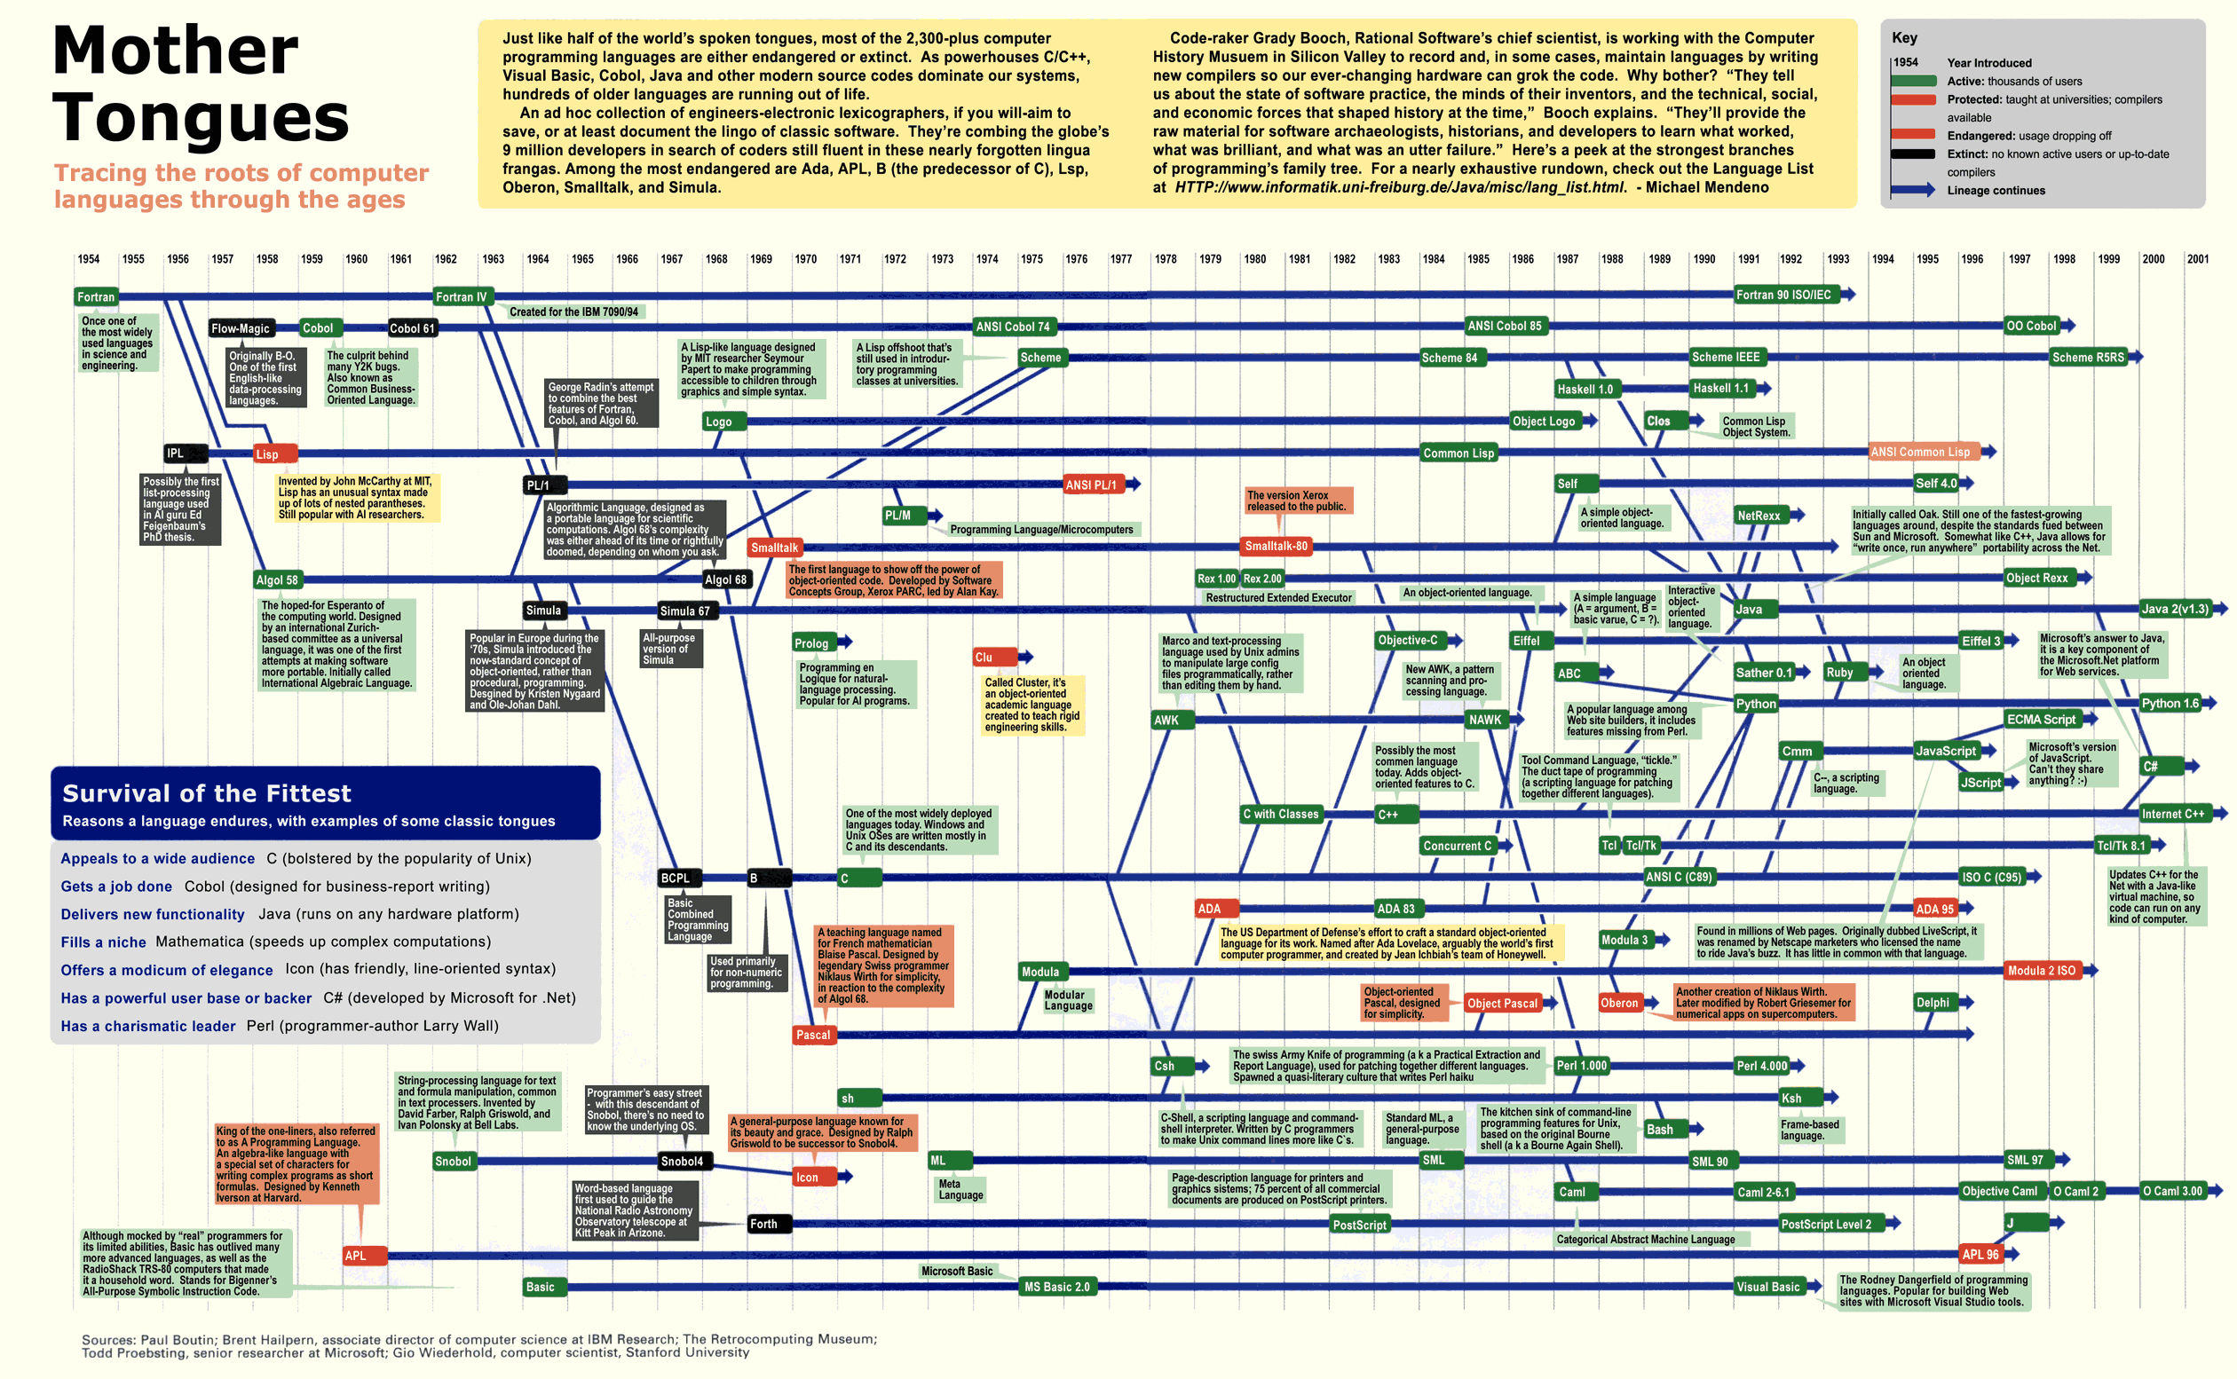

**Machine-Level Programming Language:**

**Description:**

Machine-level language, also known as machine code or binary code, is the lowest-level programming language. It consists of instructions that are directly executed by the computer's hardware. In machine code, instructions are represented using binary digits (0s and 1s).

**Advantages:**

Direct control over hardware, allowing for highly optimized code.

Efficient use of system resources.

**Disadvantages:**

Extremely difficult for humans to read and write.

Highly specific to the architecture of the computer, making it non-portable.

**Example:**

In a simple instruction set architecture (ISA), an instruction in machine code might be represented as a series of binary digits, where each part specifies an operation (e.g., add, load) and operands (e.g., registers or memory addresses).

**Use Case:**

Device drivers, firmware, and certain system-level tasks are often written in machine code or a language that can generate machine code.

**Low-Level Programming Language:**

**Description:**

Low-level programming languages are one step above machine code. They provide a more human-readable representation of the computer's instructions, often using mnemonics and symbols to represent operations and memory addresses. Examples include assembly languages.

**Advantages:**

Closer to hardware, allowing for precise control.

More human-readable than machine code, making it easier to understand.

**Disadvantages:**

Still tied to specific hardware architectures, making portability an issue.

Requires a deep understanding of computer architecture.

Example: In an assembly language like x86 assembly, instructions might be represented using mnemonics like MOV for move and ADD for addition, along with registers and memory addresses.

**Use Case:**

Writing device drivers, optimizing performance-critical sections of code, or tasks where fine-grained control over hardware is required.

**Mid-Level Programming Language:**

**Description:**

Mid-level languages provide a balance between low-level and high-level languages. They offer higher-level abstractions while still allowing direct access to system resources when needed. They typically have features like data types, loops, and conditional statements.

**Advantages:**

More portable than low-level languages.

Easier to read and write than low-level languages.

**Disadvantages:**

Less control over hardware compared to low-level languages.

Can be less efficient than low-level languages for certain tasks.

**Example:**

C is often considered a mid-level language. It provides a structured approach to programming with features like functions, data types, and control structures, while still allowing for low-level operations.

**Use Case:**

Operating systems, embedded systems, and systems programming are often done using mid-level languages like C.

**High-Level Programming Language:**

**Description:**

High-level programming languages are designed to be more abstract and user-friendly. They are further removed from the underlying hardware and provide powerful constructs for solving complex problems. They have features like object-oriented programming, built-in libraries, and higher-level data structures.

**Advantages:**

Portability across different platforms.

Easier to learn and write, facilitating faster development.

More focus on problem-solving than system-specific details.

**Disadvantages:**

Can be less efficient in terms of performance compared to lower-level languages.

May not offer as fine-grained control over system resources.

**Example:** Python, Java, and JavaScript are examples of high-level languages. They provide rich sets of libraries and tools for tasks ranging from web development to scientific computing.

**Use Case:** High-level languages are used in a wide range of applications including web development, data analysis, artificial intelligence, and more.

**Java Programming Language**



Java programming language was created by James Gosling and Mike Sheridan at Sun Microsystems, which was later acquired by Oracle Corporation. The development of Java began in the early 1990s and was officially announced to the public in 1995.

**Background at Sun Microsystems (Early 1990s):**

In the early 1990s, Sun Microsystems, a company known for its workstations and servers, recognized the need for a programming language that could run on various platforms and devices, regardless of the underlying hardware and operating system. This was especially important due to the growing diversity of computer systems at the time.

**Green Project (1991-1992):**

James Gosling, Mike Sheridan, and their team at Sun Microsystems initiated a project known as the "Green Project" to develop a new programming language that would address these challenges. The project aimed to create a language that would allow software to be executed on a wide range of devices and systems.

**Oak Programming Language (1992-1994):**

The initial version of the language created during the Green Project was called "Oak," named after an oak tree outside James Gosling's office window. The Oak language was designed with the goal of being simple, reliable, and platform-independent.

**Internet and Interactive Television (1994):**

As the development of the Oak language progressed, the team recognized its potential for use in interactive television. However, the project's scope expanded beyond television to encompass applications on the emerging World Wide Web.

**Rename to Java (1995):**

In 1995, as part of a legal settlement with Oak Technology, a company that developed computer graphics chips and had trademarked the name "Oak," the language was renamed "Java." The name "Java" was inspired by a type of coffee that the team often drank.

**Introduction to the Public (May 1995):**

On May 23, 1995, Sun Microsystems officially announced Java to the public. They positioned it as a language for developing "applets," small programs that could be embedded in web pages to provide interactivity. Java's slogan was "Write Once, Run Anywhere" (WORA), highlighting its platform independence.

**Java 1.0 Release (January 1996):**

In January 1996, Java 1.0 was released to the public. This marked the first stable release of the Java platform, including the Java Development Kit (JDK) and the Java Runtime Environment (JRE).

**Rapid Adoption and Growth (Late 1990s - Early 2000s):**

Java quickly gained popularity due to its portability, security features, and ease of use. It became a dominant language for enterprise applications, especially for web-based systems.

**Standardization (1997):**

In 1997, Sun Microsystems initiated the process to standardize Java through the Java Community Process (JCP). This allowed multiple parties, including individuals, organizations, and other companies, to contribute to the development of the language and its associated technologies.

**Expansion of the Java Ecosystem:**

Over the years, the Java ecosystem grew to include a vast array of libraries, frameworks, and tools, making it one of the most versatile and widely used programming languages in various domains, including web development, enterprise applications, mobile development (with Java ME), and more.

**Acquisition by Oracle (2010):**

In 2010, Oracle Corporation acquired Sun Microsystems, taking over the development and stewardship of the Java platform.

**Game Changer: Platform Independent and WORA(Write Once and Run Anywhere)**

***Compilation to Bytecode:***

When you write Java code, you use a text editor to create a .java file. This file contains human-readable Java source code.

The Java compiler (javac) takes this source code and translates it into an intermediate form called bytecode. Bytecode is a low-level representation of the code, similar to machine code, but it is designed to be executed by a virtual machine rather than a physical CPU.

***The Java Virtual Machine (JVM):***

The bytecode generated by the Java compiler is platform-independent. It is not tied to any specific operating system or hardware architecture.

To run a Java program, you need a software component called the Java Virtual Machine (JVM). The JVM is specific to each platform (Windows, macOS, Linux, etc.), and it acts as an abstract execution environment for Java bytecode.

***JVM Interpretation or Just-In-Time (JIT) Compilation:***

The JVM can operate in different modes, depending on the specific implementation and configuration. One common approach is interpretation.

In interpretation, the JVM reads the bytecode instructions one by one and executes the corresponding operations on the host platform. This allows the same bytecode to be executed on different platforms without modification.

***JIT Compilation (Optional):***

Some modern JVM implementations also use a technique called Just-In-Time (JIT) compilation. In this approach, the JVM dynamically compiles bytecode to native machine code at runtime, optimizing the performance of the program.

The JIT compiler analyzes sections of bytecode that are frequently executed and compiles them to native code for faster execution. This can significantly improve the performance of Java programs.

***Platform-Specific JVMs:***

While the bytecode is platform-independent, the JVM itself is not. Each operating system requires its own JVM implementation. For example, there are separate JVMs for Windows, macOS, Linux, and other platforms.

***Write Once, Run Anywhere (WORA):***

Because Java programs are compiled into bytecode and executed by a JVM, you can write your code once and run it on any platform that has a compatible JVM installed. This is often referred to as the "Write Once, Run Anywhere" (WORA) principle, which is one of the key features of Java.

***Java Runtime Environment (JRE):***

To run a Java program on a specific platform, you need to install the Java Runtime Environment (JRE) for that platform. The JRE includes the JVM and necessary libraries to execute Java applications.

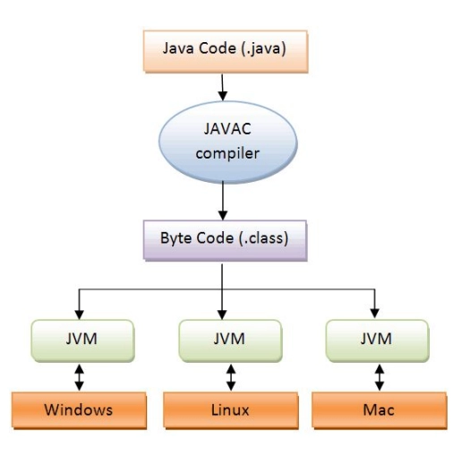

**Java Buzzwords or Features**

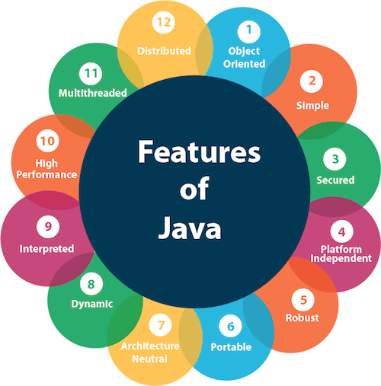

1. **Object-Oriented:**

Java is a fully object-oriented programming language. It encourages the organization of code into reusable, modular units called "objects" that represent real-world entities.

1. **Simple:**

Java was designed to be straightforward and easy to learn. It eliminates complex features found in some other languages and emphasizes clean, concise syntax.

1. **Secured:**

Java was designed with security in mind. It incorporates features such as bytecode verification, runtime security checks, and a robust security manager to protect against malicious code and ensure safe execution.

1. **Platform-Independent (Write Once, Run Anywhere - WORA):**

Java's platform independence is one of its most significant features. Once Java source code is compiled into bytecode, it can be executed on any platform that has a Java Virtual Machine (JVM) installed, regardless of the underlying hardware or operating system.

1. **Robust:**

Java aims to eliminate common programming errors by providing strong type checking, automatic garbage collection, and exception handling. This makes Java programs more reliable and less likely to crash or encounter runtime errors.

1. **Portable:**

Java's portability allows developers to write code once and run it on multiple platforms without modification. This saves time and effort, as developers do not need to rewrite code for different operating systems.

1. **Architecture-Neutral:**

Java is designed to be architecture-neutral, meaning that the compiled bytecode can be executed on any system with a compatible JVM, regardless of its underlying architecture.

1. **Dynamic:**

Java is considered a dynamic language because it supports dynamic memory allocation and garbage collection. This allows for more flexible memory management and reduces the likelihood of memory-related errors.

1. **Interpreted:**

Java is both compiled and interpreted. The source code is initially compiled into platform-independent bytecode. This bytecode is then interpreted by the Java Virtual Machine (JVM) at runtime.

1. **High Performance:**

While Java's performance may not be as optimized as lower-level languages like C or C++, it still offers competitive performance due to its Just-In-Time (JIT) compilation and runtime optimizations.

1. **Multithreaded:**

Java provides built-in support for multithreading, allowing programs to execute multiple threads concurrently. This feature is essential for developing applications that can perform tasks in parallel, such as handling user interfaces while processing background tasks.

1. **Distributed:**

Java includes libraries and APIs for building distributed applications, making it well-suited for networked environments. It supports technologies like Remote Method Invocation (RMI) and Java Naming and Directory Interface (JNDI) for distributed computing.