**How to create an account with oracle.com website?**

**Note:** In order to download any software from the oracle website you should sign up for a free account.

**STEP1:** Go to [www.oracle.com](http://www.oracle.com) website

**STEP2:** click on view accounts

**STEP3:** Under Oracle Account select Create Account

**STEP4:** Fill all your information and select Create Account.

**STEP5:** Check your email inbox and open the mail which is sent by oracle and click on verify email address button

**STEP6:** After you get success! message, Again go to oracle website and click on view accounts and under oracle Account click on Sign in and fill-in your credentials and log in

**How to Download and Install JDK?**

**STEP1:** In order to download Java JDK go to [www.oracle.com](http://www.oracle.com) website.

**STEP2:** you will get a notification “would you like to visit an oracle country site closer to you?”

Simply click on – No thanks, I will stay here**W**

**STEP3:** Click on Developers option from the menu and select Developer Resource Center option.

**STEP4:** Scroll down and under **Develop in your favorite programming language** heading select **Java**

**STEP5:** Scroll down and under Java SE select Download Oracle JDK

STEP6: scroll down and under **Java SE subscribers have more choices** make sure that Java 8 is underlined and select windows platform and download the JDK software according to your system architecture.

**Note:**

jdk-8u391-windows-i586.exe 🡺 for x32 bit operating system

jdk-8u391-windows-x64.exe 🡺 for x64 bit operating system

**Note:** JDK Version number may change time to time

Note: The Latest of Java is 21

- The Latest edition of Java might not be supported by all the platforms(AWS, Azure, Google Cloud)

- The industry standard and which is supported by all the platforms is Java 8

- That is why we will download and install and work with Java 8

- We will be also learning about all the new features and new concepts that has been introduced in the latest editions of java.

Java SE - Standard Edition

Java SE Development Kit 8u371

u == update

JDK software is available for

---------------------

Linux

macOS

Solaris

Windows

According to the system architecture you need to select the installer

it can *86 (32 bit) or *64 (64 bit) operating system, or processor

check - right click on this PC -> under system type you will find that.

*86 is compatible with only 32 bit system architecture if the system architecture is 32 bit only.

if your system is 64 bit then both *86 and *64 is compatible.

select this file jdk-8u371-windows-x64.exe

Along with JDK software - > JRE and also JVM

JDK - Development purpose

JRE - Production purpose

JVM - Provides an environment to run(execute) byte code

(Inside the JRE JVM will be there)

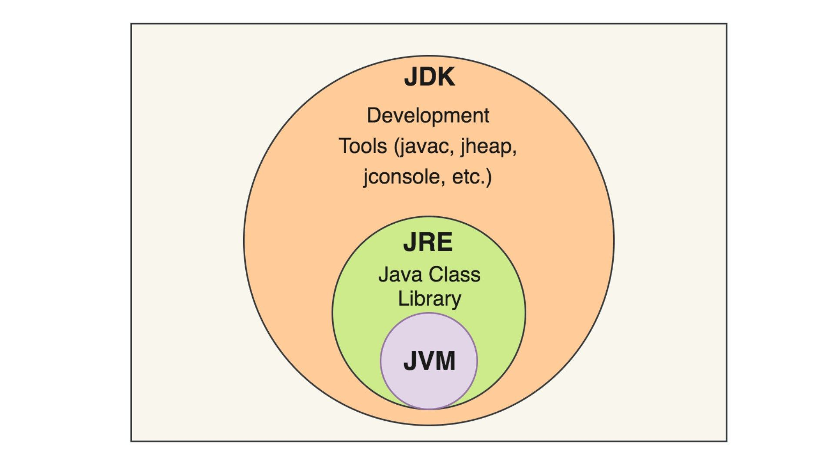

- Currently Java No.1 Development Platform(Business and Banking Applications)

- So many devices are running by using Java. Ex: Car Music Systems, lifts, Washing Machines(as embedded softwares), Android TVs, Smart Phones etc..

to find out the java version that is installed in our system trigger

java -version

software version analysis

major minor updates or patches

1 . 8 . 0_371

After the installation of JDK the first thing we need to do is setting the path environment varible.(or updating the path environment variable)

D>Developmentsoftwares>JDK8>bin || copy this folder location from the address bar

Right click on this pc -> properties -> AdvancedSystemSettings -> EnvironmentVariable - UserLevel -> select the path variable if already existing

and click on edit -> click on new -> paste the copied path of bin folder -> click on ok and in all the remaining windows.

if the path variable is created yet -> under user variable section -> click on new ->variable name 'path' uppercase of lowercase or mixed case but dont give any spaces in the beginning or in the middle or at end.

->variable value -> paste the copied bin folder location

close the previously opened command prompt(before the path setting or path updation). open a new command prompt and trigger javac

**Need of setting the path**

in order to specify the commands location(java, javac) to the command window we need to set the path.

**Installing EditPlus for the development and Learning Java Concepts through programs**

1. Go to https://www.editplus.com/ -> Select Download from top menu

you will get these two options

EditPlus 5.7 Evaluation Version

● Download EditPlus 5.7 (64-bit) == if your system is 64 bit architecture, then download this.

● More options... ==> Select this if your system is 32 bit architecture. then download.

2. Before Installing, create a folder called EditPlus inside the DevelopmentSoftwares folder.

(in windows to create a new folder shortcut cntl + shift + n)

while developing the folder name or file name follow the CamelCase Ex:(EditPlus). the first letter of each word will be in the upper-case without giving any space.

Note:: All the develoment softwares we are installing in the D drive(any drive other than C drive) because we need to lower the OS load, because the OS drive is already having OS files. its not recommended to give more load to that drive.

3. Start the installation by double-clicking on editplus.exe file(downloaded).

(Note: '.exe' is an executable file in the windows system)

4. Installation Windows

1. Accept the Licence Agreement.

2. click on yes for the windows notification(for making the changes to the system).

3. Next window: specify directories where you want to install. in this window just leave all the selected check boxes as it is, then for the program directory, already the installer is pointing default loacation 'C:\Program Files\EditPlus' instead going with this default location select the folder location that we already created 'D:\Developmentsoftwares\EditPlus' for this select the three '...' which is visible after the path indicator.

- Expand This PC -> Expand D drive -> DevelopmentSoftwares -> Then Select EditPlus folder -> then click on OK

- installation program directory should be looking like this 'D:\Developmentsoftwares\EditPlus'

- click on 'Start Copy'

4. In the Next window you will get a success message. Just click on OK.

5. Go to desktop(cntrl + D(all the opened windows will be minimized, desktop will be visible)).

6. Double click on EditPlus application shortcut

7. When you open the EditPlus for the first time after installation you will get License AgreementWindow Again, you just need to click on Yes to accept.

8. You will get Set Directories window - this one is related to the Internal EditPlus files storage.

you just need to click on OK

9. you will get a small window saying that 'Setup will overwrite the existing syntax files' Continue?

Just click on Yes.

10. EditPlus is not 100% free but we can able to use as free for the life time with minor task.

11. you will get Enter Registration Code window -> Trial -> you will get a small window called evaluation version. you just need to drag that window to the bottom of the screen, till it is not visible any more. Then maximize the main window. close the side bar(file Explorer) by dragging to the left side.

12. We need to make some configuration to the EditPlus.

click on Tools -> Preferences -> select General -> Fonts -> FontFamily = consolas, FontStyle = Bold, FontSize = 22

on the left hand-side categories, Select File Uncheck the option 'create the backup file while saving'(To avoid EditPlus creating backup files for all the files). Then click on Apply and click on OK.(To save the changes)

**Developing our first java program using simple notepad**

1. On the desktop create a folder called JavaDemo.

2. Open the windows NotePad(click on windows icon(bottom left corner)start typing notepad and pin to task bar. and click on the notepad icon on the task bar)

3. To increase the font size in the notepad press cntl + mouse(scrollUp).

4. start developing the HelloWorld Java Program

class HelloWorld

{

public static void main(String[] args)

{

System.out.println("Hello World!");

}

}

5. copy the class name 'HelloWorld' -> File -> Save As -> Desktop > JavaDemo -> Enter the file name

'Just paste class name whichever you copied'-> compulsary include the '.java' extension.

Note: For the Java files .java is the extension(Java files will be identified with the .java file extension). -> click on save.

6. Open the command prompt -> make the prompt to point to the 'Desktop > JavaDemo' Folder

Note: Folder == Directory by using command cd Desktop/JavaDemo or if it is not working use the command cd OneDrive/Desktop/JavaDemo.

Note: cd (change directory)

7. To compile the java program we need to trigger the command called javac, this will be invoking the java compiler to check for the syntax correctness of the java file.

Note: javac (java compiler)

Ex: javac JavaFileName.java == javac HelloWorld.java

8. If the program is syntactically proper, then a '.class' file will be generated in the same folder (JavaDemo). Otherwise we will get syntax error. we need to resolve that error, save the file and again we need to trigger 'javac JavaFileName.java'.

9. check the JavaDemo folder for '.class' file. select that .class file and Open that file by right clicking and select EditPlus.

Note: if you cant able to see the extenstions of the files then click on view -> select the check box of file name extensions.

We cant able to read the contents of the .class file. this is exactly what we call the byte code.

inside the .class byte code will be there. we need to execute the .class file.

10. For Executing the .class file -> use the java command 'java name_of_the_class_file'

Ex: java HelloWorld

11. From the same location 'C:\Users\vijay\Desktop\JavaDemo>' trigger 'java HelloWorld'

you will be getting 'Hello World!' as the output

Note: you should not include any .class or .java extension while executing the class file.

12. Once you trigger java HelloWorld -> JVM(Java Virtual Machine) will be invoking the main method of HelloWorld class and executing the print statement which is producting Hello World! as the output.

**Some More Configuration to the EditPlus**

1. Problem - if we are having more content in the same line then we need to scroll to the right-hand side.

Sol - To avoid this problem we need to turn on word-wrap

steps - click on Document -> Select word-wrap

2. To get more Editor space turn off -> Ruler, that is visible on top of the Editor space.

steps: click on view -> uncheck 'Ruler'

3. To get the FullScreenWindow -> just press F11(toggle for interchange)

Note: if you making any changes to the java file(even minor changes like adding or removing the space) then compulsory you need to save that file and again you need to compile that file before executing with java command.

**Windows NotePad VS EditPlus**

1. While saving the files Auto Extenstion will not be applied in case of notepad.

2. There is no syntax highlighting feature(color highlighting) in notepad so we may not be easily able to recognize keywords, identifiers, inbuilt classes.

3. There are no extra fetures in notepad which are available in the EditPlus like LineNumber, Ruler, Easy navigation between files using inbuilt package explorer and so many other tools that are very much required for the efficient and faster development of programs

Note: No need of opening and closing the command prompts again and again for each and every program you can just use the same command prompt for all the programs.

**Standard Way of Developing Java Programs**

1. Create a folder in any of the drive other than OS drive, Name it as JavaCourse.

2. Inside the JavaCourse create another folder LanguageFundamentals -> application1 -> src & classes

3. src stands for source(folder)

4. We are creating a seperate folders. for keeping .java files in the src folder and to keep generated .class files in the classes folder.

Reason: We are seperating '.class' files from '.java' files.

'.java' files in a seperate folder called 'src'.

'.class' files in a seperate folder called 'classes'.

This is the standard way of developing our java programs.

**First Approach**

C:\Users\vijay>G:

G:\>cd SomeFolderName

G:\SomeFolderName>cd JavaCourseJune

G:\SomeFolderName\JavaCourseJune>cd LanguageFundamentals

G:\SomeFolderName\JavaCourseJune\LanguageFundamentals>cd application1

G:\SomeFolderName\JavaCourseJune\LanguageFundamentals\application1>cd src

G:\SomeFolderName\JavaCourseJune\LanguageFundamentals\application1\src>

- Open the EditPlus File -> New -> Java

- you will be gettting the default code (recommended to delete(ctrl + A and backspace) and type again).

- File -> Save As -> Save it in the 'G:\SomeFolderName\JavaCourseJune\LanguageFundamentals \application1\src>' folder with FileName as A (.java extension is optional here bcz already editplus selecting Save as type to .java)

-compile the file using javac FileName.java

-if our program syntactically proper then .class file will be generated. In this case .class file is generated in the same folder(src).

- To get the FileNameExtenstions in the windows FileExplorer Just View -> Select the checkbox for

FileNameExtenstions.

Type: JAVA File == JAVA Source File (Java Source Code File)

CLASS File == Compiled version of Java Source File (.class file) Which contains byte code.

we cant able to read it, so we are chieving security. This file will be processed by the JVM.

This file is platform independent(specifically the content of this file).

- Both the files .java and .class are present in the same src folder itself, which is not a standard way develpment.

**Second Approach**

C:\Users\vijay>cd G:\SomeFolderName\JavaCourseJune\LanguageFundamentals\application1\src

C:\Users\vijay>G:

G:\SomeFolderName\JavaCourseJune\LanguageFundamentals\application1\src>

**Third Approach**

1. select and copy the address of src folder location from the windows explorer.

Ex: G:\SomeFolderName\JavaCourseJune\LanguageFundamentals\application1\src

2. open a new command prompt type cd and paste the content you just copied.

Ex: cd G:\SomeFolderName\JavaCourseJune\LanguageFundamentals\application1\src

3. if you are still not that drive and folder, just type the name of the drive and colon Ex: G:

**Fourth Approach**

1. Go to the src folder location in the windows explorer and clear the address bar content.

2. Just type cmd in the upper case or lower case and press enter.

In this location command prompt will be opening.

3. to increase the font size of the command prompt just press cntrl + mouse(scroll up)

Note: - create a new java file in editplus press Alt + F and right arrow and select java

- To save file cntrl + S

Note - to clear the command prompt window just trigger the command 'cls'

To seperate the .class files from the .java files while compiling

1. javac -d ../classes B.java

javac == java compiler

-d == option we are using along with the javac command.

this option is for interacting with the file system.

../classes ==> currently we are in the src folder. to go back to the previous folder application1 folder, and select classes folder. In this location we need to keep the generated .class file.

B.java ==> the fileName we wish to compile.

**Note: you need to trigger this command from the src location only**

**Runnnig the .class file**

**1st Approach**

src>cd ../classes

application1\classes> java B

(java classFileName)

**To go back to the src**

cd ../src

**2nd and best Approach (easier)**

java -cp ../classes B

**java ==> to invoke the JVM**

-cp ==> option 'classpath' -> it will be seaching for .class files in the directory.

../classes B ==> currently we are in the src folder. to go back to the previous folder application1 folder, and select classes folder. there you will find class file, that file we need to execute.

Note: To rename the file or folder press F2 in windows.