A

School Observation In

Government Higher Secondary /middle School,

Submitted In Partial Fulfillment of the Requirement for the Award of the Degree

Bachelor oF Education From

Pt.Ravi Shankar shukla University, Raipur (C.G) Year: 2024-2026

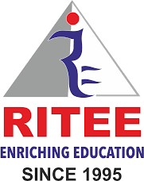

RITEE COLLEGE OF EDUCATION

Guided By: Pupile’s teacher:

**------------------------------- -------------------------**

( Education Dept.) B.Ed 2nd Semester

Submitted to:

Ritee College Of Education , Raipur

Affiliated By:

Pt.Ravi Shankar Shukla University ,Raipur