⭐ STEP 1 — Import Data into Power BI
1️⃣ Open Power BI
2️⃣ Click: Home → Get Data → Excel
3️⃣ Select: HR_Analysis_Project.xlsx
4️⃣ Import all 4 sheets:
✔ Employees
✔ Attendance
✔ Performance
✔ Attrition
5️⃣ Load them
✔ Task complete when all tables appear in the Power BI Fields pane.

⭐ STEP 2 — Power Query Cleaning
Click: Home → Transform Data
For each table:

🟦 Employees Table (tbl_Employees)
Do this:
✔ Change data types:
- Age → Whole number
- Salary → Whole number
- HireDate → Date
✔ Fix column names (if needed)
- EmployeeID
- Department
- JobRole
- Gender
✔ Add new column — ExperienceYears
Go to: Add Column → Custom Column
Formula:
Date.Year(DateTime.LocalNow()) - Date.Year([HireDate])
✔ Output: Employee experience in years.

🟩 Attendance Table (tbl_Attendance)
✔ Change Types:
- DaysPresent → Whole number
✔ Month Column
If it is text like "Jan-2024", convert to date:
Transform → Detect → or
Add Custom Column:
= Date.FromText("01-" & [Month])
Rename to → AttendanceDate

🟨 Performance Table (tbl_Performance)
✔ Change Types:
- PerformanceRating → Whole number
- PromotionEligible → Text

🟥 Attrition Table (tbl_Attrition)
✔ Change Types:
- ExitDate → Date

⭐ STEP 3 — Create the Data Model (STAR SCHEMA)
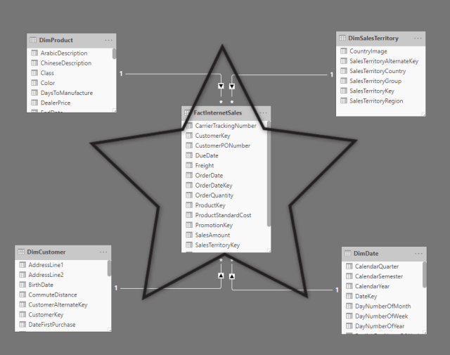
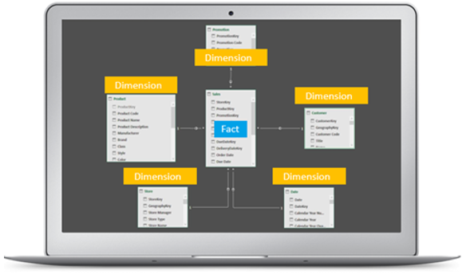
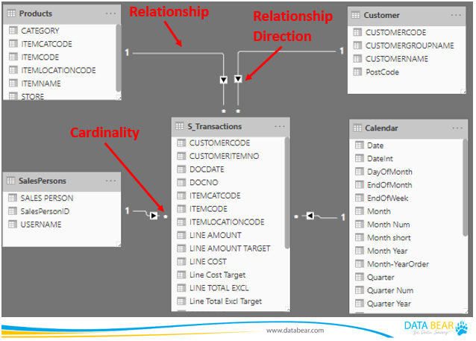
4
Go to: Model View
You MUST connect all tables using EmployeeID.
🔗 Relationships:
From Table | Column | To Table | Column
Employees | EmployeeID | Attendance | EmployeeID
Employees | EmployeeID | Performance | EmployeeID
Employees | EmployeeID | Attrition | EmployeeID
Relationship Type:
✔ One (Employees) → Many (other tables)
✔ Cross filter direction: Single
You should get:
Employees (DIM)
↓
Attendance (FACT)
↓
Performance (FACT)
↓
Attrition (FACT)
✔ MODEL COMPLETE when lines connect correctly.

⭐ STEP 4 — Create DAX Measures (Important for dashboard)
1️⃣ Total Employees:
Total Employees = COUNTROWS(Employees)
2️⃣ Total Attrition:
Total Attrition = COUNTROWS(Attrition)
3️⃣ Attrition Rate:
Attrition Rate = DIVIDE([Total Attrition], [Total Employees], 0)
4️⃣ Average Salary:
Average Salary = AVERAGE(Employees[Salary])
5️⃣ Average Performance Rating:
Avg Performance Rating = AVERAGE(Performance[PerformanceRating])
6️⃣ Gender Count:
Male Count = CALCULATE([Total Employees], Employees[Gender]="Male")
Female Count = CALCULATE([Total Employees], Employees[Gender]="Female")
7️⃣ Average Experience:
Average Experience = AVERAGE(Employees[ExperienceYears])
✔ You must create at least 7 measures.

⭐ STEP 5 — Build HR Dashboard (Page 1)
Title: HR Overview Dashboard
Add visuals:
✔ KPI Cards:
- Total Employees
- Attrition Rate
- Average Salary
- Avg Performance Rating
- Average Experience
✔ Charts:
🔹 Employee Count by Department → Bar Chart
🔹 Gender Distribution → Donut Chart
🔹 Performance Rating → Column Chart
🔹 Attrition Trend (Exit Dates) → Line Chart
Axis → ExitDate
Values → Count of EmployeeID
✔ Slicers:
- Gender
- Department
- Education
- JobRole

⭐ STEP 6 — Build Page 2: Performance Analytics
Visuals:
- Top Performers (Table)
- Performance Rating by Department
- Promotion Eligibility Donut
- Salary vs Performance scatter chart

⭐ STEP 7 — Build Page 3: Attrition Analysis
Visuals:
- Attrition Count by Department
- Attrition by Age Group
- Attrition by Gender
- Exit Reasons (Bar Chart)
- Employee Tenure vs Attrition (scatter or bar)

⭐ STEP 8 — Publish to Power BI Service
Steps:
- Home → Publish
- Select Workspace
- Open Power BI Service
- Pin visuals to Dashboard
- Enable scheduled refresh
Now your project is job-ready.

